SOCIOLOGY 2021-22 November 4, 2021

Today’s Agenda (Day 50)

- HOMEWORK CHECK

- CLASS ACTIVITY
CONT’D: Seeing the American Culture: Through Food and Housing PPT

CONT’D: Discourse for Cultural Relativism – Day 5
*Discourse focus: Is it okay to speak out against a cultural practice if that particular cultural practice violates human rights?
* Discourse format:
• PRO position (max. 5 minutes) [Pro Team]
• Rebuttal (max. 3 minutes) [Con Team]
• CON position (max. 5 minutes) [Con Team]
• REBUTTAL (max. 3 minutes) [Pro Team]
• Teams QUESTION each other (max. 5 minutes/team) [Both teams]
• CLOSING statements (max. 3 minutes/team) [Both teams, in the opposite order from opening statements]

HOMEWORK:
- READ: Chapter 4 – Society
- COMPLETE: Activity – Cultural Relativism “Discourse”

REMINDERS:

SOCIOLOGY 2021-22 ACTIVITY

CULTURAL RELATIVISM

DIRECTIONS: In groups of four, prepare to argue two of the prompts below. Be prepared to argue any side that teacher directs.
Prompt: What happens when something that is legally and morally permissible in one culture is illegal and immoral in another? How does one confront this conflicting issue? Cultural relativism in Sociology states that one should try to understand the cultural act on the culture’s own terms and make no moral judgments towards that act. But what happens when this act violates another culture’s human rights, ethics, and/or morality? Should one stand back and observe cultural relativism, or is it okay to cast judgment? Is it okay to speak out against a cultural practice if that particular cultural practice violates human rights?

Topics to Illustrate Cultural Relativism: (underlining indicates that the topic is less likely to trigger an emotional response)
a. Arranged Marriage
b. Treatment of Women in Some Muslim Nations
c. Polygamy
d. Female Genital Mutilation
e. Child Labor
f. Honor Killings

Criteria for Success:
1. Research and complete Notecards on TWO topics using the suggested resources. Be sure to understand the (1) The Cultural Relativist Approach and (2) The Ethnocentric Approach for your TWO topics.
**See below for Notecard requirements.
2. Be ready to discuss findings in class to develop a stronger argument:
___a. Be Knowledgeable about TWO Topics from the above list
___b. Know the Cultural Relativist AND Ethnocentric points of view on these topics
3. Complete the Self-Assessment and Turn in:
*Notecard Requirements:
- Title & Source section
- Copy, paste and annotate section
- In your own words section
- Original thinking section
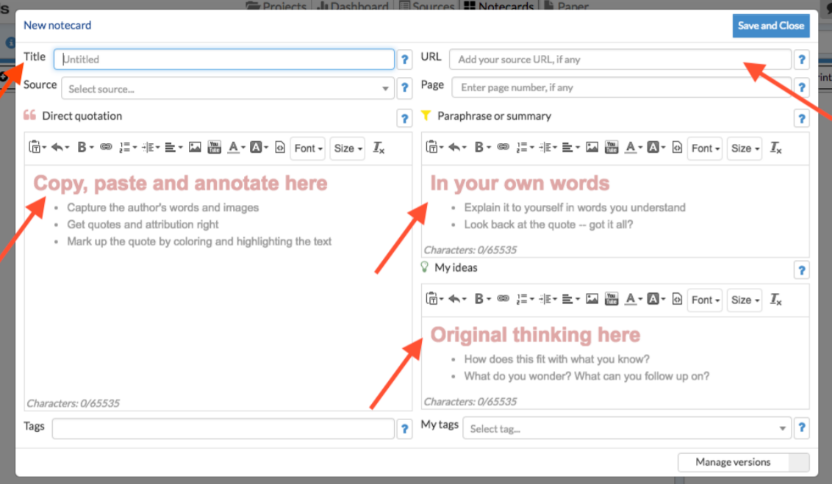
*Discourse focus: Is it okay to speak out against a cultural practice if that particular cultural practice violates human rights?
* Discourse format:
• PRO position (max. 5 minutes) [Pro Team]
• Rebuttal (max. 3 minutes) [Con Team]
• CON position (max. 5 minutes) [Con Team]
• REBUTTAL (max. 3 minutes) [Pro Team]
• Teams QUESTION each other (max. 5 minutes/team) [Both teams]
• CLOSING statements (mas. 3 minutes/team) [Both teams, in the opposite order from opening statements]

Self-Assessment:
- What did I learn from this assignment?
- How is cultural relativism relevant in my everyday life?
- What role does ethnocentrism play in my life?
- How has my perspective of these topics changed as a result of having completed the assignment?

https://shhs-southhadleyschools.libguides.com/culturalrelativism
https://shhs-southhadleyschools.libguides.com/ld.php?content_id=50498706

