SOCIOLOGY 2021-22 October 19, 2021

Today’s Agenda (Day 39)

- HOMEWORK CHECK

- CLASS ACTIVITY
CONT’D: Seeing the American Culture: Through Food and Housing PPT

CONT’D: Activity: Create a Language – see p. 2 of document

HOMEWORK:
- READ: Chapter 3 – Culture
- COMPLETE: a) Activity - Create a Language
b) Activity – Cultural Relativism “Discourse”

REMINDERS:
- Create a Language – Wed., Oct. 27

SOCIOLOGY 2021-22 ACTIVITY

CREATE A LANGUAGE

Directions: Using what you have learned create a fictional language and answer the following questions about your language. For ideas and suggestions check out the WikiHow page on How to create a Language (linked on the course website).
Resources: WikiHow: How to Create a Language https://www.wikihow.com/Create-a-Language
Hello in Many Languages https://www.omniglot.com/language/phrases/hello.htm

Step 1: Name Your Language

Step 2: Create an Alphabet
(Suggestion give some type of guide as well how each letter or symbol is pronounced)

Step 3: Create a Vocabulary/Dictionary
(Use your alphabet and an idea of how you want your language to sound to come up with some basic words for your language)

Step 4: Grammar
(Establish three basic rules for your language to help set a standard for how the language is written)

- Word order – Set standards for in which order sentences are formed (ex. noun,verb, adjective)

- Pluralization and Gender – How do nouns display plural or gender (ex. Das Boot German for The Boat, in this case “the” is female, or Die Boote German for The Boats but now “the” and “Boat” are now plural)

- Conjugate verbs – Explain how to change verbs to show past, present, and future tense.
Past –
Present –
Future –
(Ex. Spanish to Sleep Dormir Past: Dormi , Present: Duermo, Future: Dormire)

Step 5: Write a Paragraph
(Using your language write a paragraph in your new language and then have a classmate translate it)

Original:

Translation:

Step 6: Find the Language Family
(Use the link on the course website titled “Hello in Many Languages” to find a list of current and past languages. Scroll through the list to find which existing language is most similar to your own and answer the following questions)

1. Which language is most similar to yours? ___________________________________
2. Where is/was the language spoken? ___________________________________
3. Which language family is the language in? ___________________________________
4. Come up with three ideas of how the cultures might interact with one another due to their similar language.
a.
b.
c.

SOCIOLOGY 2021-22 ACTIVITY

CULTURAL RELATIVISM

DIRECTIONS: In groups of four, prepare to argue two of the prompts below. Be prepared to argue any side that teacher directs.
Prompt: What happens when something that is legally and morally permissible in one culture is illegal and immoral in another? How does one confront this conflicting issue? Cultural relativism in Sociology states that one should try to understand the cultural act on the culture’s own terms and make no moral judgments towards that act. But what happens when this act violates another culture’s human rights, ethics, and/or morality? Should one stand back and observe cultural relativism, or is it okay to cast judgment? Is it okay to speak out against a cultural practice if that particular cultural practice violates human rights?

Topics to Illustrate Cultural Relativism: (underlining indicates that the topic is less likely to trigger an emotional response)
a. Arranged Marriage
b. Treatment of Women in Some Muslim Nations
c. Polygamy
d. Female Genital Mutilation
e. Child Labor
f. Honor Killings

Criteria for Success:
1. Research and complete Notecards on TWO topics using the suggested resources. Be sure to understand the (1) The Cultural Relativist Approach and (2) The Ethnocentric Approach for your TWO topics.
**See below for Notecard requirements.
2. Be ready to discuss findings in class to develop a stronger argument:
___a. Be Knowledgeable about TWO Topics from the above list
___b. Know the Cultural Relativist AND Ethnocentric points of view on these topics
3. Complete the Self-Assessment and Turn in:
*Notecard Requirements:
- Title & Source section
- Copy, paste and annotate section
- In your own words section
- Original thinking section
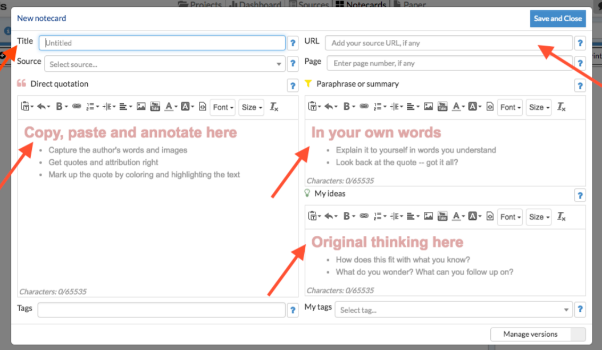

Self-Assessment:
- What did I learn from this assignment?
- How is cultural relativism relevant in my everyday life?
- What role does ethnocentrism play in my life?
- How has my perspective of these topics changed as a result of having completed the assignment?

https://shhs-southhadleyschools.libguides.com/culturalrelativism
https://shhs-southhadleyschools.libguides.com/ld.php?content_id=50498706

