PHYSICS 2021 - 22 PROJECT

Musical Instruments
BUILD A MUSICAL INSTRUMENT
This project will require both an understanding of the physics of music and the physics of musical instruments. You may work alone or in pairs using these ideas to design and build a musical instrument. I must be able to easily play at least the following full musical scale: C, D,E,F,G,A,B,C and it must not require special musical skill to play the instrument.
Resources:
- Audacity
- Visual Analyser
- Physics of Musical Instruments book

GRADING CRITERIA
Instrument Construction
· The instrument is built as ruggedly as can be expected for the type of instrument.
· Attention has been given to the aesthetic details of this instrument.
· The pitches are in tune and accurate. This means you’ve tested and confirmed they are at the correct frequencies.
· The instrument produces tones that are as clear and strong as expected with this type of instrument.
- You must be able to demonstrate how to change the loudness of the sound produced by your instrument. Loud sounds can damage hearing; do not play your instrument too near other students’ ears.
- Your instrument must be made of safe materials. Cover any sharp edges, use no electricity, etc.
- You must demonstrate and play a simple tune (or rhythm) on your instrument in a class presentation by playing a minimum of three different notes (frequencies).
- Try to use recycled materials or “upcycle” materials.
Lab Report
· The report has a professional appearance and is error-free.
· The report is rich in detail about the entire process of engineering and building the instrument. [Explain what you attached/cut/etc. where, how and why.]
· Includes a log of time spent on various activities involved in producing the instrument, a scale drawing of the instrument, photos of the building process, necessary calculations, a recount of design problems and solutions, and a self-evaluation of the work done.
· There is an appropriate use of images/videos that document the entire process.
· Everything is electronically embedded in the report and appropriate technology has been used.
· Labeled drawing of your instrument must include: (a) all parts labeled; (b) explain what each piece is composed of

Presentation
· The presentation is between three and five minutes long.
· The presentation is obviously well rehearsed with no use of notes throughout any part of the presentation. It recounts the engineering challenges and solutions to problems encountered. There is constant eye contact throughout the presentation as well as an engaging speaking style.
· The presentation includes the performance of a song that is played at the perfect pace, and which includes all or most (minimum of six of the notes) of the notes in the major scale.
Suggested easy tune (B – high note, A – middle note, G – low note):
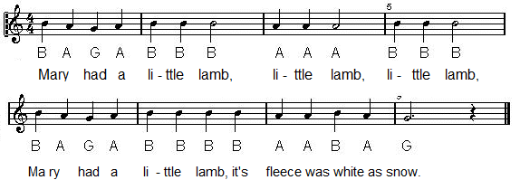
Or
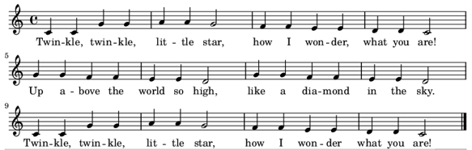
Deadlines
· Final Instrument Due: April 19th – Your report is due this day as well.
· Your Plan is due: April 13th.
· Progress Checks: April 14 – 15th. What have you done? Have you made any calculations yet? Have you bought stuff? Have you started to build? I need to know where you are. If you’ve determined things like frequencies, tube or string lengths you should include them.
· Final Progress Check: Score your instrument using the Rubric. The number of points you get on this assignment will depend on how accurately you do this!
· Presentations: April 20 and 22
Safety Notes
· I expect you to follow proper safety precautions. Safety glasses or goggles are required.
· If you plan on using power tools you MUST have the full knowledge and permission of your parents. I highly recommend parent supervision while using any power tools!!!

Rubric -
Instrument
 | Totally Inadequate (0) | Poor (1) | Acceptable (2) | Outstanding (3)
Complexity/Craftsmanship | Kleenex box and rubber bands | Instrument looks like it’s in danger of falling apart. It won’t stay in tune for more than a minute or two. | You built one of the instruments as detailed exactly in the book. Instrument is well made and sturdy and stays in tune. | You went beyond the instruments in the book or Make TV, but final product is evidently homemade and appropriate for grade level.
Pitches are in tune (correct frequencies) | Does not have 8 notes or all notes are out of tune | Some notes out of tune or doesn’t include a C-C octave | All 8 notes in tune | More than one octave, all in tune
Tone Quality | Can’t even be heard by the musician | Tones are hard to hear more than two feet away or are not “pure” (i.e. the instrument rattles or produces unintended frequencies) | Tones are as clear and strong as expected with this type of instrument | Tones can easily be heard by everyone in the class and are not dissonant.
Song Played | Song is indistinguishable due to poor sound quality and/or instrument playing. | Attempts to play required song. Identity of song is only slightly detected. | Sound quality or notes played provides audience an improved means to identifying song. | Identity of song is easy to determine from quality of sound and appropriateness of notes played.
Aesthetics/Creativity | No thought at all given to appearance | Very little though was given to the presentation of the instrument. | Design shows some originality or “spit and polish” | Very attractive or original design.

Report
 | Totally Inadequate (0) | Poor (1) | Acceptable (2) | Outstanding (3)
Error Free and Professional | Not typed or lots of errors throughout. | Several errors | Only one or two errors in grammar | No grammatical errors and I had to check Google to see if you actually wrote this, it’s so good.
Pictures throughout | No pictures or only pictures of the finished product | Only a few pictures of the process | Process well covered, pictures placed appropriately | Pictures tell the complete story. I could rebuild your instrument simply by referencing your pictures.
Calculations and Data | No data or no calculations | Data and calculations hard to understand or incomplete | Data and calculations complete and readily understandable | More data than needed was collected and/or more calculations
Discussion of the Science | No discussion of the science included OR many inaccuracies throughout. | More than two factual errors and/or an incomplete discussion of the science. | One or two errors in the science and/or missing one element in the discussion of the science. | A completely correct and thorough discussion of the science including: resonance, mode of vibration, harmonics.
Complete | More than one missing element or several incomplete elements | Missing an element or some elements incomplete | Has all required elements | Goes above and beyond the requirements

