PHYSICS 2021 - 22 PROJECT

How to Build & Race a Cardboard Boat

A Photo Journal…
-Keep an ongoing digital visual record of your process of building a cardboard boat!

The Supplies
- Corrugated Cardboard (recycled materials are preferred!)
- Duct Tape
- Long Straight Edge (rule, yardstick, measuring tape)
- Marking Pens & Pencils
- Cutting Implement (utility knife, box cutter, tin snips)
Cost: Plan for less than $50 in supplies.

Forbidden Materials!
- Two part glues  - Fiberglass resins and Plastic Epoxies  - Metal  - Plastic  - Foam Core Boards or Styrofoam  - Pasteboard or Chipboard types of Cardboard  - ANYTHING NOT LISTED IN THE ALLOWED!! | - Non-corrugated cardboard (ie.  cardboard tubes)  - Wood  - Cardboard that has been factory coated with wax  - Metal foils and paints

When to Start

Boat Building Process
Step 1: Draw a design on paper and use this design to build a small mock-up. Use this scale model to determine how many sheets of cardboard you’ll need.

The Phoenix Zoo team designed their “giraffe” boat and had a fun time testing the design on the river.

Step 2: Once you have a model that looks good, transfer the design to graph paper using appropriate dimensions. This can be used to draw a pattern on the cardboard sheets.

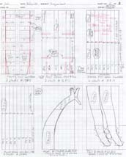

Hint: Lines to be cut should be identified differently than bend lines.

Design Considerations
- Set a goal: are you building a Fun Boat or a Speed Boat?
- Plan the right size boat – a box 1 x1 x 3 will float 180 pounds… so, if your boat is big enough to hold you, in all probability it will also be big enough to float. Standard size is 8 feet in length and 3 feet in width. If your plan deviates from this, be sure to get teacher’s approval
- If you plan to have a 3-person crew, build a boat that will fit 3 people. Be sure that you account for their weight. 3 kids will take less boat than 3 grown adults [usually]!
- Flat Bottoms tend to be less “tippy” than V-shaped bottoms.
- The lowest center of gravity (sitting in the bottom of the boat) is the most stable position. Kneeling or standing… you’ll probably tip over.
- Dimension Considerations
Longer boats go faster, but they are harder to turn.
Boats shorter than 10 feet are difficult to steer straight.
10-12 feet in length seems to be just about right.
Don’t make your boat sides too high. For example, 18 inches in height will allow room to sit and paddle without the edge of the boat blocking your arms.
Plan width based on the number of people. If there will be just one paddler, don’t go wider than 30 inches. If there are two, try about 48 inches.

Step 3: When you are ready to go, start with flat sheets of cardboard.

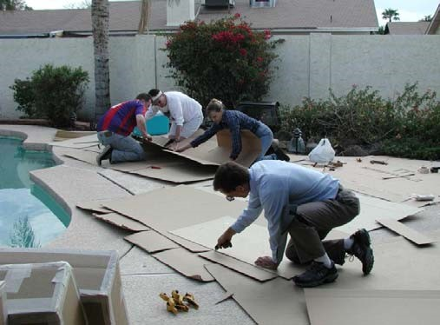
Any bends or folds in the cardboard will weaken the boat, so try to get flat, unused sheets of cardboard if at all possible.

Once you have the flat cardboard, draw the design on it. Then you are ready to start cutting & bending.

Hint: To bend cardboard cleanly, make a dent or a crease in the flat cardboard using a blunt rounded tool like the handle end of a crescent wrench.

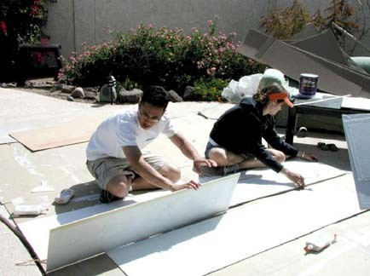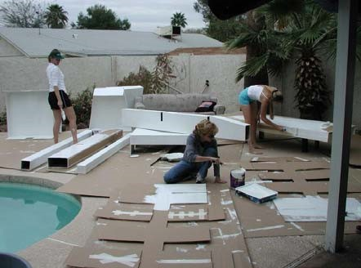

Step 4: Usually a boat will be made up of multiple pieces, assembled together and taped.

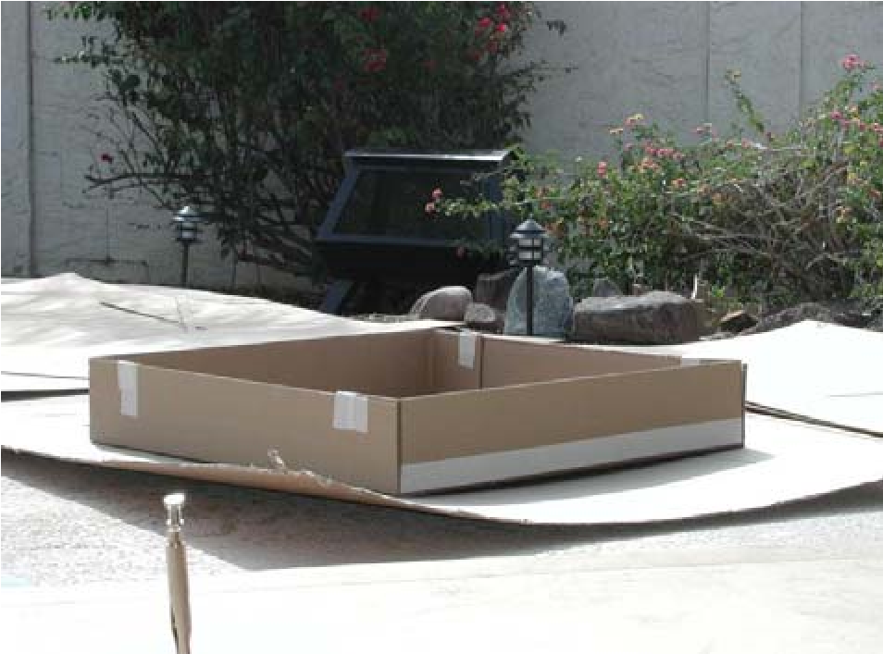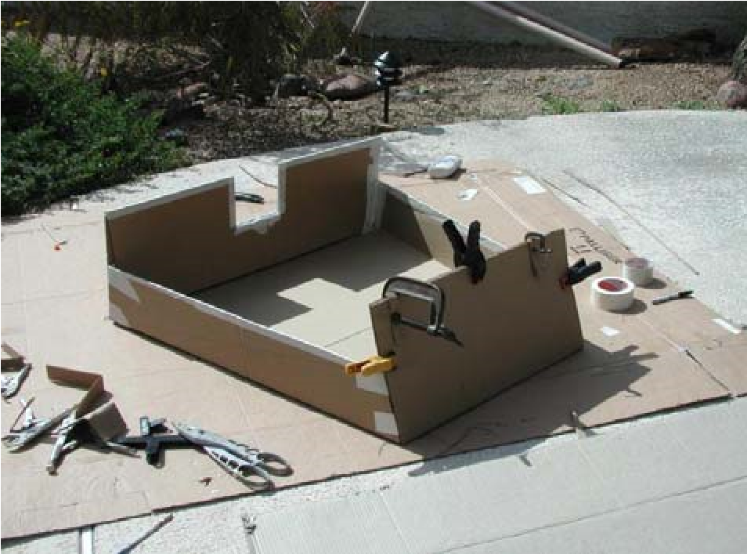

Step 5: Use only duct tape to connect joints of edges.

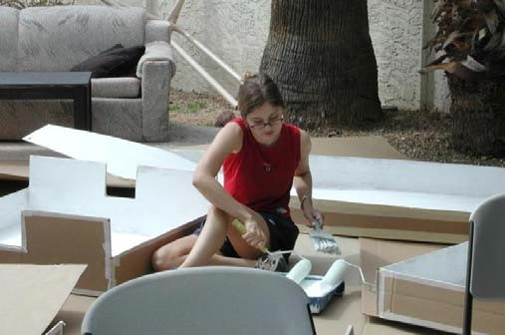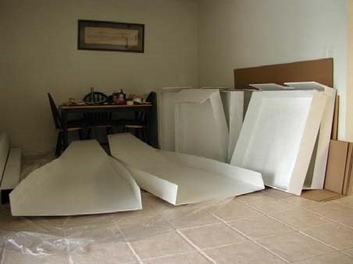

The Great Cardboard Boat Regatta®

All boats must be completed by June 10, 9 am. Races will start by 1:30 pm.

All boats go through a technical inspection. Nothing but cardboard and duct tape… They’ll be looking for things like Styrofoam, metal, screws. Don’t do it!

Finally, all dressed up and ready to go. If you cannot swim, bring a personal life jacket. Be prepared to carry your boat to the starting line.

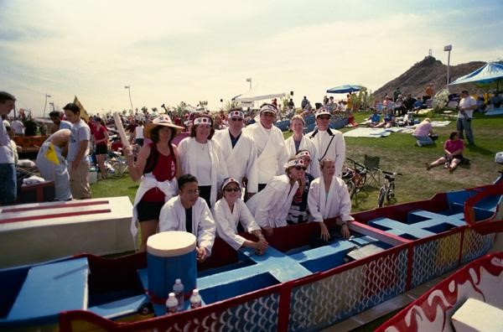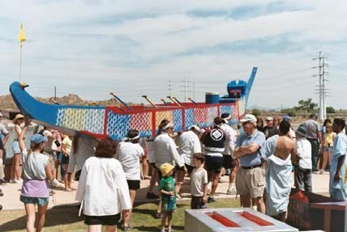

Getting into the boat can be tricky. Watch your balance & don’t capsize… Paddle Hard!!!

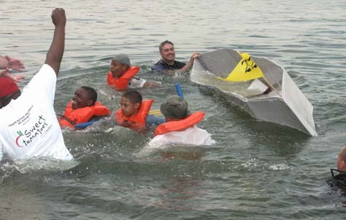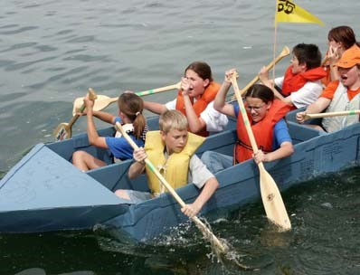

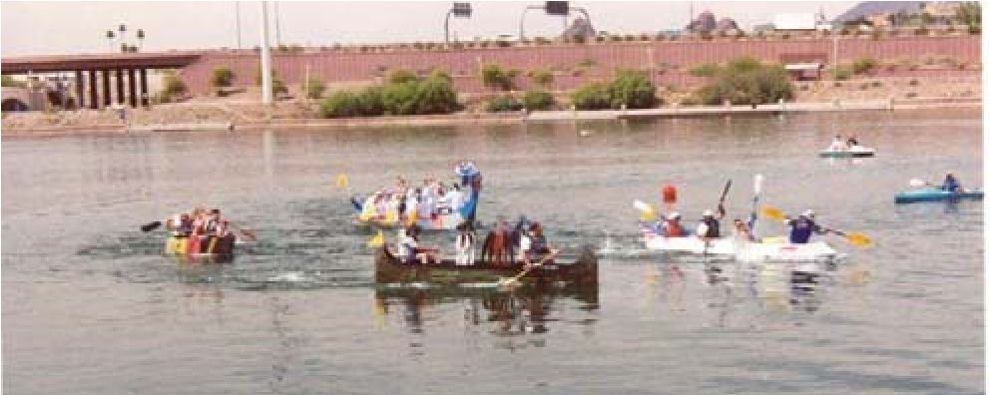
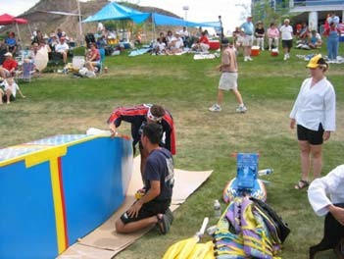
Come prepared to do minor repairs between races – mainly to patch any leaks…

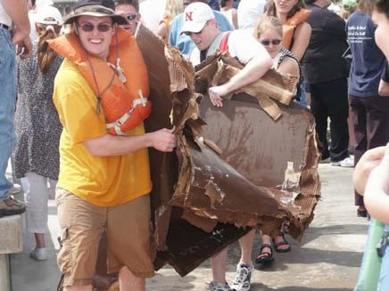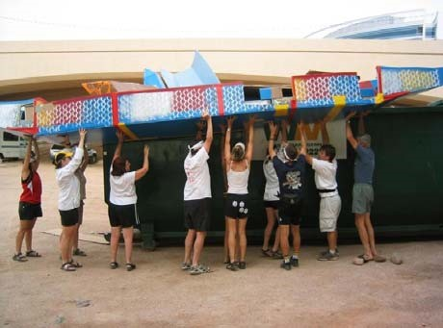

Last step -- please don’t leave without throwing out the trash… Sometimes cardboard boats can get a bit soggy…

