PHYSICS 2021 - 22 October 21, 2021

Today’s Agenda (Day 41)

- HOUSEKEEPING ITEMS

- HOMEWORK CHECK:

- CLASS ACTIVITY
QUIZ: Chapter 5 & 6 Vocabulary
*Go to www.socrative.com enter room “MSBPHYSICS” enter ID #

CONT’D: Chapter 6 PPT Review
- Section 6.1 – Projectile Motion
- Section 6.2 – Circular Motion
- Section 6.3 – Relative Velocity

HOMEWORK:
- READ: Chapter 6 – Motion in Two Dimensions
- STUDY: Chapter 6 Test
http://glencoe.mheducation.com/sites/0078807220/student_view0/self-check_quizzes.html

Chapter 5 – Forces in Two Dimensions
Components | Kinetic friction | Coefficient of kinetic friction | Equilibrant
Vector resolution | Static friction | Coefficient of static friction

Ch 6 – Motion in Two Dimensions
Projectile | Trajectory | Uniform circular motion
Centripetal acceleration | Centripetal force | Reference frame

REMINDERS:
- QUIZ: Chapter 5 & 6 Vocabulary Oct. 21
- TEST: Chapter 6 Oct. 26

PHYSICS 2021 - 22 CHAPTER REVIEW
PRACTICE PROBLEMS 6.1
- You throw a stone horizontally at a speed of 5.0 m/s from the top of a cliff that is 78.4 m high.
- How long does it take the stone to reach the bottom of the cliff?
- How far from the base of the cliff does the stone hit the ground?
- What are the horizontal and vertical components of the stone’s velocity just before it hits the ground?
- Lucy and her friend are working at an assembly plant making wooden toy giraffes. At the end of the line, the giraffes go horizontally off the edge of a conveyor belt and fall into a box below. If the box is 0.60 m below the level of the conveyor belt and 0.40 m away from it, what must be the horizontal velocity of giraffes as they leave the conveyor belt?
- A player kicks a football from ground level with an initial velocity of 27.0 m/s, 30.0 ° above the horizontal as shown in Figure 5. Find each of the following. Assume that forces from the air on the ball are negligible.
- The ball’s hang time
- The ball’s maximum height
- The horizontal distance the ball travels before hitting the ground
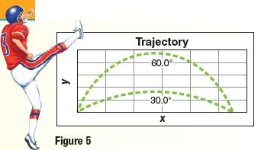
- The player from the previous problem then kicks the ball with the same speed but 60.0° from the horizontal. What is the ball’s hang time, horizontal distance traveled and maximum height?
- A rock is thrown from a 50.0 m high cliff with an initial velocity of 7.0 m/s at an angle of 53.0 ° above the horizontal. Find the velocity when it hits the ground below.
- Two baseballs are pitched horizontally from the same height but at different speeds. The faster ball crosses home plate within the strike zone, but the slower ball is below the batter’s knees. Why do the balls pass the batter at different heights?
- A tennis ball is thrown out a window 28 m above the ground at an initial velocity of 15.0 m/s and 20.0° below the horizontal. How far does the ball move horizontally before it hits the ground?
- A softball player tosses a ball into the air with an initial velocity of 11.0 m/s, as shown in Figure 7. What will be the ball’s maximum height?
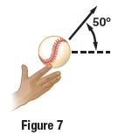

PRACTICE PROBLEMS 6.2
- A runner moving at a speed of 8.8 m/s rounds a bend with a radius of 25 m. What is the centripetal
acceleration of the runner, and what agent exerts the centripetal force on the runner?
- An airplane traveling at 201 m/s makes a turn. What is the smallest radius of the circular path (in kilometers) the pilot can make and keep the centripetal acceleration under 5.0 m/s2?
- A 45 kg merry-go-round worker stands on the ride’s platform 6.3 m from the center as shown in Figure 11. If her speed (v_{worke}) as she goes around the circle is 4.1 m/s, what is the force of friction (F _{f}) necessary to keep her from falling off the platform?
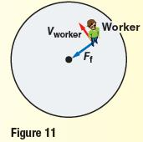
- A 16 g ball at the end of a 1.4 m string is swung in a horizontal circle. It revolves every 1.09 s. What is the magnitude of the string’s tension?
- A car racing on a flat track travels at 22 m/s around a curve with a 56-m radius. Find the car’s centripetal acceleration. What minimum coefficient of static friction between the tires and the road is necessary for the car to round the curve without slipping?
- What is the direction of the force that acts on the clothes in the spin cycle of a top-load washing machine? What exerts the force?
- An object swings in a horizontal circle, supported by a 1.8 m string. It completes a revolution in 2.2 s. What is the object’s centripetal acceleration?
- A 40.0 g stone in Figure 13 is whirled horizontally at a speed of 2.2 m/s. What is the tension in the string?
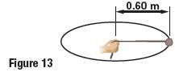

PRACTICE PROBLEMS 6.3
- You are riding in a bus moving slowly through heavy traffic at 2.0 m/s. You hurry to the front of the bus at 4.0 m/s relative to the bus. What is your speed relative to the street?
- Rafi is pulling a toy wagon through a neighborhood at a speed of 0.75 m/s. A caterpillar in the wagon is crawling toward the rear of the wagon at a rate of 2.0 cm/s. What is the caterpillar’s velocity relative to the ground?
- A boat is rowed directly upriver at a speed of 2.5 m/s relative to the water. Viewers on the shore see that the boat is moving at only 0.5 m/s relative to the shore. What is the speed of the river? Is it moving with or against the boat?
- A boat is traveling east at a speed of 3.8 m/s. A person walks across the boat with a velocity of 1.3 m/s south.
a) What is the person’s speed relative to the water?
b) In what direction, relative to the ground, does the person walk?
- An airplane flies due north at 150 km/h relative to the air. There is a wind blowing at 75 km/h to the east relative to the ground. What is the plane’s speed relative to the ground?
- The airplane in Figure 17 flies at 200.0 km/h relative to the air. What is the velocity of the plane relative to the ground it flies during the following wind conditions?
- A 50.0 km/h tailwind
- A 50.0 km/h headwind
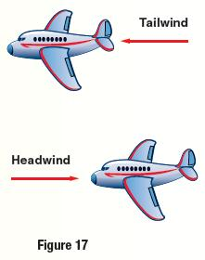
- A motorboat heads west at 13 m/s relative to a river that flows due north at 5.0 m/s. what is the velocity (both the magnitude and direction) of the motorboat relative to the shore?
- You are boating on a river that flows toward the east. Because of your knowledge of physics, you head your boat 53° west of north and have a velocity of 6.0 m/s due north relative to the shore.
- What is the velocity of the current?
- What is the speed of your boat relative to the water?

PHYSICS 2021 - 22 LAB ACTIVITY

Paper Airplane Mini-Project

http://sciencefair.math.iit.edu/projects/airplane/
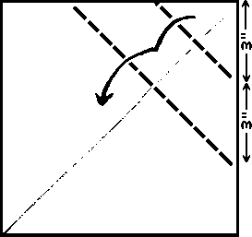

Objective
To test and conclude the best designs for paper airplanes with respect to flight time, distance, and accuracy.

Concept
There are numerous designs of paper airplanes. Each design is unique and alters the plane's flight. Some are made for distance, others for flight time, and some for accuracy. We will test these different models to see what planes are really the best. Use designs that you know of or find online (www.bestpaperairplanes.com suggested).
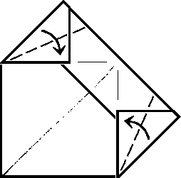

Materials
- Several pieces of 8 1/2" x 11" paper
- Scissors
- Hula hoop
- String
- Stopwatch
- Measuring tape
Safety Note: Be aware of others around you when you are throwing these airplanes. Some designs have a sharp nose and can fly very fast.

Hypothesis
When you have all of your plane choices, guess which design will fly the farthest, for the longest time, and with the most accuracy.

Procedure
- Working in pairs or threesomes, research how to design the most suitable paper airplanes for each of the criteria listed above (ie. for distance, for duration of flight and for accuracy).
- Make all of the paper airplanes that you plan on using (min. of 3). Label them.
- In an open area with plenty of room to fly, throw all of the planes and record the distance that they flew. Repeat this until you have 5 - 10 trials for each plane.
- After you have finished with the distance, get your stopwatch for the timed flight portion.
- Hold the stopwatch in one hand and the paper airplane in the other hand. Start the timer as you release the airplane from your other hand. Stop the timer as the plane hits the ground. Record the times and repeat until you have 5 trials for each plane.
- For the accuracy portion of the experiment, tie one end of the string to the hula hoop and the other end to something to hang from (basketball hoop, tree branch, etc.)
- Stand about 15-20 feet away from the hanging hula hoop.
- For each plane, throw it at least 15 - 20 times to try to get it to fly through the hula hoop. Record the number of times that each plane successfully makes it through the hula hoop.
- Try different throwing techniques during each procedure to find the best way to throw each plane for each aspect you are going for (ex: try throwing fast, slow, throw with some angle, etc.). Record your observations.
- Prepare a Lab Report at the conclusion of the lab. Use Lab Template.
- Prepare Presentation Slides to review your experiment and discuss the physics behind the mechanics and functioning of a paper airplane.

Results
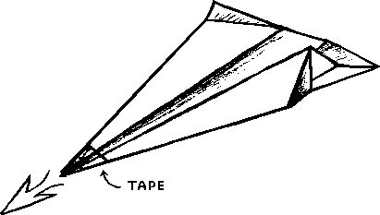
a) For the first and second parts of the procedure, average out the distances and times for each plane.
b) Make three graphs: one with the distances for each plane, one for the times of each plane, and one for the number of times that each plane made it through the hula hoop.
c) How do the results for each plane compare?
d) Any exceptionally good or bad planes?
e) Was your hypothesis correct?
f) Why do you think the best planes performed as well as they did?

Discussion
Use your knowledge of conceptual physics, which you have learned to date (ie. the mechanics of physics: motion, velocity, acceleration, effect of gravity/drag force/fluid forces/forces of friction, Newton’s Laws of Physics, and forces in two dimensions)
You will need to prepare a short Power Point Presentation discussing your airplanes’ designs and why they were most suited for the criteria detailed in the hypothesis section.
You will be assessed not only on the design features of your airplanes but also in the explanation of the integration of the concepts covered in class as to each of the planes’ performance.

Extension
- Can you create your own paper airplane design that is better than the planes that you used in the experiment?
- What if you were allowed to have attachments on the planes? How would these affect the performance of your plane?
- What would work best to improve the results of any of the planes? Explain in detail.

