PHYSICS 2021 - 22 October 15, 2021

Today’s Agenda (Day 37)

- HOUSEKEEPING ITEMS

- HOMEWORK CHECK:
Chapter 4 Test Prep Questions
Chapter 5 & 6 Vocabulary

- CLASS ACTIVITY
PAIRS: Work on Chapter 5 Chapter Review Questions – see p. 2 of document

HOMEWORK:
- READ: Chapter 5 – Motion in Two Dimensions
- STUDY: Chapter 5 Test
http://glencoe.mheducation.com/sites/0078807220/student_view0/self-check_quizzes.html

Chapter 5 – Forces in Two Dimensions
Components | Kinetic friction | Coefficient of kinetic friction | Equilibrant
Vector resolution | Static friction | Coefficient of static friction

Ch 6 – Motion in Two Dimensions
Projectile | Trajectory | Uniform circular motion
Centripetal acceleration | Centripetal force | Reference frame

REMINDERS:
- Chapter 5 & 6 Vocabulary – Oct. 15
- TEST: Chapter 5 Oct. 19
- QUIZ: Chapter 5 & 6 Vocabulary Oct. 21

PHYSICS 2021 - 22 CHAPTER REVIEW
PRACTICE PROBLEMS 5.1

- A car is driven 125.0 km due west then 65.0 km due south. What is the magnitude of its displacement? Solve this problem both graphically and mathematically, and check your answers against each other.
- Two shoppers walk from the door of the mall to their car. They walk 250.0 m down a lane of cars, and then turn 90° to the right and walk an additional 60.0 m. How far is the shoppers’ car from the mall door? Solve this problem both graphically and mathematically, and check your answers against each other.
- A hiker walks 4.5 km in one direction then makes a 45° turn to the right and walks another 6.4 km. What is the magnitude of the hiker’s displacement?
- Challenge An ant crawls on the sidewalk. It first moves south a distance of 5.0 cm. It then turns southwest and crawls 4.0 cm. What is the magnitude of the ant’s displacement?
- Could a vector ever be shorter than one of its components? Could a vector ever be equal in length to one of its components? Explain.
- Two ropes tied to a tree branch hold up a child’s swing as shown in Figure 7. The tension in each rope is 2.28 N. What is the combined force (magnitude and direction) of the two ropes on the swing?
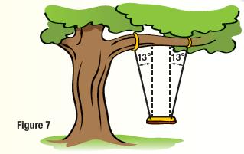
- Components of Vectors Find the components of vectors K and L in Figure 9.
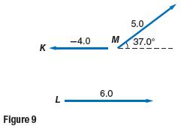

PRACTICE PROBLEMS 5.2
- Gwen exerts a 36-N horizontal force as she pulls a 52-N sled across a cement sidewalk at constant speed. What is the coefficient of kinetic friction between the sidewalk and the metal sled runners? Ignore air resistance.
- Mr. Ames is dragging a box full of books from his office to his car. The box and books together have a combined weight of 134 N. If the coefficient of static friction between the pavement and the box is 0.55, how hard must Mr. Ames push horizontally on the box in order to start it moving?
- Thomas sits on a small rug on a polished wooden floor. The coefficient of kinetic friction between the rug and the slippery wooden floor is only 0.12. If Thomas weighs 650 N, what horizontal force is needed to pull the rug and Thomas across the floor at a constant speed?
- Challenge You need to move a 105-kg sofa to a different location in the room. It takes a 403-N force to start the sofa moving. What is the coefficient of static friction between the sofa and the carpet?
- You want to move a 41-kg bookcase to a different place in the living room. If you push with a force of 65 N and the bookcase accelerates at 0.12 m/s 2, what is the coefficient of kinetic friction between the bookcase and the carpet?
- Consider the force pushing the box in Example Problem 4. How long would it take for the velocity of the box to double to 2.0 m/s?
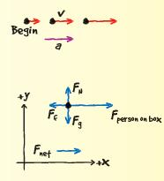
- Friction At a wedding reception, you notice a boy who looks like his mass is about 25 kg running across the dance floor then sliding on his knees until he stops. If the kinetic coefficient of friction between the boy’s pants and the floor is 0.15, what is the friction force acting on him as he slides?
- Velocity Dinah is playing cards with her friends, and it is her turn to deal. A card has a mass of 2.3 g, and it slides 0.35 m along the table before it stops. If the coefficient of kinetic friction between the card and the table is 0.24, what was the initial speed of the card as it left Dinah’s hand?

PHYSICS 2021 - 22 LAB ACTIVITY

Paper Airplane Mini-Project

http://sciencefair.math.iit.edu/projects/airplane/
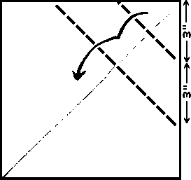

Objective
To test and conclude the best designs for paper airplanes with respect to flight time, distance, and accuracy.

Concept
There are numerous designs of paper airplanes. Each design is unique and alters the plane's flight. Some are made for distance, others for flight time, and some for accuracy. We will test these different models to see what planes are really the best. Use designs that you know of or find online (www.bestpaperairplanes.com suggested).
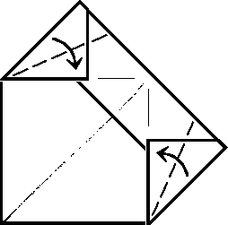

Materials
- Several pieces of 8 1/2" x 11" paper
- Scissors
- Hula hoop
- String
- Stopwatch
- Measuring tape
Safety Note: Be aware of others around you when you are throwing these airplanes. Some designs have a sharp nose and can fly very fast.

Hypothesis
When you have all of your plane choices, guess which design will fly the farthest, for the longest time, and with the most accuracy.

Procedure
- Working in pairs or threesomes, research how to design the most suitable paper airplanes for each of the criteria listed above (ie. for distance, for duration of flight and for accuracy).
- Make all of the paper airplanes that you plan on using (min. of 3). Label them.
- In an open area with plenty of room to fly, throw all of the planes and record the distance that they flew. Repeat this until you have 5 - 10 trials for each plane.
- After you have finished with the distance, get your stopwatch for the timed flight portion.
- Hold the stopwatch in one hand and the paper airplane in the other hand. Start the timer as you release the airplane from your other hand. Stop the timer as the plane hits the ground. Record the times and repeat until you have 5 trials for each plane.
- For the accuracy portion of the experiment, tie one end of the string to the hula hoop and the other end to something to hang from (basketball hoop, tree branch, etc.)
- Stand about 15-20 feet away from the hanging hula hoop.
- For each plane, throw it at least 15 - 20 times to try to get it to fly through the hula hoop. Record the number of times that each plane successfully makes it through the hula hoop.
- Try different throwing techniques during each procedure to find the best way to throw each plane for each aspect you are going for (ex: try throwing fast, slow, throw with some angle, etc.). Record your observations.
- Prepare a Lab Report at the conclusion of the lab. Use Lab Template.
- Prepare Presentation Slides to review your experiment and discuss the physics behind the mechanics and functioning of a paper airplane.

Results
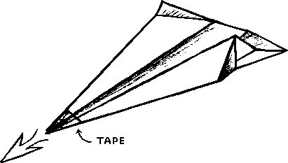
a) For the first and second parts of the procedure, average out the distances and times for each plane.
b) Make three graphs: one with the distances for each plane, one for the times of each plane, and one for the number of times that each plane made it through the hula hoop.
c) How do the results for each plane compare?
d) Any exceptionally good or bad planes?
e) Was your hypothesis correct?
f) Why do you think the best planes performed as well as they did?

Discussion
Use your knowledge of conceptual physics, which you have learned to date (ie. the mechanics of physics: motion, velocity, acceleration, effect of gravity/drag force/fluid forces/forces of friction, Newton’s Laws of Physics, and forces in two dimensions)
You will need to prepare a short Power Point Presentation discussing your airplanes’ designs and why they were most suited for the criteria detailed in the hypothesis section.
You will be assessed not only on the design features of your airplanes but also in the explanation of the integration of the concepts covered in class as to each of the planes’ performance.

Extension
- Can you create your own paper airplane design that is better than the planes that you used in the experiment?
- What if you were allowed to have attachments on the planes? How would these affect the performance of your plane?
- What would work best to improve the results of any of the planes? Explain in detail.

