PHYSICS 2021 - 22 October 13, 2021

Today’s Agenda (Day 35)

- HOUSEKEEPING ITEMS

- HOMEWORK CHECK:
Chapter 4 Test Prep Questions

- CLASS ACTIVITY
CONT’D: Chapter 5 PPT Review
- Section 5.1 – Vectors
- Section 5.2 – Friction
- Section 5.3 – Forces in two dimensions

HOMEWORK:
- READ: Chapter 5 – Motion in Two Dimensions
- COMPLETE: Chapter 5 & 6 Vocabulary
- STUDY: Chapter 5 Test
http://glencoe.mheducation.com/sites/0078807220/student_view0/self-check_quizzes.html

Chapter 5 – Forces in Two Dimensions
Components | Kinetic friction | Coefficient of kinetic friction | Equilibrant
Vector resolution | Static friction | Coefficient of static friction

Ch 6 – Motion in Two Dimensions
Projectile | Trajectory | Uniform circular motion
Centripetal acceleration | Centripetal force | Reference frame

REMINDERS:
- Chapter 5 & 6 Vocabulary – Oct. 15
- TEST: Chapter 5 Oct. 19
- QUIZ: Chapter 5 & 6 Vocabulary Oct. 21

PHYSICS 2021 - 22 CHAPTER REVIEW
PRACTICE PROBLEMS 5.1

- A car is driven 125.0 km due west then 65.0 km due south. What is the magnitude of its displacement? Solve this problem both graphically and mathematically, and check your answers against each other.
- Two shoppers walk from the door of the mall to their car. They walk 250.0 m down a lane of cars, and then turn 90° to the right and walk an additional 60.0 m. How far is the shoppers’ car from the mall door? Solve this problem both graphically and mathematically, and check your answers against each other.
- A hiker walks 4.5 km in one direction then makes a 45° turn to the right and walks another 6.4 km. What is the magnitude of the hiker’s displacement?
- Challenge An ant crawls on the sidewalk. It first moves south a distance of 5.0 cm. It then turns southwest and crawls 4.0 cm. What is the magnitude of the ant’s displacement?
- Could a vector ever be shorter than one of its components? Could a vector ever be equal in length to one of its components? Explain.
- Two ropes tied to a tree branch hold up a child’s swing as shown in Figure 7. The tension in each rope is 2.28 N. What is the combined force (magnitude and direction) of the two ropes on the swing?
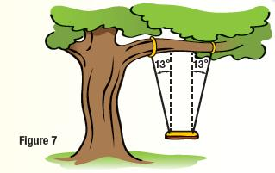
- Components of Vectors Find the components of vectors K and L in Figure 9.
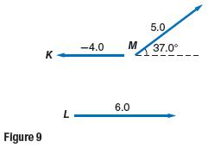

PRACTICE PROBLEMS 5.2
- Gwen exerts a 36-N horizontal force as she pulls a 52-N sled across a cement sidewalk at constant speed. What is the coefficient of kinetic friction between the sidewalk and the metal sled runners? Ignore air resistance.
- Mr. Ames is dragging a box full of books from his office to his car. The box and books together have a combined weight of 134 N. If the coefficient of static friction between the pavement and the box is 0.55, how hard must Mr. Ames push horizontally on the box in order to start it moving?
- Thomas sits on a small rug on a polished wooden floor. The coefficient of kinetic friction between the rug and the slippery wooden floor is only 0.12. If Thomas weighs 650 N, what horizontal force is needed to pull the rug and Thomas across the floor at a constant speed?
- Challenge You need to move a 105-kg sofa to a different location in the room. It takes a 403-N force to start the sofa moving. What is the coefficient of static friction between the sofa and the carpet?
- You want to move a 41-kg bookcase to a different place in the living room. If you push with a force of 65 N and the bookcase accelerates at 0.12 m/s 2, what is the coefficient of kinetic friction between the bookcase and the carpet?
- Consider the force pushing the box in Example Problem 4. How long would it take for the velocity of the box to double to 2.0 m/s?
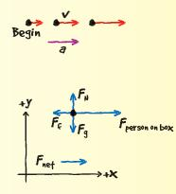
- Friction At a wedding reception, you notice a boy who looks like his mass is about 25 kg running across the dance floor then sliding on his knees until he stops. If the kinetic coefficient of friction between the boy’s pants and the floor is 0.15, what is the friction force acting on him as he slides?
- Velocity Dinah is playing cards with her friends, and it is her turn to deal. A card has a mass of 2.3 g, and it slides 0.35 m along the table before it stops. If the coefficient of kinetic friction between the card and the table is 0.24, what was the initial speed of the card as it left Dinah’s hand?

