**PHYSICS 2021 - 22 October 1, 2021**

**Today’s Agenda (Day 33)**

1. HOUSEKEEPING ITEMS

🡪

1. HOMEWORK CHECK:

🡪 LAB REPORT: Zooom

🡪 Chapter 4 Test Prep Questions

1. CLASS ACTIVITY

🡪 SUBMIT: Chapter 4 Test Prep Questions – see p. 4 of document

🡪 COMPLETE: Lab Report - Zooom

HOMEWORK:

* READ: Chapter 5 – Motion in Two Dimensions
* COMPLETE: Chapter 5 & 6 Vocabulary
* STUDY: Chapter 5 Test

<http://glencoe.mheducation.com/sites/0078807220/student_view0/self-check_quizzes.html>

Chapter 5 – Forces in Two Dimensions

|  |  |  |  |
| --- | --- | --- | --- |
| Components | Kinetic friction | Coefficient of kinetic friction | Equilibrant |
| Vector resolution | Static friction | Coefficient of static friction |  |

Ch 6 – Motion in Two Dimensions

|  |  |  |
| --- | --- | --- |
| Projectile | Trajectory | Uniform circular motion |
| Centripetal acceleration | Centripetal force | Reference frame |

REMINDERS:

* ~~LAB REPORT: Zooom – Oct. 1~~
* Chapter 5 & 6 Vocabulary – Oct. 15
* **TEST: Chapter 5 🡪 Oct. 19**
* **QUIZ: Chapter 5 & 6 Vocabulary 🡪 Oct. 21**

**PHYSICS 2021 - 22** LAB ACTIVITY

**MOTION:** Zoooooooom! How fast is fast?

# Objectives

* Identify how to determine an object’s speed
* Determine lab procedure to calculate an object’s average speed and acceleration
* Understand the difference between speed and velocity
* Understand the relationship between acceleration and velocity

# Pre-Lab Questions

1. What is a reference point?

1. What two things must you know to determine speed?

1. What is the difference between speed and velocity?

# Group Lab

**Materials**

* Toy car
* Meter stick
* Stopwatch
* Masking Tape
* Table/floor

In your groups of three, discuss and write down the procedure to determine the average speed of your toy car.

Procedure

Velocity and Speed

Take 15 minutes in your group to come up with lab procedures. If they are having problems refer them to Pre-lab question number 2.

**Procedure**

1. **Place a piece of masking tape on the floor/table and label it *reference point.***
2. **Place the front of the car at the starting point**
3. **Group member 1 will count to three. On three, group member 2 will push the car and group member 3 will start timing.**
4. **At the moment the car stops, group member 3 will stop timing.**
5. **Mark the final location of the car and measure the distance (in meters) from the starting point.**
6. **In the table record the distance the car traveled and the time to travel that distance.**
7. **Calculate speed.**

Perform the procedures we determined as a class three times. Record all **your** data in table below. Be sure to include the units **and show calculations**. **Graph your results.**

**ACTIVITY: Horizontal**

|  |  |  |  |  |  |
| --- | --- | --- | --- | --- | --- |
| Trial  Number | Distance | Time | Average Speed | Average Velocity | Average Acceleration |
| 1 |  |  |  |  |  |
| 2 |  |  |  |  |  |
| 3 |  |  |  |  |  |

For each trial, have students note who pushed the car, who timed the car, and who measured the distance. The students should rotate through each position.

|  |  |  |  |  |  |
| --- | --- | --- | --- | --- | --- |
| Trial  Number | Distance | Time | Average Speed | Average Velocity | Average Acceleration |
| 1 |  |  |  |  |  |
| 2 |  |  |  |  |  |
| 3 |  |  |  |  |  |

**EXTENSION**: Apply logic to design an experiment to determine the effects of having an incline and a decline on the distance that the car travels and the time to travel that distance. **State your hypotheses for each situation. Record your procedures for each situation. Ensure three trials for each of the incline and decline activities. Graph your results. State your conclusion of the effect of changing the surface plane on the distance and time traveled by your car.**

**ACTIVITY: Incline**

|  |  |  |  |  |  |
| --- | --- | --- | --- | --- | --- |
| Trial  Number | Distance | Time | Average Speed | Average Velocity | Average Acceleration |
| 1 |  |  |  |  |  |
| 2 |  |  |  |  |  |
| 3 |  |  |  |  |  |

**ACTIVITY: Decline**

**PHYSICS 2021 - 22** TEST PREP

**FORCES IN ONE DIMENSION**

Choose the best answer for each of the following questions. Mark your answers on the answer sheet   
provided by your teacher.

1. Two horizontal forces, one 180.0 N and the other 200.0 N, are exerted in opposite directions on a boat on a lake. What is the magnitude of the net horizontal force on the boat?

2. Two dogs play tug-of-war with a rope toy that has a mass of 0.50 kg. If one dog pulls on the toy with a force of 140.0 N, and the other dog pulls in the opposite direction with a force of 138.0 N, what is the magnitude of the horizontal acceleration of the toy?

3. What is the magnitude of the force of gravity on a person who has a mass of 80.0 kg?

4. A 60.0-kg boy rides in an elevator that accelerates upward at 1.80 m/s2. What is the magnitude of the net force exerted on the boy?

5. The free-body diagrams below show four ways that two different forces could be exerted on an object.

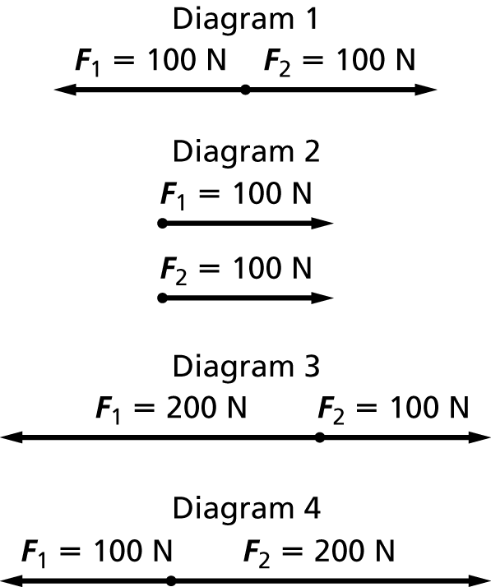

In which diagram is the object in equilibrium?

6. Two teams, the Fifes and the Drums, are playing tug-of-war. Each team has 3 members. Both teams exert a force of 2002 N on the rope. The rope is not accelerating. What is the net force on the rope?

7. Two people are paddling together in a canoe. Each exerts a horizontal force of 238 N toward the back of the canoe. What is the net horizontal force on the canoe?

**8.** Refer to item 7 above. If the combined weight of the canoe and the two paddlers is 190 kg, what is the acceleration of the canoe?

*Use the diagram to answer problems 9 and 10.*

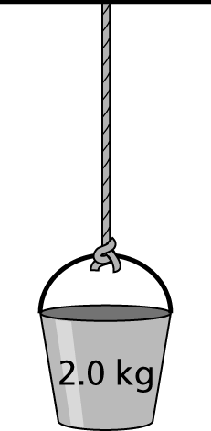

**9.** The figure shows a bucket hanging motionless from a rope. Assume that the rope has no mass. What is the net force on the bucket?

10. What is the tension on the rope?