**PHYSICS 2021 - 22 September 30, 2021**

**Today’s Agenda (Day 32)**

1. HOUSEKEEPING ITEMS

🡪

1. HOMEWORK CHECK:

🡪

1. CLASS ACTIVITY

🡪 PRACTICE: Chapter 4 Summary Review Questions

🡪 COMPLETE: Lab Report - Zooom

HOMEWORK:

* READ: Chapter 5 – Motion in Two Dimensions
* COMPLETE: Chapter 5 & 6 Vocabulary
* STUDY: Chapter 5 Test

<http://glencoe.mheducation.com/sites/0078807220/student_view0/self-check_quizzes.html>

Chapter 5 – Forces in Two Dimensions

|  |  |  |  |
| --- | --- | --- | --- |
| Components | Kinetic friction | Coefficient of kinetic friction | Equilibrant |
| Vector resolution | Static friction | Coefficient of static friction |  |

Ch 6 – Motion in Two Dimensions

|  |  |  |
| --- | --- | --- |
| Projectile | Trajectory | Uniform circular motion |
| Centripetal acceleration | Centripetal force | Reference frame |

REMINDERS:

* LAB REPORT: Zooom – Oct. 1
* Chapter 5 & 6 Vocabulary – Oct. 15

**PHYSICS 2021 - 22 SUMMARY REVIEW**

**PRACTICE PROBLEMS 4.1**

1. *For this scenario, specify the system, draw a motion diagram and a free-body diagram. Label all forces with their agents, and indicate the direction of the acceleration and of the net force. Draw vectors of appropriate lengths. Ignore air resistance unless otherwise indicated.*

You hold a softball in the palm of your hand and toss it up. Draw the diagrams while the ball is still touching our hand.

1. Two horizontal forces, 225 N and 165 N, are exerted on a canoe. If these forces are applied in the same direction, find the net horizontal force on the canoe.
2. Three confused sled dogs are trying to pull a sled across the Alaskan snow. Alutia pulls east with a force of 35 N, Seward also pulls east but with a force of 42 N, and big Kodiak pulls west with a force of 53 N. What is the net force on the sled?
3. A spring scale is used to exert a net force of 2.7 N on a cart. If the cart’s mass is 0.64 kg, what is the cart’s acceleration?
4. Two horizontal forces are exerted on a large crate. The first force is 317 N to the right. The second force is 173 N to the left.
5. Draw a force diagram for the horizontal forces acting on the crate.
6. What is the net force acting on the crate?
7. The box is initially at rest. Five seconds later, its velocity is 6.5 m/s to the right. What is the crate’s mass?
8. Identify each of the following as either **a) a contact force, b) a field force, or c) not a force**:

i) mass v) air resistance

ii) inertia vi) spring force

iii) the push of a hand vii) gravity

iv) friction viii) acceleration

**PRACTICE PROBLEMS 4.2**

1. You place a watermelon on a spring scale calibrated to measure in newtons. If the watermelon’s mass is 4.0 kg, what is the scale’s reading?
2. You place a 22.50 kg television on a spring scale. If the scale reads 235.2 N, what is the gravitational field at that location?
3. A 0.50 kg guinea pig is lifted up from the ground. What is the smallest force needed to lift it? Describe the particular motion resulting from this minimum force.
4. On Earth, a scale shows that you weight 585 N.
5. What is your mass?
6. What would the scale read on the Moon (g = 1.60 N/kg)?
7. Use the results from Example Problem 3 to answer questions about a scale in an elevator on Earth. What force would be exerted by the scale on a person in the following situations?
8. The elevator moves upward at constant speed.
9. It slows at 2.0 m/s2 while moving downward.
10. It speeds up at 2.00 m/s2 while moving downward.
11. It moves downward at constant speed.
12. In what direction is the net force as the elevator slows to a stop as it is moving down?
13. You are riding in an elevator holding a spring scale with a 1 kg mass suspended from it. You look at the scale and see that it reads 9.3 N. What, if anything, can you conclude about the elevator’s motion at that time?

**PRACTICE PROBLEMS 4.3**

1. You lift a relatively light bowling ball with your hand, accelerating it upward. What are the forces on the ball? What forces does the ball exert? What objects are these forces exerted on?
2. Diego and Mika are trying to fix a tire on Diego’s car, but they are having trouble getting the tire loose. When they pull together in the same direction, Mika with a force of 23 N and Diego with a force of 31 N, they just barely get the tire to move off the wheel. What is the magnitude of the strength of the force between the tire and the wheel?
3. A block hangs from the ceiling by a massless rope. A second block is attached to the first block and hangs below it on another piece of massless rope. If each of the two blocks has a mass 5.0 kg, what is the tension in each rope?
4. A 65 kg driver jumps off of a 10.0 m tower. Assume that air resistance is negligible.
5. Find the driver’s velocity when the diver hits the water.
6. The diver comes to a stop 2.0 m below the surface. Find the net force exerted by the water.
7. Three blocks are stacked on top of one another. The top block has a mass of 4. Kg, the middle one has a mass of 1.2 kg and the bottom one has a mass of 3.7 kg. Identify and calculate any normal forces between the objects.

**PHYSICS 2021 - 22** LAB ACTIVITY

**MOTION:** Zoooooooom! How fast is fast?

# Objectives

* Identify how to determine an object’s speed
* Determine lab procedure to calculate an object’s average speed and acceleration
* Understand the difference between speed and velocity
* Understand the relationship between acceleration and velocity

# Pre-Lab Questions

1. What is a reference point?

1. What two things must you know to determine speed?

1. What is the difference between speed and velocity?

# Group Lab

**Materials**

* Toy car
* Meter stick
* Stopwatch
* Masking Tape
* Table/floor

In your groups of three, discuss and write down the procedure to determine the average speed of your toy car.

Procedure

Velocity and Speed

Take 15 minutes in your group to come up with lab procedures. If they are having problems refer them to Pre-lab question number 2.

**Procedure**

1. **Place a piece of masking tape on the floor/table and label it *reference point.***
2. **Place the front of the car at the starting point**
3. **Group member 1 will count to three. On three, group member 2 will push the car and group member 3 will start timing.**
4. **At the moment the car stops, group member 3 will stop timing.**
5. **Mark the final location of the car and measure the distance (in meters) from the starting point.**
6. **In the table record the distance the car traveled and the time to travel that distance.**
7. **Calculate speed.**

Perform the procedures we determined as a class three times. Record all **your** data in table below. Be sure to include the units **and show calculations**. **Graph your results.**

**ACTIVITY: Horizontal**

|  |  |  |  |  |  |
| --- | --- | --- | --- | --- | --- |
| Trial  Number | Distance | Time | Average Speed | Average Velocity | Average Acceleration |
| 1 |  |  |  |  |  |
| 2 |  |  |  |  |  |
| 3 |  |  |  |  |  |

For each trial, have students note who pushed the car, who timed the car, and who measured the distance. The students should rotate through each position.

|  |  |  |  |  |  |
| --- | --- | --- | --- | --- | --- |
| Trial  Number | Distance | Time | Average Speed | Average Velocity | Average Acceleration |
| 1 |  |  |  |  |  |
| 2 |  |  |  |  |  |
| 3 |  |  |  |  |  |

**EXTENSION**: Apply logic to design an experiment to determine the effects of having an incline and a decline on the distance that the car travels and the time to travel that distance. **State your hypotheses for each situation. Record your procedures for each situation. Ensure three trials for each of the incline and decline activities. Graph your results. State your conclusion of the effect of changing the surface plane on the distance and time traveled by your car.**

**ACTIVITY: Incline**

|  |  |  |  |  |  |
| --- | --- | --- | --- | --- | --- |
| Trial  Number | Distance | Time | Average Speed | Average Velocity | Average Acceleration |
| 1 |  |  |  |  |  |
| 2 |  |  |  |  |  |
| 3 |  |  |  |  |  |

**ACTIVITY: Decline**

**PHYSICS 2021 - 22** TEST PREP

**FORCES IN ONE DIMENSION**

Choose the best answer for each of the following questions. Mark your answers on the answer sheet   
provided by your teacher.

1. Two horizontal forces, one 180.0 N and the other 200.0 N, are exerted in opposite directions on a boat on a lake. What is the magnitude of the net horizontal force on the boat?

2. Two dogs play tug-of-war with a rope toy that has a mass of 0.50 kg. If one dog pulls on the toy with a force of 140.0 N, and the other dog pulls in the opposite direction with a force of 138.0 N, what is the magnitude of the horizontal acceleration of the toy?

3. What is the magnitude of the force of gravity on a person who has a mass of 80.0 kg?

4. A 60.0-kg boy rides in an elevator that accelerates upward at 1.80 m/s2. What is the magnitude of the net force exerted on the boy?

5. The free-body diagrams below show four ways that two different forces could be exerted on an object.

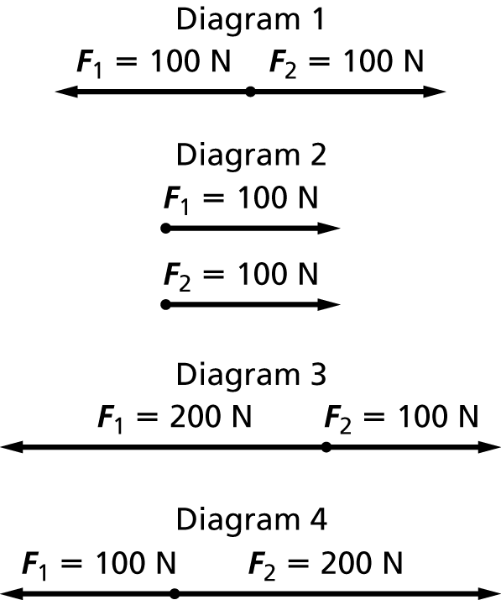

In which diagram is the object in equilibrium?

6. Two teams, the Fifes and the Drums, are playing tug-of-war. Each team has 3 members. Both teams exert a force of 2002 N on the rope. The rope is not accelerating. What is the net force on the rope?

7. Two people are paddling together in a canoe. Each exerts a horizontal force of 238 N toward the back of the canoe. What is the net horizontal force on the canoe?

**8.** Refer to item 7 above. If the combined weight of the canoe and the two paddlers is 190 kg, what is the acceleration of the canoe?

*Use the diagram to answer problems 9 and 10.*

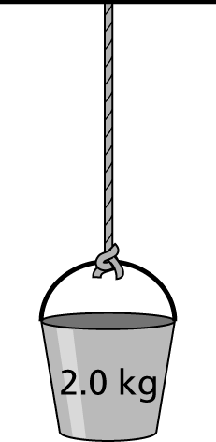

**9.** The figure shows a bucket hanging motionless from a rope. Assume that the rope has no mass. What is the net force on the bucket?

10. What is the tension on the rope?