PHYSICS 2021 - 22 May 13, 2022

Today’s Agenda (Day 157)

- HOUSEKEEPING ITEMS

- HOMEWORK CHECK:

- CLASS ACTIVITY
FIELD TRIP
MONDAY: Ch 18 PPT Review
- Section 18.2 – Convex and Concave Lenses
- Section 18.3 – Applications of Lenses

HOMEWORK:
- READ: Chapter 18 – Refraction and Lenses
- STUDY: Chapter 17Test
http://glencoe.mheducation.com/sites/0078807220/student_view0/self-check_quizzes.html

Ch 17 – Reflection and Mirrors
Specular reflection | Diffuse reflection | Plane mirror | Object | Image
Virtual image | Concave mirror | Principal axis | Focal point | Focal length
Real image | Spherical aberration | Convex mirror | magnification

Ch 18 – Refraction and Lenses
Index of refraction | Critical angle | Total internal reflection | Dispersion
Lens | Convex lens | Thin lens equation | Chromatic aberration
Achromatic lens | Nearsightedness | farsightedness | Concave lens

Ch 19 – Interference and Diffraction
Incoherent light | Coherent light | Interference fringes | Monochromatic light
Thin-film interference | Diffraction pattern | Diffraction grating | Rayleigh criterion

REMINDERS:
- TEST: Chapter 17 May 17
- QUIZ: Ch 17 & 18 Vocabulary May 19
- TEST: Chapter 18 May 24
- TEST: Chapter 19 June 2

PHYSICS 2021 - 22 Review Questions

CH 17 PRACTICE PROBLEMS
SECTION 17.1
- Explain why the reflection of light off ground glass changes from diffuse to specular if you spill water on it.
- If a light ray reflects off a plane mirror at an angle of 35° to the normal, what was the angle of incidence of the ray?
- Light from a laser strikes a plane mirror at an angle of 38° to the normal. If the laser is moved so that the angle of incidence increases by 13°, what is the new angle of reflection?
- A ray of light’s angle of incidence is 42°.
a. What is the angle of reflection?
b. What is the angle the incident ray makes with the mirror?
c. What is the angle between the incident ray and the reflected ray?
- You position two plane mirrors at right angles to one another. A light ray strikes one mirror at an angle of 60° to the normal. It then reflects toward the second mirror. What its angle of reflection off the second mirror?
- A dog looks at its image, as shown in Figure 10. What is the image position, height, and type?
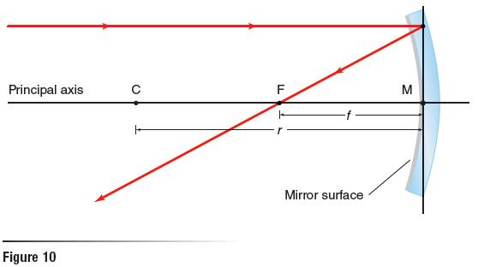
- Categorize each of the following as a specular or a diffuse reflecting surface: paper, polished metal, window glass, rough metal, plastic milk jug, smooth water surface, and ground glass
- A car is following another car down a straight road. The first car has a rear window tilted 45°. Draw a ray diagram showing the position of the Sun that would cause sunlight to reflect into the eyes of the driver of the second car.
- Explain how diffuse reflection of light off an object enables you to see an object from any angle.

SECTION 17.2
- You place an object 36.0 cm in front of a concave mirror with a 16.0-cm focal length. Determine the image position.
- You place a 3.0-cm-tall object 20.0 cm from a 16.0-cm-radius concave mirror. Determine the image position and image height.
- A concave mirror has a 7.0 cm focal length. You place a 2.4 cm tall object 16.0 cm from the mirror. Determine the image height.
- You place an object near a concave mirror with a 10 cm focal length. The image is 3.0 cm tall inverted, and 16.0 cm from the mirror. What are the object position and object height?
- You place an object 20.0 cm in front of a convex mirror with a –15.0-cm focal length. Find the image position using both a scale diagram and the mirror equation.
- A convex mirror has a focal length of –13.0 cm. You place a 6.0-cm diameter lightbulb 60.0 cm from that mirror. What is the lightbulb’s image position and diameter?
- A 1.8-m-tall girl stands 2.4 m from a store’s security mirror. Her image appears to be 0.36 m tall.
a. What is the image’s distance?
b. What is the focal length of the mirror?
- A convex mirror is needed to produce an image that is three-fourths the size of an object and located 24 cm behind the mirror.
a. What is the object’s distance?
b. What focal length should be specified?
- If you know the focal length of a concave mirror, where should you place an object so that its image is upright and larger compared to the object? Will this produce a real or virtual image?
- You place an object 20.0 cm in front of a concave mirror with a focal length of 9.0 cm. What is the magnification of the image?
- You place a 3.0-cm-tall object 22.0 cm in front of a concave mirror that has a focal length of 12.0 cm. Find the image position and height by drawing a ray diagram to scale. Verify your answer using the mirror and magnification equations.
- You place a 6.0-cm-tall object 16.4 cm from a convex mirror. If the image of the object is 2.8 cm tall, what is the mirror’s radius of curvature?

PHYSICS 2021 - 22 Review Questions

CH 18 PRACTICE PROBLEMS
SECTION 18.1
- A laser beam in air enters ethanol at an angle of incidence of 37.0°. What is the angle of refraction?
- As light travels from air into water, the angle of refraction is 25.0° to the normal. Find the angle of incidence.
- Light in air enters a diamond facet at 45.0°. What is the angle of refraction?
- A block of unknown material is submerged in water. Light in the water enters the block at an angle of incidence of 31.0°. The angle of refraction of the light in the block is 27.0°. What is the index of refraction of the material of the block?
- Light travels from air into another medium. The angle of incidence is 45.0° and the angle of refraction is 27.7°. What is the other medium?
- You notice that when a light ray enters a certain liquid from water, it is bent toward the normal, but when it enters the same liquid from float glass, it is bent away from the normal. What can you conclude about the liquid’s index of refraction?
- A ray of light in air has an angle of incidence of 30.0° on a block of unknown material and an angle of refraction of 20.0°, as shown in Figure 10. What is the index of refraction of the material?
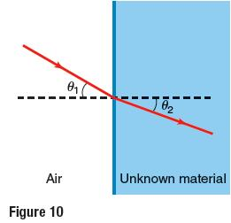
- A beam of light passes from water into polyethylene with n = 1.50. If Θ₁ ₌ 57.5°, what is the angle of refraction in the polyethylene?
- What is the speed of light in chloroform (n = 1.51)?
- If you were to use quartz and float glass to make an optical fiber, which would you use for the cladding layer? Why?
- Why can you see the image of the Sun just above the horizon when the Sun itself has already set?
- Could an index of refraction ever be less than 1? What would this imply about the speed of light in that medium?
- In what direction would you have to be looking to see a rainbow on a rainy late afternoon? Explain.

SECTION 18.2
- A 2.25-cm-tall object is 8.5 cm to the left of a convex lens of 5.5-cm focal length. Find the image position and height.
- An object near a convex lens produces a 1.8 cm tall real image that is 10.4 cm from the lens and inverted. If the focal length of the lens is 6.8 cm, what are the object position and height?
- An object is placed to the left of a convex lens with a 25 mm focal length so that its image is the same size as the object. What are the image and object position?
- Calculate the image position and height of a 2.0 cm tall located 25 cm from a convex lens with a focal length of 5.0 cm. What is the orientation of the image?
- Use a scale ray diagram to find the image position of an object that is 30 cm to the left of a convex lens with a 10 cm focal length.
- A magnifier with a focal length of 30 cm is used to view a 1 cm tall object. Us a ray diagram to determine the location and size of the image when the magnifier is positioned 10 cm from object.
- Magnifying lenses normally are used to produce images that are larger than the related objects, but they also can produce images that are smaller than the related objects. Explain.
- Redraw the ray diagram in Figure 19 and use it to determine the location and size of the image. Use the thin lens equation and the magnification equation to verify your answer.
- An object is placed 1.5 cm from a convex lens with a focal length of 1.0 m. Use the thin lens equation to determine the distance of the image from the lens. If the object height is 2.0 m, what is the image height? Is the image real or virtual? Is the image inverted or upright?
- Calculations in this chapter use a thin lens approximation. What does this mean? Why is a thin lens approximation used?
- Use the ray diagram in Figure 20 to determine whether the images for object 1 will be reduced or enlarged, inverted or upright, and real or virtual. Do the same for object 2.
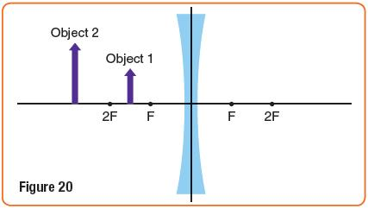
- A 6.5-cm tall salt shaker is viewed through a diverging lens with a focal length of 5.0 cm.
- If the shaker is 6.0 cm from the lens, what is the image distance from the lens? Is the image virtual or real?
- What is the magnification? Is the image smaller or larger than the object?
- If the salt shaker is moved to 4 cm from the lens, what is the distance of the image from the lens? What is the magnification? Is the image now smaller or larger than the object?
- An air lens constructed of two watch glasses is placed in a tank of water. Copy Figure 21 and draw the effect of this lens on parallel light rays incident on the lens.
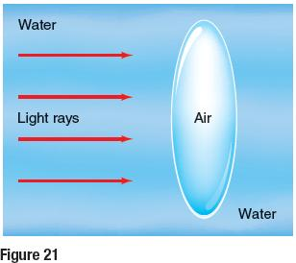

SECTION 18.3
- Which type of lens, convex or concave, should a nearsighted person use? Which type should a farsighted person use? See Figure 28. Explain.
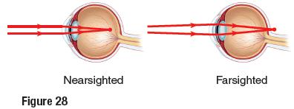
- Explain why the cornea is the primary focusing element in the eye.
- Your camera is focused on a tree 2 m away. You now want to focus it on a tree that is farther away. Will the lens move closer to the sensor or farther away?
- How does the angle of incidence compare with the angle of refraction when a light ray passes from air into glass at a nonzero angle?
- How does the angle of incidence compare with the angle of refraction when a light ray leaves glass and enters air at a nonzero angle?
- Figure 29 depicts a ray of light traveling from air into several mediums. Rank the mediums according to index of refraction from greatest to least. Specifically indicate any ties.
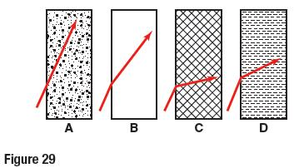
- Although the light coming from the Sun is refracted while passing through Earth’s atmosphere, the light is not separated into its spectrum. What does this indicate about the speeds of different colors of light traveling through air?
- Explain why the Moon looks red during a lunar eclipse.

