PHYSICS 2021 - 22 May 5, 2022

Today’s Agenda (Day 151)

- HOUSEKEEPING ITEMS

- HOMEWORK CHECK:
Chapters 17 & 18 Vocabularies

- CLASS ACTIVITY
CONT’D: Ch 17 PPT Review
- Section 17.2 – Curved Mirrors

HOMEWORK:
- READ: Chapter 17 – Reflection and Mirrors
- STUDY: Chapter 17Test
http://glencoe.mheducation.com/sites/0078807220/student_view0/self-check_quizzes.html

Ch 17 – Reflection and Mirrors
Specular reflection | Diffuse reflection | Plane mirror | Object | Image
Virtual image | Concave mirror | Principal axis | Focal point | Focal length
Real image | Spherical aberration | Convex mirror | magnification

Ch 18 – Refraction and Lenses
Index of refraction | Critical angle | Total internal reflection | Dispersion
Lens | Convex lens | Thin lens equation | Chromatic aberration
Achromatic lens | Nearsightedness | farsightedness | Concave lens

REMINDERS:
- TEST: Chapter 17 May 17
- QUIZ: Ch 17 & 18 Vocabulary May 19
- TEST: Chapter 18 May 24
- TEST: Chapter 19 June 2

PHYSICS 2021 - 22 Review Questions

CH 17 PRACTICE PROBLEMS
SECTION 17.1
- Explain why the reflection of light off ground glass changes from diffuse to specular if you spill water on it.
- If a light ray reflects off a plane mirror at an angle of 35° to the normal, what was the angle of incidence of the ray?
- Light from a laser strikes a plane mirror at an angle of 38° to the normal. If the laser is moved so that the angle of incidence increases by 13°, what is the new angle of reflection?
- A ray of light’s angle of incidence is 42°.
a. What is the angle of reflection?
b. What is the angle the incident ray makes with the mirror?
c. What is the angle between the incident ray and the reflected ray?
- You position two plane mirrors at right angles to one another. A light ray strikes one mirror at an angle of 60° to the normal. It then reflects toward the second mirror. What its angle of reflection off the second mirror?
- A dog looks at its image, as shown in Figure 10. What is the image position, height, and type?
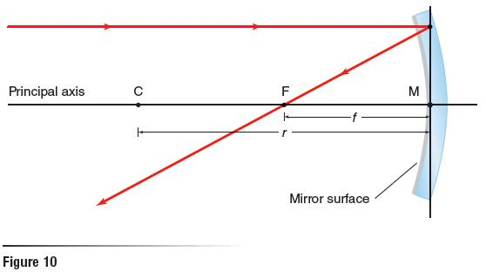
- Categorize each of the following as a specular or a diffuse reflecting surface: paper, polished metal, window glass, rough metal, plastic milk jug, smooth water surface, and ground glass
- A car is following another car down a straight road. The first car has a rear window tilted 45°. Draw a ray diagram showing the position of the Sun that would cause sunlight to reflect into the eyes of the driver of the second car.
- Explain how diffuse reflection of light off an object enables you to see an object from any angle.

SECTION 17.2
- You place an object 36.0 cm in front of a concave mirror with a 16.0-cm focal length. Determine the image position.
- You place a 3.0-cm-tall object 20.0 cm from a 16.0-cm-radius concave mirror. Determine the image position and image height.
- A concave mirror has a 7.0 cm focal length. You place a 2.4 cm tall object 16.0 cm from the mirror. Determine the image height.
- You place an object near a concave mirror with a 10 cm focal length. The image is 3.0 cm tall inverted, and 16.0 cm from the mirror. What are the object position and object height?
- You place an object 20.0 cm in front of a convex mirror with a –15.0-cm focal length. Find the image position using both a scale diagram and the mirror equation.
- A convex mirror has a focal length of –13.0 cm. You place a 6.0-cm diameter lightbulb 60.0 cm from that mirror. What is the lightbulb’s image position and diameter?
- A 1.8-m-tall girl stands 2.4 m from a store’s security mirror. Her image appears to be 0.36 m tall.
a. What is the image’s distance?
b. What is the focal length of the mirror?
- A convex mirror is needed to produce an image that is three-fourths the size of an object and located 24 cm behind the mirror.
a. What is the object’s distance?
b. What focal length should be specified?
- If you know the focal length of a concave mirror, where should you place an object so that its image is upright and larger compared to the object? Will this produce a real or virtual image?
- You place an object 20.0 cm in front of a concave mirror with a focal length of 9.0 cm. What is the magnification of the image?
- You place a 3.0-cm-tall object 22.0 cm in front of a concave mirror that has a focal length of 12.0 cm. Find the image position and height by drawing a ray diagram to scale. Verify your answer using the mirror and magnification equations.
- You place a 6.0-cm-tall object 16.4 cm from a convex mirror. If the image of the object is 2.8 cm tall, what is the mirror’s radius of curvature?

