PHYSICS 2021 - 22 April 22, 2022

Today’s Agenda (Day 148)

- HOUSEKEEPING ITEMS

- HOMEWORK CHECK:

- CLASS ACTIVITY
Project Presentation – Musical Instrument – cont’d

HOMEWORK:
- READ: Chapter 17 – Reflection and Mirrors
- STUDY: Chapter 17Test
http://glencoe.mheducation.com/sites/0078807220/student_view0/self-check_quizzes.html

Ch 17 – Reflection and Mirrors
Specular reflection | Diffuse reflection | Plane mirror | Object | Image
Virtual image | Concave mirror | Principal axis | Focal point | Focal length
Real image | Spherical aberration | Convex mirror | magnification

Ch 18 – Refraction and Lenses
Index of refraction | Critical angle | Total internal reflection | Dispersion
Lens | Convex lens | Thin lens equation | Chromatic aberration
Achromatic lens | Nearsightedness | farsightedness | Concave lens

REMINDERS:
- Chapters 17 & 18 Vocabularies – May 4
- TEST: Chapter 17 May 10
- QUIZ: Ch 17 & 18 Vocabulary May 12
- TEST: Chapter 18 May 24

PHYSICS 2021 - 22 Review Questions

CH 16 PRACTICE PROBLEMS
SECTION 16.1
- A lamp is moved from 30 cm to 90 cm above the pages of a book. Compare the illumination on the book before and after the lamp is moved.
- Draw a graph of the illuminance produced by a lamp with a luminous flux of 2275 lm at distances from 0.50 m to 5.0 m.
- A 64 cd point source of light is 3.0 m away from a painting. What is the illumination on the painting in lux?
- A screen is placed between two lamps so that they illuminate the screen equally, as shown in Figure 9. The first lamp emits a luminous flux of 1445 lm and is 2.5 m from the screen. What is the distance of the second lamp from the screen if the luminous flux is 2375 lm?
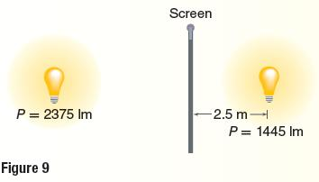
- A public school law requires a minimum illuminance of 160 lx at the surface of each student’s desk. An architect’s specifications call for classroom lights to be located 2.0 m above the desks. What is the minimum luminous flux that the lights must produce?
- Your local public library is planning to remodel the computer lab. The contractors have purchased fluorescent lamps with a rated luminous flux of 1750 lm. The desired illumination on the keyboard surfaces is 175 lx. Assume a single lamp illuminates each keyboard. What distance above the surface should the lights be placed to achieve the desired illumination? If the contractors had also already purchased fixtures to hold the lights that when installed would be 1.5 m above the keyboard surface, would the desired illuminance be achieved? If not, would the illuminance be greater or less than desired? What change in the lamp’s luminous flux would be required to achieve the desired illuminance?
- What evidence have you observed that light travels in a straight line?
- Why might you choose a window shade that is translucent? Opaque?
- Does one lightbulb provide more or less illuminance than two identical lightbulbs at twice the distance?
- Two lamps illuminate a screen equally from distances shown in Figure 12. If lamp A is rated 75 cd, what is lamp B rated?
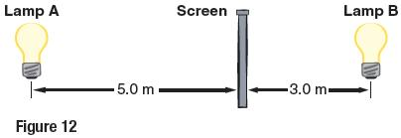
- A lightbulb illuminating your keyboard provides only half the illuminance that it should. If it is currently 1.0 m away, how far should it be to provide the correct illuminance?
- How far does light travel in the time it takes sound to travel 1 cm in air at 20⁰C?

SECTION 16.2
- Oxygen can be made to produce light with a wavelength of 513 nm. What is the frequency of this light?
- A hydrogen atom in a galaxy moving with a speed of 6.55 x 10⁶ m/s away from Earth emits light with a frequency of 6.16 x 10¹⁴ Hz. What frequency of light from that hydrogen atom would be observed by an astronomer on Earth?
- A hydrogen atom in a galaxy moving with a speed of 6.55 x 10⁶ m/s away from Earth emits light with a wavelength of 486 nm. What wavelength would be observed on Earth from that hydrogen atom?
- An astronomer is looking at the spectrum of a galaxy and finds that it has an oxygen spectral line of 525 nm, while the laboratory value is measured at 513 nm. Calculate how fast the galaxy would be moving relative to Earth. Explain whether the galaxy is moving toward or away from Earth and how you know.
- Describe the relative motions of objects when light is redshifted and when light is blueshifted. Answer using the term Doppler Effect.
- What color of light must be combined with blue light to obtain white light?
- What color will a yellow banana appear to be when illuminated by each of the following:
- White light b) green and red light c) blue light
- What primary pigment colors must be mixed to produce red? Explain your answer in terms of color subtraction for pigment colors
- Describe a simple experiment you could do to determine whether sunglasses in a store are polarizing.
- Use figure 24 to determine the direction the polarizing axis of polarizing sunglasses should be oriented to reduce glare from the surface of a road: vertically or horizontally? Explain.
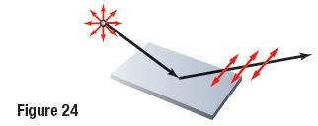
- The speed of red light is slower in air and water than in a vacuum. The frequency, however, does not change when red light enters water. Does the wavelength change? If so, how?
- Why are the insides of binoculars and cameras painted black?
- An apple is red because it reflects red light and absorbs blue and green light.
- Why does red cellophane look red in reflected light?
- Why does red cellophane make a white lightbulb look red when you hold the cellophane between your eye and the lightbulb?
- What happens to the blue and green light?

