PHYSICS 2021 - 22 August 31, 2021

Today’s Agenda (Day 10)

- HOUSEKEEPING ITEMS

- HOMEWORK CHECK:

- CLASS ACTIVITY
CONT’D: Chapter 1 PPT Review
- Section 1 – Methods of Science
- Section 2 – Mathematics and Physics
- Section 3 – Measurement
- Section 4 – Graphing the Data

HOMEWORK:
- READ: Chapter 1 – A Physics Toolkit
- READ: Chapter 2 – Representing Motion
- COMPLETE: Chapter 2 Vocabulary (short version) and Cornell Notes
- STUDY: Chapter 1 and Math Review
- STUDY: Ch 1 & 2 Vocabulary
Chapter 1 Vocabulary
Physics | Scientific methods | Hypothesis | Model | Scientific theory
Scientific law | Dimensional analysis | Significant figures | Measurement | Precision
Accuracy | Independent variable | Dependent variable | Line of best fit | Linear relationship
Quadratic relationship | Inverse relationship

Chapter 2 Vocabulary
Particle model | Distance | Time interval | Instantaneous position
Coordinate system | Magnitude | Displacement | Average velocity
Origin | Vector | Resultant | Average speed
Position | Scalar | Position-time graph | Instantaneous velocity

REMINDERS:
- Chapter 1 Notes – Aug. 30
- TEST: Chapter 1 (includes math review) Tuesday, September 7
- QUIZ: Ch 1 & 2 Vocabulary Thursday, September 9
- TEST: Chapter 2 Tuesday, September 14

PHYSICS 2021 - 22 MATH REVIEW

TRIGONOMETRY
Answer the following questions using Pythagorean theorem, trigonometric functions and inverse trigonometric functions. For full credit, be sure to show your setup and work for each problem.
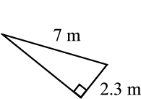
1. Fill in the missing side of each triangle:
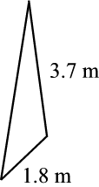
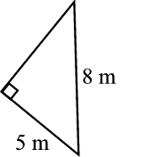
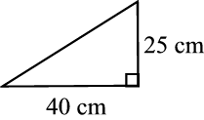
a) b) c) d)

2. Find the marked side of each triangle:
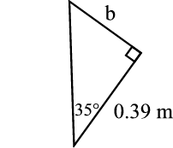
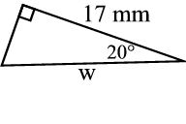
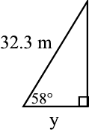
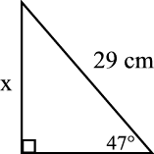
a) b) c) d)

3. Find the value for the marked angle
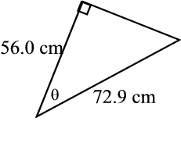
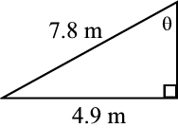
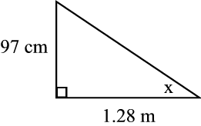
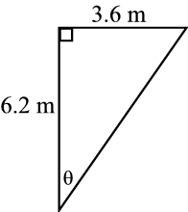
a) b) c) d)

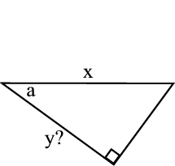

4. Write an expression for the variable with the question mark in terms of the other variables given.
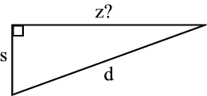
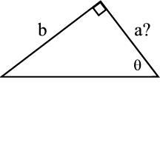
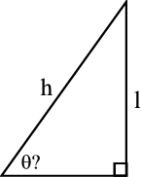
a) b) c) d)

