(H)ENGLISH LANGUAGE ARTS (ELA) 2022-23 August 25, 2022

Today’s Agenda (Day 7)

- Housekeeping Items

- Homework Check:

- Class Activity:
CONT’D: a) Everyday Use – Alice Walker – cont’d
*Complete “Understanding the Plot”
*Write a Letter from YOUR sister’s perspective
*Begin “Attacking the Prompt”
b) REVIEW: MLA In-Text Citation Practice
c) Journal Prompt #1: Describe a facet of your identity, background or story that is essential to who you are.

FRIDAY: QUIZ – For Whom the Bell Tolls [CH1 – 30] AND MLA Citation

HOMEWORK:
- READ: For Whom the Bell Tolls – up to end of Ch 33 (Monday Night)
up to end of Ch 37 (Wednesday Night)
up to end of Ch 43 (Friday Night)
- COMPLETE: For Whom the Bell Tolls Vocabulary

Vocabulary - For Whom the Bell Tolls
Aberration | Accord | Advocate | Allegiance | Anarchy | Arrogant | austere
Axiom | Bastion | Battalion | Benevolent | Besiege | Bigotry | Blasphemy
Brusque | Bureaucracy | Clemency | Conscript | Conspirator | Consummate | Contempt
Contrite | Convoluted | Correspond | Crescendo | Culminate | Culvert | Cynical
Deploy | Desultory | Dexterity | Dialectic | Diffident | Disdain | disparage
Dissipate | Dubious | Duplicity | Endow | Exhort | Formidable | Hemorrhage
Insolent | Judicious | Liquidate | Machinations | Mutiny | Partisan | Peasant
Phenomenon | Portent | Precede | Presumptuous | Proletariat | Propaganda | purge
Quell | Remnant | Reproach | Republic | Repugnant | Resignation | Rhetoric
Scorn | Scrutiny | Sentry | Serrated | Socialism | Stolid | treacherous
Treachery | Tyranny | Utmost | Volition | Wither

REMINDERS:
- QUIZ: Hemingway [end of Ch 30] AND MLA Citation Aug. 26
- VOCABULARY: For Whom the Bell Tolls – Aug. 27
- QUIZ: Hemingway [Ch 31 – end of book] Aug. 31
- QUIZ: Hemingway Vocabulary Sept. 5

(H)ENGLISH LANGUAGE ARTS (ELA) 2022-23 ACTIVITY

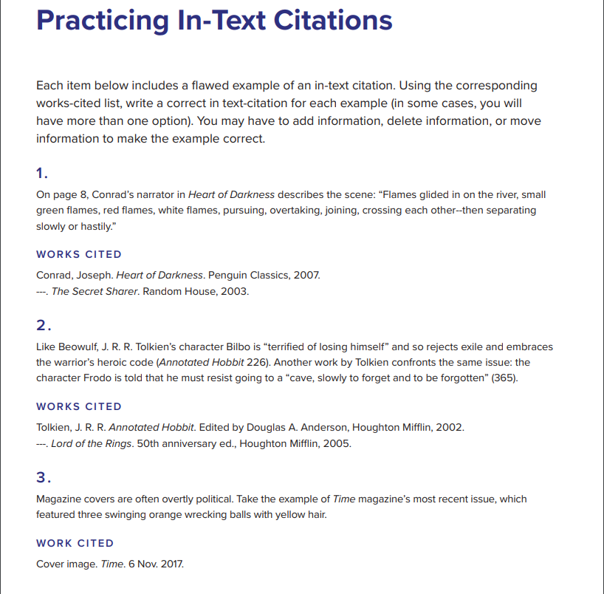

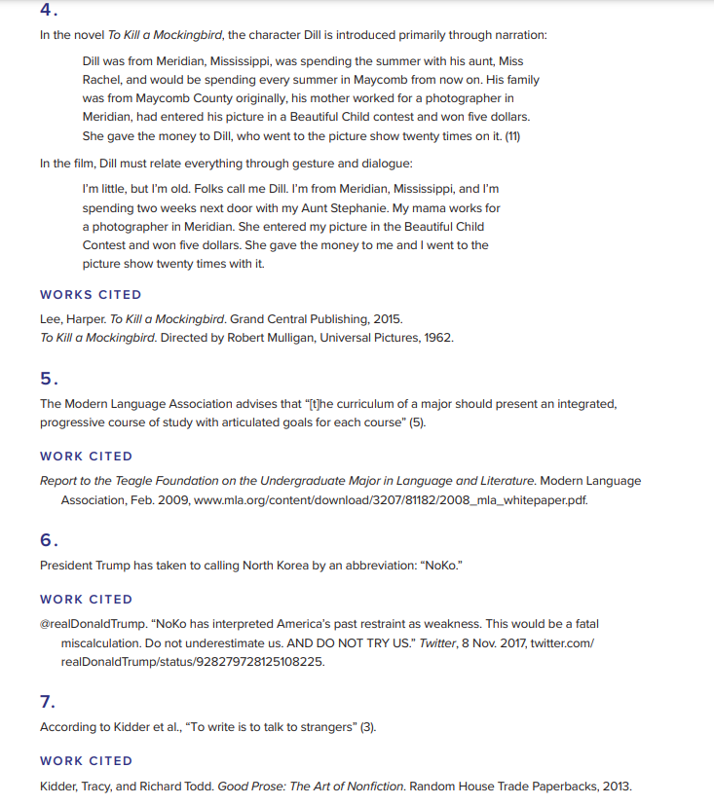

(H)ENGLISH LANGUAGE ARTS (ELA) 2022-23 ACTIVITY

“Everyday Use” by Alice Walker

Pre-Reading: Into the Text
- Complete the Min-Web Quest as shown below, to gain background information about quilts.
- THINK, PAIR, SHARE: Spend a minute thinking about traditions and heirlooms in your family. Share what comes to mind with a partner and then share with the whole class. Complete the following T-chart:
Family traditions and heirloom | Why they are important
- Discuss if you value family traditions and heirlooms. Why or why not?
Mini-Web Quest
Directions:
- Go to www.iseek.com
- Search for “quilts” or “history of quilting” or “African American quilting”.
- Answer the questions below. Be sure to cite the website(s) you used to get your answers.
- You can use Wikipedia, but you must also get information from at least one other website.
Questions:
- What is a quilt and how is one made?
- What are some uses of quilts—historically and today?
- List at least three facts about African American quilting.
Works Cited:

Reading: Through the Text
- As you read “Everyday Use”, half of the class will be “Maggie” and the other half will be “Dee”. Underline YOUR character’s thoughts, actions, words, etc. as you read.
- Upon completion of the reading, complete the “Character Study of Maggie/Dee”. Work in groups to share your highlighted portions and discuss each of the categories. For the expert category, each student needs to write down the best quote from the text on the left side and their inferences about their character on the right side.
- Working in your GROUPS, complete also the “Understanding the Plot” section.
- INDIVIDUALLY: Write a letter from the point-of-view of the sister you studied to the other one. What would they say?
Post-Reading: Beyond the Text (writing the essay)
- Begin by “attacking the prompt” within your table grouping. Discuss what you must write.
- As a CLASS, we will complete a Venn Diagram about Dee and Maggie.
- As a CLASS, we will review what a thesis statement is. Begin thinking about YOUR thesis.
- INDIVIDUALLY: Complete the “Planning the Body of Your Essay” section. Revisit the Venn Diagram and make a list of all the characteristics you can use for the point-by-point comparison (their personalities, appearance, motivations, POVs, beliefs, values, etc.)

PROMPT
Everyday Use by Alice Walker is a short story exploring one particular culture’s historical traditions. The two sisters, although raised in the same family, have very different ideas of how to best preserve their heritage. In a multi-paragraph essay, compare and contrast Maggie and Dee based on their motivations, personalities, and points of view with respect to preserving their heritage. Make sure to include specific details and examples from the story in your analysis.

As you write, remember your essay will be scored based on how well you:
- Develop a multi-paragraph response to the assigned topic that clearly communicates your thesis to the audience.
- Support your thesis with meaningful examples and references from the text, carefully citing any direct quotes.
- Organize your essay in a clear and logical manner, including an introduction, body and conclusion.
- Use well-structured sentences and language that are appropriate for your audience.
- Edit your work to conform to the conventions of standard American English.

ATTACKING THE PROMPT
- Underline what the prompt is asking you to DO (look for verbs).
- Circle WHAT the prompt asks you to produce.

Character Study of MAGGIE in “Everyday Use”
As we read “Everyday Use”, highlight the following: Inference: An intelligent guess based on
- Maggie’s thoughts. What goes on in her mind? Evidence in the story and on what you
- Maggie’s words. What does she say out loud? Already know. When making inferences
- Maggie’s actions. What does she do? How does she behave? About characters, you’ll base many of
- Descriptions of how Maggie looks. Your guesses on what they say and do.
One Quote From Text | Your Inferences About Maggie
Maggie’s Thoughts

Maggie’s Words

Maggie’s Actions

Maggie’s Appearance

Character Study of DEE in “Everyday Use”
As we read “Everyday Use”, highlight the following: Inference: An intelligent guess based on
- Dee’s thoughts. What goes on in her mind? Evidence in the story and on what you
- Dee’s words. What does she say out loud? Already know. When making inferences
- Dee’s actions. What does she do? How does she behave? About characters, you’ll base many of
- Descriptions of how Dee looks. Your guesses on what they say and do.
One Quote From Text | Your Inferences About Dee
Dee’s Thoughts

Dee’s Words

Dee’s Actions

Dee’s Appearance

“Everyday Use” Understanding the Plot

- Describe the major conflict in the story and why it occurred.
- Describe how the conflict affected Maggie and Dee.
- Describe the climax, or turning point, of the story.
- Describe the outcome, or the resolution, and how Maggie and Dee were affected.

Alice Walker “Everyday Use” (1973)
I will wait for her in the yard that Maggie and I made so clean and wavy yesterday afternoon. A yard like this is more comfortable than most people know. It is not just a yard. It is like an extended living room. When the hard clay is swept clean as a floor and the fine sand around the edges lined with tiny, irregular grooves, anyone can come and sit and look up into the elm tree and wait for the breezes that never come inside the house.
Maggie will be nervous until after her sister goes: she will stand hopelessly in corners, homely and ashamed of the burn scars down her arms and legs, eying her sister with a mixture of envy and awe. She thinks her sister has held life always in the palm of one hand, that "no" is a word the world never learned to say to her.
You've no doubt seen those TV shows where the child who has "made it" is confronted, as a surprise, by her own mother and father, tottering in weakly from backstage. (A pleasant surprise, of course: What would they do if parent and child came on the show only to curse out and insult each other?) On TV mother and child embrace and smile into each other's faces. Sometimes the mother and father weep, the child wraps them in her arms and leans across the table to tell how she would not have made it without their help. I have seen these programs.
Sometimes I dream a dream in which Dee, and I are suddenly brought together on a TV program of this sort. Out of a dark and soft-seated limousine I am ushered into a bright room filled with many people. There I meet a smiling, gray, sporty man like Johnny Carson who shakes my hand and tells me what a fine girl I have. Then we are on the stage and Dee is embracing me with tears in her eyes. She pins on my dress a large orchid, even though she has told me once that she thinks orchids are tacky flowers.
In real life I am a large, big-boned woman with rough, man-working hands. In the winter I wear flannel nightgowns to bed and overalls during the day. I can kill and clean a hog as mercilessly as a man. My fat keeps me hot in zero weather. I can work outside all day, breaking ice to get water for washing; I can eat pork liver cooked over the open fire minutes after it comes steaming from the hog. One winter I knocked a bull calf straight in the brain between the eyes with a sledgehammer and had the meat hung up to chill before nightfall. But of course, all this does not show on television. I am the way my daughter would want me to be: a hundred pounds lighter, my skin like an uncooked barley pancake. My hair glistens in the hot bright lights. Johnny Carson has much to do to keep up with my quick and witty tongue.
But that is a mistake. I know even before I wake up. Who ever knew a Johnson with a quick tongue? Who can even imagine me looking a strange white man in the eye? It seems to me I have talked to them always with one foot raised in flight, with my head fumed in whichever way is farthest from them. Dee, though. She would always look anyone in the eye. Hesitation was no part of her nature.
"How do I look, Mama?" Maggie says, showing just enough of her thin body enveloped in pink skirt and red blouse for me to know she's there, almost hidden by the door.
"Come out into the yard," I say.
Have you ever seen a lame animal, perhaps a dog run over by some careless person rich enough to own a car, sidle up to someone who is ignorant enough to be kind to him? That is the way my Maggie walks. She has been like this, chin on chest, eyes on ground, feet in shuffle, ever since the fire that burned the other house to the ground.
Dee is lighter than Maggie, with nicer hair and a fuller figure. She's a woman now, though sometimes I forget. How long ago was it that the other house burned? Ten, twelve years? Sometimes I can still hear the flames and feel Maggie's arms sticking to me, her hair smoking and her dress falling off her in little black papery flakes. Her eyes seemed stretched open, blazed open by the flames reflected in them. And Dee. I see her standing off under the sweet gum tree she used to dig gum out of; a look of concentration on her face as she watched the last dingy gray board of the house fall in toward the red-hot brick chimney. Why don't you do a dance around the ashes? I'd wanted to ask her. She had hated the house that much.
I used to think she hated Maggie, too. But that was before we raised money, the church and me, to send her to Augusta to school. She used to read to us without pity; forcing words, lies, other folks' habits, whole lives upon us two, sitting trapped and ignorant underneath her voice. She washed us in a river of make-believe, burned us with a lot of knowledge we didn't necessarily need to know. Pressed us to her with the serf' oust way she read, to shove us away at just the moment, like dimwits, we seemed about to understand.
Dee wanted nice things. A yellow organdy dress to wear to her graduation from high school; black pumps to match a green suit she'd made from an old suit somebody gave me. She was determined to stare down any disaster in her efforts. Her eyelids would not flicker for minutes at a time. Often, I fought off the temptation to shake her. At sixteen she had a style of her own: and knew what style was.
I never had an education myself. After second grade the school was closed down. Don't ask my why: in 1927 colored asked fewer questions than they do now. Sometimes Maggie reads to me. She stumbles along good-naturedly but can't see well. She knows she is not bright. Like good looks and money, quickness passes her by. She will marry John Thomas (who has mossy teeth in an earnest face) and then I'll be free to sit here and I guess just sing church songs to myself. Although I never was a good singer. Never could carry a tune. I was always better at a man's job. I used to love to milk till I was hooked in the side in '49. Cows are soothing and slow and don't bother you, unless you try to milk them the wrong way.
I have deliberately turned my back on the house. It is three rooms, just like the one that burned, except the roof is tin; they don't make shingle roofs anymore. There are no real windows, just some holes cut in the sides, like the portholes in a ship, but not round and not square, with rawhide holding the shutters up on the outside. This house is in a pasture, too, like the other one. No doubt when Dee sees it she will want to tear it down. She wrote me once that no matter where we "choose" to live, she will manage to come see us. But she will never bring her friends. Maggie and I thought about this, and Maggie asked me, "Mama, when did Dee ever have any friends?"
She had a few. Furtive boys in pink shirts hanging about on washday after school. Nervous girls who never laughed. Impressed with her they worshiped the well-turned phrase, the cute shape, the scalding humor that erupted like bubbles in lye. She read to them.
When she was courting Jimmy T she didn't have much time to pay to us, but turned all her faultfinding power on him. He flew to marry a cheap city girl from a family of ignorant flashy people. She hardly had time to recompose herself.
When she comes, I will meet—but there they are!
Maggie attempts to make a dash for the house, in her shuffling way, but I stay her with my hand. "Come back here," I say. And she stops and tries to dig a well in the sand with her toe.
It is hard to see them clearly through the strong sun. But even the first glimpse of leg out of the car tells me it is Dee. Her feet were always neat-looking, as if God himself had shaped them with a certain style. From the other side of the car comes a short, stocky man. Hair is all over his head a foot long and hanging from his chin like a kinky mule tail. I hear Maggie suck in her breath. "Uhnnnh, " is what it sounds like. Like when you see the wriggling end of a snake just in front of your foot on the road. "Uhnnnh."
Dee next. A dress down to the ground, in this hot weather. A dress so loud it hurts my eyes. There are yellows and oranges enough to throw back the light of the sun. I feel my whole face warming from the heat waves it throws out. Earrings gold, too, and hanging down to her shoulders. Bracelets dangling and making noises when she moves her arm up to shake the folds of the dress out of her armpits. The dress is loose and flows, and as she walks closer, I like it. I hear Maggie go "Uhnnnh" again. It is her sister's hair. It stands straight up like the wool on a sheep. It is black as night and around the edges are two long pigtails that rope about like small lizards disappearing behind her ears.
"Wasuzo-Teano!" she says, coming on in that gliding way the dress makes her move. The short stocky fellow with the hair to his navel is all grinning and he follows up with "Asalamalakim, my mother and sister!" He moves to hug Maggie, but she falls back, right up against the back of my chair. I feel her trembling there and when I look up, I see the perspiration falling off her chin.
"Don't get up," says Dee. Since I am stout it takes something of a push. You can see me trying to move a second or two before I make it. She turns, showing white heels through her sandals, and goes back to the car. Out she peeks next with a Polaroid. She stoops down quickly and lines up picture after picture of me sitting there in front of the house with Maggie cowering behind me. She never takes a shot without making sure the house is included. When a cow comes nibbling around the edge of the yard, she snaps it and me and Maggie and the house. Then she puts the Polaroid in the back seat of the car and comes up and kisses me on the forehead.
Meanwhile Asalamalakim is going through motions with Maggie's hand. Maggie's hand is as limp as a fish, and probably as cold, despite the sweat, and she keeps trying to pull it back. It looks like Asalamalakim wants to shake hands but wants to do it fancy. Or maybe he don't know how people shake hands. Anyhow, he soon gives up on Maggie.
"Well," I say. "Dee."
"No, Mama," she says. "Not 'Dee,' Wangero Leewanika Kemanjo!"
"What happened to 'Dee'?" I wanted to know.
"She's dead," Wangero said. "I couldn't bear it any longer, being named after the people who oppress me."
"You know as well as me you was named after your aunt Dicie," I said. Dicie is my sister. She named Dee. We called her "Big Dee" after Dee was born.
"But who was she named after?" asked Wangero.
"I guess after Grandma Dee," I said.
"And who was she named after?" asked Wangero.
"Her mother," I said, and saw Wangero was getting tired. "That's about as far back as I can trace it," I said. Though, in fact, I probably could have carried it back beyond the Civil War through the branches.
"Well," said Asalamalakim, "there you are."
"Uhnnnh," I heard Maggie say.
"There I was not," I said, "before 'Dicie' cropped up in our family, so why should I try to trace it that far back?"
He just stood there grinning, looking down on me like somebody inspecting a Model A car. Every once in a while, he and Wangero sent eye signals over my head.
"How do you pronounce this name?" I asked.
"You don't have to call me by it if you don't want to," said Wangero.
"Why shouldn't 1?" I asked. "If that's what you want us to call you, we'll call you."
"I know it might sound awkward at first," said Wangero.
"I'll get used to it," I said. "Ream it out again."
Well, soon we got the name out of the way. Asalamalakim had a name twice as long and three times as hard. After I tripped over it two or three times, he told me to just call him Hakim-a-barber. I wanted to ask him was he a barber, but I didn't really think he was, so I didn't ask.
"You must belong to those beef-cattle peoples down the road," I said. They said "Asalamalakim" when they met you, too, but they didn't shake hands. Always too busy: feeding the cattle, fixing the fences, putting up salt-lick shelters, throwing down hay. When the white folks poisoned some of the herd the men stayed up all night with rifles in their hands. I walked a mile and a half just to see the sight.
Hakim-a-barber said, "I accept some of their doctrines, but farming and raising cattle is not my style." (They didn't tell me, and I didn't ask, whether Wangero (Dee) had really gone and married him.)
We sat down to eat and right away he said he didn't eat collards and pork was unclean. Wangero, though, went on through the chitlins and com bread, the greens and everything else. She talked a blue streak over the sweet potatoes. Everything delighted her. Even the fact that we still used the benches her daddy made for the table when we couldn't effort to buy chairs.
"Oh, Mama!" she cried. Then turned to Hakim-a-barber. "I never knew how lovely these benches are. You can feel the rump prints," she said, running her hands underneath her and along the bench. Then she gave a sigh and her hand closed over Grandma Dee's butter dish. "That's it!" she said. "I knew there was something I wanted to ask you if I could have." She jumped up from the table and went over in the corner where the churn stood, the milk in it crabber by now. She looked at the churn and looked at it.
"This churn top is what I need," she said. "Didn't Uncle Buddy whittle it out of a tree you all used to have?"
"Yes," I said.
"Un huh," she said happily. "And I want the dasher, too."
"Uncle Buddy whittle that, too?" asked the barber.
Dee (Wangero) looked up at me.
"Aunt Dee's first husband whittled the dash," said Maggie so low you almost couldn't hear her. "His name was Henry, but they called him Stash."
"Maggie's brain is like an elephant's," Wangero said, laughing. "I can use the chute top as a centerpiece for the alcove table," she said, sliding a plate over the chute, "and I'll think of something artistic to do with the dasher."
When she finished wrapping the dasher the handle stuck out. I took it for a moment in my hands. You didn't even have to look close to see where hands pushing the dasher up and down to make butter had left a kind of sink in the wood. In fact, there were a lot of small sinks; you could see where thumbs and fingers had sunk into the wood. It was beautiful light-yellow wood, from a tree that grew in the yard where Big Dee and Stash had lived.
After dinner Dee (Wangero) went to the trunk at the foot of my bed and started rifling through it. Maggie hung back in the kitchen over the dishpan. Out came Wangero with two quilts. They had been pieced by Grandma Dee and then Big Dee and me had hung them on the quilt frames on the front porch and quilted them. One was in the Lone Star pattern. The other was Walk Around the Mountain. In both of them were scraps of dresses Grandma Dee had won fifty and more years ago. Bits and pieces of Grandpa Jattell's Paisley shirts. And one teeny faded blue piece, about the size of a penny matchbox, that was from Great Grandpa Ezra's uniform that he wore in the Civil War.
"Mama," Wanegro said sweet as a bird. "Can I have these old quilts?"
I heard something fall in the kitchen, and a minute later the kitchen door slammed.
"Why don't you take one or two of the others?" I asked. "These old things was just done by me and Big Dee from some tops your grandma pieced before she died."
"No," said Wangero. "I don't want those. They are stitched around the borders by machine."
"That'll make them last better," I said.
"That's not the point," said Wangero. "These are all pieces of dresses Grandma used to wear. She did all this stitching by hand. Imag' ine!" She held the quilts securely in her arms, stroking them.
"Some of the pieces, like those lavender ones, come from old clothes her mother handed down to her," I said, moving up to touch the quilts. Dee (Wangero) moved back just enough so that I couldn't reach the quilts. They already belonged to her.
"Imagine!" she breathed again, clutching them closely to her bosom.
"The truth is," I said, "I promised to give them quilts to Maggie, for when she marries John Thomas."
She gasped like a bee had stung her.
"Maggie can't appreciate these quilts!" she said. "She'd probably be backward enough to put them to everyday use."
"I reckon she would," I said. "God knows I been saving 'em for long enough with nobody using 'em. I hope she will!" I didn't want to bring up how I had offered Dee (Wangero) a quilt when she went away to college. Then she had told they were old-fashioned, out of style.
"But they're priceless!" she was saying now, furiously; for she has a temper. "Maggie would put them on the bed and in five years they'd be in rags. Less than that!"
"She can always make some more," I said. "Maggie knows how to quilt."
Dee (Wangero) looked at me with hatred. "You just will not understand. The point is these quilts, these quilts!"
"Well," I said, stumped. "What would you do with them?"
"Hang them," she said. As if that was the only thing you could do with quilts.
Maggie by now was standing in the door. I could almost hear the sound her feet made as they scraped over each other.
"She can have them, Mama," she said, like somebody used to never winning anything, or having anything reserved for her. "I can 'member Grandma Dee without the quilts."
I looked at her hard. She had filled her bottom lip with checkerberry snuff and gave her face a kind of dopey, hangdog look. It was Grandma Dee and Big Dee who taught her how to quilt herself. She stood there with her scarred hands hidden in the folds of her skirt. She looked at her sister with something like fear but she wasn't mad at her. This was Maggie's portion. This was the way she knew God to work.
When I looked at her like that something hit me in the top of my head and ran down to the soles of my feet. Just like when I'm in church and the spirit of God touches me and I get happy and shout. I did something I never done before: hugged Maggie to me, then dragged her on into the room, snatched the quilts out of Miss Wangero's hands and dumped them into Maggie's lap. Maggie just sat there on my bed with her mouth open.
"Take one or two of the others," I said to Dee.
But she turned without a word and went out to Hakim~a~barber.
"You just don't understand," she said, as Maggie and I came out to the car. "What don't I understand?" I wanted to know.
"Your heritage," she said, and then she turned to Maggie, kissed her, and said, "You ought to try to make something of yourself, too, Maggie. It's really a new day for us. But from the way you and Mama still live you'd never know it."
She put on some sunglasses that hid everything above the tip of her nose and chin.
Maggie smiled, maybe at the sunglasses. But a real smile, not scared. After we watched the car dust settle, I asked Maggie to bring me a dip of snuff. And then the two of us sat there just enjoying, until it was time to go in the house and go to bed.

