CHEMISTRY 2022-23 January 25, 2023

Today’s Agenda (Day 95)

- HOUSEKEEPING ITEMS
BRING for TUESDAY: wax paper
- Homework Check:
Ch 11 Mini Lab
Ch 12 Launch Lab

- Class Activity:
CHEM LAB: Compare States of Evaporation

DAY 4: Chapter 12 PPT Review
- Section 12.3 – Liquids and Solids
- Section 12.4 – Phase Changes

HOMEWORK:
- READ: Chapter 12 – States of Matter
- READ: Chapter 13 - Gases
- COMPLETE: Chapter 13 & 14 Vocabulary
- STUDY: Chapter12 Test

Chapter 13 Vocabulary
absolute zero | Avogadro's principle | Boyle's law | Charles's law | combined gas law | Gay-Lussac's law | ideal gas constant
ideal gas law | molar volume

Chapter 14 Vocabulary
boiling point elevation | Brownian motion | colligative property | Colloid | Concentration | freezing point depression | heat of solution
Henry's law | Immiscible | Insoluble | Miscible | Molality | Molarity | mole fraction
Osmosis | osmotic pressure | saturated solution | Solvation | supersaturated solution | unsaturated solution | vapor pressure lowering

REMINDERS:
- TEST: Ch 12 Jan. 24 Jan. 26
- Chapter 13 & 14 Vocabulary – Jan. 26
- QUIZ: Chapters 13 & 14 Vocabulary Jan. 31
- TEST: Ch 13 Feb. 2

CHEMISTRY 2022-23 PRACTICE PROBLEM
CHAPTER 12 – States of Matter
Practice Problems 12.1 – Graham’s Law
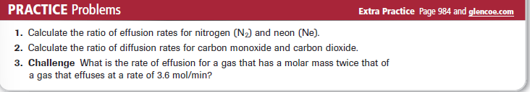
Practice Problems 12.2 – Partial Pressure of a Gas
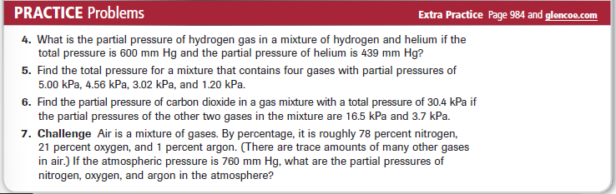

CHEMISTRY 2022-23 CHEM LAB

