CHEMISTRY 2022-23 November 22, 2022

Today’s Agenda (Day 57)

- HOUSEKEEPING ITEMS
BRING: ammonia, effervescent tablets, Epsom salts
- Homework Check:
Practice Problems 9.1 – 9.5

- Class Activity:

TEST: Chapter 9
*Go to www.socrative.com enter room “MSBCHEM2020” enter ID #

HOMEWORK:
- READ: Chapter 10 – The Mole
- COMPLETE:
- STUDY: Chapter 9 Test, Chapter 9 - 11 Vocabulary Quiz
Chapter 9 – Chemical Reactions
aqueous solution | chemical equation | chemical reaction | Coefficient | combustion reaction | complete ionic equation | decomposition reaction
double-replacement reaction | net ionic equation | Precipitate | Product | Reactant | single-replacement reaction | Solute
Solvent | spectator ion | synthesis reaction
Chapter 10 – The Mole
Avogadro’s number | Empirical formula | hydrate | Molar mass | Mole | Molecular formula | Percent composition
Chapter 11 – Stoichiometry
Actual yield | Excess reactant | Limiting reactant | Mole ratio | Percent yield | Stoichiometry | Theoretical yield

REMINDERS:
- QUIZ: Ch 9 - 11 Vocabulary Nov. 22 Note addition of vocabulary words!
- TEST: Ch 9 Nov. 22
- TEST: Ch 10 Dec. 1
- TEST: Ch 11 Dec. 8
- MIDTERM EXAM: Ch 1 - 11

CHEMISTRY 2022-23 PRACTICE PROBLEMS

CHAPTER 9 – Reactions and Equations
Practice Problems 9.1 – Write Balanced Chemical Equation
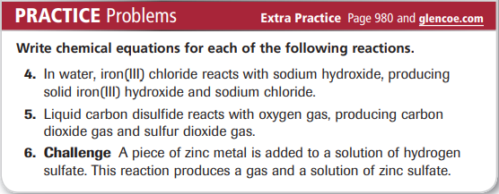
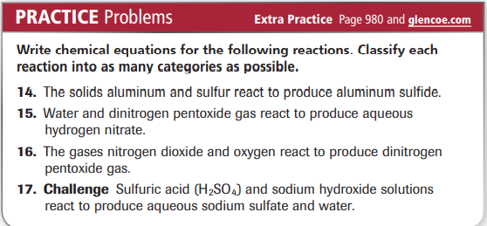
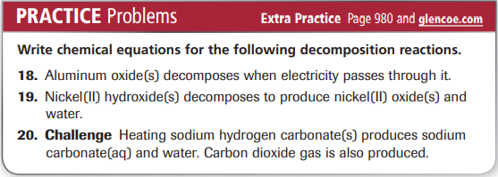
Practice Problems 9.2 – Single- and Double-Replacement Reactions
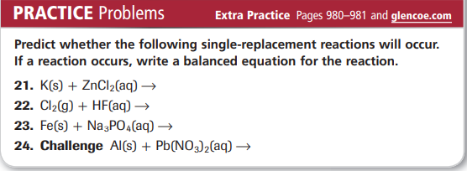
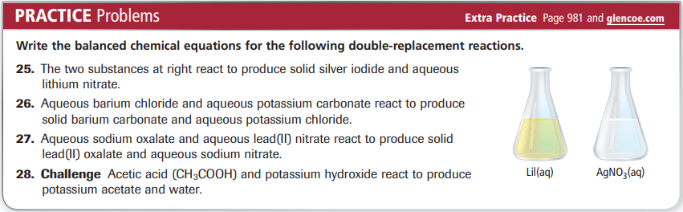

Practice Problems 9.3 – Reactions That Form a Precipitate
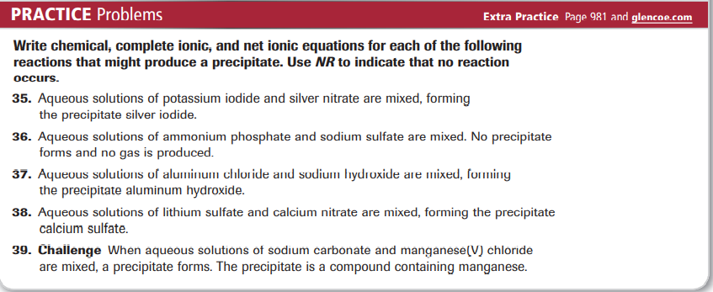

Practice Problems 9.4 - Reactions That Form Water
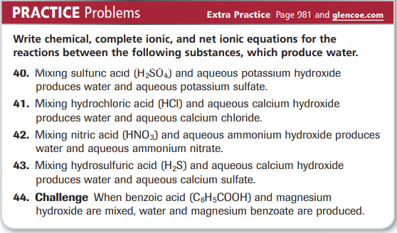

Practice Problems 9.5 – Reactions That Form Gases
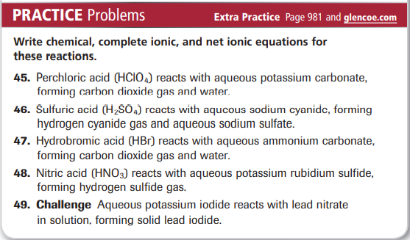

CHEMISTRY 2022-23 LAUNCH LAB

CHAPTER 9 LAUNCH LAB – How do you know when a chemical change has occurred

An indicator is a chemical that is added to the substances in a chemical reaction to show when change occurs.

Procedure
1. Read and complete the lab safety form.
2. Measure 10.0 mL of distilled water in a 25-mL graduated cylinder and pour it into a 100-mL beaker. Using a pipette, add one drop of 0.1M ammonia to the water. WARNING: Ammonia vapors are extremely irritating.
3. Stir 15 drops of universal indicator into the solution with a stirring rod. Observe the solution’s color. Measure its temperature with a thermometer.
4. Drop an effervescent tablet into the solution. Observe what happens. Record your observations, including any temperature change.

Analysis
1. Describe any changes in the color or temperature of the solution.
2. Explain Was a gas produced? If so, what did you observe to support this conclusion?
3. Analyze Did a physical change or a chemical change occur? Explain.

Inquiry
What does the universal indicator tell you about the solution? Design an experiment to support your prediction.

CHEMISTRY 2022-23 MINI LAB

CHAPTER 9 MINI LAB – Observe a Precipitate – Forming Reaction

How do two liquids form a solid?

Procedure
1. Read and complete the lab safety form.
2. Place 50 mL distilled water in a 150-mL beaker.
3. Measure about 4 g NaOH pellets on a balance. Add the NaOH pellets to the beaker one at a time. Mix with a stirring rod until each NaOH pellet dissolves before adding the next pellet.
4. Measure about 6 g Epsom salts (MgSO₄) and place it in another 150-mL beaker. Add 50 mL distilled water to the Epsom salts. Mix with another stirring rod until the Epsom salts dissolve.
5. Slowly pour the Epsom salts solution into the NaOH solution. Record your observations.
6. Stir the new solution. Record your observations.
7. Allow the precipitate to settle, then decant the liquid from the solid into a 100-mL graduated cylinder. 8. Dispose of the solid as instructed by your teacher.

Analysis
1. Write a balanced chemical equation for the reaction between the NaOH and MgSO₄. Note that most sulfate compounds exist as ions in aqueous solutions.
2. Write the complete ionic equation for this reaction.
3. Determine which ions are spectator ions, then write the net ionic equation for this reaction.

