CHEMISTRY 2022-23 November 15, 2022

Today’s Agenda (Day 54)

- HOUSEKEEPING ITEMS

- Homework Check:

- Class Activity:
TEST: Chapter 8
*Go to www.socrative.com enter room “MSBCHEM2020” enter ID #

WEDNESDAY: Mini-Lab 8 – Compare Melting Points

HOMEWORK:
- READ: Chapter 9 – Chemical Reactions
- COMPLETE: Practice Problems 9.1 – 9.5
- STUDY: Chapter 8 Test, Chapter 9 Vocabulary Quiz & Test
Chapter 9 – Chemical Reactions
aqueous solution | chemical equation | chemical reaction | Coefficient | combustion reaction | complete ionic equation | decomposition reaction
double-replacement reaction | net ionic equation | Precipitate | Product | Reactant | single-replacement reaction | Solute
Solvent | spectator ion | synthesis reaction

REMINDERS:
- TEST: Ch 8 Nov. 15 Note change of Date!
- Practice Problems 9.1 – 9.5 – Nov. 17
- QUIZ: Ch 9 Vocabulary Nov. 21
- TEST: Ch 9 Nov. 22

CHEMISTRY 2022-23 MINI LAB

CHAPTER 8 MINI LAB – Compare Melting Points

How can you determine the relationship between bond type and melting point? The properties of a compound depend on whether the bonds in the compound are ionic or covalent.

Procedure
1. Read and complete the lab safety form.
2. Create a data table for the experiment.
3. Using a permanent marker, draw three lines on the inside bottom of a disposable, 9-inch aluminum pie pan to create three, equal wedges. Label the wedges, A, B, and C.
4. Set the pie pan on a hot plate. WARNING: Hot plate and metal pie pan will burn skin—handle with care.
5. Obtain samples of the following from your teacher and deposit them onto the labeled wedges as follows: sugar crystals (C ₁₂H ₂₂O ₁₁), A; salt crystals (NaCl) B; paraffin (C ₂₃H ₄₈), C.
6. Predict the order in which the compounds will melt.
7. Turn the temperature knob on the hot plate to the highest setting. You will heat the compounds for 5 min. Assign someone to time the heating of the compounds.
8. Observe the compounds during the 5-min period. Record which compounds melt and the order in which they melt.
9. After 5 min, turn off the hot plate and remove the pie pan using a hot mitt or tongs.
10. Allow the pie pan to cool and then place it in the proper waste container.
Analysis
1. State Which solid melted first? Which solid did not melt?
2. Apply Based on your observations and data, describe the melting point of each solid as low, medium, high, or very high.
3. Infer Which compounds are bonded with ionic bonds? Which are bonded with covalent bonds?
4. Summarize how the type of bonding affects the melting points of compounds.
CHEMISTRY 2022-23 PRACTICE PROBLEMS

CHAPTER 9 – Reactions and Equations
Practice Problems 9.1 – Write Balanced Chemical Equation
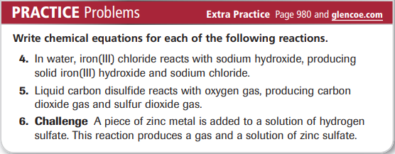
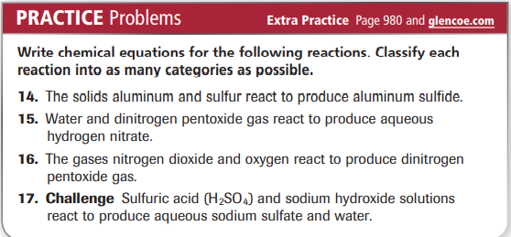
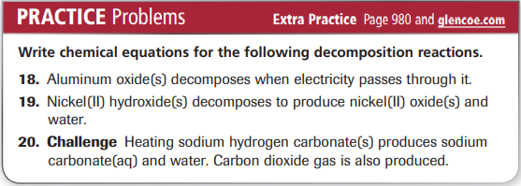
Practice Problems 9.2 – Single- and Double-Replacement Reactions
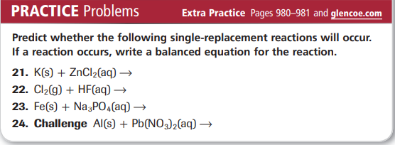
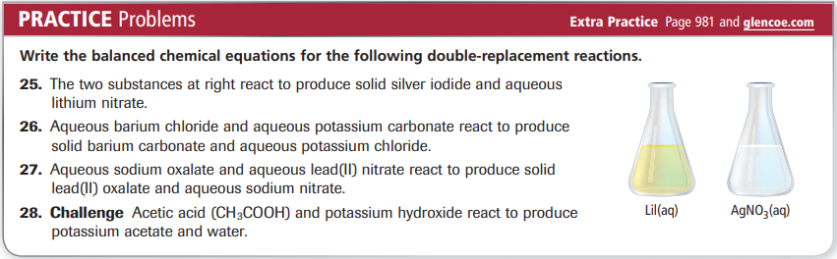

Practice Problems 9.3 – Reactions That Form a Precipitate
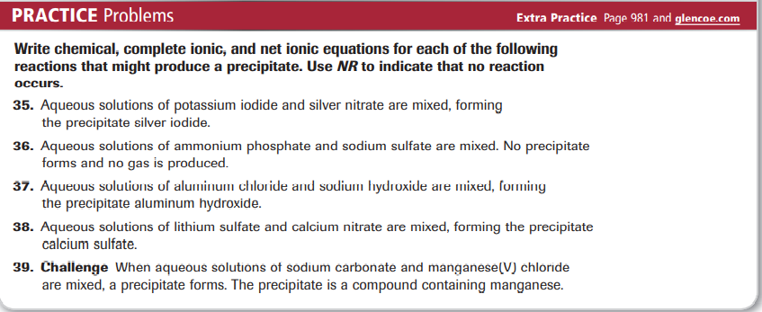

Practice Problems 9.4 - Reactions That Form Water
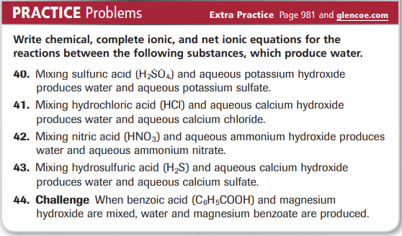

Practice Problems 9.5 – Reactions That Form Gases
