CHEMISTRY 2022-23 October 20, 2022

Today’s Agenda (Day 40)

- HOUSEKEEPING ITEMS

- Homework Check:
Chapter 6 Practice Problems
Mini-Lab 6.2 Organize Elements
Chapter 7 Vocabulary
- Class Activity:
TEST: Ch 6
*Go to www.socrative.com enter room “MSBCHEM2020” enter ID #
FRIDAY: Chapter 7 PPT Review
- Section 7.1 – Ion Formation
- Section 7.2 – Ionic Bonds and Ionic Compounds
- Section 7.3 – Names and Formulas for Ionic Compounds
- Section 7.4 – Metallic Bonds and the Properties of Metals

HOMEWORK:
- READ: Chapter 6 – Periodic Table and Periodic Law
- READ: Chapter 7 – Ionic Compounds and Metals
- COMPLETE: Chapter 8 Vocabulary
- STUDY: Chapter 7 Test, Chapter 7 & 8 Vocabulary

CHAPTER 7
Alloy | Anion | Cation | chemical bond | crystal lattice | delocalized electron
Electrolyte | electron sea model | formula unit | ionic bond | ionic compound | lattice energy
metallic bond | monatomic ion | oxidation number | Oxyanion | polyatomic ion

CHAPTER 8
coordinate covalent bond | covalent bond | endothermic reaction | exothermic reaction | Hybridization | Lewis structure
Molecule | Oxyacid | pi bond | polar covalent bond | Resonance | sigma bond
structural formula | VSEPR model

REMINDERS:
- Chapter 7 Vocabulary – Oct. 20
- TEST: Ch 6 Oct. 20
- TEST: Ch 7 Oct. 27
- Chapter 8 Vocabulary – Oct. 27
- QUIZ: Chapter 7 & 8 Vocabulary Nov. 1
- TEST: Ch 8 Nov. 8

CHEMISTRY 2022-23 PRACTICE PROBLEMS

CHAPTER 7 – Ionic Compounds and Metals
Practice Problems 7.1 – Formation of Ionic Compounds
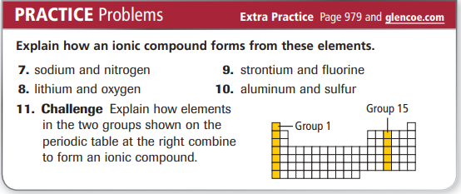
Practice Problems 7.2 – Formula for an Ionic Compound
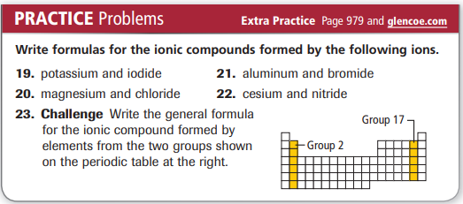
Practice Problems 7.3 – Formula for a Polyatomic Ionic Compound
