CHEMISTRY 2022-23 October 11, 2022

Today’s Agenda (Day 33)

- HOUSEKEEPING ITEMS

- Homework Check:
Chapter 6 Vocabulary

- Class Activity:
DAY 1: Chapter 6 PPT Review
- Section 6.1 – Development of the Modern Periodic Table
- Section 6.2 – Classification of the Elements
- Section 6.3 – Periodic Trends
HOMEWORK:
- READ: Chapter 6 – Periodic Table and Periodic Law
- COMPLETE: Periodic Table Reinforcement – see p. 2 of document, Chapter 6 Practice Problems
- STUDY: Chapter 5 & 6 Vocabulary, Chemicals & Symbols
CHAPTER 5
Amplitude | atomic emission spectrum | atomic orbital | Aufbau principle | de Broglie equation | electromagnetic radiation
electromagnetic spectrum | electron configuration | electron-dot structure | energy sublevel | Frequency | ground state
Heisenberg uncertainty principle | Hund's rule | Pauli exclusion principle | photoelectric effect | Photon | Planck's constant
principal energy level | principal quantum number | Quantum | quantum mechanical model of the atom | quantum number | valence electron
wavelength

CHAPTER 6
actinide series | alkali metal | alkaline earth metal | Electronegativity | Group | Halogen
inner transition metal | Ion | ionization energy | lanthanide series | Metal | Metalloid
noble gas | Nonmetal | octet rule | Period | periodic law | representative element
transition element | transition metal
REMINDERS:
- Chapter 6 Vocabulary – Oct. 11
- Mini Lab 6: Heats of Fusion & Vaporization – Oct. 12
- QUIZ: Ch 5 & 6 Vocabulary Oct. 13
- Periodic Table Reinforcement – Oct. 14
- Chapter 6 Practice Problems – Oct. 18
- QUIZ: Chemicals and Symbols [elements, polyatomic ions, acids] Oct. 18
- TEST: Ch 6 Oct. 20

CHEMISTRY 2022-23 PERIODIC TABLE REINFORCEMENT

Chemicals and Symbols

INSTRUCTIONS: Please complete the table below with the appropriate chemical symbols (and ionic charge) for each element, common polyatomic ion, AND acid listed.

ELEMENTS, IONIC CHARGES, AND SYMBOLS
Hydrogen - | Helium - | Lithium - | Beryllium - | Boron - | Carbon - | Nitrogen - | Oxygen - | Fluorine -
Neon - | Sodium - | Magnesium - | Aluminum - | Silicon - | Phosphorus- | Sulfur - | Chlorine - | Argon -
Potassium- | Calcium - | Chromium - | Manganese - | Iron - | Cobalt - | Nickel - | Copper - | Zinc -
Arsenic - | Selenium - | Bromine - | Krypton - | Palladium - | Silver - | Cadmium - | Tin - | Iodine -
Xenon - | Cesium - | Barium - | Platinum - | Gold - | Mercury - | Lead - | Radon - | Radium -

COMMON POLYATOMIC IONS & ACIDS
Acetate | Acetate | Ammonium | Bromate | Carbonate | Chlorate | Chlorite | Chromate | Cyanate
Cyanide | Dichromate | dihydrogen phosphate | hydrogen carbonate / bicarbonate | hydrogen phosphate | hydrogen sulfate / bisulfate | Hydroxide | Hypochlorite | Iodate
Nitrate | Nitrite | Oxalate | Perchlorate | Permanganate | Peroxide | Phosphate | Phosphite | Sulfate
Sulfite | Thiocyanate | Thiosulfate
Acetic | Bromic | Chloric | Chlorous | Hydrobromic | Hydrochloric | Nitric | Phosphoric | Sulfuric

CHEMISTRY 2022-23 MINI LAB

MINI LAB 6: Periodicity of Molar Heats of Fusion & Vaporization

Making and Using Graphs The heats required to melt or to vaporize a mole (a specific amount of matter) of matter are known as the molar heat of fusion (H_{f}) and the molar heat of vaporization (H_{v}), respectively. These heats are unique properties of each element. You will investigate if the molar heats of fusion and vaporization for the period 2 and 3 elements behave in a periodic fashion.

Materials either a graphing calculator, a computer graphing program, or graph paper; Reference Table R-7 or access to comparable element data references

Procedure Use Table R-7: Properties of Elements in Reference Tables [see back of textbook] to look up and record the molar heat of fusion and the molar heat of vaporization for the period 3 elements listed in the table. Then, record the same data for the period 2 elements.

Analysis
1. Graph molar heats of fusion versus atomic number. Connect the points with straight lines and label the curve. Do the same for molar heats of vaporization.
2. Do the graphs repeat in a periodic fashion? Describe the graphs to support your answer.

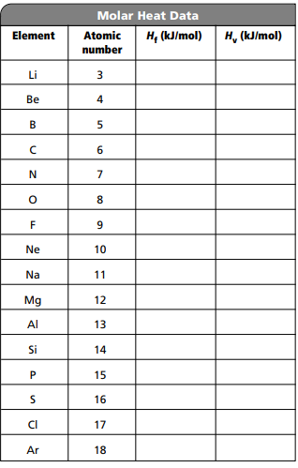

CHEMISTRY 2022-23 PRACTICE PROBLEMS

CHAPTER 6 – Periodic Table and Periodic Law
Practice Problems 6.1 – Electron Configuration and the Periodic Table
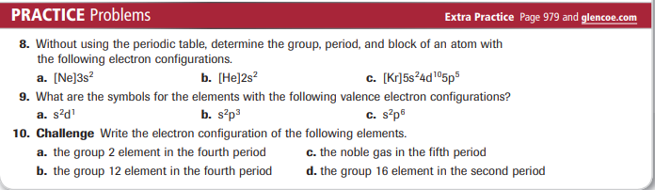
Practice Problems 6.2 – Interpret Trends in Atomic Radii
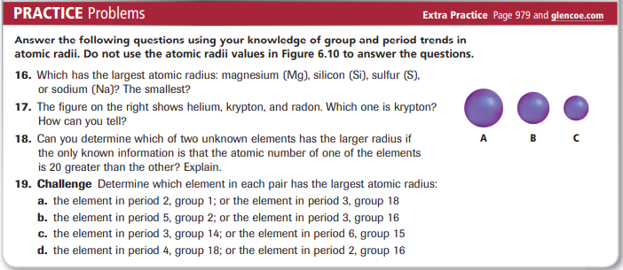

CHEMISTRY 2022-23 MINI - LAB

CHAPTER 6 MIN LAB – Organize Elements
Can you find the pattern?

Procedure
1. Read and complete the lab safety form.
2. Make a set of element cards based on the information in the chart at right.
3. Organize the cards by increasing mass and start placing them into a 4 × 3 grid.
4. Place each card based on its properties, and leave gaps when necessary.

Analysis
1. Make a table listing the placement of each
element.
2. Describe the period (across) and group (down) trends for the color in your new table.
3. Describe the period and group trends for the mass in your new table. Explain your placement of any elements that do not fit the trends.
4. Predict the placement of a newly found element, Ph, that is a fuchsia gas. What would be an expected range for the mass of Ph?
5. Predict the properties for the element that would fill the last remaining gap in the table.

