CHEMISTRY 2022-23 August 19, 2022

Today’s Agenda (Day 3)

- HOUSEKEEPING ITEMS

- Homework Check:

- Class Activity:
REVIEW: Comparison of APA vs. MLA

REVIEW: a) Lab Equipment - https://youtu.be/chODOKSPJS4
b) Safety Signs

HOMEWORK:
- READ: Chapter 1 – Introduction to Chemistry

CHAPTER 1
Applied research | Chemistry | Conclusion | Control | Dependent variable | experiment
Hypothesis | Independent variable | Mass | Model | Pure research | Qualitative data
Quantitative data | Scientific law | Substance | Theory | Weight

REMINDERS:
- Return signed/completed forms: August 19, 2022
- Contact Form
- Student Handbook Form
- BYOD Form
- APs/Electives
- Teacher Contact Info: sbeland@luschool.com
msbeland.weebly.com

CHEMISTRY 2022-23 ACTIVITY

IDENTIFYING LABORATORY EQUIPMENT/APPARATUS
Purpose
What are the names and functions of the pieces of laboratory equipment/apparatus found in a typical chemistry laboratory?
Procedure
1. Locate each piece of laboratory equipment on the benches in the room.
2. Match the equipment with the description of its function.
3. Record the name and draw the piece of equipment beside its function.
Observations
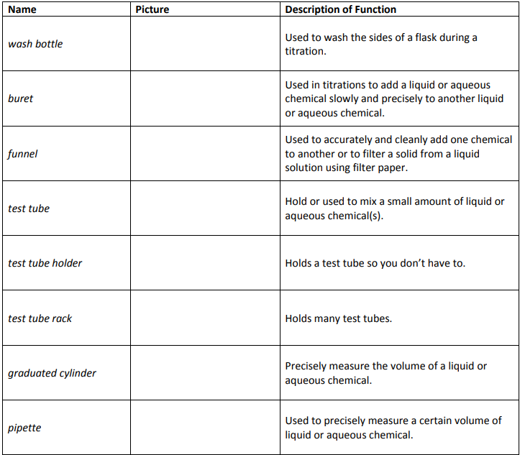
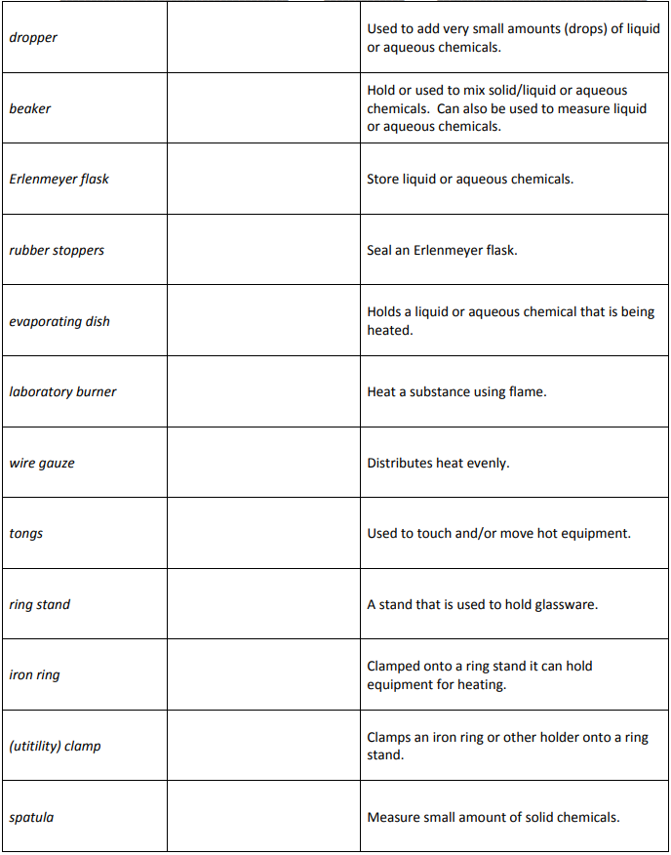

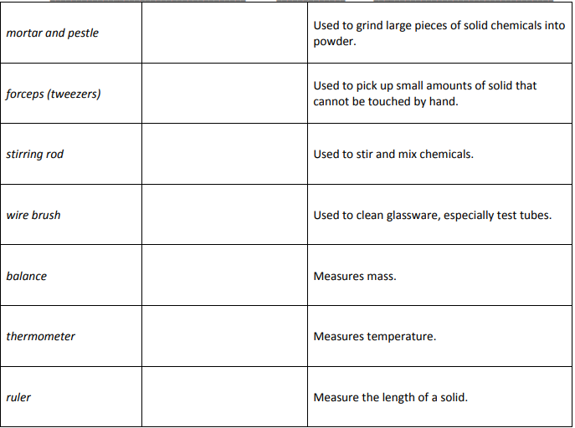

Questions
- Which laboratory equipment/apparatus can be used to measure liquid?
- Which laboratory equipment/apparatus are useful when measuring and mixing an acid and water?
- What tool or tools would you use to make each of the following measurements?
- amount of milk in a small glass
- length of a sheet of paper
- temperature of a swimming pool
- mass of a baseball

