CHEMISTRY 2022-23 September 23, 2022

Today’s Agenda (Day 27)

- HOUSEKEEPING ITEMS
**CHEX MIX – 1 per team** MONDAY!!
- Homework Check:
Lab 3.3 – Dye Separation
Lab 3.2 – Properties of Water
Chapter 4 Practice Problems
Chapter 5 Vocabulary
- Class Activity:
BEGIN: Chapter 5 PPT Review
- Section 5.1 – Light and Quantized Energy
- Section 5.2 – Quantum Theory and the Atom
- Section 5.3 – Electron Configuration
HOMEWORK:
- READ: Chapter 5 – Electrons in Atoms
- COMPLETE: Chapter 6 Vocabulary
- STUDY: Chapter 5 Test

CHAPTER 5
Amplitude | atomic emission spectrum | atomic orbital | Aufbau principle | de Broglie equation | electromagnetic radiation
electromagnetic spectrum | electron configuration | electron-dot structure | energy sublevel | Frequency | ground state
Heisenberg uncertainty principle | Hund's rule | Pauli exclusion principle | photoelectric effect | Photon | Planck's constant
principal energy level | principal quantum number | Quantum | quantum mechanical model of the atom | quantum number | valence electron
wavelength

CHAPTER 6
actinide series | alkali metal | alkaline earth metal | Electronegativity | Group | Halogen
inner transition metal | Ion | ionization energy | lanthanide series | Metal | Metalloid
noble gas | Nonmetal | octet rule | Period | periodic law | representative element
transition element | transition metal

REMINDERS:
- Chapter 5 Practice Problems – Sept. 27
- TEST: Ch 5 Sept. 29
- Chapter 6 Vocabulary – Oct. 11
- QUIZ: Ch 5 & 6 Vocabulary Oct. 13
- TEST: Ch 6 Oct. 18
CHEMISTRY 2022-23 PRACTICE PROBLEMS

CHAPTER 5 – Structure of the Atom
Practice Problems 5.1 – Calculating Wavelength of an EM Wave
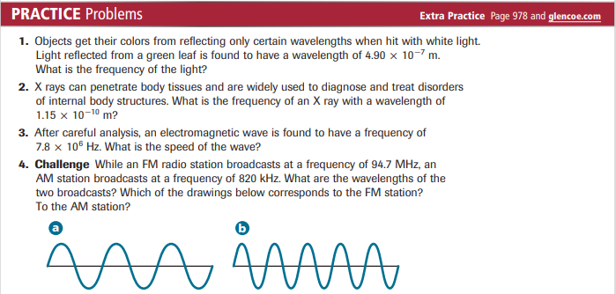
Practice Problems 5.2 – Calculate the Energy of a Photon
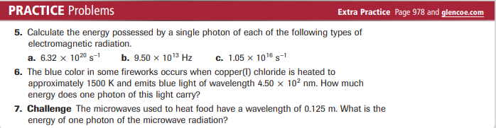
Problem-Solving Lab – Interpret Scientific Illustrations
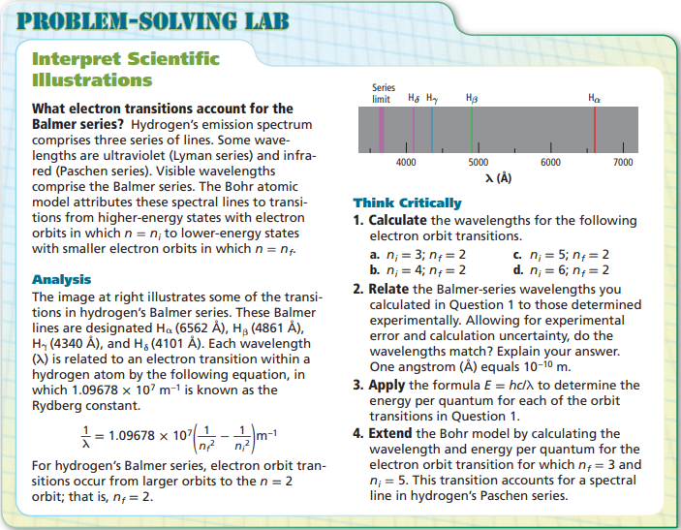
Practice Problems 5.3 – Filling Atomic Orbitals
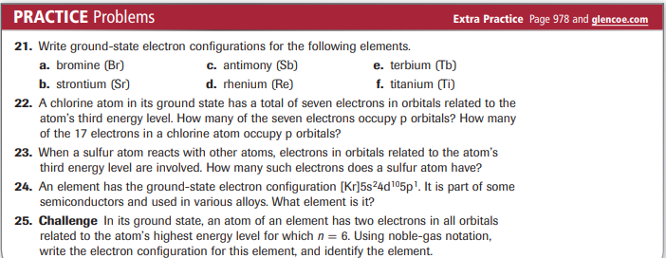
Practice Problems 5.3 – Electron-Dot Structures
