CHEMISTRY 2022-23 September 21, 2022

Today’s Agenda (Day 25)

- HOUSEKEEPING ITEMS

- Homework Check:
Lab 3.3 – Dye Separation
Lab 3.2 – Properties of Water
- Class Activity:
DAY 3: Chapter 4 PPT Review
- Section 4.3 – How Atoms Differ
- Section 4.4 – Unstable Nuclei and Radioactive Decay

HOMEWORK:
- READ: Chapter 4 – The Structure of the Atom
- READ: Chapter 5 – Electrons in Atoms
- COMPLETE: Chapter 5 Vocabulary
- STUDY: Chapter 4 Test

CHAPTER 5
Amplitude | atomic emission spectrum | atomic orbital | Aufbau principle | de Broglie equation | electromagnetic radiation
electromagnetic spectrum | electron configuration | electron-dot structure | energy sublevel | Frequency | ground state
Heisenberg uncertainty principle | Hund's rule | Pauli exclusion principle | photoelectric effect | Photon | Planck's constant
principal energy level | principal quantum number | Quantum | quantum mechanical model of the atom | quantum number | valence electron
wavelength

CHAPTER 6
actinide series | alkali metal | alkaline earth metal | Electronegativity | Group | Halogen
inner transition metal | Ion | ionization energy | lanthanide series | Metal | Metalloid
noble gas | Nonmetal | octet rule | Period | periodic law | representative element
transition element | transition metal

REMINDERS:

- Chapter 4 Practice Problems – Sept. 21
- TEST: Ch 4 Sept. 22
- Chapter 5 Vocabulary – Sept. 22
- TEST: Ch 5 Sept. 29
- Chapter 6 Vocabulary – Oct. 11
- QUIZ: Ch 5 & 6 Vocabulary Oct. 13
- TEST: Ch 6 Oct. 18

CHEMISTRY 2022-23 PRACTICE PROBLEMS

CHAPTER 4 – Structure of the Atom
Practice Problems 4.1 – Atomic Number
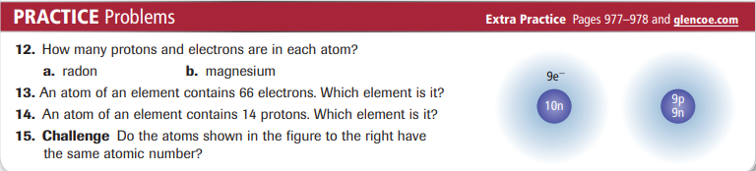

Practice Problems 4.2 – Use Atomic and Mass Number
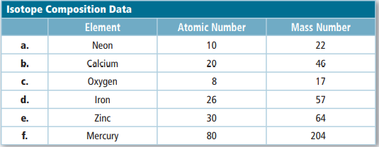
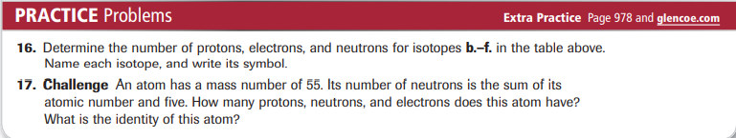

Practice Problems 4.3 – Calculate Atomic Mass
