CHEMISTRY 2022-23 September 12, 2022

Today’s Agenda (Day 19)

- HOUSEKEEPING ITEMS
**Need ICE and SAND**; Bring materials for Wednesday Mixtures Lab!!
- Homework Check:
Chapter 3 Vocabulary
Chapter 3 Practice Problems
- Class Activity:
DAY 4: Chapter 3 PPT Review
- Section 3.3 – Mixtures of Matter
- Section 3.4 – Elements and Compounds
TUESDAY: CHAPTER 3 LABS: Separating Ink Dyes, Properties of Water
WEDNESDAY: Lab - Mixtures

HOMEWORK:
- READ: Chapter 3 – Matter: Properties and Changes
- COMPLETE: Chapter 4 Vocabulary (abridged template)
- STUDY: Chapter 3
CHAPTER 3
chemical change | chemical property | Chromatography | Compound | Crystallization | Distillation
Element | extensive property | Filtration | Gas | heterogeneous mixture | homogeneous mixture
intensive property | law of conservation of mass | law of definite proportions | law of multiple proportions | Liquid | Mixture
percent by mass | periodic table | phase change | physical change | physical property | Solid
Solution | states of matter | Sublimation | Vapor

CHAPTER 4
alpha particle | Atom | atomic mass | atomic mass unit | atomic number | beta particle
beta radiation | cathode ray | Dalton's atomic theory | Electron | gamma ray | Isotope
mass number | Neutron | nuclear reaction | Nucleus | Proton | Radiation
radioactive decay | Radioactivity

REMINDERS:
- TEST: Ch 3 Sept. 15
- Chapter 3 Practice Problems – Sept. 12
- Chapter 4 Vocabulary – Sept. 14
- QUIZ: Ch 3 and 4 Vocabulary Sept. 20
- TEST: Ch 4 Sept. 22

CHEMISTRY 2022-23 LAB ACTIVITY

LAB 3.3 - Observe Dye Separation
How does paper chromatography allow you to separate substances?
Chromatography is an important diagnostic tool used by chemists. and forensic technicians to separate and analyze substances.
Hypothesis: ?

Procedure
1. Read and complete the lab safety form.
2. Fill a 9-oz wide-mouth plastic cup with water to about 2 cm from the top. Wipe off any water drops on the lip of the cup.
3. Place a piece of round filter paper on a clean, dry surface. Make a concentrated ink spot in the center of the paper by firmly pressing the tip of a black water-soluble pen or marker onto the paper.
4. Use scissors or another sharp object to create a small hole, about the diameter of a pen tip, in the center of the ink spot. WARNING: sharp objects can puncture skin.
5. Roll one quarter of an 11-cm round filter paper into a tight cone. This will act as a wick to draw the ink. Work the pointed end of the wick into the hole in the center of the round filter paper.
6. Place the paper/wick apparatus on top of the cup of water, with the wick in the water. The water will move up the wick and outward through the round paper.
7. When the water has moved to within about 1 cm of the edge of the paper (about
20 minutes), carefully remove the paper from the water-filled cup and put it on a second
empty cup.

Data: ?
Analysis
1. Record the number of distinct dyes you can identify on a drawing of the round filter paper. Label the color bands.
2. Infer why you see different colors at different locations on the filter paper.

3. Compare your chromatogram with those of your classmates. Explain any differences you might observe.

CHEMISTRY 2022-23 LAB ACTIVITY
LAB 3.2 – Properties of Water
Liquid water is difficult to find in the universe. Scientists have found frozen ice in places such as Mars and gaseous water vapor in atmospheres such as that on Venus. However, no one has been able to find liquid water anywhere other than on Earth. Water is the only natural substance that is found in all three states of matter (solid, liquid, and gas) at the temperatures normally found on Earth. By exploring a few of the properties of water, you will discover what makes water unique.

Problem
What is unique about these three properties of water: boiling point, specific heat capacity, and density change over phase change?
Objectives
- Graph the estimated boiling point of water.
- Collect, graph, and interpret temperature versus time data.
- Compare the heat capacity of sand with that of water.
- Calculate and compare the densities of liquid water and ice.
Materials
2 beakers (400-mL)
ring stand and clamp
wire gauze
Bunsen burner
sand
thermometer
timer or stopwatch
balance
50-mL graduated cylinder
graph paper
water

Safety Precautions
- Always wear safety goggles and a lab apron.
- Hair and loose clothing must be tied back.
- Hot objects will not appear to be hot. Be careful when handling the sand and water after heating.
- Clean up any spills immediately.

Pre-Lab
1. The following is a partial list of the properties of water. Classify the properties as chemical or physical: acts as a universal solvent, has high boiling point, exhibits high specific heat capacity, has density of about 1g/mL, has a pH that is neutral, has no odor, is colorless.
2. Describe hydrogen bonding and boiling point.
3. Define the following terms: a. temperature; b. heat; and c. specific heat capacity.
4. Review the equation for calculating density.
5. Read the entire laboratory activity. Form a hypothesis as to whether the density of ice will be higher or lower density than the density of water. Record your hypothesis on page 24.
Part A: Boiling Point
Procedure
Look at the table on the next page, which compares the boiling point of the hydrides (compounds with hydrogen in them) of the carbon (IVA) and oxygen (VA) families. Note that the boiling point of H₂O is missing. Plot on a graph the boiling point temperatures of the compounds versus their molecular weights.
The Carbon Family, Group IVA Elements |  | The Oxygen Family, Group VA Elements
Compound | Boiling point °C | Compound | Boiling point °C
CH₄ | −164 | H₂O | Predict
SiH₄ | −112 | H₂S | −61
GeH₄ | −90 | H₂Se | −41
SnH₄ | −52 | H₂Te | −2
Data and Observations
From the data, predict and plot the expected boiling point of water.
Analyze and Conclude
1. Interpreting Data From the graphed data, what is your predicted boiling point for water? How many degrees different is this from the actual boiling point of water?
2. Making and Using Graphs According to your predicted boiling point, in what state (solid, liquid, or gas) would water exist at room temperature (25°C) without hydrogen bonding?
3. Drawing Conclusions What does this exercise tell you about the power of hydrogen bonding?

Part B: Specific Heat Capacity
Procedure
1. In one 400-mL beaker, put 300 g of water. In another beaker, put 300 g of sand.
2. Place a thermometer in the sand and allow it to equilibrate for approximately 1 min. Record the temperature in your data table, then remove the thermometer.
3. While waiting for the temperature to equilibrate, set up an apparatus similar to the one in Figure A.
4. Light the Bunsen burner and adjust the flame so that it is medium hot with a large light blue cone.
5. Slide the burner under the sand and begin timing.
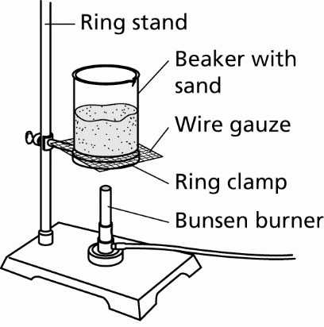

Figure A

6. Heat the sand for 1 min. Then, shut off the burner and immediately place the thermometer in the sand so that the bulb is in the center of the sand. Wait until the highest temperature has been reached and then record this as the “After heating 1 min” temperature in Data Table 1.
7. After recording the temperature, immediately start timing and recording the temperature every 30 s for a total of 120 s.
8. Set aside the beaker of sand.
9. Place the thermometer in the water and allow it to equilibrate for about 1 min.
10. Turn the Bunsen burner on, but DO NOT make any adjustments. The burner should be identical to its previous settings for the beaker of sand.
11. Slide the burner under the water and begin timing. Repeat steps 5–8 using the beaker of water.
Cleanup and Disposal
1. Do not allow the sand to go down the drain.
2. Carefully return the warm sand to the designated container.

Data and Observations
Data Table 1
 | Sand temperature (°C) | Water temperature (°C)
Initial temperature
After heating 1 min
Turn burner off
After cooling 30 s
After cooling 60 s
After cooling 90 s
After cooling 120 s
1. On a sheet of graph paper, make a graph of time versus temperature for your after-cooling data. You should have four points each for sand and water. This graph is called a cooling curve. Make sure you place the independent variable on the x-axis.
2. Which substance, sand or water, required less heat to raise its temperature?
3. Which substance, sand or water, lost its heat more rapidly?
Analyze and Conclude
1. Interpreting Data Discuss the differences in the cooling curves for sand and water. Explain their significance.
2. Applying Concepts Of all known substances, water has one of the highest heat capacities. In light of this, explain how and why water is used as a coolant in car radiators.

Part C: Density
Procedure
1. Obtain the mass of a clean, dry, 50-mL graduated cylinder.
2. Pour exactly 45.0 mL of tap water in a plastic graduated cylinder.
3. In Data Table 2, record the mass of the cylinder and the 45.0 mL of water.
4. Place the graduated cylinder in the freezer overnight.
5. On the following day, record the mass and volume of the ice as soon as it is removed from the freezer.
6. Calculate the density for both water and ice.
Hypothesis
_______________________________________________
_______________________________________________
Cleanup and Disposal
Loosen the ice in the graduated cylinder by running warm water over the outside.
Data and Observations
Data Table 2
Mass of the graduated cylinder
Mass of the cylinder  water
Mass of water
Volume of water
Density of water
Mass of the cylinder  ice
Mass of ice
Volume of ice
Density of ice

Analyze and Conclude
1. Recognizing Cause and Effect If the mass remains constant for the water and ice but the volume changes, explain how this will affect the density.
2. Error Analysis Was your hypothesis supported? Explain. What could be done to improve the precision and accuracy of your measurements?
Real-World Chemistry
1. Wine grapes must be grown in temperate climates because the grapes and their vines cannot tolerate weather too hot or too cold. Usually, grapes are grown near bodies of water, such as rivers or lakes. Why do you think grapes are grown near water?
2. Moisture and changing temperatures are the major contributors to the formation of potholes. Explain how one of water’s properties can deteriorate highways so viciously.

CHEMISTRY 2022-23 PRACTICE PROBLEMS

CHAPTER 3 – Matter: Properties and Change
Practice Problems 3.2 – Law of Conservation of Mass
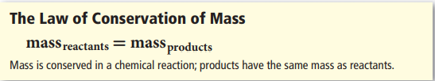
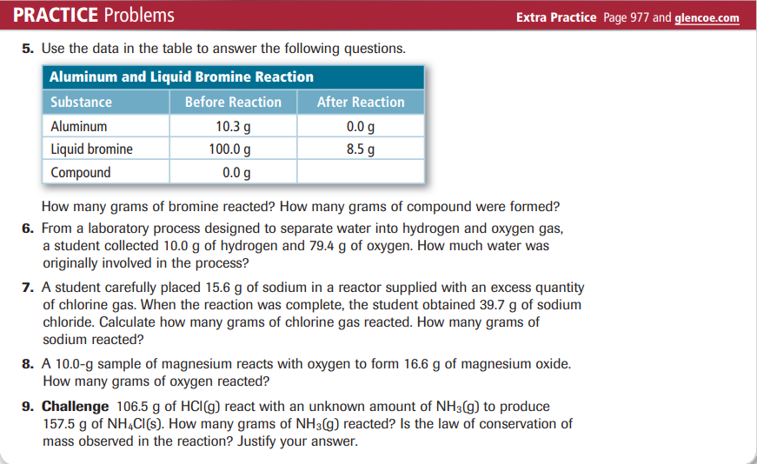
Practice Problems 3.4 – Law of Definite Proportions
