CHEMISTRY 2022-23 September 8, 2022

Today’s Agenda (Day 17)

- HOUSEKEEPING ITEMS

- Homework Check:
Lab 1.1 AND Ch 2 Launch Lab
Lab 1.2 AND Ch 2 Mini-Lab

- Class Activity:
DAY 2: Chapter 3 PPT Review
- Section 3.2 – Changes in Matter
- Section 3.3 – Mixtures of Matter
- Section 3.4 – Elements and Compounds
CHAPTER 3 LABS: Separating Ink Dyes, Matter and Chemical Reactions, Properties of Water

HOMEWORK:
- READ: Chapter 3 – Matter: Properties and Changes
- COMPLETE: Chapter 3 Vocabulary (abridged template)
- STUDY: Chapter 3

CHAPTER 3
chemical change | chemical property | Chromatography | Compound | Crystallization | Distillation
Element | extensive property | Filtration | Gas | heterogeneous mixture | homogeneous mixture
intensive property | law of conservation of mass | law of definite proportions | law of multiple proportions | Liquid | Mixture
percent by mass | periodic table | phase change | physical change | physical property | Solid
Solution | states of matter | Sublimation | Vapor

REMINDERS:
- Chapter 3 Vocabulary – Sept. 10
- TEST: Ch 3 Sept. 15
- Chapter 3 Practice Problems – Sept. 12

CHEMISTRY 2022-23 PRACTICE PROBLEMS

CHAPTER 3 – Matter: Properties and Change
Practice Problems 3.2 – Law of Conservation of Mass
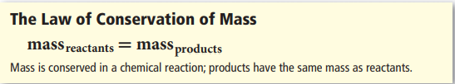
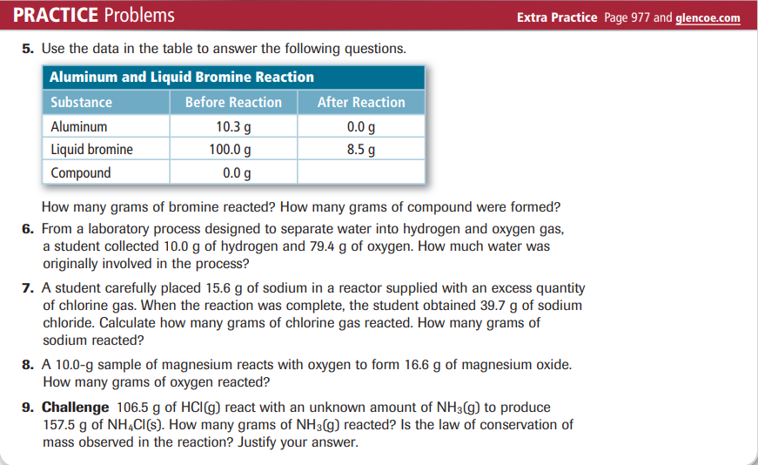
Practice Problems 3.4 – Law of Definite Proportions
