CHEMISTRY 2022-23 September 6, 2022

Today’s Agenda (Day 15)

- HOUSEKEEPING ITEMS

- Homework Check:
Lab 1.1 AND Ch 2 Launch Lab
Lab 1.2 AND Ch 2 Mini-Lab

- Class Activity:
TEST: Chapter 2
*Go to www.socrative.com enter room “MSBCHEM2022” enter ID #

WEDNESDAY: Chapter 3 PPT Review
- Section 3.1 – Properties of Matter
- Section 3.2 – Changes in Matter
- Section 3.3 – Mixtures of Matter
- Section 3.4 – Elements and Compounds
CHAPTER 3 LABS: Separating Ink Dyes, Matter and Chemical Reactions, Properties of Water

HOMEWORK:
- READ: Chapter 3 – Matter: Properties and Changes
- COMPLETE: Chapter 3 Vocabulary (abridged template)
- STUDY: Chapter 3

CHAPTER 3
chemical change | chemical property | Chromatography | Compound | Crystallization | Distillation
Element | extensive property | Filtration | Gas | heterogeneous mixture | homogeneous mixture
intensive property | law of conservation of mass | law of definite proportions | law of multiple proportions | Liquid | Mixture
percent by mass | periodic table | phase change | physical change | physical property | Solid
Solution | states of matter | Sublimation | Vapor

REMINDERS:
- TEST: Ch 2 Sept. 6
- Lab 1.2 AND Ch 2 Mini-Lab – Sept. 6
- Chapter 3 Vocabulary – Sept. 10
- TEST: Ch 3 Sept. 15

CHEMISTRY 2022-23 LAB ACTIVITY

LAB 1.2 – Effective Use of a Bunsen Burner
During chemical or physical changes, energy is often transferred in the form of heat. This transfer can be measured by a change in temperature. In this activity, you will test the effective use of a Bunsen burner. You will vary the height of the position of a beaker of water above the burner and observe how long it takes to boil the water. All other factors will be kept constant. The intensity of the flame and the height of the platform used to hold the beaker of water will not change. Because the intensity of the flame does not change, the amount of heat provided by the flame will be a constant. In addition, a given amount of water will always require the same amount of energy to boil.
Problem
How far from a flame should a beaker of water be positioned for heating to be most efficient?
Objectives
• Heat a beaker of water using a Bunsen burner.
• Measure distances using a ruler.
• Measure temperature using a thermometer.
Materials

100-mL graduated cylinder
250-mL beakers
(4) Bunsen burner striker or matches
thermometer
ring stand
ring
wire gauze
ruler
stopwatch or clock with a second hand
beaker tongs or hot mitts
hot pad
distilled water

Safety Precautions 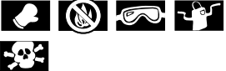
• Always wear safety goggles and a lab apron.
• Never eat or taste any substance used in the lab.
• Assume all glassware is hot and handle with gloves.
• Boiling water can burn skin.
Pre-Lab
1. What are the constants in this experiment?
2. What are the variables in this experiment?
3. Which measurement in this experiment is the dependent variable?
4. Read over the entire laboratory activity. Hypothesize about what the most effective position above the flame will be. Record your hypothesis on page 6.
Procedure
1. Label four 250-mL beakers 1, 2, 3, and 4. Using a graduated cylinder, measure 100 mL of distilled water into Beaker 1. Measure and record the temperature of the water in Data Table 1. Repeat this process three more times for the remaining three beakers.
2. Set up a ring stand and attach the ring to the stand. Place the wire gauze on the ring to provide a platform on which to place the beaker of water.
3. Use burner connector safety tubing to connect the Bunsen burner to the gas inlet. Make sure the hose does not have any cracks or holes.
4. Light the burner by first turning on the gas flow and using the striker to ignite the gas. If you use a match, light the match first before turning on the gas. Hold the match close to the bottom side of the burner nozzle to light the gas.
5. When the flame is lit, adjust the gas flow and oxygen flow so that the flame is blue with an inner light-blue cone. A yellow flame is too cool and needs more oxygen. Your teacher may have additional directions on the operation of the Bunsen burner.
6. After you adjust the flame, move the burner to the ring stand and observe the height of the wire gauze above the flame. Adjust the height so the wire gauze is approximately halfway up the inner blue cone. Refer to Figure A, Test 1 height. Estimate the distance from the top of the burner to the wire gauze with a ruler and record this distance as Test 1 in Data Table 2. This will be your starting distance. Turn off the flame.
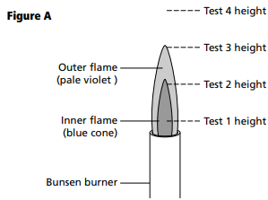
7. Place Beaker 1 on the wire gauze. Ignite the flame and measure the time (in s) it takes for the water to boil. Record this time in Data Table 2.
8. Turn off the flame and using beaker tongs and hot mitts, carefully remove the hot beaker of water from the wire gauze and place it on a hot pad on your lab bench.
9. Turn on the flame and adjust the height so the wire gauze is now at the top of the inner blue cone. Refer to Figure A, Test 2 height. Estimate the distance from the top of the burner to the wire gauze with the ruler and record this distance in Data Table 2. Turn off the flame.
10. Repeat steps 6–8 using Beaker 2.
11. Turn on the flame and adjust the height so the wire gauze is now positioned the same distance from the top of the inner blue cone as the top was positioned from the starting distance, halfway up the inner blue cone. Refer to Figure A, Test 3 height. For example, if the starting distance was 3 cm and the top of the inner blue cone is 6 cm, then the new position will be 9 cm above the burner top. Estimate the distance from the top of the burner to the wire gauze with the ruler and record this distance in Data Table 2. Turn off the flame.
12. Repeat steps 6–8 using Beaker 3.
13. Turn on the flame and adjust the height so the wire gauze is moved to a new position that is the same distance increment as before. Refer to Figure A, Test 4 height. For example, if the starting position was 3 cm, the height for test number 2 was 6 cm and the height for test number 3 was 9 cm, then the height for test 4 will be 12 cm. Estimate the distance from the top of the burner to the wire gauze with the ruler and record this distance in Data Table 2. This will be your starting distance. Turn off the flame.
14. Repeat steps 6–8 using Beaker 4.
15. When the beakers are cool, empty the water in the sink and dry the glassware.
Hypothesis
?
Cleanup and Disposal
1. Clean and dry all glassware.
2. Return all lab equipment to its proper place.
3. Clean up your work area.
Data and Observations 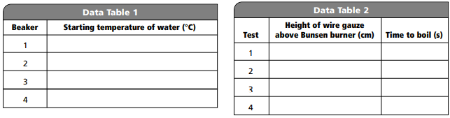
Analyze and Conclude
1. Observing and Inferring Why did you turn off the burner between experiment setups?
2. Thinking Critically Why is the height of the wire gauze the independent variable?
3. Thinking Critically Why is the time to get the water to boil the dependent variable?
4. Comparing and Contrasting What observed differences did you note among the results of the four tests?
5. Drawing a Conclusion Why did it take less time for the water to boil when the wire gauze was placed at the tip of the inner blue cone?
6. Thinking Critically Why was it necessary to use beaker tongs or hot mitts to remove the beaker of water after the test but not before the test?
7. Error Analysis What are some sources of error in this activity?
Real-World Chemistry
1. Suppose you wanted to measure the heat produced by a Bunsen burner flame. Why would holding a thermometer in the flame be the wrong approach?
2. Why did you check to make sure that the hose to the burner did not have any holes or cracks?

CHEMISTRY 2022-23 LAB ACTIVITY

CHAPTER 2 Mini Lab – Determine Density
What is the density of an unknown and irregularly shaped solid? To calculate the density of an object, you need to know its mass and volume. The volume of an irregularly shaped solid can be determined by measuring the amount of water it displaces.
Procedure
1. Read and complete the lab safety form.
2. Obtain several unknown objects from your teacher. Note: Your teacher will identify each object as A, B, C, and so on.
3. Create a data table to record your observations.
4. Measure the mass of the object using a balance. Record the mass and the identity of the object in your data table.
5. Add about 15 mL of water to a graduated cylinder. Measure and record the initial volume in your data table. Because the surface of the water in the cylinder is curved, make volume readings at eye level and at the lowest point on the curve, as shown in the figure. The curved surface is called a meniscus.
6. Tilt the graduated cylinder, and carefully slide the object down the inside of the cylinder. Be sure not to cause a splash. Measure and record the final volume in your data table.
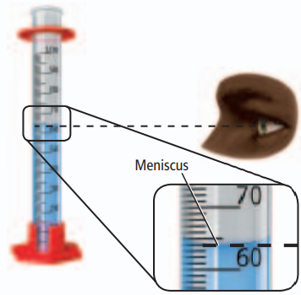
Analysis
1. Calculate Use the initial and final volume readings to calculate the volume of each mystery object.
2. Calculate Use the calculated volume and the measured mass to calculate the density of each unknown object. 3. Explain Why can’t you use the water displacement method to find the volume of a sugar cube?
4. Describe how you can determine a washer’s volume without using the water displacement method. Note, that a washer is similar to a short cylinder with a hole through it.

