CHEMISTRY 2022-23 April 17, 2023

Today’s Agenda (Day 145)

- HOUSEKEEPING ITEMS
BRING:
- Homework Check:

- Class Activity:
TEST: Ch 19 – POSTPONED UNTIL Tuesday, April 18

BEGIN: Chapter 20 PPT Review
- Section 20.1 – Voltaic Cells
- Section 20.2 – Batteries
- Section 20.3 - Electrolysis

WEDNESDAY: Launch Lab 18 & 19, ?Mini Lab 18, Chem Lab 17
HOMEWORK:
- READ: Chapter 20 – Electrochemistry
- COMPLETE:
- STUDY: Ch 19 Test, Chapter 20 Test

CHAPTER 20 VOCABULARY
anode | battery | cathode | corrosion | dry cell | electrochemical cell
electrolysis | electrolytic cell | fuel cell | galvanization | half-cell | primary battery
reduction potential | salt bridge | secondary battery | standard hydrogen electrode | voltaic cell

REMINDERS:
- TEST: Ch 19 April 13 April 18
- QUIZ: Ch 20 Vocabulary April 20
- TEST: Ch 20 April 20 May 4

CHEMISTRY 2022-23 LAUNCH LAB
CHAPTER 18 LAUNCH LAB – What is in Your Cupboards?
You can learn something about the properties of products in your household by testing them with strips of paper called litmus paper. Can you separate household products into two groups?
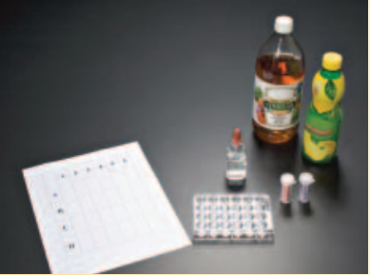
Procedure
1. Read and complete the lab safety form.
2. Place three or four drops of several household products into separate wells of a microplate. Draw a chart to show the position of each liquid.
3. Test each product with red and blue litmus paper. Place two drops of phenolphthalein in each sample. Record your observations.
WARNING: Phenolphthalein is flammable. Keep away from flames.

Analysis
1. Classify the products into two groups based on your observations.
2. Describe how the groups differ. What can you conclude?

Inquiry
Choose one sample that reacted with the phenolphthalein. Can you reverse the reaction? Design an experiment to test your hypothesis.

CHEMISTRY 2022-23 LAUNCH LAB
CHAPTER 19 LAUNCH LAB – What happens when iron and copper (II) sulfate react?
Rust is the product of a reaction between iron and oxygen. Iron can also react with substances other than oxygen.
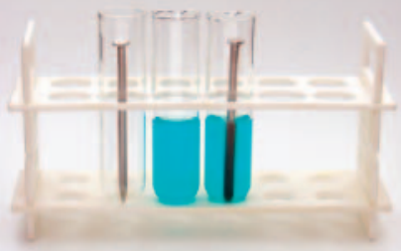

Procedure
1. Read and complete the lab safety form.
2. Use a piece of steel wool to polish the end of an iron nail.
3. Add about 3 mL of 1.0M copper (II) sulfate (CuSO₄) solution to a test tube. Place the polished end of the nail into the CuSO₄ solution. Let the test tube stand in a test-tube rack, and observe it for about 10 min. Record your observations.
Analysis
1. Explain what happened to the color of the copper (II) sulfate solution.
2. Identify the substance clinging to the nail.
3. Write the balanced chemical equation for the reaction you observed.
Inquiry
What do you think would happen if copper was placed in an iron sulfate solution? Design an investigation to test your hypothesis.

CHEMISTRY 2022-23 LAUNCH LAB
CHAPTER 20 LAUNCH LAB – How can you make a batter from a lemon?
You can purchase a handy package of portable power at any convenience store—a battery. You can also light a bulb with a lemon. How are these power sources alike?

Procedure
1. Read and complete the lab safety form.
2. Insert zinc and copper strips into a lemon, about 2 cm apart from each other.
3. Attach the black lead from a voltmeter to the zinc and the red lead to the copper. Read the potential difference (voltage) shown on the voltmeter and record your reading.
4. Remove one of the metals from the lemon, and observe what happens to the potential difference on the voltmeter

Analysis
1. Explain the purpose of the zinc and copper metals.
2. Infer What is the function of the lemon?

Inquiry
Do you think that you can make a battery from foods other than lemons? Form a hypothesis about other foods—or types of foods—that can be made into batteries. Then, design a battery using another food.

CHEMISTRY 2022-23 MINI LAB

CHAPTER 18 MINI LAB – Compare Acid Strengths
How can you determine the relative strengths of acid solutions?
Procedure
1. Read and complete the lab safety form.

2. Use a 10-mL graduated cylinder to measure 3 mL of glacial acetic acid. Use a dropping pipette to transfer the acid into Well A1 of a 24-well microplate.
WARNING: Glacial acetic acid is corrosive and toxic by inhalation. Handle with caution.

3. Lower the electrodes of a conductivity tester into Well A1. Record your results.

4. Rinse the graduated cylinder and pipette with water. Measure 3 mL of 6.0M acetic acid and transfer it to Well A2 of the microplate. Test and record the conductivity of the solution.

5. Repeat Step 4 with 1.0M acetic acid and 0.10M acetic acid using wells A3 and A4, respectively.

Analysis
1. Write the equation for the ionization of acetic acid in water and the equilibrium constant expression (K_{eq} = 1.8 × 1 0⁻⁵). What does the size of K_{eq} indicate about the degree of ionization?
2. Explain whether the following approximate percent ionizations fit your laboratory results: glacial acetic acid, 0.1%; 6.0M acetic acid, 0.2%; 1.0M acetic acid, 0.4%; 0.1M acetic acid, 1.3%.
3. State a hypothesis that explains your observations using your answer to Question 2.
4. Utilize your hypothesis to draw a conclusion about the need to use large amounts of water for rinsing when acid spills on living tissue.

CHEMISTRY 2022-23 MINI LAB

CHAPTER 19 MINI LAB – Observe a Redox Reaction
How can tarnish be removed from silver?

Procedure
1. Read and complete the lab safety form.
2. Lightly buff a piece of aluminum foil with steel wool to remove any oxide coating.
3. Wrap a small, tarnished object in the aluminum foil, making sure that the tarnished area makes firm contact with the foil.
4. Place the wrapped object in a 400-mL beaker and add a sufficient volume of tap water to cover it completely.
5. Add about 1 spoonful of baking soda and about 1 spoonful of table salt to the beaker.
6. Using beaker tongs, set the beaker and its contents on a hot plate, and heat until the water is almost boiling. Maintain the heat for approximately 15 min, until the tarnish disappears.
Analysis
1. Write the equation for the reaction of silver with hydrogen sulfide that yields silver sulfide and hydrogen.
2. Write the equation for the reaction of the tarnish (silver sulfide) with the aluminum foil that yields aluminum sulfide and silver.
3. Determine which metal, aluminum or silver, is more reactive. How do you know this from your results?
4. Explain why you should not use an aluminum pan to clean silver objects.
CHEMISTRY 2022-23 MINI LAB

CHAPTER 20 MINI LAB – Observe Corrosion
Which metal will corrode?

Procedure
1. Read and complete the lab safety form.
2. Use sandpaper to buff the surfaces of four iron nails. Wrap two nails with magnesium ribbon and two nails with copper. Wrap the metals tightly so that the nails do not slip out.
3. Place each of the nails in a separate beaker. Add distilled water to one of the beakers containing a copper-wrapped nail and one of the beakers containing a magnesium-wrapped nail. Add enough distilled water to just cover the wrapped nails. Add salt water to two additional beakers. Record your observations of the nails in each beaker.
4. Let the beakers stand overnight in the warmest place available. Examine the nails and solutions the next day and record your observations.

Analysis

1. Describe the difference between copper-wrapped nails in the distilled water and the salt water after they have been standing overnight.
2. Describe the difference between the magnesium-wrapped nails in the distilled water and in the salt water.
3. Explain the difference between a copper-wrapped nail and a magnesium-wrapped nail.

CHEMISTRY 2022-23 PRACTICE PROBLEM
CHAPTER 20 - Electrochemistry

Practice Problems 20.1 – Calculate a Cell Potential
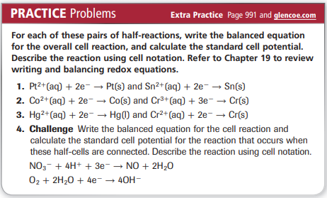

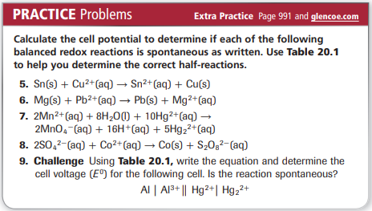

CHEMISTRY 2022-23 PROBLEM-SOLVING LAB

CHAPTER 20 - Data Analysis Lab

How can you get electric current from microbes? Scientists have studied the use of microbes as biofuel cells. A biofuel cell directly converts microbial metabolic energy into electric current. An electron mediator facilitates transfer of electrons to an electrode. An electron mediator is a compound that taps into the electron transport chain of cells and steals the electrons that are produced.

Data and Observations
The graph shows the current produced in a biofuel cell with (blue line) and without (green line) the use of an electron mediator.
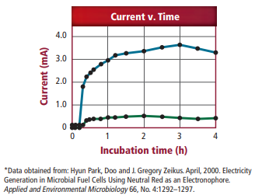

Think Critically
1. Infer the approximate time when the electron mediator was introduced.
2. Determine Did the introduction of the electron mediator make a difference in the current production? Explain your answer.
3. Analyze What is the highest current obtained by the cell?
CHEMISTRY 2022-23 CHEM LAB 17
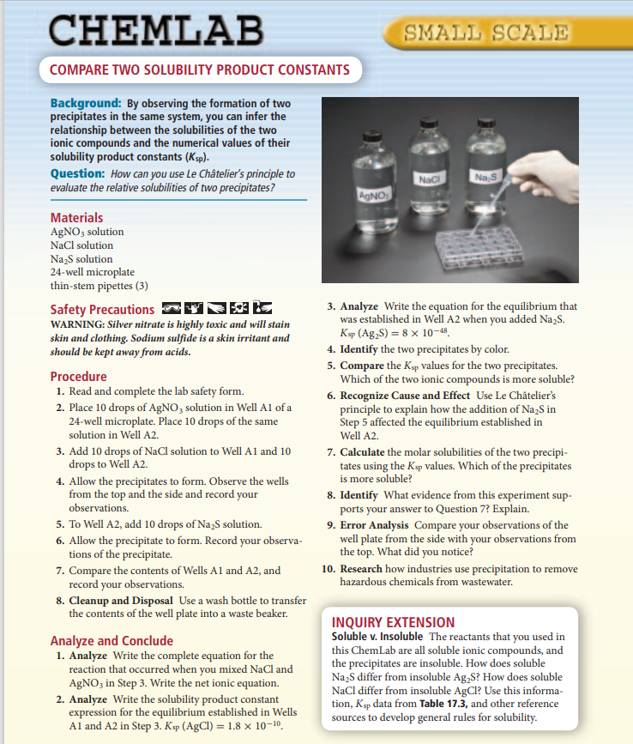

CHEMISTRY 2022-23 CHEM LAB 19
