CHEMISTRY 2022-23 April 4, 2023

Today’s Agenda (Day 138)

- HOUSEKEEPING ITEMS
BRING:
- Homework Check:
Chapter 17 Vocabulary
- Class Activity:
QUIZ: Ch 17_18 Vocabulary

DAY 2: Chapter 18 PPT Review
- Section 18.1 – Introduction to Acids and Bases
- Section 18.2 – Strengths of Acids and Bases
- Section 18.3 – Hydrogen Ions and pH
- Section 18.4 - Neutralization

HOMEWORK:
- READ: Chapter 18 – Acids and Bases
- COMPLETE:
- STUDY: Ch 17 & 18 Vocabulary Quiz and Ch 18 Test

CHAPTER 17 VOCABULARY
chemical equilibrium | common ion | common ion effect | equilibrium constant | heterogeneous equilibrium | homogeneous equilibrium
law of chemical equilibrium | Le Chatelier's principle | reversible reaction | solubility product constant

CHAPTER 18 VOCABULARY
acid ionization constant | acid-base indicator | acidic solution | Amphoteric | Arrhenius model | base ionization constant
basic solution | Bronsted-Lowry model | Buffer | buffer capacity | conjugate acid | conjugate acid-base pair
conjugate base | end point | equivalence point | ion product constant for water | Lewis model | neutralization reaction
pH | pOH | Salt | salt hydrolysis | strong acid | strong base
Titrant | Titration | weak acid | weak base

REMINDERS:
- QUIZ: Ch 17_18 Vocabulary April 4
- TEST: Ch 18 April 6
- QUIZ: Ch 19 Vocabulary April 11
- TEST: Ch 19 April 13
- QUIZ: Ch 20 Vocabulary April 18
- TEST: Ch 20 April 20

CHEMISTRY 2022-23 LAUNCH LAB
CHAPTER 18 LAUNCH LAB – What is in Your Cupboards?
You can learn something about the properties of products in your household by testing them with strips of paper called litmus paper. Can you separate household products into two groups?
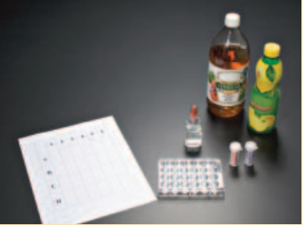
Procedure
1. Read and complete the lab safety form.
2. Place three or four drops of several household products into separate wells of a microplate. Draw a chart to show the position of each liquid.
3. Test each product with red and blue litmus paper. Place two drops of phenolphthalein in each sample. Record your observations.
WARNING: Phenolphthalein is flammable. Keep away from flames.

Analysis
1. Classify the products into two groups based on your observations.
2. Describe how the groups differ. What can you conclude?

Inquiry
Choose one sample that reacted with the phenolphthalein. Can you reverse the reaction? Design an experiment to test your hypothesis.
CHEMISTRY 2022-23 MINI LAB

CHAPTER 18 MINI LAB – Compare Acid Strengths
How can you determine the relative strengths of acid solutions?
Procedure
1. Read and complete the lab safety form.

2. Use a 10-mL graduated cylinder to measure 3 mL of glacial acetic acid. Use a dropping pipette to transfer the acid into Well A1 of a 24-well microplate.
WARNING: Glacial acetic acid is corrosive and toxic by inhalation. Handle with caution.

3. Lower the electrodes of a conductivity tester into Well A1. Record your results.

4. Rinse the graduated cylinder and pipette with water. Measure 3 mL of 6.0M acetic acid and transfer it to Well A2 of the microplate. Test and record the conductivity of the solution.

5. Repeat Step 4 with 1.0M acetic acid and 0.10M acetic acid using wells A3 and A4, respectively.

Analysis
1. Write the equation for the ionization of acetic acid in water and the equilibrium constant expression (K_{eq} = 1.8 × 1 0⁻⁵). What does the size of K_{eq} indicate about the degree of ionization?
2. Explain whether the following approximate percent ionizations fit your laboratory results: glacial acetic acid, 0.1%; 6.0M acetic acid, 0.2%; 1.0M acetic acid, 0.4%; 0.1M acetic acid, 1.3%.
3. State a hypothesis that explains your observations using your answer to Question 2.
4. Utilize your hypothesis to draw a conclusion about the need to use large amounts of water for rinsing when acid spills on living tissue.

CHEMISTRY 2022-23 PRACTICE PROBLEM
CHAPTER 18 – Acids and Bases

Practice Problems 18.1 – Properties of Acids and Bases

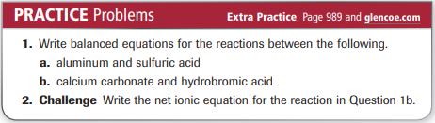

Practice Problems 18.2 – The Bronsted-Lowry Model
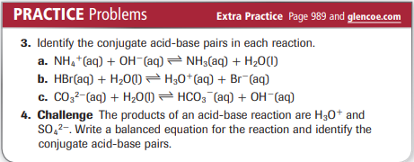

Practice Problems 18.3 – Acid Ionization Constant
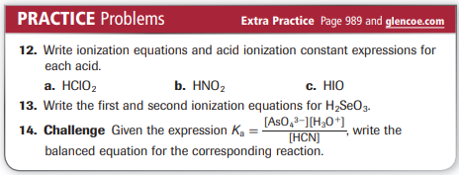

Practice Problems 18.4 – Base Ionization Constant
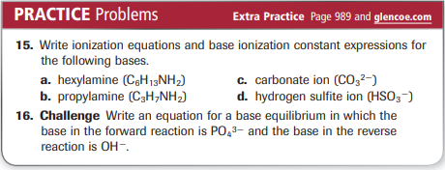
Problems 18.5 – Calculate [H ⁺] and [OH ⁻] Using K_{w}
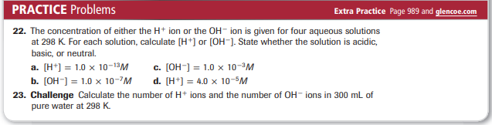
Problems 18.6 – Calculate pH from [H ⁺]
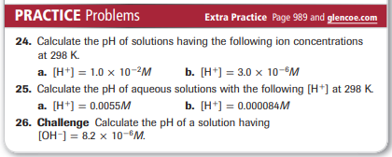
Problems 18.7 – Calculate pOH and pH from [OH ⁻]
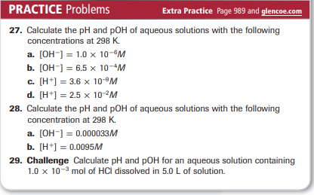
Problems 18.8 – Calculate [H ⁺] and [OH ⁻] from pH
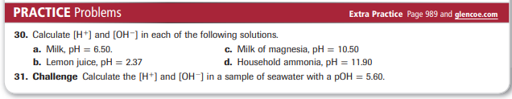
Problems 18.9 – Calculate K_{a} from pH
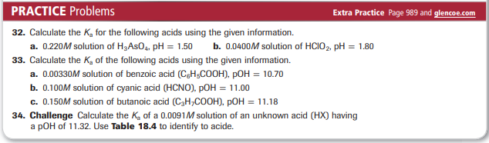
Problems 18.10 – Molarity from Titration Data
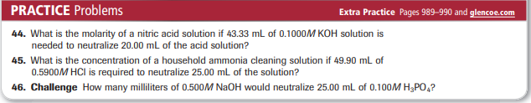
Problems 18.11 – Salt Hydrolysis
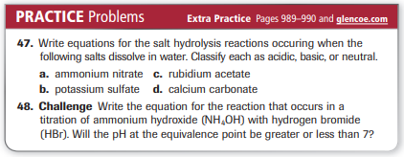
CHEMISTRY 2022-23 PROBLEM-SOLVING LAB

CHAPTER 18 Problem Solving Lab – Apply Scientific Explanations

How does your blood maintain its pH? Human blood contains three types of cells. Red blood cells deliver oxygen to every part of the body. White blood cells fight infections, and platelets aid in clotting when bleeding occurs. The critical functions of these cells are impaired if the pH of blood is not maintained within the narrow range of 7.1 to 7.7. Beyond this range, proteins in the body lose their structures and abilities to function. Fortunately, several buffers maintain the necessary acid/base balance. The carbonic acid/hydrogen carbonate (H₂CO₃/ HCO₃⁻) buffer is the most important.

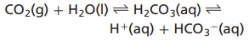
As acids and bases enter the bloodstream as a result of normal activity, the blood’s buffer systems shift to effectively maintain a healthful pH.

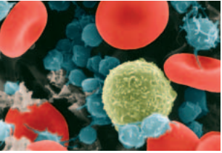
Analysis
Depending on the body’s metabolic rate and other factors, the H₂CO₃/ HCO₃⁻ equilibrium will shift according to Le Châtelier’s principle. In addition, the lungs can alter the rate at which CO₂ is expelled from the body by breathing, and the kidneys can alter the rate of removal of HCO₃⁻ ions.

Think Critically
1. Determine how many times greater the [H⁺] is if the blood’s pH changes from pH 7.4 to 7.1.
2. Suggest a reason why a 20:1 ratio of HCO₃⁻ to CO₂ in the blood is favorable for maintaining a healthy pH.
3. Predict whether, for each situation, the pH of the blood will rise or fall, and which way the H₂CO₃/ HCO₃⁻ equilibrium will shift.
a. A person with a severe stomach virus vomits many times during a 24-h period.
b. To combat heartburn, a person takes too much (NaHCO₃).

CHEMISTRY 2022-23 CHEM LAB 17
