CHEMISTRY 2022-23 February 15, 2023

Today’s Agenda (Day 110)

- HOUSEKEEPING ITEMS
BRING: ice, rock salt, masking tape
- Homework Check:

- Class Activity:
LABS: Ch 13 Mini Lab – Model a Fire Extinguisher
Ch 14 Launch Lab – How Energy Changes when Solutions Form

DAY 4: Begin Chapter 14 PPT Review
- Section 14.4 – Colligative Properties of Solutions

HOMEWORK:
- READ: Chapter 14 – Mixtures and Solutions
- COMPLETE:
- STUDY: Ch 14 Test

Chapter 14 Vocabulary
boiling point elevation | Brownian motion | colligative property | Colloid | Concentration | freezing point depression | heat of solution
Henry's law | Immiscible | Insoluble | Miscible | Molality | Molarity | mole fraction
Osmosis | osmotic pressure | saturated solution | Solvation | supersaturated solution | unsaturated solution | vapor pressure lowering

REMINDERS:
- TEST: Ch 14 Feb. 16

CHEMISTRY 2022-23 MINI LAB

CHAPTER 13 MINI LAB – Model a Fire Extinguisher
Why is carbon dioxide used in fire extinguishers?

Procedure
1. Read and complete the lab safety form.
2. Measure the temperature with a thermometer. Obtain the air pressure with a barometer or weather radio. Record your data.
3. Roll a 23-cm × 30-cm piece of aluminum foil into a cylinder that is 30 cm long and roughly 6 cm in diameter. Tape the edges with masking tape.
4. Use matches to light a candle.
WARNING: Run water over the extinguished match before throwing it away. Keep hair and clothing away from the flame.
5. Place 30 g of baking soda (NaHCO₃) in a large beaker. Add 40 mL of vinegar (5% CH₃COOH).
6. Quickly position the foil cylinder at about 45° up and away from the top of the candle flame.
WARNING: Do not touch the end of the aluminum tube that is near the burning candle.
7. While the reaction in the beaker is actively producing carbon dioxide gas, carefully pour the gas, but not the liquid, out of the beaker and into the top of the foil tube. Record your observations.

Analysis
1. Apply Calculate the molar volume of carbon dioxide gas (CO₂) at room temperature and atmospheric pressure.
2. Calculate the room-temperature densities in grams per liter of carbon dioxide, oxygen, and nitrogen gases. Recall that you will need to calculate the molar mass of each gas in order to calculate densities.
3. Interpret Do your observations and calculations support the use of carbon dioxide gas to extinguish fires? Explain
CHEMISTRY 2022-23 LAUNCH LAB

CHAPTER 14 LAUNCH LAB – How Does Energy Change When Solutions Form

When a solution is formed, there is an energy change that results from the interaction of two forces—the intermolecular forces among dissolving particles and the attractive forces between solute and solvent particles. How can this change be observed?
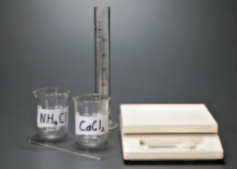

Procedure
1. Read and complete the lab safety form.
2. Measure 10 g of ammonium chloride (NH₄Cl) using a balance and place it in a 100-mL beaker.
3. Measure 30 mL of water with a 50-mL graduated cylinder, and add to the NH₄Cl, stirring with your stirring rod.
4. Feel the bottom of the beaker and record your observations.
5. Repeat Steps 2–4 using calcium chloride (CaC l₂).
6. Dispose of the solutions by flushing them down a drain with water.

Analysis
1. Compare Which dissolving process is exothermic, and which is endothermic?
2. Infer What are everyday applications for dissolving processes that are exothermic? Endothermic?

Inquiry
If you wanted a greater temperature change, would you add more solute or more solvent? Explain.
CHEMISTRY 2022-23 PRACTICE PROBLEM
CHAPTER 14 – Mixtures and Solutions
Practice Problems 14.1 – Calculate Percent by Mass
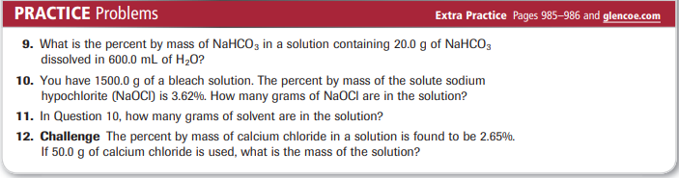

Practice Problems 14.1 – Calculate Percent by Volume
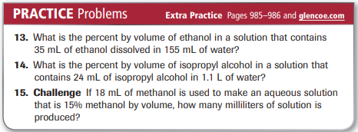

Practice Problems 14.2 – Calculating Molarity
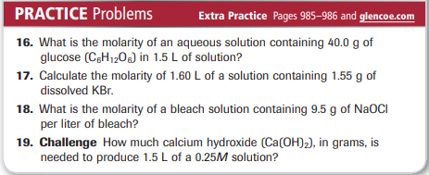

Practice Problems 14.2 – Preparing Molar Solutions
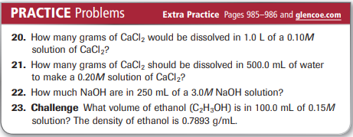

Practice Problems 14.3 – Diluting Stock Solutions
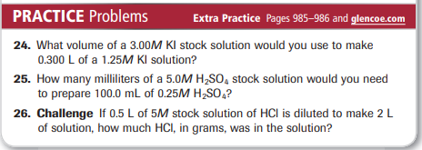

Practice Problems 14.4 – Calculating Molality
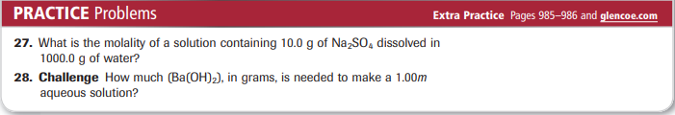

Practice Problems 14.4 – Calculating Mole Fraction
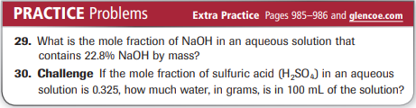

Practice Problems 14.5 – Henry’s Law
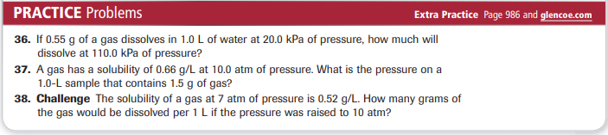

Practice Problems 14.6 – Changes in Boiling and Freezing Points
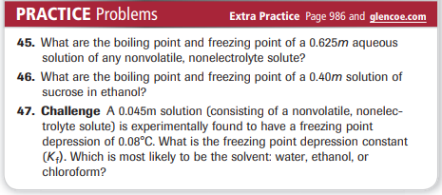
CHEMISTRY 2022-23 MINI LAB 14

CHAPTER 14 MINI LAB – Examine Freezing Point Depression
How do you measure freezing point depression?

Procedure
1. Read and complete the lab safety form.
2. Fill two 400-mL beakers with crushed ice. Add 50 mL of cold tap water to each beaker.
3. Measure the temperature of each beaker using a nonmercury thermometer.
4. Stir the contents of each beaker with a stirring rod until both beakers are at a constant temperature—approximately 1 min. Record the temperature.
5. Add 75 g of rock salt (NaCl) to one of the beakers. Continue stirring both beakers. Some of the salt will dissolve.
6. When the temperature in each beaker is constant, record the final readings.
7. To clean up, flush the contents of each beaker down the drain with excess water.

Analysis
1. Compare your readings taken for the ice water and the salt water. How do you explain the observed temperature change?
2. Explain why salt was added to only one of the beakers.
3. Explain Salt is a strong electrolyte that produces two ions, N a + and C l -, when it dissociates in water. Explain why this is important to consider when calculating the colligative property of freezing point depression.
4. Predict whether it would be better to use coarse rock salt or fine table salt when making homemade ice cream. Explain.

