CHEMISTRY 2022-23 August 31, 2022

Today’s Agenda (Day 11)

- HOUSEKEEPING ITEMS

- Homework Check:
Practice Problems 2.1 – 2.2
Ch 2 Vocabulary

- Class Activity:
DAY 2: Chapter 2 PPT Review
- Section 2.1 – Units and Measurements
- Section 2.2 – Scientific Notation & Dimensional Analysis
- Section 2.3 – Uncertainty in Data
- Section 2.4 – Representing Data
LAB: Lab Techniques and Lab Safety / Liquid Layers
FRIDAY: Lab –Density / Effective Use of a Bunsen Burner
HOMEWORK:
- READ: Chapter 2 – Analyzing Data
- COMPLETE: Chapter 2 Vocabulary (abridged template)
- STUDY: Chapter 1 and 2 Vocabulary, Lab Safety, Chapter 2

CHAPTER 1
Applied research | Chemistry | Conclusion | Control | Dependent variable | experiment
Hypothesis | Independent variable | Mass | Model | Pure research | Qualitative data
Quantitative data | Scientific law | Substance | Theory | Weight

CHAPTER 2
Accuracy | base unit | conversion factor | density | derived unit | dimensional analysis
Error | Graph | Kelvin | Kilogram | Liter | Meter
percent error | Precision | scientific notation | Second | significant figure

REMINDERS:
- Ch 2 Vocabulary – Aug. 30
- Practice Problems 2.2 – 2.3 – Aug. 31
- TEST: Ch 1 Aug. 30
- QUIZ: Ch 1 & 2 Vocabulary AND Lab Safety Sept. 1
- TEST: Ch 2 Sept. 6
- Lab 1.1 AND Ch 2 Launch Lab – Sept. 5

CHEMISTRY 2022-23 PRACTICE PROBLEMS

CHAPTER 2 – Analyzing Data
Practice Problems 2.2 – Dimensional Analysis: Writing Conversion Factors
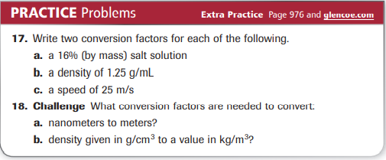
Practice Problems 2.2 – Dimensional Analysis: Using Conversion Factors
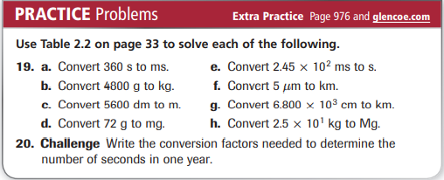
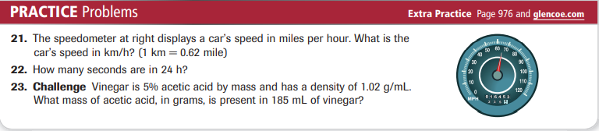
Practice Problems 2.3 – Calculating Percent Error
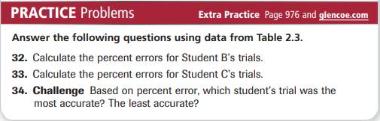
Practice Problems 2.3 – Significant Figures
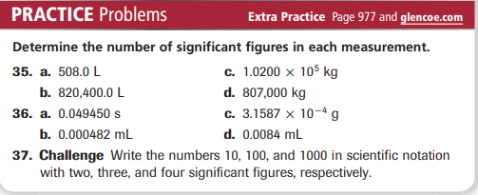
Practice Problems 2.3 – Rounding Numbers
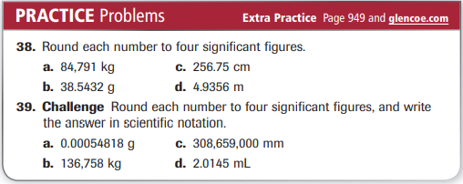
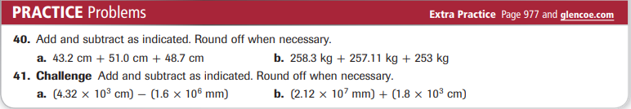
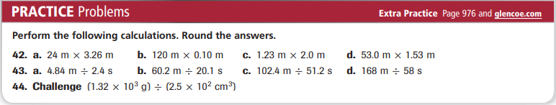
CHEMISTRY 2022-23 LAB ACTIVITY

LAB 1.1 – Laboratory Techniques & Lab Safety
Chemistry has been developed largely through experimentation. Chemistry courses use laboratory experiences to demonstrate, clarify, and develop principles of chemistry. Behavior in the laboratory is more structured than in the classroom. Certain rules of conduct pertaining to safety and keeping a clean work environment must be followed at all times. You must also adopt correct procedures for using glassware and other pieces of equipment. General safety rules are summarized at the beginning of this lab manual. However, there often will be more specific safety rules or special procedures to follow when performing an experiment. Your teacher will provide these added instructions before you perform any lab activity. If you are unsure of any procedure, always ask your teacher before proceeding. In this activity, you will practice some laboratory techniques and apply laboratory safety rules. You will determine the mass of different solid materials, measure the volume of a liquid, and separate mixtures of chemicals. You will also review specific safety rules.
Problem
How can the mass of an object be measured? How can the volume of a liquid be measured? How can a mixture be separated?
Objectives
• Measure the mass of solid substances.
• Measure a volume of water.
• Separate components of a mixture through filtration.
Materials

table salt
sand
distilled water
100-mL graduated cylinder
250-mL beakers
(2) 50-mL beakers
(2) balance ring stand
Ring
funnel
scoops
(2) stirring rod
filter paper
weighing paper
water bottle
watch glass

Safety Precautions
• Always wear safety goggles and a lab apron.
• Never eat or taste any substance used in the lab.
Pre-Lab
1. What is the safety rule concerning working alone in the laboratory?
2. What is the safety rule concerning the handling of excess chemicals?
3. What should you do if you spill a chemical?
4. Read the entire laboratory activity. Hypothesize what safety precautions will be needed to handle the different chemicals and lab equipment in this experiment. Record your hypothesis on page 3.
Procedure
1. Using a scoop, transfer a small amount of table salt to a 50-mL beaker.
2. Measure the mass of a piece of weighing paper to 0.1 g using a laboratory balance. Record this mass in Data Table 1.
3. Add about 5.0 g of table salt from the 50-mL beaker to the weighing paper. Record the mass of the weighing paper and table salt to 0.1 g in Data Table 1.
4. Transfer the table salt to the 250-mL beaker and place all excess table salt into an appropriate waste container, as indicated by your teacher.
5. Using another scoop, transfer a small amount of sand to the second 50-mL beaker. Using the techniques described in steps 2 and 3, measure out about 5.0 g of sand. Then transfer the sand to the 250-mL beaker containing the table salt.
6. Using a 100-mL graduated cylinder, measure out 80 mL of distilled water. Measure the volume of the water to 0.1 mL by reading at the bottom of the meniscus, as illustrated in Figure A. Record the volume of water measured in Data Table 1.
7. Pour the water into the 250-mL beaker containing the table salt and sand. Using the stirring rod, gently stir the mixture for 1 minute. Record your observations in Data Table 2.
8. Place a clean 250-mL beaker on the base of the ring stand. Attach the ring to the ring stand and set the funnel in the ring so that the stem of the funnel is in the beaker. Adjust the height of the ring so that the bottom of the funnel stem is approximately halfway up the beaker. Fold a piece of filter paper as illustrated in Figure B. Place the folded filter cone in the funnel.
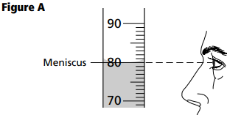
9. To avoid splashing and to maintain control, you will pour the liquid down a stirring rod. Place the stirring rod across the top of the 250-mL beaker that contains the mixture, as shown in Figure B. The stirring rod should rest in the spout and extend several inches beyond the spout. Grasp the beaker with your hand and place your index finger over the stirring rod to keep it in place. Slowly pour the contents of the beaker into the filter cone, allowing the liquid to pass through the filter paper and collect in the beaker.
10. While holding the beaker at an angle, use the water bottle to rinse the beaker and wash any remaining solid from the beaker into the filter cone. Record your observations in Data Table 2.
11. Allow the filter cone to drain. Then remove the filter cone and carefully unfold the filter paper. Place the filter paper on a watch glass and record your observations in Data Table 2.
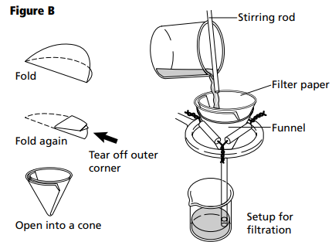
Hypothesis
?
Data and Observations
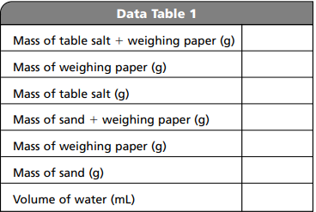
• To find the “Mass of table salt,” subtract the “Mass of weighing paper” from the “Mass of table salt + weighing paper.”
• To find the “Mass of sand,” subtract the “Mass of weighing paper” from the “Mass of sand + weighing paper.”
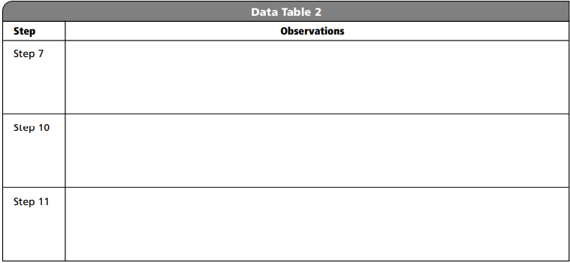
Cleanup and Disposal
1. Place all chemicals in the appropriately labeled waste container.
2. Return all lab equipment to its proper place.
3. Clean up your work area

Analyze and Conclude
1. Observing and Inferring Why were the excess reagents not put back into the original reagent bottle?
2. Comparing and Contrasting What differences were observed between the mixture of salt and sand in the 250-mL beaker and the same materials after the water was added?
3. Drawing a Conclusion Why were the samples of table salt and sand placed into 50-mL beakers prior to weighing?
4. Thinking Critically
a. If one of the pieces of glassware is dropped and breaks, why is it necessary to clean up the broken glass immediately?
b. If one of the pieces of broken glass is dropped and breaks, why is it necessary to tell the teacher immediately?
5. Thinking Critically Why is it necessary to wear safety goggles and a lab apron while performing experiments in the lab?
6. Error Analysis What are some possible sources of error in this activity?

Real-World Chemistry
1. Why is eating, drinking, or chewing gum not allowed in a laboratory?
2. Why must you always wash your hands after working in a laboratory?
3. Why do you never work alone in a chemical laboratory?

CHEMISTRY 2022-23 LAB ACTIVITY

CHAPTER 2 – Launch Lab
How can you form layers of liquids?
You know that ice floats in water, whereas a rock sinks. Not surprisingly, water and other liquids sometimes form distinct layers when poured together.
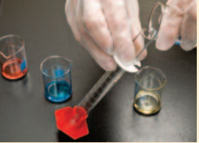
Procedure
1. Read and complete the lab safety form.
2. Observe 5-mL samples of alcohol (dyed red), glycerol (dyed blue), corn oil, and water. Plan the order in which to add the liquids to a graduated cylinder to form four layers. WARNING: Keep alcohol away from open flames.
3. Test your plan by adding the liquids, one at a time, to the graduated cylinder. When adding each liquid, tilt the graduated cylinder, and slowly pour the liquid so it runs down the inside. When adding the glycerol, allow it to settle before adding the next liquid.
4. Did the liquids form four distinct layers? If not, rinse out the graduated cylinder and repeat Steps 2 and 3 using a different order.
Analysis
1. Identify the order, from top to bottom, of the layers in the graduated cylinder.
2. Hypothesize what property of the liquids is responsible for the arrangement of the layers.
Inquiry
What do you think would happen if small pieces of metal, plastic, and wood were added to the layers of liquids in the graduated cylinder?

