CHEMISTRY 2022-23 February 2, 2023

Today’s Agenda (Day 101)

- HOUSEKEEPING ITEMS
BRING: balloons, ice, paper towel cardboard roll, popcorn
- Homework Check:
Chapter 13 & 14 Vocabulary

- Class Activity:
FRIDAY: LAUNCH LAB: Effect of Temperature on Volume of a Gas
CHEM LAB: Pressure of Popcorn

DAY 3: Chapter 13 PPT Review
- Section 13.2 – The Ideal Gas Law
- Section 13.3 – Gas Stoichiometry

HOMEWORK:
- READ: Chapter 13 - Gases
- COMPLETE:
- STUDY: Ch 13 Test

Chapter 13 Vocabulary
absolute zero | Avogadro's principle | Boyle's law | Charles's law | combined gas law | Gay-Lussac's law | ideal gas constant
ideal gas law | molar volume

Chapter 14 Vocabulary
boiling point elevation | Brownian motion | colligative property | Colloid | Concentration | freezing point depression | heat of solution
Henry's law | Immiscible | Insoluble | Miscible | Molality | Molarity | mole fraction
Osmosis | osmotic pressure | saturated solution | Solvation | supersaturated solution | unsaturated solution | vapor pressure lowering

REMINDERS:
- TEST: Ch 13 Feb. 7

CHEMISTRY 2022-23 LAUNCH LAB

CHAPTER 13 LAUNCH LAB – How Does Temperature Affect the Volume of a Gas

In the hot-air balloon at left, the burners raise the temperature of the air inside the balloon to keep it aloft. 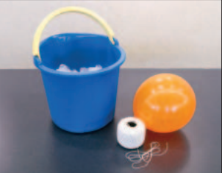

Procedure
1. Read and complete the lab safety form.
2. Inflate a round balloon, and tie it closed.
3. Pour cold water into a bucket until it is half full, then add ice. Use paper towels to wipe up any spilled water. 4. Use string to measure the circumference of the balloon.
5. Use a stirring rod to stir the water in the bucket to equalize the temperature. Submerge the balloon in the ice water for 15 min.
6. Remove the balloon from the water. Measure the circumference again.

Analysis
1. Describe what happened to the size of the balloon when its temperature decreased.
2. Predict what might happen to the balloon’s size if the bucket contained warm water.

Inquiry
What do you think would happen if you filled the balloon with helium instead of air and repeated the experiment?

CHEMISTRY 2022-23 MINI LAB

CHAPTER 13 MINI LAB – Model a Fire Extinguisher
Why is carbon dioxide used in fire extinguishers?

Procedure
1. Read and complete the lab safety form.
2. Measure the temperature with a thermometer. Obtain the air pressure with a barometer or weather radio. Record your data.
3. Roll a 23-cm × 30-cm piece of aluminum foil into a cylinder that is 30 cm long and roughly 6 cm in diameter. Tape the edges with masking tape.
4. Use matches to light a candle.
WARNING: Run water over the extinguished match before throwing it away. Keep hair and clothing away from the flame.
5. Place 30 g of baking soda (NaHCO₃) in a large beaker. Add 40 mL of vinegar (5% CH₃COOH).
6. Quickly position the foil cylinder at about 45° up and away from the top of the candle flame.
WARNING: Do not touch the end of the aluminum tube that is near the burning candle.
7. While the reaction in the beaker is actively producing carbon dioxide gas, carefully pour the gas, but not the liquid, out of the beaker and into the top of the foil tube. Record your observations.

Analysis
1. Apply Calculate the molar volume of carbon dioxide gas (CO₂) at room temperature and atmospheric pressure.
2. Calculate the room-temperature densities in grams per liter of carbon dioxide, oxygen, and nitrogen gases. Recall that you will need to calculate the molar mass of each gas in order to calculate densities.
3. Interpret Do your observations and calculations support the use of carbon dioxide gas to extinguish fires? Explain
CHEMISTRY 2022-23 PRACTICE PROBLEM
CHAPTER 13 – Gases
Practice Problems 13.1 – Boyle’s Law
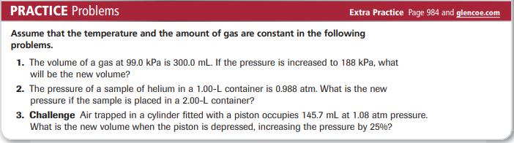

Problem-Solving Lab: Apply Scientific Explanations
What does Boyle’s law have to do with breathing? You take a breath about 20 times per minute, exchanging carbon dioxide gas for life-sustaining oxygen. How do pressure and volume change in your lungs as you breathe?
Analysis
The spongy, elastic tissue that makes up your lungs allows them to expand and contract in response to movement of the diaphragm, a strong muscle beneath the lungs. As your diaphragm moves downward, increasing lung volume, you inhale. As your diaphragm moves upward, decreasing lung volume, you exhale.
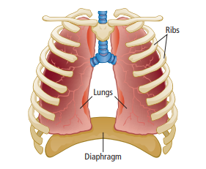
Think Critically
1. Apply Boyle’s law to explain why air enters your lungs when you inhale and leaves when you exhale.
2. Explain what happens inside the lungs when a blow to the abdomen knocks the wind out of a person. Use Boyle’s law to determine your answer.
3. Infer Parts of the lungs lose elasticity and become enlarged when a person has emphysema. From what you know about Boyle’s law, why does this condition affect breathing?
4. Explain why beginning scuba divers are taught never to hold their breath while ascending from deep water.

Practice Problems 13.2 – Charles’ Law
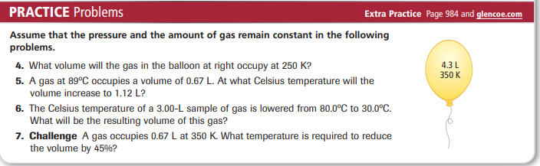

Practice Problems 13.3 – Gay-Lussac’s Law
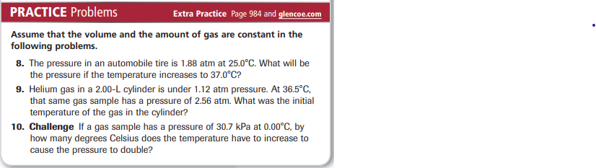

Practice Problems 13.4 – Combined Gas Law
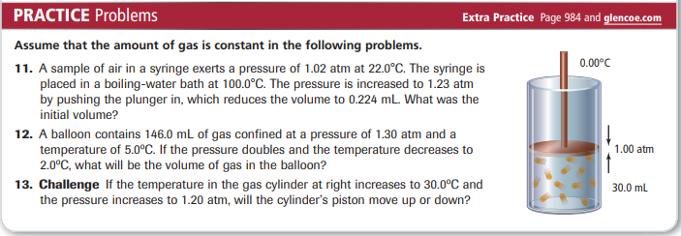

Practice Problems 13.5 – Molar Volume
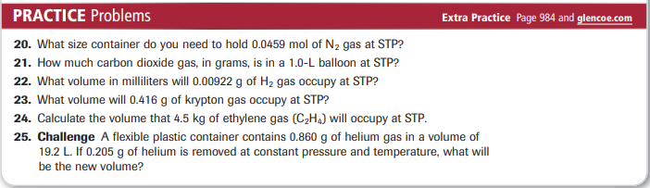
Practice Problems 13.6 – Ideal Gas Law
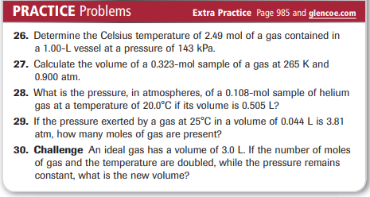
Practice Problems 13.7 – Volume-Volume Problems
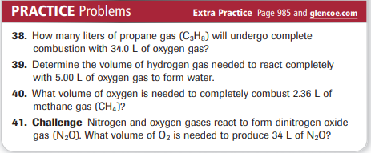
Practice Problems 13.8 – Volume-Mass Problems
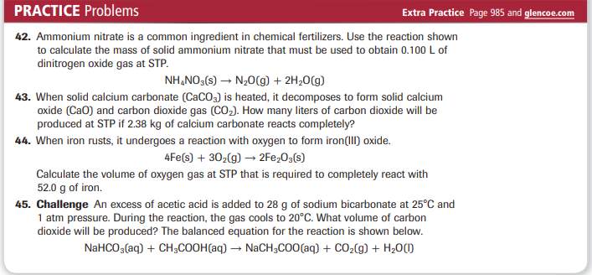

CHEMISTRY 2022-23 CHEM LAB 13

