CHEMISTRY 2022-23 August 30, 2022

Today’s Agenda (Day 10)

- HOUSEKEEPING ITEMS

- Homework Check:
Practice Problems 2.1 – 2.2
Ch 2 Vocabulary

- Class Activity:
TEST: Chapter 1
*Go to www.socrative.com enter room “MSBCHEMISTRY” enter ID #

WEDNESDAY: Chapter 2 PPT Review
- Section 2.1 – Units and Measurements
- Section 2.2 – Scientific Notation & Dimensional Analysis
- Section 2.3 – Uncertainty in Data
- Section 2.4 – Representing Data
WEDNESDAY: Lab – Lab Techniques and Lab Safety / Effective Use of a Bunsen Burner
FRIDAY: Lab – Liquid Layers and Density
HOMEWORK:
- READ: Chapter 2 – Analyzing Data
- COMPLETE: Chapter 2 Vocabulary (abridged template)
- STUDY: Chapter 1 and 2 Vocabulary, Lab Safety, Chapter 2

CHAPTER 1
Applied research | Chemistry | Conclusion | Control | Dependent variable | experiment
Hypothesis | Independent variable | Mass | Model | Pure research | Qualitative data
Quantitative data | Scientific law | Substance | Theory | Weight

CHAPTER 2
Accuracy | base unit | conversion factor | density | derived unit | dimensional analysis
Error | Graph | Kelvin | Kilogram | Liter | Meter
percent error | Precision | scientific notation | Second | significant figure

REMINDERS:
- Ch 2 Vocabulary – Aug. 30
- Practice Problems 2.2 – 2.3 – Aug. 31
- TEST: Ch 1 Aug. 30
- QUIZ: Ch 1 & 2 Vocabulary AND Lab Safety Sept. 1
- TEST: Ch 2 Sept. 6

CHEMISTRY 2022-23 PRACTICE PROBLEMS

CHAPTER 2 – Analyzing Data
Practice Problems 2.2 – Dimensional Analysis: Writing Conversion Factors
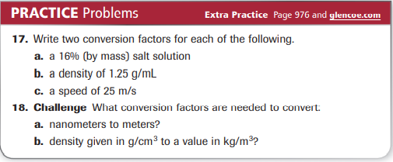
Practice Problems 2.2 – Dimensional Analysis: Using Conversion Factors
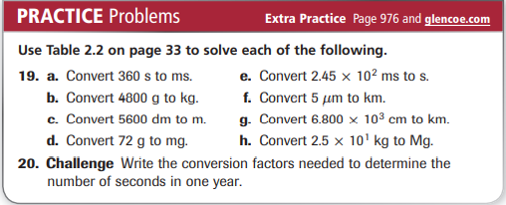
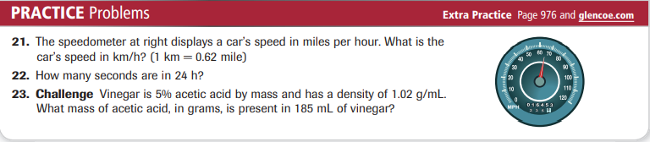
Practice Problems 2.3 – Calculating Percent Error
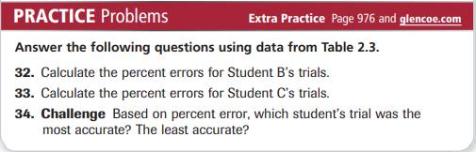
Practice Problems 2.3 – Significant Figures
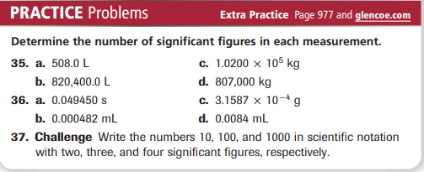
Practice Problems 2.3 – Rounding Numbers
