Chapter 49: Nervous Systems

Concept 49.1 Nervous systems consist of circuits of neurons and supporting cells

- This concept begins with a look at the evolution of nervous systems. You will want to study this to tie in with your study of animal diversity. To master this concept, you will need to be solid in the vocabulary that is used here. Begin by defining these terms:

nerve net
nerve
cephalization
ganglia
- For the animals sketched below, give the common name of the organism and its phylum. Also note the important features of its nervous system.

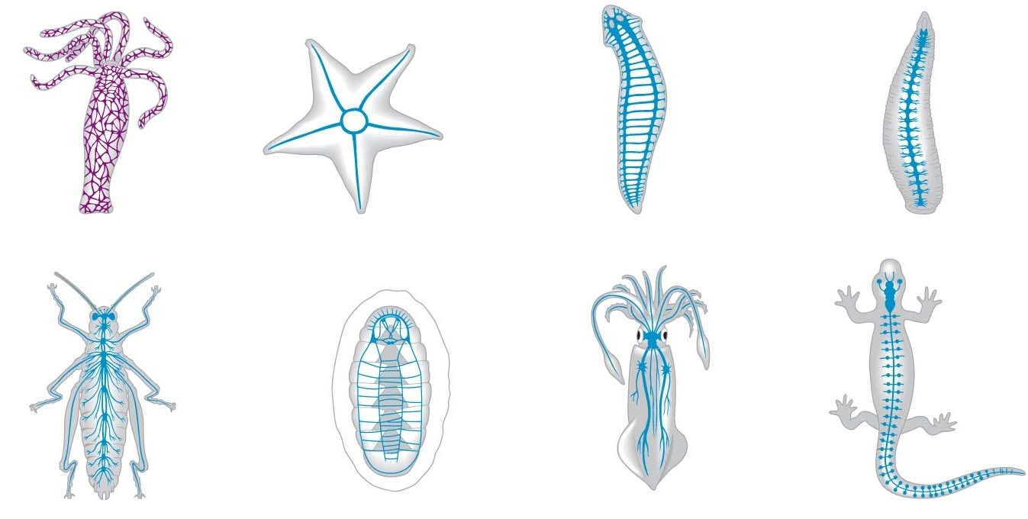

- Which phylum has a nerve net? ______________ is the first phylum to show cephalization?
__________ has a ventral nerve cord? ____________ a dorsal nerve cord?
_______________________
- What are the two components of the central nervous system?

- A reflex is the body’s automatic response to certain stimuli. Give two examples of reflex responses.

- A reflex arc is illustrated and explained in Figure 49.3. It is important for you to understand this pathway, so take some time with the figure below. Label the following: stimulus, receptors (sensors), sensory neuron, interneuron, spinal cord, gray matter, white matter, motor neuron, effector (muscle).

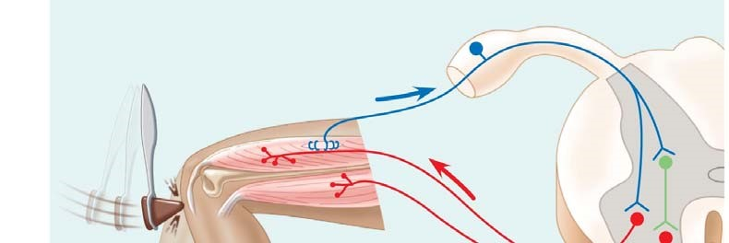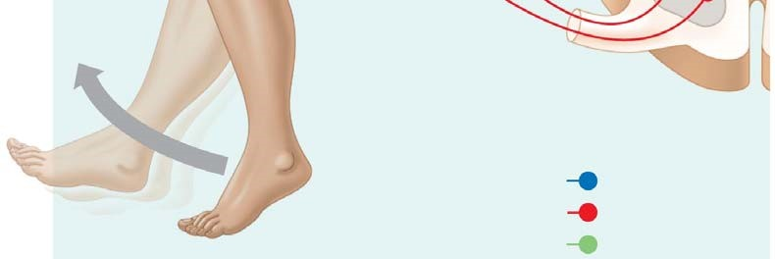

- What is the function of cerebrospinal fluid in mammals? Where is it found?

- Distinguish between white matter and gray matter.

- Neurons conduct nerve impulses. What are the specialized support cells that have other functions, including myelination, structural support, and protection?

- What makes up the peripheral nervous system (PNS)? What is the function of the PNS?

- Go back to the figure in question 6, and correctly label the afferent and efferent neurons.

- Figure 49.7 shows the branches of the peripheral nervous system. Label these branches. Which branch is sometimes called the “voluntary nervous system”? Which one is often termed “involuntary?” Include these terms on the diagram below.
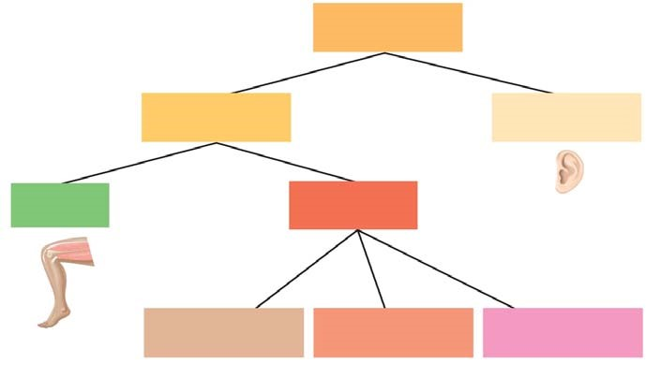

- What would be the effect of stimulation by the sympathetic nervous system on heart rate?

What would be the effect of stimulation by the parasympathetic nervous system on peristalsis?

- Concept Check Question 1 in your text asks: Which division of your autonomic nervous system would likely be activated if you learned that an exam you had forgotten about would start in 5 minutes? Explain your answer.

- Now, take the question above a step further, and describe the specific physiological responses that would occur.
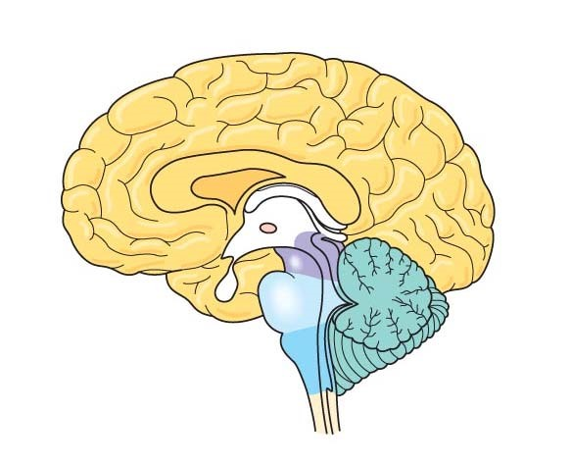
- Label the following structures on the figure of the brain, and give a primary function of each labeled structure. brainstem (includes pons, medulla)
cerebrum
cerebellum
thalamus
hypothalamus
- Label the pituitary gland on this figure.

Concept 49.3 The cerebral cortex controls voluntary movement and cognitive functions
18. On the brain figure, use a colored pencil to sketch in the four lobes of the cortex. Describe a function centered in each lobe.

