BIOLOGY 2022-23 January 23, 2023

Today’s Agenda (Day 93)

- HOUSEKEEPING ITEMS

- Homework Check:

- Class Activity:
Day 15: Science Fair
*Finalize Experimental Setup – Gather all materials, prepare all supporting apparatus
*Begin Day 1 of your experiment – AFTER approval by teacher!

Day 5: Chapter 12 PPT Review
- Section 12.3 – DNA, RNA, and Protein
- Section 12.4 – Gene Regulation and Protein

HOMEWORK:
- READ: Chapter 12 – Molecular Genetics
- COMPLETE: Chapter 12 Reading Guide Questions
- STUDY: Chapter 12 Test
REMINDERS:

- TEST: Ch 12 Tuesday, Jan. 24

CHAPTER 12 VOCABULARY
Codon | DNA polymerase | Double helix | Gene regulation | Intron
Exon | Messenger RNA | Mutagen | Mutation | Nucleosome
Okazaki fragment | Operon | Ribosomal RNA | RNA | RNA polymerase
Semiconservative replication | Transcription | Transfer RNA | translation

CHAPTER 13 VOCABULARY
Bioinformatics | Cloning | DNA fingerprinting | DNA ligase | DNA microarray
Gel electrophoresis | Gene therapy | Genetic engineering | Genome | Genomics
Haplotype | Inbreeding | Pharmacogenomics | Plasmid | Polymerase chain reaction
Proteomics | Recombinant DNA | Restriction enzyme | Selective breeding | Single nucleotide polymorphism
Test cross | Transformation | Transgenic organism

Chapter 14 – The History of Life

Cambrian explosion | Endosymbiont theory | Eon | Epoch | Era | Fossil
Geologic time scale | Half-life | K-T boundary | Law of superposition | Paleontologist | Period
Plate tectonics | Radiometric dating | Relative dating | Spontaneous generation | Theory of biogenesis

Chapter 15 – Evolution

Adaptive radiation | Allopatric speciation | Analogous structure | Ancestral trait | Artificial selection | Biogeography
Bottleneck | Camouflage | Derived trait | Directional selection | Disruptive selection | Embryo
Evolution | Fitness | Founder effect | Genetic drift | Gradualism | Hardy-Weinberg principle
Homologous structure | Mimicry | Natural selection | Post-zygotic isolating mechanism | Pre-zygotic isolating mechanism | Punctuated equilibrium
Sexual selection | Stabilizing selection | Sympatric speciation | Vestigial structure

BIOLOGY 2022-23 READING GUIDE

Chapter 12 Molecular Genetics Reading Guide

DIRECTIONS: Refer to your textbook to respond to the following questions.
- Describe Frederick Griffith’s experiment shown below.
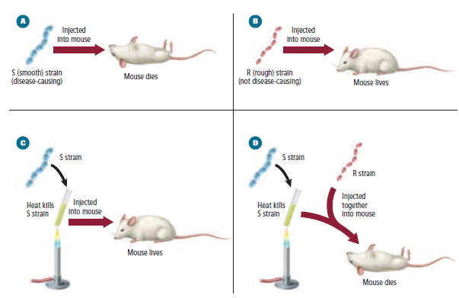
- How did Oswald Avery identify the molecule that transformed the R strain of bacteria into the S strain?
- Describe how Hershey and Chase definitively proved DNA was the transforming factor.
- List the three parts of a DNA nucleotide.
- Label the parts of the nucleotide below.
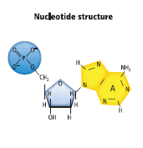
- Name and draw DNA’s two purines.
- Name and draw DNA’s two pyrimidines.
- What is the most obvious difference between your drawings in number 6 and 7 above?
- List three important features of Watson and Crick’s proposed DNA molecule.
- Draw a DNA double helix and label the sugar, phosphate, and nitrogen bases.
- Describe the orientation (direction) of the two strands in a DNA molecule.
- How do nucleosomes form?
- What is semiconservative replication? What are the three main stages of this type of replication?
- Describe the 3 main events during the unwinding stage of replication.
- What is the role of DNA polymerase in replication?
- Explain why DNA replication is more complex in eukaryotes than bacteria.
- Describe the function of each of the following in protein synthesis: rRNA, mRNA, and tRNA
- What happens during transcription?
- Why is mRNA so much shorter than the DNA it is made from?
- Differentiate between codons and anticodons.
- What happens during translation?
- Why has Beadle and Tatum’s “one gene, one enzyme” hypothesis been modified since they presented it in the 1940s.
- What are the three parts of an operon?
- Describe AND give an example of three types of DNA mutations.
- Why do you think most mutations in eukaryotes are recessive?

BIOLOGY 2022-23 READING GUIDE
Chapter 13 Genetics & Biotechnology

DIRECTIONS: Refer to your textbook to respond to the following questions.

- Describe how genetic engineering was used in regards to GFP.
- What is a genome?
- What are restriction enzymes used for?
- In gel electrophoresis, why is an electric current necessary?
- How is the pattern created by gel electrophoresis achieved?
- How is recombinant DNA produced?
- Explain the process of transformation.
- Why is DNA sequencing useful to scientists?
- What is polymerase chain reaction (PCR) used for?
- Describe the three main steps involved in PCR.
- How are transgenic organisms created?
- What was the goal of the Human Genome Project?
- How was one continuous human genome sequenced?
- The protein coding regions of DNA are virtually identical in all humans. How does DNA fingerprinting distinguish between people?
- What is the amino acid sequence of a start codon? The 3 stop codons?
- What is a SNP?
- What must be true for a variation to be considered a SNP?
- Describe the HapMap Project.
- List three disease of how gene therapy may someday be used to cure them.
- Compare and contrast genomics and proteomics.

