BIOLOGY 2022-23 January 6, 2023

Today’s Agenda (Day 82)

- HOUSEKEEPING ITEMS

- Homework Check:

- Class Activity:
Day 4: Science Fair
*Begin literature review – Make a list of topic headings and subheadings that will help you and the reader to know what your project and experimental design/prototype is about.
*Begin and provide the "Reference" Page that cites the prospective resources/websites you will/may be using to learn about your topic and to create your literature review.

DAY 2: Chapter 11 PPT Review
- Section 11.1 – Basic Patterns of Human Inheritance
- Section 11.2 – Complex Patterns of Inheritance
- Section 11.3 – Chromosomes and Human Heredity

HOMEWORK:
- READ: Chapter 11 – Complex Inheritance and Human Heredity
- COMPLETE: Chapter 11 Vocabulary and Reading Guide Questions
- STUDY: Chapter 11 Vocabulary Quiz & Test
CHAPTER 11 VOCABULARY
Autosome | Carrier | Codominance | Epistasis | Incomplete dominance
Karyotype | Multiple alleles | Nondisjunction | Pedigree | Polygenic trait
Sex chromosome | Sex-linked trait | telomere
CHAPTER 12 VOCABULARY
Codon | DNA polymerase | Double helix | Gene regulation | Intron
Exon | Messenger RNA | Mutagen | Mutation | Nucleosome
Okazaki fragment | Operon | Ribosomal RNA | RNA | RNA polymerase
Semiconservative replication | Transcription | Transfer RNA | translation

REMINDERS:

- Chapter 11 Vocabulary - Jan. 8
- Chapter 11 Reading Guide – Jan. 10
- QUIZ: Ch 11 Vocabulary Tue, Jan. 10
- TEST: Ch 11 Thursday, Jan. 12

BIOLOGY 2022-23 January 4, 2023

Chapter 11 Human Heredity Reading Guide
Review pages 296 - 315 in the Glencoe Science Biology Textbook and answer the following questions.
- What is a carrier? What is the genotype of a carrier?
- Describe what each symbol represents in the pedigree below:
- How is it possible that one of the children in the following pedigree expresses Tay-Sachs?
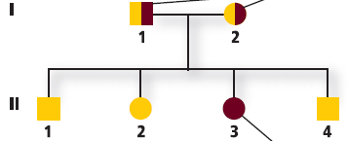
- How can pedigrees be used to infer genotypes?
- Can two parents with albinism (a recessive genetic disorder) have an unaffected child? Explain.
- What is incomplete dominance? Give an example.
- This shows the crossing of snapdragons. What is the phenotypic ratio for this incomplete dominant cross?
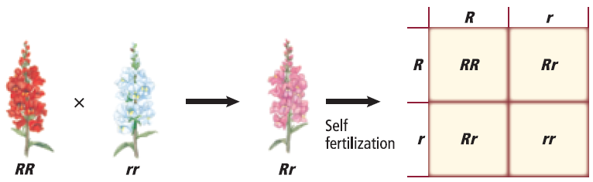
- How does codominance differ from incomplete dominance?
- Explain how coat color in rabbits is inherited.
- What are the two types of sex chromosomes? What is the genotype of a male? Female?
- What does the condition shown here cause in cats?
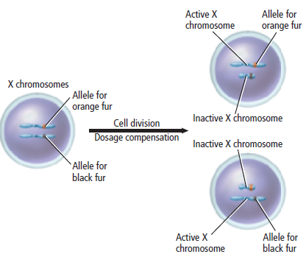
- Why are males more likely to be affected by sex-linked traits?
- Study this Punnett square. Why does the father not have color blindness?
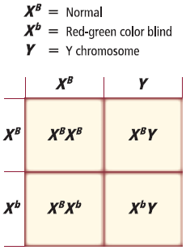
- How can the environment affect phenotype?
- How is a karyotype prepared?
- What are telomeres? What may telomeres be involved with?
- Describe what happens during nondisjunction.
- Why is down syndrome called trisomy 21?
- What can parents do if they are unsure if they are a carrier for a genetic disease?
- Describe the risks and benefits for two types of fetal testing.

SCIENCE FAIR 2023 OUTLINE - Updated

- WHAT IS THE SITUATION/PHENOMENON/PROBLEM THAT YOU WOULD LIKE TO INVESTIGATE?

- WHO ARE YOUR PARTNERS? (Maximum 3 per team)

- WHAT CATEGORY WOULD IT FALL UNDER: (Circle the appropriate category.)

Technical Environment Science

- WHAT IS YOUR HYPOTHESIS OR MODEL YOU WILL BE INVESTIGATING/CREATING?

- STATE THE FOLLOWING:
- Independent Variable

- Dependent Variable

- Control Variable(s)

- Operational Definition(s)

- Prototype (if doing TECHNICAL)

- DESCRIBE BRIEFLY WHAT YOU WANT TO DO, WHY YOU WANT TO EXPLORE THIS TOPIC, AND WHAT IS THE SIGNIFICANCE TO EITHER SXM OR GLOBALLY?

- LIST THE MATERIALS YOU WILL/EXPECT TO NEED:

- OUTLINE THE PROCEDURES FOR THIS INVESTIGATION/MODEL CREATION:

- YOU WILL BE EXPECTED TO CONDUCT A LITERATURE REVIEW OF YOUR TOPIC. PROVIDE A LIST OF KEYWORDS/QUESTIONS THAT YOU WILL TYPE INTO THE SEARCH ENGINE TO RESEARCH YOUR TOPIC.

- BRIEFLY DESCRIBE WHAT YOU WILL BE THE FOCUS FOR EACH OF THE FOLLOWING WEEKS:
- Week 1

- Week 2

- Week 3

- Week 4

- Week 5

- Week 6

