BIOLOGY 2022-23 November 22, 2022

Today’s Agenda (Day 58)

- HOUSEKEEPING ITEMS

- Homework Check:
Mini-Lab 7.2 – Investigate Osmosis

- Class Activity:
TEST: Ch 8
*Go to www.socrative.com enter room “MSBBIOLOGY” enter ID #

MONDAY: DAY 2: Chapter 9 PPT Review
- Section 9.1 – Cellular growth
- Section 9.2 – Mitosis and cytokinesis
- Section 9.3 – Cell cycle regulation

HOMEWORK:
- READ: Chapter 9 – Cellular Reproduction
- COMPLETE: Chapter 9 Vocabulary and Reading Guide Questions
- STUDY: Chapter 8 Test
CHAPTER 9 VOCABULARY
Anaphase | Apoptosis | Cancer carcinogen | Cell cycle | Centromere
Chromatin | Chromosome | Cyclin | Cyclin-dependent kinase | Cytokinesis
Interphase | Metaphase | Mitosis | Prophase | Sister chromatid
Spindle apparatus | Stem cell | Telophase

REMINDERS:

- TEST: Ch 8 Nov. 22 Note change of date!
- Chapter 9 Vocabulary – Nov. 23
- Chapter 9 Reading Guide – Nov. 28
- QUIZ: Ch 9 Vocabulary – Nov. 29
- TEST: Ch 9 Dec. 1
- TEST: Ch 10 Dec. 8
- ? QUIZ: Ch 10 Vocabulary – Dec. 12
- MIDTERM EXAM: Ch 1 - 10

BIOLOGY 2022-23 READING GUIDE

Chapter 9 - Cell Reproduction

DIRECTIONS: Refer to your textbook to respond to the following questions.

- What is the key factor that limits cell size?
- Why is it a major problem for a cell if it gets too big (use surface area and volume in your explanation)?
- What are the benefits to a cell staying small?
- How does the need for signaling proteins in a cell limit cell size?
- When a cell reaches its size limit, what are the only two things a cell can do?
- What happens during interphase?
- What happens during mitosis? What happens during cytokinesis?
- What determines how long the cell cycle takes?
- Describe what happens during G1, S, and G2 stages of interphase.
- How do prokaryotic cells reproduce?
- What is chromatin? What happens to chromatin in prophase?
- Label the chromatids and centromere in the picture below. Describe what both structures do.

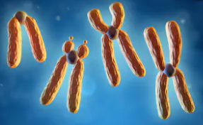
- What is a centriole?
- Label the stages of mitosis shown here.

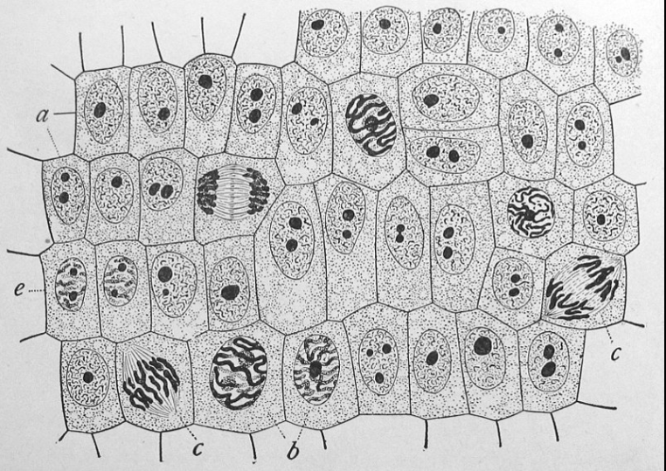

- Describe the main feature of each of the phases of mitosis: prophase, metaphase, anaphase, and telophase.
- Compare and contrast cytokinesis in animal cells and plant cells.
- What monitors a cell’s progress from phase to phase during the cell cycle?
- Explain the different checkpoints that occur during the cell cycle.
- How is cancer related to the cell cycle?
- List three carcinogens.
- Why does the risk of cancer increase with age?
- What is apoptosis? Give an example.
- What is so unique about stem cells?
- Compare and contrast embryonic stem cells and adult stem cells.
- Describe a possible application for stem cells.

