BIOLOGY 2022-23 November 9, 2022

Today’s Agenda (Day 51)

- HOUSEKEEPING ITEMS
BRING for MONDAY: Onions, Iodine
- Homework Check:
Virtual Lab - Introduction to the Microscope
Mini-Lab 7.1 – Discover Cells
Ch 8 Vocabulary
- Class Activity:
THURSDAY: Chapter 7
*Go to www.socrative.com enter room “MSBBIOLOGY” enter ID #

WEDNESDAY: LAB: Mini-Lab 7.2 – Investigate Osmosis
HOMEWORK:
- READ: Chapter 7 – Cell Structure and Function
- READ: Chapter 8 – Cellular Energy
- COMPLETE:
- STUDY: Chapter 7 Test

CHAPTER 8 VOCABULARY
Adenosine triphosphate | Aerobic process | Aerobic respiration | Anaerobic process | Calvin cycle
Cellular respiration | Energy | Fermentation | Glycolysis | Granum
Krebs cycle | Metabolism | NADP+ | Photosynthesis | Pigment
Rubisco | Stroma | Thermodynamics | thylakoid

REMINDERS:

- Mini-Lab 7.1 – Discover Cells – Nov. 9
- Mini-Lab 7.2 – Investigate Osmosis – Nov. 14
- TEST: Ch 7 Nov. 10

BIOLOGY 2022-23 READING GUIDE

Chapter 7 Cellular Structure & Function
Review pages 182 – 207 in the Glencoe Science Biology Textbook and answer the following questions.
- List the three principles of the Cell Theory.
- Describe one strength and one weakness of both a compound light microscope and an electron microscope.
- What is the essential function of the plasma membrane?
- Compare and contrast eukaryotic cells and prokaryotic cells.
- Describe the endosymbiont theory.
- When describing the plasma membrane, selectively permeable and phospholipid bilayer are almost always mentioned. What do these terms mean?
- What are transport proteins used for in the plasma membrane?
- Some scientists consider the role of cytoplasm more vital (important) in prokaryotes rather than eukaryotes. Explain why.
- Draw the eukaryotic cell below and label and define all organelles listed on Table (p199).
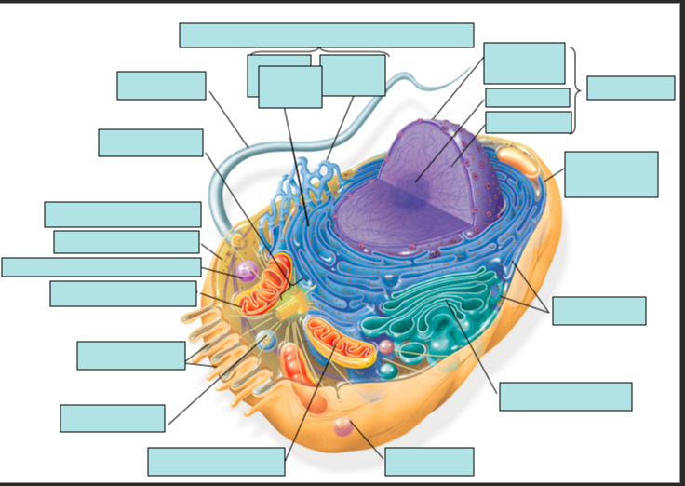
- Would you expect to find more mitochondria in a muscle cell or a skin cell? Explain your answer.
- Plant cells have a cell wall (animal cells don’t), what is its function?
- Describe the process of protein synthesis mentioning all the organelles involved in the process.
- Define diffusion. Give an example.
- What is meant by the term dynamic equilibrium?
- How is facilitated diffusion different from simple diffusion?
- How does osmosis work?
- Define isotonic solution, hypotonic solution, and hypertonic solution.
- Describe how a cell behaves in each of the following: isotonic solution, hypotonic solution, and hypertonic solution.
- Determine which type of solution each red blood cell is in from each of the diagrams below:
A.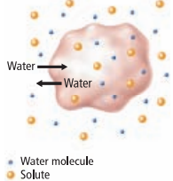 B. 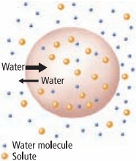 C.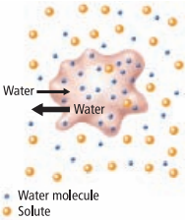

- What is the main difference between active transport and diffusion?
- Compare and contrast exocytosis and endocytosis.

BIOLOGY 2022-23 VIRTUAL LAB

CHAPTER 7 VIRTUAL LAB – Introduction to the Microscope

OVERVIEW In this pre-lab exercise, you will be introduced to the concepts of light microscopy and learn how to safely use compound light microscopes in a lab environment.

LEARNING OBJECTIVES
• Identify the parts of the light microscope and describe the function of each.
• List the steps in focusing a light microscope.
• Describe how to properly handle the light microscope, focus slides, and clean the microscope when finished.

THE MICROSCOPE AND YOUR EYES Students often wonder if they should remove their glasses when using a microscope. If you are nearsighted or farsighted, there is no need to wear your glasses. The focus adjustments will compensate. If you have astigmatism, however, you should wear your glasses because microscope lenses do not correct for this problem.

PROCEDURE 1: Introduction to the Microscope and its Parts
1) Go to http://www.ncbionetwork.org/iet/microscope/.
2) Click on the Guide link (bottom of the home page).
3) Click through the six parts of the Guide, starting with the Introduction. You can use the arrows at the bottom of the Guide box to guide you through the chapters.
4) When you have completed all six sections, click Close.
5) Next click on the Learn link (bottom of the page), which will take you to an image of a microscope with question marks.
6) Starting at the top of the microscope, click on the question mark identifying the part of the microscope.
7) Read the description of the part of the microscope and take notes as needed.
8) Continue clicking on question marks until all turn to green check marks.
a) Do not forget to click on the question marks for items associated with the microscope.
b) You may click on any green check mark to review any part of the microscope.
c) Use the checklist below to ensure all parts have been identified.
9) Click on the Next button (bottom right).
10) Start on the left and click on the question mark. When the lens enlarges, click on each question mark, read the description and take notes as needed. The question mark should turn into a green check mark.
11) Click on the Next button (bottom right).
12) Click on the Dry Slide and Oiled Slide buttons to see the difference in why immersion oil is used for the 100X objective lens.
13) Click on the Next button (bottom right).
14) Click on the Eyepiece Options and Lens Options to learn about calculating total magnification. Try all combinations and see how the Letter E slide image changes.
15) Click on the Next button (bottom right) to return to the home page.
16) Answer the provided questions.

*Be aware! Depending on its age, manufacturer, and cost, in a laboratory a compound microscope may have only some of the features discussed in this section.

MICROSCOPE PARTS Identify all parts of the microscope and associated items.
___ On/ Off switch ___ Eyepiece/ Ocular lens ___ Arm
___ Nosepiece ___ Objective lenses ___ Stage
___ Diaphragm ___ Stage adjustment knob ___ Base
___ Coarse adjustment knob ___ Lens paper ___ Fine adjustment knob ___ Immersion oil ___ Slide/ slide box ___ Kimwipes

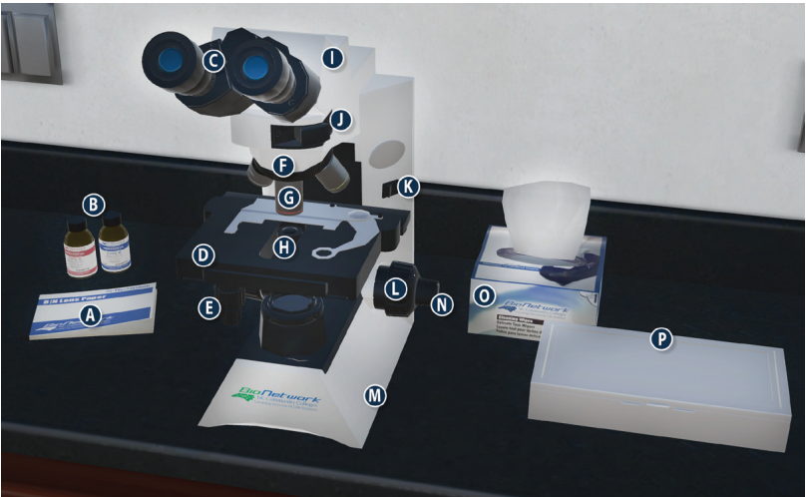

QUESTIONS
1) What is the proper way to carry a microscope?
2) What is the typical magnification of an ocular lens? What other magnifications are possible?
3) What are the magnification abilities of each of the objective lenses?
a) Scanning (small lens), red ring =
b) Low-power (medium lens), yellow ring =
c) High-power (large lens), blue ring =
d) Oil immersion (largest lens), white ring =
4) Why do you use immersion oil with 100X objective lens?
5) What is the total magnification of a sample with an ocular lens power of 15X and using a 40X objective lens?
6) What is a diaphragm? What does it do?

PROCEDURE 2: How to use a compound microscope to view slides
1) Click on the Explore link (bottom of the home page).
2) Click on the question mark on the slide box.
3) In the Slide Catalog, click on the Sample Slides.
4) Click on the Letter E slide. It will automatically be placed on the stage of the microscope.
5) When the Microscope View window opens, make sure that the 4X circle is highlighted in blue.
NOTE: Always begin examining slides with the lowest power objective.
6) Use the slider under Coarse Focus to find the E.
NOTE: The coarse adjustment knob should only be used when you are viewing a specimen with the 4X objective lens.
7) Then use the slider under Fine Focus to make the image “crisp and clear.”
8) You can click on the E in the viewing window to move the image and visualize different parts. Sketch your view of the letter E at 4X in the results area.
9) Next click on the 10X circle. The nosepiece on the microscope will rotate automatically.
10) Repeat steps 6 – 8 to see part of the E. Sketch your view of the letter E at 10X in the results area. 11) Click on the 40X circle and repeat steps 7 & 8. You may need to use the slider under Light Adjustment for better visualization. Sketch your view of the letter E at 40X in the results area.
12) Click on the 100X circle. A notice to add immersion oil will open.
13) Click on the question mark on the immersion oil bottles to add oil to the microscope.
14) Repeat steps 7 & 8. You may need to use the slider under Light Adjustment again for better visualization. Sketch your view of the letter E at 100X in the results area.
15) When you have visualized the Letter E slide using all 4 objective lenses, click on Remove Slide (top right).
16) Read the notice about using lens paper to clean the immersion oil off the microscope and click on the question mark over the lens paper. Choose wisely!
17) Click on the Main button (bottom left corner) to return to the home page.

RESULTS: Sketch the letter “e” at each of the resolutions
QUESTIONS 1) What did you notice about the letter E when you increased in magnification from the 4x to the 10x and then to the 40X:
a) Did the size (magnification) increase or decrease?
b) Could you see more of the entire letter or less?

BIOLOGY 2022-23 MINI LAB

CHAPTER 7.1 MINI LAB – Discover Cells
How can you describe a new discovery? Imagine you are a scientist looking through the eyepiece of some new-fangled instrument called a microscope and you see a field of similarly shaped objects. You might recognize that the shapes you see are not merely coincidence and random objects. Your whole idea of the nature of matter is changing as you view these objects.
PART A – Prepared Slides
Procedure
1. Review the lab safety precautions for this activity.
2. Prepare a data table in which you will record observations and drawings for three slides.
3. View the prepared slides that your teacher provides for your group.
4. Describe and draw what you see. Be sure to include enough detail in your drawings to convey the information to other scientists who have not observed cells.
Analysis
1. Describe What analogies or terms could explain the images in your drawings?
2. Explain How could you show Hooke, with twenty-first-century technology, that his findings were valid?

PART B – Preparing Wet Mounts
Materials
Small cork
Plain glass microscope slide
Slide cover slip
Sharp knife or scalpel
water
1. Carefully cut a very thin slice of cork using a razor blade or sharp knife (the 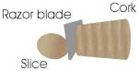thinner the slice, the easier it will be to view with your microscope).
2. To make a wet mount of the cork, put one drop of water in the center of a plain glass slide – the water droplet should be larger than the slice of cork.
3. Gently set the slice of cork on top of the drop of water (tweezers might be helpful for this). If you are not able to cut a thin enough slice of the whole diameter of the cork, a smaller section will work.
4. Take one cover slip and hold it at an angle to the slide so that one edge of it touches the water droplet on the surface of the slide.
5. Then, being careful not to move the cork around, lower the cover slip without trapping any air bubbles beneath it.
6. The water should form a seal around the cork. Use the corner of a paper towel to blot up any excess water at the edges of the coverslip.
7. To keep the slide from drying out, you can make a seal of petroleum jelly around the cover slip with a toothpick.
8. Begin with the lowest-power objective to view your slide. Then switch to a higher power objective to see more detail. Use this same wet mount method for the other cell specimens listed below.
EXTENSION:
- Find out how to make a smear of cheek cells, observe root and stem sections, and look at leaf cells under high power. Get directions here for making these slides.
PART C – Making Simple Slides
Materials
Clear Scotch tape
A few granules of salt, sugar, ground coffee, sand
Compound microscope
1. To make a slide, tear a 2 ½-3” long piece of Scotch tape and set it sticky side up on the kitchen table or other work area.
2. Fold over about ½” of the tape on each end to form finger holds on the sides of the slide.
3. Next, sprinkle a few grains of salt or sugar in the middle of the sticky part of the slide. You can repeat this with the other substances if you like, just be sure to label each slide you make with an ink pen or permanent marker so you will know what’s on the slides! 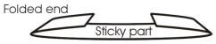

BIOLOGY 2022-23 MINI LAB

CHAPTER 7.2 MINI LAB – Investigate Osmosis
What will happen to cells placed in a strong salt solution? Regulating flow and amount of water into and out of the cell is critical to the survival of that cell. Osmosis is one method used to regulate a cell’s water content.
Procedure
1. Read and complete the lab safety form.
2. Prepare a control slide using onion epidermis, water, and iodine stain as directed by your teacher.
3. Prepare a test slide using onion epidermis, salt water, and iodine stain as directed by your teacher.
4. Predict the effect, if any, that the salt solution will have on the onion cells in the test slide.
5. View the control slide using a compound microscope under low power and sketch several onion cells.
6. View the test slide under the same magnification and sketch your observations.
Analysis
1. Analyze and Conclude Was your prediction correct or incorrect? Explain.
2. Explain Use the process of osmosis to explain what you observe.

