BIOLOGY 2022-23 November 1, 2022

Today’s Agenda (Day 47)

- HOUSEKEEPING ITEMS

- Homework Check:
Mini-lab: Enzymatic Browning
- Class Activity:
TEST: Ch 6 Nov. 1
*Go to www.socrative.com enter room “MSBBIOLOGY” enter ID #

WEDNESDAY: DAY 2: Chapter 7 PPT Review
- Section 7.3 – Structures and Organelles
- Section 7.4 – Cellular Transport

HOMEWORK:
- READ: Chapter 7 – Cell Structure and Function
- COMPLETE: Chapter 7 Reading Guide Questions
- STUDY: Chapter 6 Test, Chapter 7 Vocabulary and Test

CHAPTER 7 VOCABULARY
Active transport | Cell | Cell theory | Cell wall | Centriole | Chloroplast
Cilium | Cytoplasm | Cytoskeleton | Diffusion | Dynamic equilibrium | Endocytosis
Endoplasmic reticulum | Eukaryotic cell | Exocytosis | Facilitated diffusion | Flagellum | Fluid mosaic model
Golgi apparatus | Hypertonic solution | Hypotonic solution | Isotonic solution | Lysosome | Mitochondrion
Nucleolus | Nucleus | Organelle | Osmosis | Phospholipid bilayer | Plasma membrane
Prokaryotic cell | Ribosome | Selective permeability | Transport protein | vacuole

REMINDERS:

- TEST: Ch 6 Nov. 1 !! CHANGE OF DATE!!
- QUIZ: Ch 7 Vocabulary Nov. 3
- Chapter 7 Reading Guide – Nov. 3
- TEST: Ch 7 Nov. 8

BIOLOGY 2022-23 READING GUIDE

Chapter 7 Cellular Structure & Function
Review pages 182 – 207 in the Glencoe Science Biology Textbook and answer the following questions.
- List the three principles of the Cell Theory.
- Describe one strength and one weakness of both a compound light microscope and an electron microscope.
- What is the essential function of the plasma membrane?
- Compare and contrast eukaryotic cells and prokaryotic cells.
- Describe the endosymbiont theory.
- When describing the plasma membrane, selectively permeable and phospholipid bilayer are almost always mentioned. What do these terms mean?
- What are transport proteins used for in the plasma membrane?
- Some scientists consider the role of cytoplasm more vital (important) in prokaryotes rather than eukaryotes. Explain why.
- Draw the eukaryotic cell below and label and define all organelles listed on Table (p199).
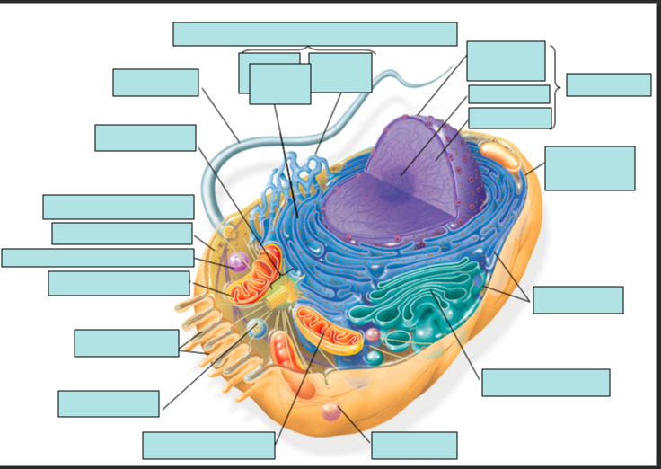
- Would you expect to find more mitochondria in a muscle cell or a skin cell? Explain your answer.
- Plant cells have a cell wall (animal cells don’t), what is its function?
- Describe the process of protein synthesis mentioning all the organelles involved in the process.
- Define diffusion. Give an example.
- What is meant by the term dynamic equilibrium?
- How is facilitated diffusion different from simple diffusion?
- How does osmosis work?
- Define isotonic solution, hypotonic solution, and hypertonic solution.
- Describe how a cell behaves in each of the following: isotonic solution, hypotonic solution, and hypertonic solution.
- Determine which type of solution each red blood cell is in from each of the diagrams below:
A.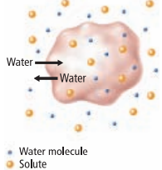 B. 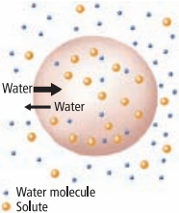 C.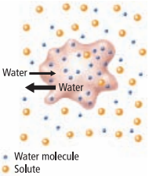

- What is the main difference between active transport and diffusion?
- Compare and contrast exocytosis and endocytosis.

