BIOLOGY 2022-23 October 31, 2022

Today’s Agenda (Day 46)

- HOUSEKEEPING ITEMS

- Homework Check:
Mini-lab: Enzymatic Browning
- Class Activity:
BEGIN: Chapter 7 PPT Review
- Section 7.1 – Cell Discovery and Theory
- Section 7.2 – The Plasma Membrane
- Section 7.3 – Structures and Organelles
- Section 7.4 – Cellular Transport

HOMEWORK:
- READ: Chapter 7 – Cell Structure and Function
- COMPLETE: Chapter 7 Reading Guide Questions
- STUDY: Chapter 6 Test, Chapter 7 Vocabulary and Test

CHAPTER 7 VOCABULARY
Active transport | Cell | Cell theory | Cell wall | Centriole | Chloroplast
Cilium | Cytoplasm | Cytoskeleton | Diffusion | Dynamic equilibrium | Endocytosis
Endoplasmic reticulum | Eukaryotic cell | Exocytosis | Facilitated diffusion | Flagellum | Fluid mosaic model
Golgi apparatus | Hypertonic solution | Hypotonic solution | Isotonic solution | Lysosome | Mitochondrion
Nucleolus | Nucleus | Organelle | Osmosis | Phospholipid bilayer | Plasma membrane
Prokaryotic cell | Ribosome | Selective permeability | Transport protein | vacuole

REMINDERS:

- Mini-lab: Enzymatic Browning – Oct. 31
- TEST: Ch 6 Nov. 1 !! CHANGE OF DATE!!
- QUIZ: Ch 7 Vocabulary Nov. 3
- Chapter 7 Reading Guide – Nov. 3
- TEST: Ch 7 Nov. 8

BIOLOGY 2022-23 MINI LAB

CHAPTER 6 MINI LAB – Investigate Enzymatic Browning
What factors affect enzymatic browning? When sliced, an apple’s soft tissue is exposed to oxygen, causing a chemical reaction called oxidation. Enzymes in the apple speed this reaction, producing darkened, discolored fruit. In this lab, you will investigate methods used to slow enzymatic browning.
Procedure ’
1. Read and complete the lab safety form.
2. Predict the relative amount of discoloration each of these apple wedges will show when exposed to air. Justify your prediction.
Sample 1: Untreated apple wedge Sample 3: Apple wedge submerged in lemon juice
Sample 2: Apple wedge submerged Sample 4: Apple wedge submerged in sugar solution in boiling water
3. Prepare 75 mL of each of the following: boiling water, lemon juice, and sugar solution in three 250-mL beakers.
4. Slice an apple into four wedges. Immediately use tongs to submerge each wedge in a different liquid. Put one wedge aside.
5. Submerge the wedges for three minutes, then place on a paper towel, skin side down. Observe for 10 min, then record the relative amount of discoloration of each apple wedge.

Analysis
1. Analyze How did each treatment affect the chemical reaction that occurred on the fruit’s soft tissue? Why were some of the treatments successful?
2. Think Critically A restaurant owner wants to serve fresh-cut fruit. What factors might be considered in choosing a recipe and preparation method?

BIOLOGY 2022-23 READING GUIDE

Chapter 7 Cellular Structure & Function
Review pages 182 – 207 in the Glencoe Science Biology Textbook and answer the following questions.
- List the three principles of the Cell Theory.
- Describe one strength and one weakness of both a compound light microscope and an electron microscope.
- What is the essential function of the plasma membrane?
- Compare and contrast eukaryotic cells and prokaryotic cells.
- Describe the endosymbiont theory.
- When describing the plasma membrane, selectively permeable and phospholipid bilayer are almost always mentioned. What do these terms mean?
- What are transport proteins used for in the plasma membrane?
- Some scientists consider the role of cytoplasm more vital (important) in prokaryotes rather than eukaryotes. Explain why.
- Draw the eukaryotic cell below and label and define all organelles listed on Table (p199).
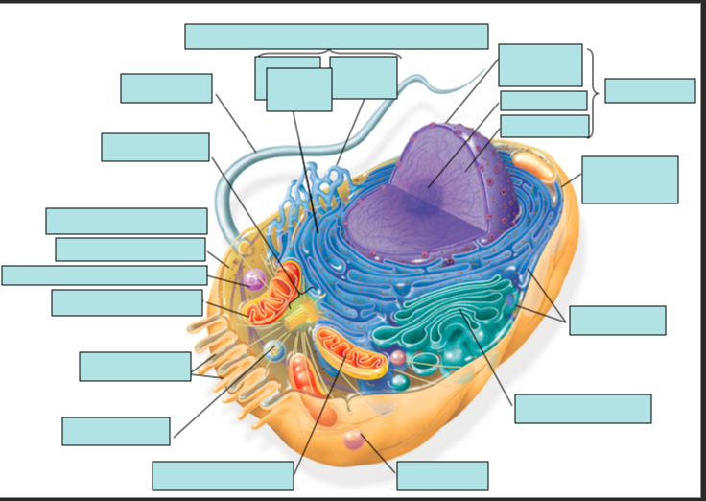
- Would you expect to find more mitochondria in a muscle cell or a skin cell? Explain your answer.
- Plant cells have a cell wall (animal cells don’t), what is its function?
- Describe the process of protein synthesis mentioning all the organelles involved in the process.
- Define diffusion. Give an example.
- What is meant by the term dynamic equilibrium?
- How is facilitated diffusion different from simple diffusion?
- How does osmosis work?
- Define isotonic solution, hypotonic solution, and hypertonic solution.
- Describe how a cell behaves in each of the following: isotonic solution, hypotonic solution, and hypertonic solution.
- Determine which type of solution each red blood cell is in from each of the diagrams below:
A.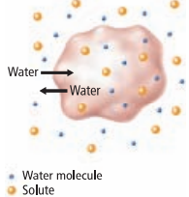 B. 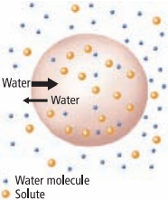 C.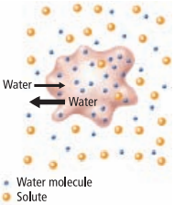

- What is the main difference between active transport and diffusion?
- Compare and contrast exocytosis and endocytosis.

