BIOLOGY 2022-23 April 5, 2023

Today’s Agenda (Day 139)

- HOUSEKEEPING ITEMS

- Homework Check:
ACTIVITY: Identify Bacteria
- Class Activity:

BEGIN: Chapter 20 PPT Review
- Section 20.1 – Introduction to Fungi
- Section 20.2 – Diversity of Fungi
- Section 20.3 – Ecology of Fungi

HOMEWORK:
- READ: Chapter 20 - Fungi
- COMPLETE:
- STUDY: Chapter 20 Test

REMINDERS:

- TEST: Ch 19 April 4
- TEST: Ch 20 April 11
- TEST: Ch 30 - 31 April 18
- QUIZ: Ch 30 - 32 Vocabulary April 20
- TEST: Ch 32 May 4
- TEST: Ch 33 May 9
- QUIZ: Ch 33 & 34 Vocabulary May 11
- TEST: Ch 34 May 23
- QUIZ: Ch 35 Vocabulary May 25
- TEST: Ch 35 May 30
- QUIZ: Ch 36 Vocabulary June 1
- TEST: Ch 36 June 6

Chapter 19 - Protists

Acrasin | Alternation of generations | Bioluminescent | Colony | Contractile vacuole | Microsporidium
Pellicle | Plasmodium | Protozoan | Pseudopod | Test | trichocyst

Chapter 20 - Fungi

Ascocarp | Ascospore | Ascus | Basidiocarp | Basidiospore | Basidium
Bioindicator | Chitin | Conidiophore | Fruiting body | Gametangium | Haustorium
Hypha | Lichen | Mycelium | Mycorrhiza | Rhizoid | Septum
Sporangium | Spore | Stolon

Chapter 30 - Mammals

Cerebellum | Cerebral cortex | Diaphragm | Gestation | Gland | Mammary gland
Marsupial | Monotreme | Placenta | Placental mammal | Therapsid | uterus

Chapter 31 – Animal Behavior

Agonistic behavior | Altruistic behavior | Behavior | Circadian rhythm | Classical conditioning | Cognitive behavior
Courting behavior | Dominance hierarchy | fixed action pattern | Foraging behavior | habituation | Imprinting
Innate behavior | Language | Learned behavior | Migratory behavior | Nurturing behavior | Operant conditioning
Territorial behavior

Chapter 32 Integumentary, Skeletal and Muscular Systems
Actin | Appendicular skeleton | Axial skeleton | Cardiac muscle | Compact bone | Dermis
Epidermis | Hair follicle | Involuntary muscle | Keratin | Ligament | Melanin
Myofibril | Myosin | Ossification | Osteoblast | Osteoclast | Osteocyte
Red bone marrow | Sarcomere | Sebaceous gland | Skeletal muscle | Smooth muscle | Spongy bone
Tendon | Voluntary muscle | Yellow bone marrow

BIOLOGY 2022-23 READING GUIDE
Chapter 20 Reading Guide
- Describe characteristics shared by all fungi. How many species of fungi are known today?
- Compare and contrast multicellular fungi and unicellular fungi.
- Describe two ways the physical structure of a fungi differs from that of a plant.
- Compare and contrast the two types of hyphae shown below.
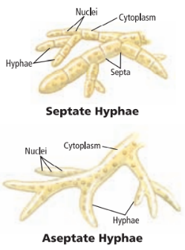
- Compare and contrast saprophytic fungi and mutualistic fungi. Give one example of each type.
- What is a fairy ring? Why do fairy rings form?
- List and describe three different methods fungi use to reproduce.
- Describe three different adaptations fungi use for survival.
- What is illustrated in the diagram below?
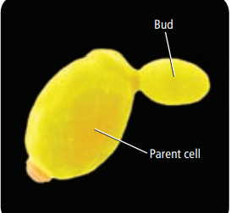
- Describe the life cycle of the common mold shown below.
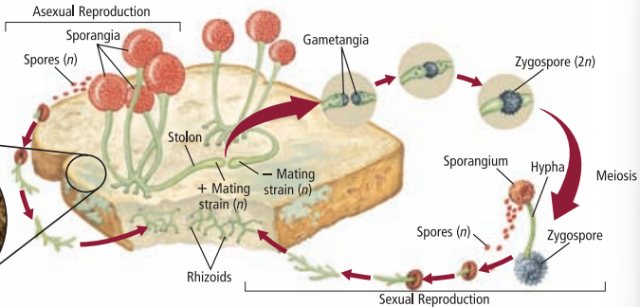
- Describe the life cycle of sac fungi.
- Describe the life cycle of club fungi.
- What is mutualism? Give an example.
- What is a lichen?
- How do lichens survive a severe drought?
- What is a bioindicator? Why are lichens considered to be bioindicators?
- Describe two examples of beneficial fungi.
- What role does fungi play in food production for humans?
- What is bioremediation? How are fungi useful in terms of bioremediation?
- Describe two examples of harmful fungi.

