BIOLOGY 2022-23 March 30, 2023

Today’s Agenda (Day 135)

- HOUSEKEEPING ITEMS

- Homework Check:

- Class Activity:
QUIZ: Ch 19 & 20 Vocabulary

DAY3: Chapter 19 PPT Review
- Section 19.3 – Algae – Plantlike Protists
- Section 19.4 – Funguslike Protists

HOMEWORK:
- READ: Chapter 19 - Protists
- COMPLETE:
- STUDY: Chapter 19 & 20 Vocabulary Quiz AND Chapter 19 Test

REMINDERS:

- TEST: Ch 19 April 4
- QUIZ: Ch 19 & 20 Vocabulary March 30
- TEST: Ch 20 April 6
- TEST: Ch 30 - 31 April 13
- QUIZ: Ch 32 Vocabulary April 18
- TEST: Ch 32 April 20
- TEST: Ch 33 May 4
- QUIZ: Ch 33 & 34 Vocabulary May 9
- TEST: Ch 34 May 11
- QUIZ: Ch 35 Vocabulary May 23
- TEST: Ch 35 May 25
- QUIZ: Ch 36 Vocabulary May 30
- TEST: Ch 36 June 1

Chapter 19 - Protists

Acrasin | Alternation of generations | Bioluminescent | Colony | Contractile vacuole | Microsporidium
Pellicle | Plasmodium | Protozoan | Pseudopod | Test | trichocyst

Chapter 20 - Fungi

Ascocarp | Ascospore | Ascus | Basidiocarp | Basidiospore | Basidium
Bioindicator | Chitin | Conidiophore | Fruiting body | Gametangium | Haustorium
Hypha | Lichen | Mycelium | Mycorrhiza | Rhizoid | Septum
Sporangium | Spore | Stolon

BIOLOGY 2022-23 READING GUIDE
Chapter 19 Reading Guide
Review pages 542 – 565 in the Glencoe Science Biology Textbook and answer the following questions.
- How are protists classified? What is the one trait all protists share?
- List and describe the three different methods protists use to obtain nutrition.
- Describe a typical habitat for a protist.
4. How do ciliophora move?
5. Describe the structure of a paramecia. (Include all vocabulary on page 547)
- Compare and contrast binary fission and conjugation as forms of reproduction for ciliates.
- Describe the structure of an amoeba.
- What do amoebas use cysts for?
- Describe three characteristics shared by all sporozoans.
- List and describe a disease caused by sporozoans that are members of the genus Plasmodium.
- Describe common traits shared by zooflagellates.
- Why are algae considered to be plant-like?
- What are diatoms? How do they reproduce?
- What does bioluminescent mean? Name a bioluminescent insect (it isn’t in the book).
- What are red tides? Why are red tides potentially so dangerous?
- Compare and contrast brown algae and green algae.
- List and describe three uses of algae.
- Describe what is meant by alternation of generations (be sure to include haploid and diploid in your answer).
- Describe common characteristics shared by slime molds.
- Compare and contrast acellular slime molds and cellular slime molds.
- What impact has downy mildew had on the history of the United States?
BIOLOGY 2022-23 READING GUIDE
Chapter 20 Reading Guide
- Describe characteristics shared by all fungi. How many species of fungi are known today?
- Compare and contrast multicellular fungi and unicellular fungi.
- Describe two ways the physical structure of a fungi differs from that of a plant.
- Compare and contrast the two types of hyphae shown below.
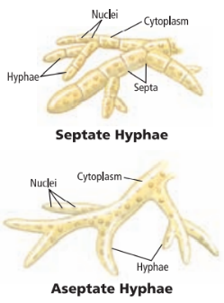
- Compare and contrast saprophytic fungi and mutualistic fungi. Give one example of each type.
- What is a fairy ring? Why do fairy rings form?
- List and describe three different methods fungi use to reproduce.
- Describe three different adaptations fungi use for survival.
- What is illustrated in the diagram below?
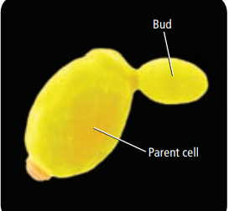
- Describe the life cycle of the common mold shown below.
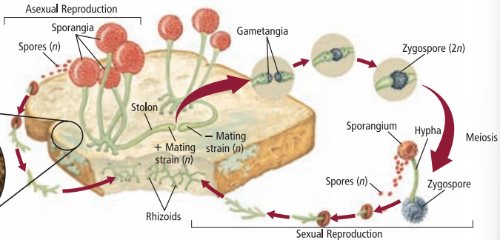
- Describe the life cycle of sac fungi.
- Describe the life cycle of club fungi.
- What is mutualism? Give an example.
- What is a lichen?
- How do lichens survive a severe drought?
- What is a bioindicator? Why are lichens considered to be bioindicators?
- Describe two examples of beneficial fungi.
- What role does fungi play in food production for humans?
- What is bioremediation? How are fungi useful in terms of bioremediation?
- Describe two examples of harmful fungi.

