BIOLOGY 2022-23 March 8, 2023

Today’s Agenda (Day 120)

- HOUSEKEEPING ITEMS

- Homework Check:

- Class Activity:
FRIDAY: UPON RETURN FROM BREAK: CONT’D: PRESENTATION: How Many CATs – DNA Profiling Simulation
DAY 2: Ch 15 PPT Review
- Section 15.2 – Evidence of Evolution
- Section 15.3 – Shaping Evolutionary Theory
HOMEWORK:
- READ: Chapter 15 – Evolution
- READ: Chapter 17 – Organizing Life’s Diversity
- COMPLETE:
- STUDY: Chapter 15 Test

REMINDERS:

- TEST: Ch 15 Tuesday, Mar. 9
- TEST: Ch 17 March 16
- QUIZ: Ch 17 & 18 Vocabulary March 21
- TEST: Ch 18 March 23
- QUIZ: Ch 19 & 20 Vocabulary April 4
- TEST: Ch 19 March 30
- TEST: Ch 20 April 6
- TEST: Ch 30 - 31 April 13
- QUIZ: Ch 32 Vocabulary April 18
- TEST: Ch 32 April 20
- TEST: Ch 33 May 4
- QUIZ: Ch 33 & 34 Vocabulary May 9
- TEST: Ch 34 May 11
- QUIZ: Ch 35 Vocabulary May 23
- TEST: Ch 35 May 25
- QUIZ: Ch 36 Vocabulary May 30
- TEST: Ch 36 June 1

Chapter 15 – Evolution

Adaptive radiation | Allopatric speciation | Analogous structure | Ancestral trait | Artificial selection | Biogeography
Bottleneck | Camouflage | Derived trait | Directional selection | Disruptive selection | Embryo
Evolution | Fitness | Founder effect | Genetic drift | Gradualism | Hardy-Weinberg principle
Homologous structure | Mimicry | Natural selection | Post-zygotic isolating mechanism | Pre-zygotic isolating mechanism | Punctuated equilibrium
Sexual selection | Stabilizing selection | Sympatric speciation | Vestigial structure

Chapter 17 – Organizing Life’s Diversity

Archaea | Binomial nomenclature | Character | Cladistics | Cladogram | Classification
Division | Domain | Family | Fungus | Genus | Kingdom
Molecular clock | Order | Phylogeny | Phylum | Protist | Taxon
taxonomy

Chapter 18 – Bacteria and Viruses

Bacteria | Binary fission | Capsid | Capsule | Conjugation | Endospore
Lysogenic cycle | Lytic cycle | Nucleoid | Pilus | Prion | Retrovirus
Virus

BIOLOGY 2022-23 READING GUIDE
Chapter 15 Evolution

DIRECTIONS: Refer to your textbook to respond to the following questions.

- What did Darwin suspect happen to species on the Galapagos Islands?
- What did Thomas Malthus suggest would happen to the human population?
- How did Darwin take Malthus’ ideas to help describe what he had seen in the Galapagos Islands?
- Describe the process of natural selection.
- Darwin’s theory of evolution by natural selection has four basic principles that explain how traits of a population can change over time. List the four principles.
- Define evolution. What is the driving mechanism behind evolution?
- How does the fossil record provide evidence to support evolutionary change?
- What is the significance of Archaeopteryx? What organisms did it evolve from?
- Compare derived traits and ancestral traits.
- Explain why all of the bones of human, horse, cat, porpoise, and bat (as shown on p.425 of textbook) share a similar structure? How did they develop different functions?
- Which of the forelimbs mentioned in #10 would most likely resemble a whale’s fin?
- What are vestigial structures?
- How does evolutionary theory predict vestigial structures?
- Eagles and May beetles are not closely related, yet they both have wings. How can this be explained?
- How does comparative embryology provide support for evolutionary theory?
- What does the graph below suggest?

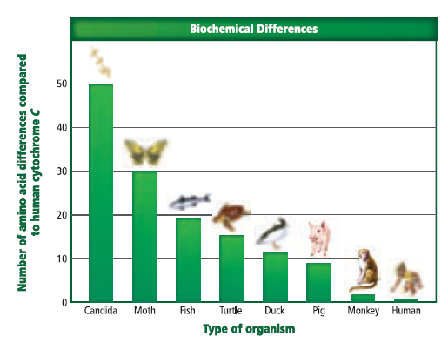
- Would the cytochrome c of a reptile or a bird be expected to have more amino acid differences when compared to that of a human? Explain (use the graph for this question).
- What is an adaptation? How are adaptations related to fitness?
- Compare and contrast camouflage and mimicry.
- Give an example of how an organism uses mimicry to increase its chances of survival.
- How is the helplessness of a human baby a consequence of adaptation rather than an evolutionary advantage?
- Describe what natural selection explains in terms of evolution.
- Explain the Hardy-Weinberg principle.
- How does the Hardy-Weinberg principle help explain the following picture?
- According to the Hardy-Weinberg principle, what are the five conditions that a population in genetic equilibrium must meet to remain that way?
- What is the consequence of a non-random mating population of organisms (according to H-W)?
- What is the consequence of a small population of organisms (according to H-W)?
- Describe the founder effect. Whys is this an example of genetic drift?
- What effect has the bottleneck had on the reproductive rate of cheetahs?
- How can mutations benefit a population?
- List the three main ways in which natural selection alters phenotypes.
- Give an example of stabilizing selection in humans.
- Describe 2 examples of directional selection (don’t just list them).
- Describe one example of disruptive selection.
- How can sexual selection change the frequency of a trait in a population?
- Describe an example of how sexual selection has resulted in a different appearance for males and females of a species.
- Compare and contrast prezygotic and postzygotic isolating mechanisms.
- Describe an example of a prezygotic isolating mechanism.
- Describe an example of a postzygotic isolating mechanism.
- Compare and contrast allopatric speciation and sympatric speciation.
- Describe and provide an example of adaptive radiation.
- Give an example of coevolution and explain why your example illustrates the concept.
- What is the driving force behind convergent evolution?
- Describe an example of convergent evolution.

BIOLOGY 2022-23 READING GUIDE
Chapter 17 Organizing Life’s Diversity

DIRECTIONS: Refer to your textbook to respond to the following questions.

- Why are biologist so concerned with classification?
- What is taxonomy? Who was the first person to formally use taxonomic classification?
- Explain binomial nomenclature. Give an example.
- Why is it important that scientists always use an organism’s scientific name rather than its common name?
- How did the study of evolution affect taxonomy (classification system)?
- How is genus (define it) an example of a taxon?
- Which is more inclusive: family or genus? Explain your answer.
- How are order, class, and phylum related?
- How are kingdom and domain related?
- List and describe the three concepts of species.
- List a limitation to each of the concepts of species you used in number 10.
- List a benefit to each of the concepts of species you used in number 10.
- Compare and contrast analogous and homologous structures? Which one indicates a shared common ancestor?
- What are biochemical characters? How do scientists use them to determine evolutionary relationships?
- Describe two techniques scientists use to compare DNA sequences.
- Define cladistics. What are the two main types of characters used when doing cladistic analyses?
- In this cladogram (below), which species shares ancestral characteristics with the three organisms being compared?
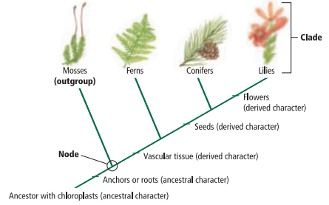
- What is the primary assumption made when constructing cladograms?
- What does the trunk of Darwin’s tree of life represent?
- What do the branches of Darwin’s tree of life represent?

23. List AND describe the four kingdoms of Domain Eukarya. Give an example of each.

BIOLOGY 2022-23 READING GUIDE

CH 18 Bacteria & Viruses Reading Guide

- Describe what scientists think the first organisms on Earth were like.
- Why are prokaryotes now divided into two domains? What are the two domains?
- Describe the importance of bacteria to humans.
- Where do Archae live? What is another name for Archae?
- Compare and contrast bacteria and Archae.
- Compare and contrast thermoacidophiles and halophiles.
- What are methanogens? Where do they live?
- Using the picture below, describe the function of all of the labeled structures.
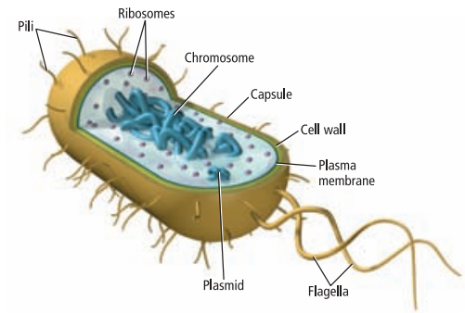
- List and describe the three general shapes of prokaryotes.
- How do Gram-positive bacteria look when they are stained? Why do they look this way?
- How do Gram-negative bacteria look when they are stained? Why do they look this way?
- Describe two different ways that prokaryotes move.
- Compare and contrast binary fission and conjugation as reproductive methods for prokaryotes.
- What process is shown in the figure below?
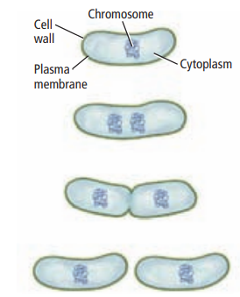
- Describe the difference between obligate anaerobes and facultative anaerobes.
- Describe how each of the following types of prokaryotes obtain food: heterotrophs, photoautotrophs, and chemoautotrophs.
- How do endospores help bacteria survive?
- Why is nitrogen fixation essential for life on Earth?
- List three types of food that are all made with the help of bacteria.
- Describe two different ways bacteria can cause disease.
- What is a virus?
- Describe a theory on how viruses evolved.
- Describe the general structure of a virus (be sure to include the definition of capsid in your answer).
- How do viruses infect hosts cells?
- Compare and contrast the lytic cycle and the lysogenic cycle in viruses.
- What is a retrovirus?
- What are prions? Name two diseases caused by prions.
- What type of viruses are illustrated below? How do you know?
