BIOLOGY 2022-23 August 31, 2022

Today’s Agenda (Day 11)

- HOUSEKEEPING ITEMS

- Homework Check:
Chapter 1 Notes
Ch 2 Vocabulary

- Class Activity:
Day 2: Ch 2 PPT Review
- Section 2.3 – Cycling of Matter
REVIEW: Lab Equipment, Safety Protocols and Symbols – work in PAIRS to complete p. 2- 16 of documents

HOMEWORK:
- READ: Chapter 2 – Principles of Ecology
- READ: Chapter 3 – Communities, Biomes and Ecosystems
- COMPLETE: Chapter 3 Vocabulary [abridged template]
- STUDY: Ch 1 & 2 Vocabulary, Ch 1 & 2 Test
CHAPTER 1
Adaptation | Biology | Constant | Control group | Data | Dependent variable
Development | Ethics | Experiment | Experimental group | Growth | Homeostasis
Hypothesis | Independent variable | Inference | Law | Metric system | Observation
Organism | Organization | Peer review | Reproduction | Response | Science
Scientific method | SI | Species | Stimulus | theory
CHAPTER 2
Abiotic factor | Autotroph | Biogeochemical cycle | Biological community | Biomass | Biome
Biosphere | Carnivore | Commensalism | Denitrification | Detritivore | Ecology
Ecosystem | Food chain | Food web | Habitat | Herbivore | Heterotroph
Matter | Nutrient | Mutualism | Niche | Nitrogen fixation | Omnivore
Parasitism | Population | Predation | Symbiosis | Trophic level

CHAPTER 3
Abyssal zone | Aphotic zone | Benthic zone | Boreal forest | Climate | Climax community
Community | Desert | ecological succession | Estuary | Grassland | Intertidal zone
Limiting factor | Limnetic zone | Littoral zone | Photic zone | Plankton | Primary succession
Profundal zone | Secondary succession | Sediment | Temperate forest | Tolerance | Tropical rain forest
Tropical savanna | Tropical seasonal forest | Tundra | Weather | Wetlands | woodland

REMINDERS:
- QUIZ: Ch 1 & 2 Vocabulary Sept. 1
- TEST: Ch 1 & 2 Sept. 6
- QUIZ: Lab Equipment, Safety Protocols, Safety Symbols Sept. 8
BIOLOGY 2022-23 LAB INFORMATION
Lab Equipment Activity
Part A: Working with your lab partner, identify each of the pieces of laboratory equipment. Write the name of the lab equipment in the space by its picture, as well as the letter next to the name on this worksheet.
Letter | Lab Equipment
_________ | 1. Beaker
_________ | 2. Graduated Cylinder
_________ | 3. Test Tube Rack
_________ | 4. Test Tube
_________ | 5. Watch Glass
_________ | 6. Tongs
_________ | 7. Erlenmeyer Flask
_________ | 8. Scoopula/Spatula
_________ | 9. Funnel
_________ | 10. Test Tube Holder
_________ | 11. Wire Gauze
_________ | 12. Ring stand
_________ | 13. Bunsen Lab Burner
_________ | 14. Iron Ring
_________ | 15. Water Bottle
_________ | 16. Evaporating Dish
_________ | 17. Goggles
_________ | 18. Pipettes
_________ | 19. Eye Dropper
_________ | 20. Hot Plate
_________ | 21. Thermometer
_________ | 22. Utility Clamp
Part B: Identify which piece of lab equipment would be most useful for each of the following tasks. Some lab equipment will not be used.
- Measuring exactly 43 mL of water ___________________________
- Removing solid chemicals from a reagent bottle _____________________
- Pouring 50 mL of liquid from one container to another
___________________________
- Holding 50 mL of boiling water ___________________________
- Dropping small quantities of liquids into test tubes
___________________________
- Holding a test tube over a Bunsen burner for heating
___________________________
- Protects your eyes from spattering solids and splashing liquids
___________________________
- Determine if water is boiling ___________________________
- Covering a beaker of boiling water to prevent splattering
___________________________
10.These five pieces of lab equipment would hold a test tube in a beaker of boiling water above a Bunsen burner
___________________________
___________________________
___________________________
___________________________
___________________________
11.Rinsing out glassware with distilled water ___________________________
12.Heating a dissolved substance in water to drive off water
___________________________
13.Holding hot objects in flame ___________________________
14.Heating substances to a constant temperature
___________________________
15.Transferring small quantities of liquid solutions from one container into another
___________________________
16.Measuring approximate amounts of liquids ___________________________

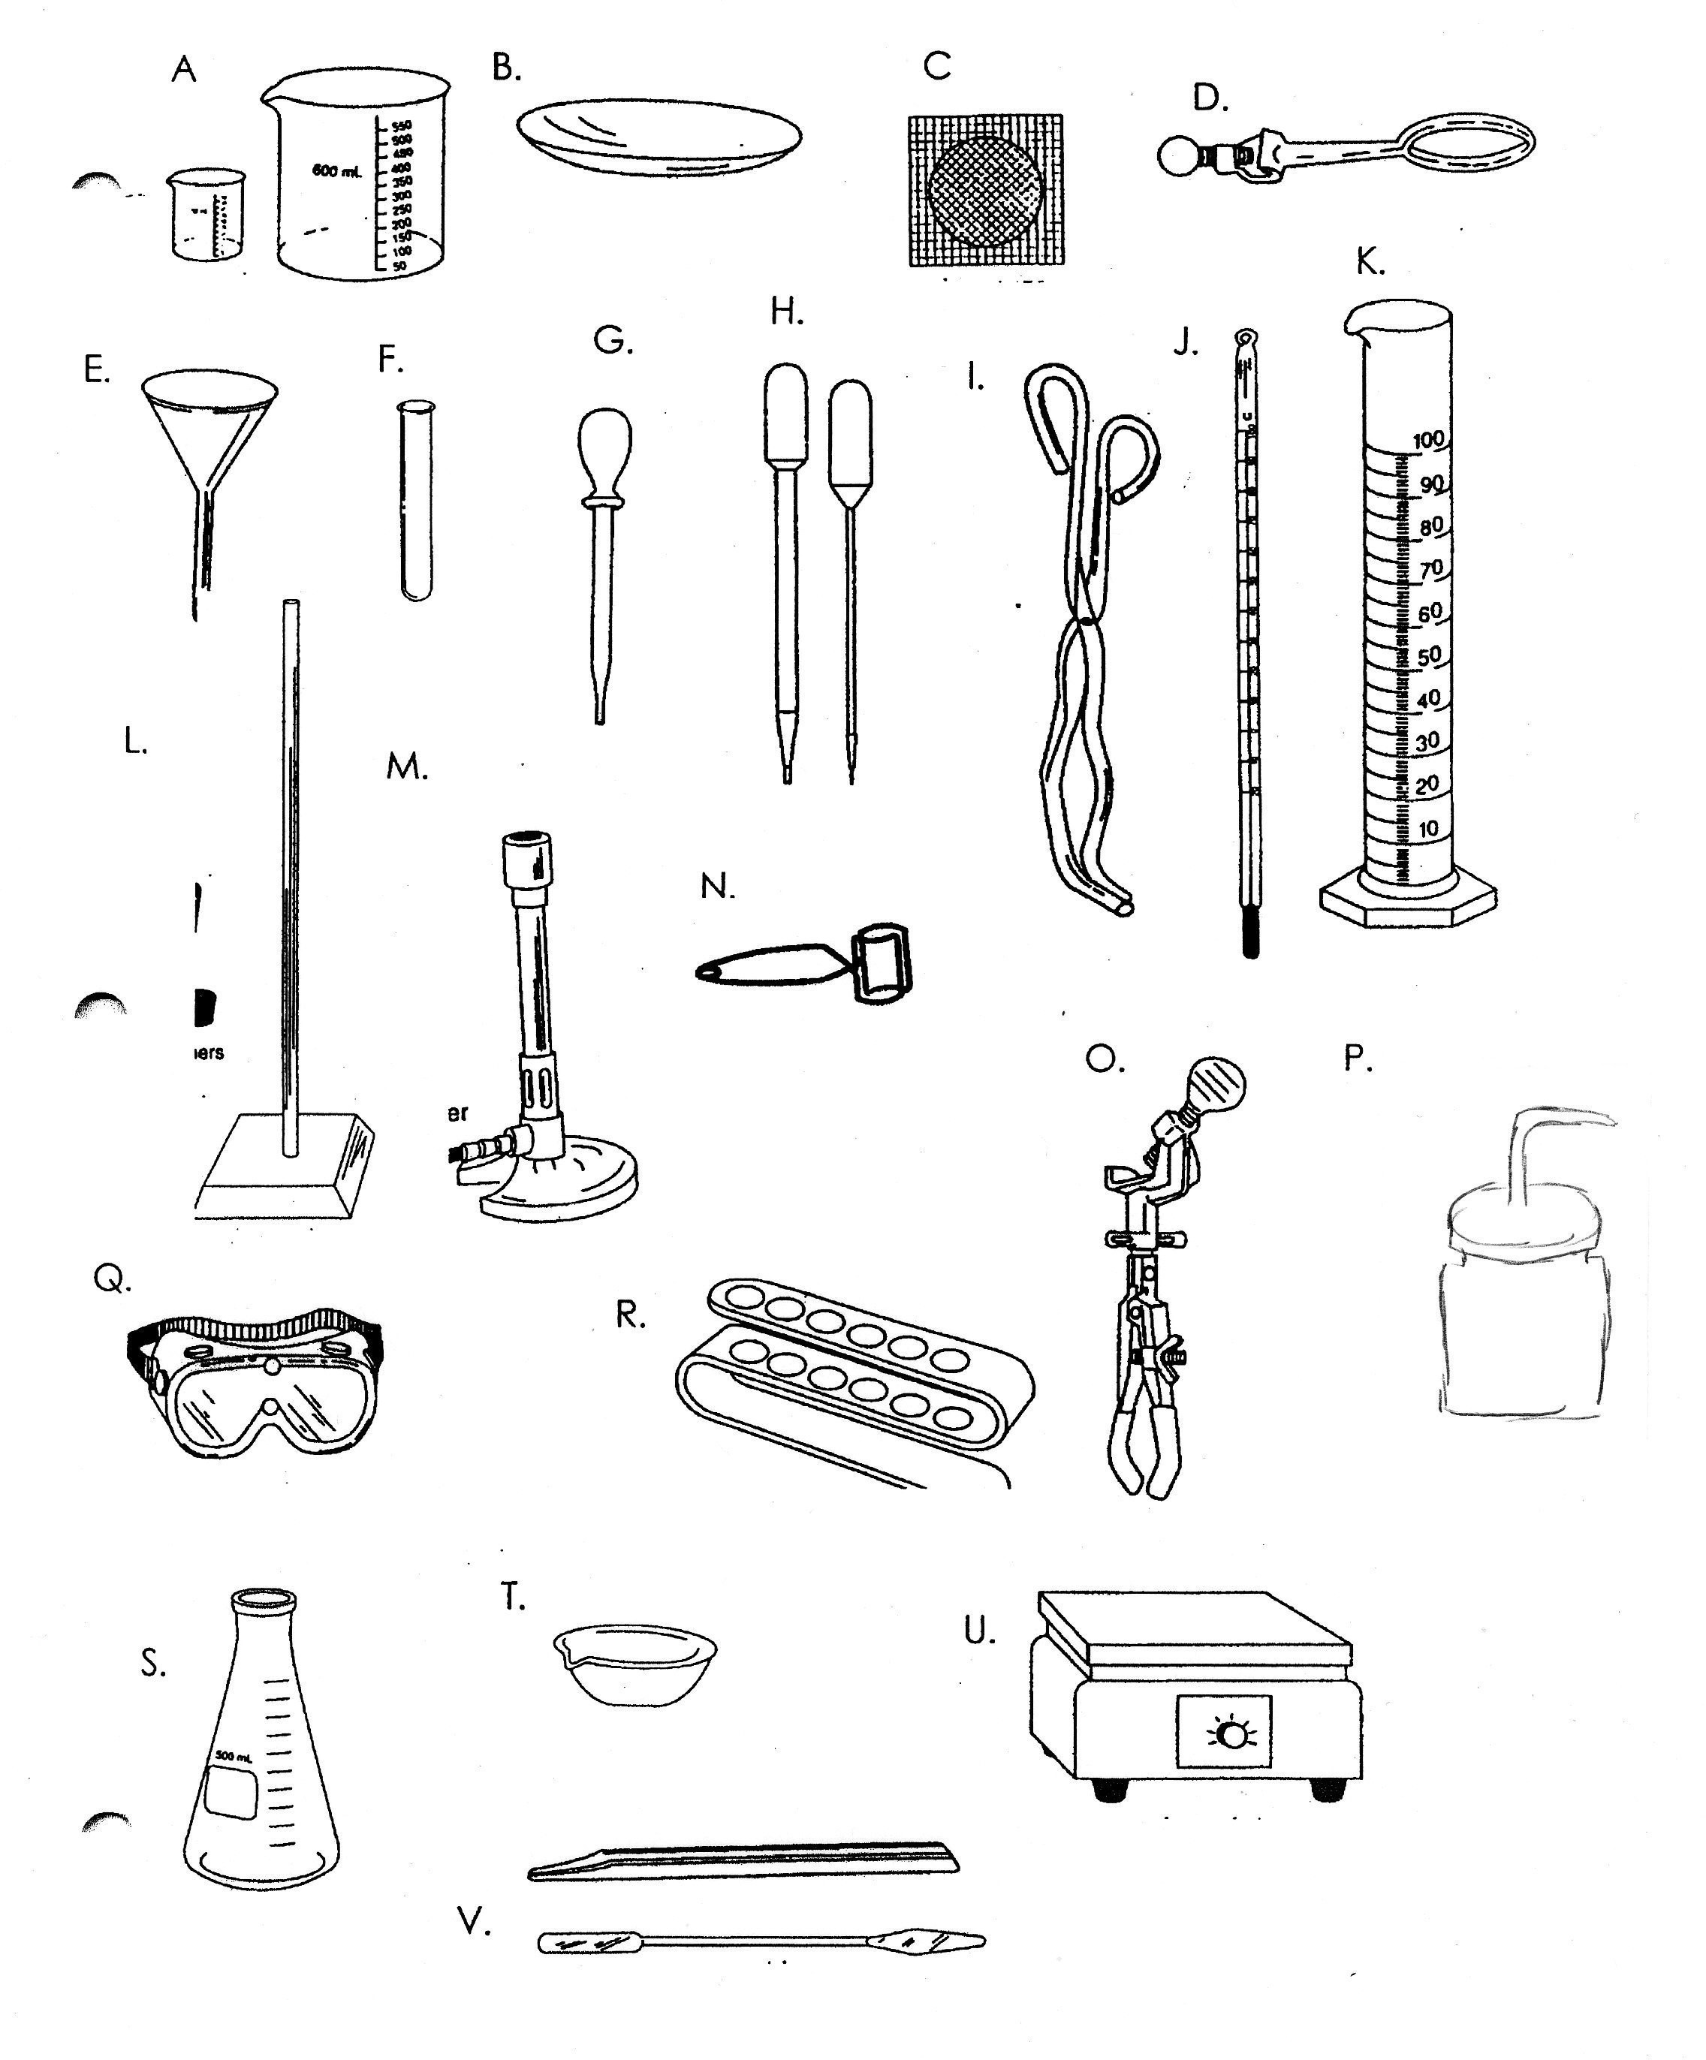

BIOLOGY 2022-23 LAB INFORMATION

Safety in the Biology Laboratory
Working in the biology laboratory can be interesting, exciting, and rewarding. But it can also be quite dangerous if you are not serious and alert and if proper safety precautions are not taken at all times. You are responsible for maintaining an enjoyable, instructional, and safe environment in the biology laboratory. Unsafe practices endanger not only you but the people around you as well.
Read the following information about safety in the biology laboratory carefully. Review applicable safety information before you begin each Laboratory Investigation. If you have any questions about safety or laboratory procedures, be sure to ask your teacher.

Safety Symbol Guide
All the investigations in this laboratory manual have been designed with safety in mind. If you follow the instructions, you should have a safe and interesting year in the laboratory. Before beginning any investigation, make sure you read the safety rules on pages 8–11 of Laboratory Manual A.
The safety symbols shown on page 8 are used throughout Laboratory Manual A. They appear first next to the Safety section of an investigation and then next to certain steps in an investigation where specific safety precautions are required. The symbols alert you to the need for special safety precautions. The description of each symbol indicates the precaution(s) you should take whenever you see the symbol in an investigation.
© Prentice-Hall, Inc.
Biology Laboratory Manual A/Safety in the Biology Laboratory

Safety Symbols
These symbols alert you to possible dangers.
Safety Goggles Always wear safety goggles to protect your eyes in any activity involving chemicals, flames, or heating, or the possibility of broken glassware.
Laboratory Apron Wear a laboratory apron to protect your skin and clothing.
Breakage You are working with breakable materials, such as glassware. Handle breakable materials with care. Do not touch broken glassware.
Heat-resistant Gloves Use hand protection when handling hot materials. Hot equipment or hot water can cause burns. Do not touch hot objects with your bare hands.
Plastic Gloves Wear disposable plastic gloves to protect yourself from chemicals or organisms that could be harmful. Keep your hands away from your face. Dispose of the gloves according to your teacher’s instructions at the end of the activity.
Heating Use a clamp or tongs to pick up hot glassware. Do not touch hot objects
with your bare hands.
Sharp Object Pointed-tip scissors, scalpels, knives, needles, pins, or tacks can cut or puncture your skin. Always direct a sharp edge or point away from yourself and others. Use sharp instruments only as directed.
Electric Shock Avoid the possibility of electric shock. Never use electrical equipment around water, or when equipment is wet or your hands are wet. Be sure cords are untangled and cannot trip anyone. Disconnect the equipment when it is not in use.
Corrosive Chemical Avoid getting acids or other corrosive chemicals on your skin or clothing, or in your eyes. Do not inhale the vapors. Wash your hands when you are finished with the activity.
Poison Do not let any poisonous chemical come in contact with your skin, and do not inhale its vapors. Wash your hands when you are finished with the activity.
Laboratory Manual A/Safety Symbols
Physical Safety When an experiment involves physical activity, take precautions to avoid injuring yourself or others. Follow instructions from your teacher. Alert your teacher if there is any reason you should not participate in the activity.
Animal Safety Treat live animals with care to avoid harming the animals or yourself. Working with animal parts or preserved animals also may require caution. Wash your hands when you are finished.
Plant Safety Handle plants only as directed by your teacher. If you are allergic to certain plants, tell your teacher before doing an activity in which plants are used. Avoid touching poisonous plants or plants with thorns. Wash your hands when you are finished with the activity.
Flames You may be working with flames from a Bunsen burner, candle, or matches. Tie back loose hair and clothing. Follow instructions from your teacher about lighting and extinguishing flames.
No Flames Flammable materials may be present. Make sure no flames, sparks,
or exposed heat sources are present.
Fumes When poisonous or unpleasant vapors may be involved, work in a ventilated area. Avoid inhaling vapors directly. Only test an odor when directed to do so by your teacher, and use a wafting motion to direct the vapor toward your nose.
Disposal Chemicals and other used materials must be disposed of safely. Follow the instructions from your teacher.
Hand Washing Wash your hands thoroughly. Use antibacterial soap and warm water. Lather both sides of your hands and between your fingers. Rinse well.
© Prentice-Hall, Inc.
General Safety Awareness You may see this symbol when none of the other symbols appears. In this case, follow the specific instructions provided. You may also see this symbol when you are asked to develop your own procedure. Have your teacher approve your plan before you go further.

Science Safety Rules
One of the first things a scientist learns is that working in the laboratory can be an exciting experience. But the laboratory can also be quite dangerous if proper safety rules are not followed at all times. To prepare yourself for a safe year in the laboratory, read over the following safety rules. Then read them a second time. Make sure you understand each rule. If you do not, ask your teacher to explain any rules you are unsure of.

Dress Code
- Many materials in the laboratory can cause eye injury. To protect yourself from possible injury, wear safety goggles whenever you are working with chemicals, burners, or any substance that might get into your eyes. Never wear contact lenses in the laboratory.
- Wear a laboratory apron or coat whenever you are working with chemicals or heated substances.
- Tie back long hair to keep your hair away from any chemicals, burners and candles, or other laboratory equipment.
- Remove or tie back any article of clothing or jewelry that can hang down and touch chemicals and flames. Do not wear sandals or open-toed shoes in the laboratory. Never walk around the laboratory barefoot or in stocking feet.

General Safety Rules
- Be serious and alert when working in the laboratory. Never “horse around” in the laboratory.
- Be prepared to work when you arrive in the laboratory. Be sure that you understand the procedure to be employed in any laboratory investigation and the possible hazards associated with it.
© Prentice-Hall, Inc.
- Read all directions for an investigation several times. Follow the directions exactly as they are written. If you are in doubt about any part of the investigation, ask your teacher for assistance.
- Never perform activities that are not authorized by your teacher. Obtain permission before “experimenting” on your own.
- Never handle any equipment unless you have specific permission.
- Take extreme care not to spill any material in the laboratory. If spills occur, ask your teacher immediately about the proper cleanup procedure. Never simply pour chemicals or other substances into the sink or trash container.
- Never eat or taste anything or apply cosmetics in the laboratory unless directed to do so. This includes food, drinks, candy, and gum, as well as chemicals. Wash your hands before and after performing every investigation.
- Know the location and proper use of safety equipment such as the fire extinguisher, fire blanket, first-aid kit, safety shower, and eyewash station.
- Notify your teacher of any medical problems you may have, such as allergies or asthma.
- Keep your laboratory area clean and free of unnecessary books, papers, and equipment.

First Aid
- Report all accidents, no matter how minor, to your teacher immediately.
- Learn what to do in case of specific accidents such as getting acid in your eyes or on your skin. (Rinse acids off your body with lots of water.)
- Become aware of the location of the first aid kit. Your teacher should administer any required first aid due to injury. Or your teacher may send you to the school nurse or call a physician.
Biology Laboratory Manual A/Science Safety Rules
- Know where and how to report an accident or fire. Find out the location of the fire extinguisher, phone, and fire alarm. Keep a list of important phone numbers such as the fire department and school nurse near the phone. Report any fires to your teacher at once.

Heating and Fire Safety
- Never use a heat source such as a candle or burner without wearing safety goggles.
- Never heat a chemical you are not instructed to heat. A chemical that is harmless when cool can be dangerous when heated.
- Maintain a clean work area and keep all materials away from flames.
- Never reach across a flame.
- Make sure you know how to light a Bunsen burner. (Your teacher will demonstrate the proper procedure for lighting a burner.) If the flame leaps out of a burner toward you, turn the gas off immediately. Do not touch the burner. It may be hot. And never leave a lighted burner unattended.
- Point a test tube or bottle that is being heated away from you and others. Chemicals can splash or boil out of a heated test tube.
- Never heat a liquid in a closed container. The expanding gases produced may blow the container apart, injuring you or others.
- Never pick up a container that has been heated without first holding the back of your hand near it. If you can feel the heat on the back of your hand, the container may be too hot to handle. Use a clamp, tongs, or heat-resistant gloves when handling hot containers.

Using Chemicals Safely
- Never mix chemicals for the “fun of it.” You might produce a dangerous, possibly explosive, substance.
- Never touch, taste, or smell a chemical that you do not know for a fact is harmless. Many chemicals are poisonous. If you are instructed to note the fumes in an investigation, gently wave your hand over the opening of a container and direct the fumes toward your nose. Do not inhale the fumes directly from the container.
- Use only those chemicals needed in the investigation. Keep all lids closed when a chemical is not being used. Notify your teacher whenever chemicals are spilled.
- Dispose of all chemicals as instructed by your teacher. To avoid contamination, never return chemicals to their original containers.
- Be extra careful when working with acids or bases. Pour such chemicals over the sink, not over your work bench.
- When diluting an acid, pour the acid into water. Never pour water into the acid.
- Rinse any acids off your skin or clothing with water. Immediately notify your teacher of any acid spill.

Using Glassware Safely
- Never force glass tubing into a rubber stopper. A turning motion and lubricant will be helpful when inserting glass tubing into rubber stoppers or rubber tubing. Your teacher will demonstrate the proper way to insert glass tubing.
- Never heat glassware that is not thoroughly dry. Use a wire screen to protect glassware from any flame.
- Keep in mind that hot glassware will not appear hot. Never pick up glassware without first checking to see if it is hot.
- If you are instructed to cut glass tubing, fire polish the ends immediately to remove sharp edges.
- Never use broken or chipped glassware. If glassware breaks, notify your teacher and dispose of the glassware in the proper trash container.
- Never eat or drink from laboratory glassware. Clean glassware thoroughly before putting it away.
© Prentice-Hall, Inc.

Using Sharp Instruments
- Handle scalpels or razor blades with extreme care. Never cut material toward you; cut away from you.
Laboratory Manual A/Science Safety Rules
- Be careful when handling sharp, pointed objects such as scissors, pins, and dissecting probes.
- Notify your teacher immediately if you cut yourself or receive a cut.

Handling Living Organisms
- No investigations that will cause pain, discomfort, or harm to mammals, birds, reptiles, fish, and amphibians should be done in the classroom or at home.
- Treat all living things with care and respect. Do not touch any organism in the classroom or laboratory unless given permission to do so. Many plants are poisonous or have thorns, and even tame animals may bite or scratch if alarmed.
- Animals should be handled only if necessary. If an animal is excited or frightened, pregnant, feeding, or with its young, special handling is required.
- Your teacher will instruct you as to how to handle each species that may be brought into the classroom.
© Prentice-Hall, Inc.
- Treat all microorganisms as if they were harmful. Use antiseptic procedure, as directed by your teacher, when working with microbes. Dispose of microbes as your teacher directs.
- Clean your hands thoroughly after handling animals or the cage containing animals.
- Wear gloves when handling small mammals. Report animal bites or stings to your teacher at once.

End-of-Investigation Rules
- When an investigation is completed, clean up your work area and return all equipment to its proper place.
- Wash your hands after every investigation.
- Turn off all burners before leaving the laboratory. Check that the gas line leading to the burner is off as well.

Laboratory Skills 1

Recognizing Laboratory Safety

Introduction
An important part of your study of biology will be working in a laboratory. In the laboratory, you and your classmates will learn biology by actively conducting and observing experiments. Working directly with living things will provide opportunities for you to better understand the principles of biology discussed in your textbook or talked about in class.
Most of the laboratory work you will do is quite safe. However, some laboratory equipment, chemicals, and specimens can be dangerous if handled improperly. Laboratory accidents do not just happen. They are caused by carelessness, improper handling of equipment and specimens, or inappropriate behavior.
In this investigation, you will learn how to prevent accidents and thus work safely in a laboratory. You will review some safety guidelines and become acquainted with the location and proper use of safety equipment in your classroom laboratory.

Problem
What are the proper practices for working safely in a biology laboratory?

Pre-Lab Discussion
Read the entire investigation. Then, work with a partner to answer the following questions.
- Why might eating or drinking in the laboratory be dangerous?

- How can reading through the entire investigation before beginning the Procedure help prevent accidents?

3.
Look around the room. What safety equipment do you recognize?
4.
What safety procedures should you follow when cleaning up at the
end of an investigation?
© Prentice-Hall, Inc.
5. Can minor safety procedures be skipped in order to finish the investigation before the bell rings?
Materials (per group)
Biology textbook
Laboratory safety equipment (for demonstration)

Procedure
- Carefully read the list of laboratory safety rules listed in Appendix B of your textbook.
- Special symbols are used throughout this laboratory manual to call attention to investigations that require extra caution. Use Appendix B in your textbook as a reference to describe what each symbol printed below means.
1.

2.

3.

4.

5.

6.
7.
© Prentice-Hall, Inc.
8.

- Your teacher will point out the location of the safety equipment in your classroom laboratory. Pay special attention to instructions for using such equipment as fire extinguishers, eyewash fountains, fire blankets, safety showers, and items in first-aid kits. Use the space provided below to list the location of all safety equipment in your laboratory.

Analysis and Conclusions
Observing Look at each of the following drawings and explain why the laboratory activities pictured are unsafe.
1.
2.
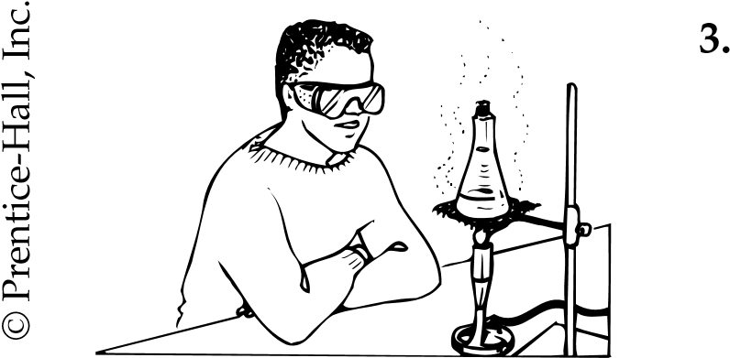
4.

Going Further
Many houseplants and some plants found in biology laboratories are poisonous. Use appropriate library resources to do research on several common poisonous plants. Share your research with your classmates. You may prepare a booklet describing common poisonous plants. Use drawings or photographs to illustrate your booklet.
© Prentice-Hall, Inc.
Laboratory Skills 2

Identifying Laboratory Equipment

Introduction
Scientists use a variety of tools to explore the world around them. Tools are very important in the advancement of science. The type of tools scientists use depends on the problems they are trying to solve. A scientist may use something as simple as a metric ruler to measure the length of a leaf. At another time, the same scientist may use a complex computer to analyze large amounts of data concerning hundreds of leaves.
In this investigation, you will identify pieces of laboratory equipment likely to be found in a biology laboratory. You will also learn the function of each piece of laboratory equipment.

Problem
What are the names and functions of some of the pieces of laboratory equipment found in a typical biology laboratory?

Pre-Lab Discussion
Read the entire investigation. Then, work with a partner to answer the following questions.
- What kinds of measurements might you need to make in the laboratory?

- What kinds of equipment would you need for these tasks?

- Why are there several types of glassware marked for measuring?

- How might glassware be used differently?
5.
When might you need to use a thermometer in the lab?
© Prentice-Hall, Inc.

Figure 1

Analysis and Conclusions
- Classifying Which laboratory tools can be used to magnify small objects so they can be seen more easily?

- Classifying Which laboratory tools are useful when looking at the internal organs of an earthworm?

- Applying Concepts What tool or tools would you use to make each of the following measurements?

a. amount of milk in a small glass

  - length of a sheet of paper
© Prentice-Hall, Inc.

  - temperature of the water in a swimming pool

  - mass of a baseball

- Drawing Conclusions How do laboratory tools improve the observations made by a scientist?

