AP BIOLOGY 2021-22 January 21, 2022

Today’s Agenda (Day 92)

- Housekeeping Items

- Homework Check:

- Class Activity:
ACTIVITIES: a) Hardy-Weinberg Principle – Teddy Graham Lab
b) Chi-Square – Modeling Using Candy
*Work in PAIRS and complete

HOMEWORK:
- READ: Chapters 14 – 18
- COMPLETE: Ch 16 Reading Guide
- STUDY: Chapter 15 Test

Chapter 15 – Chromosomal Basis of Inheritance
aneuploidy | Barr body | chromosome theory of inheritance | Deletions | Down syndrome | duplications
genomic imprinting | Inversions | linkage map | linked genes | monosomy | nondisjunction
parental types | Polyploidy | recombinant types | sex-linked genes | Translocations | trisomy

Chapter 16 – Molecular Basis of Inheritance
Antiparallel | DNA ligase | DNA pol I | DNA pol III | DNA replication | double helix
Euchromatin | Helicase | Heterochromatin | Histone | lagging strand | leading strand
mismatch repair | Nucleases | Nucleosomes | nucleotide excision repair | Okazaki fragments | Phages
Primase | Primer | replication fork | semiconservative | Telomeres

REMINDERS:

- Ch 16 Vocabulary – Jan. 24
- QUIZ: Ch 15_16 Vocabulary Jan. 25
- Ch 16 Reading Guide – Jan. 26
- TEST: Chapter 16 January 27

AP BIOLOGY 2021-22 ACTIVITY

Teddy Graham Lab

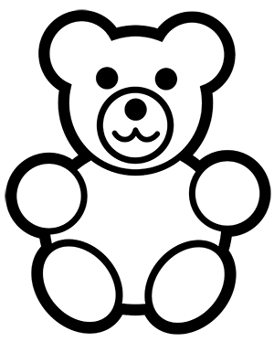
Introduction:

You are a bear-eating monster. There are two kinds of bears: happy bears and sad bears. You can tell the difference between them by the way they hold their hands. Happy bears hold their hands high in the air, and sad bears hold their hands down low. Happy bears taste sweet and are easy to catch. Sad bears taste bitter, are sneaky, and are hard to catch. Because of this, you eat only happy bears.

New bears are born every 'year' (during hibernation) and the birth rate is one new bear for every old bear left from the last year. The happy trait is recessive, so the happy bears are homozygous recessive. In addition, because the sad trait is dominant, the sad bears are either homozygous or heterozygous dominant.

Make a prediction ​about what will happen to the phenotypic and genotypic frequencies in the population after a few generations. Explain your reasoning.

Procedure:

1. Obtain a population of 10 bears and record the number of happy and sad bears and the total population number. Assume that the genotypes in your beginning population are homozygous dominant or recessive (there are no heterozygotes).

Using the equation for Hardy-Weinberg equilibrium, calculate the frequencies of both the dominant and recessive alleles and the genotypes that are represented in the population.

p²​ ​ + 2pq + q²​ ​ = 1 p + q = 1

Example:​ If 5 of the 10 bears are happy, then 10 out of 20 alleles would be happy alleles. Therefore, the ​q​²​ number would​ be 0.5. You must then determine the q ​ number by taking the square of 0.5.​

- Eat three happy bears. (If you do not have three happy bears, then eat the difference in sad bears.) You will use the remaining bears to produce offspring during breeding season. Each remaining bear will produce one new bear.

- Repeat this process for four generations of bears and construct a data table to show how many of happy and sad bears are in the population for each generation. Data should reflect the ​frequency​ of each type of bear.

Generation | p​²​ (sad) | 2pq (sad) | q​²​ (happy) | p | q
1 (initial)
2
3
4

- Using your data, construct a graph that will show what happens to the bear population over time. Use percentages of happy and sad bears for each generation. Changes in frequencies should be shown on the same graph.

Analysis

Prepare a short summary of what you observed in this activity that addresses the following:

  - What is happening to the genotype and allele frequencies in the population of Teddy Grahams?
  - What would you expect to happen if you continued the selection process for additional generations?
  - How would the frequencies change if you were to now select for the sad bears?
  - Why doesn’t the recessive allele disappear from the population? How is it protected?
AP BIOLOGY 2021-22 ACTIVITYChi Square (X²) Modeling Using Candy
https://www.biologycorner.com/worksheets/chi_square_candy.html
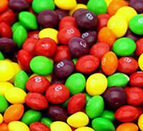
The Chi Square test is often used in science to determine if data you observe from an experiment is close enough to the predicted data. In genetics, for instance, you might expect to get a 75% to 25% ratio if you crossed two heterozygous tall plants (Tt x Tt). Calculating the X² values help you determine whether the results follow the prediction and if the variations from the exact ratio are due to random chance. It's the question of "how close is close enough?" If the numbers differ greatly from your expected results, then it's possible that other factors may be influencing your results.
The Chi-square test is intended to test how likely it is that an observed distribution is due to chance. It is also called a "goodness of fit" statistic, because it measures how well the observed distribution of data fits with the distribution that is expected if the variables are independent.
Another way to describe the Chi-square test is that it tests the null hypothesis that the variables are independent, that there is no relationship between the two things being tested. Wherever the observed data doesn't fit the model, the likelihood that the variables are dependent becomes stronger, thus proving the null hypothesis incorrect!

Question: Do Companies Selling Candy Equally Distribute Candy Colors in Bags?
Null Hypothesis: Candy is evenly distributed; each bag contains the same number of colors.
Alternate Hypothesis: One (or more) colors is found in greater frequency.
Materials: several bags of colored candy, such as M & M's, Skittles, Reese's Pieces, or Gummy Bears. You will need approximately 100-200 candies.

Procedure:
1) Look into the bag and determine how many colors are present and write them into Table 1
2) Without counting, estimate the number (percentage out of 100%) of each color and write them into Table 1 under "Percentage Expected"
3) Sort the candy and write down the number of each color into Table 1 under "Number Observed"
4) Complete the table by determining the total number of candies and "number expected" columns
Color of Candy | Percentage Estimate | Number Observed | Number Expected  (total # of candy x percentage estimate)
 |  | Total # of candies =
As you look at the data above, consider the two comparable numbers. The number you would expect to count if your percentage estimate was correct, and then the number you actually counted (number observed). For example, if you initially thought that you'd see 25% yellow candies, and you counted 200 pieces, you would then expect to see 50 yellow candies. You may have only counted 40 yellows.
The Chi Square (X²) Equation
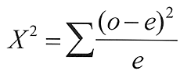
In order to complete the calculation, you sum each of the traits (colors) that you measured. To help you with this, we will break the process into steps.
 | Classes (colors) | Expected (e) | Observed (o) | 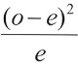
1
2
3
4
5
 | Sum (add the values from row 1-5); this is your X² value
Use the chi square chart below to determine if your X² supports or rejects your hypothesis.
The degree of freedom is determined by subtracting 1 from the number of colors you analyzed. (For example, if you had 4 colors to count, the degrees of freedom is 3)
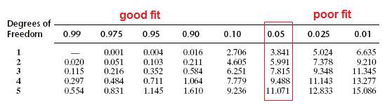

Summary and Analysis
1) What was your initial hypothesis?

2) How do you show that your hypothesis is correct (or incorrect)?

3) Explain what is meant by a "good fit"?

4) Propose a way that a chi square analysis could be used in other experiments, such as genetics or drug trials.

AP BIOLOGY 2021-22 READING GUIDE

Chapter 16: The Molecular Basis of Inheritance

Concept 16.1 DNA is the genetic material

- What are the two chemical components of chromosomes?

- Why did researchers originally think that protein was the genetic material?

- Distinguish between the virulent and nonvirulent strains of Streptococcus pneumoniae studied by Frederick Griffith.

- What was the purpose of Griffith’s studies?

- Use this figure to summarize the experiment in which Griffith became aware that hereditary information could be transmitted between two organisms in an unusual manner.
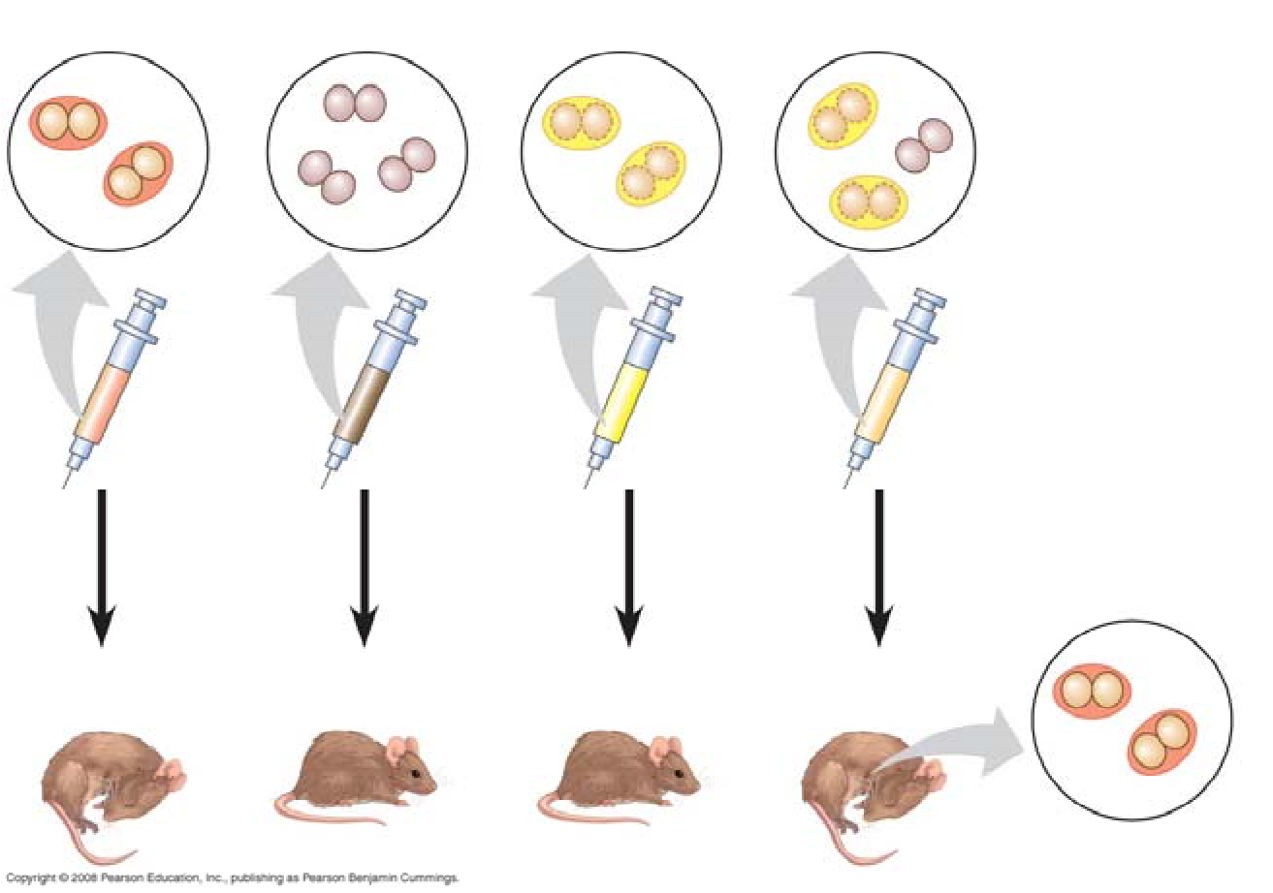
- Define transformation.

- What did Oswald Avery determine to be the transforming factor? ___________ Explain his experimental approach.

- Sketch a T2 bacteriophage and label its head, tail sheath, tail fiber, and DNA.

- How does a bacteriophage destroy a bacterial cell? Look ahead to Chapter 19, Figure 19.5, to explain this.

- How did Hershey and Chase “label” viral DNA and viral protein so that they could be distinguished? Explain why they chose each radioactive tag in light of the chemical composition of DNA and protein.
- Describe the means by which Hershey and Chase established that only the DNA of a phage enters an E. coli cell. What conclusions did these scientists draw based on these observations?

- What are Chargaff’s Rules? How did he arrive at them?

- List the three components of a nucleotide.

- Who built the first model of DNA and shared the 1962 Nobel Prize for discovery of its structure?

- What was the role of Rosalind Franklin in the discovery of the double helix?

- Distinguish between the structure of pyrimidines and purines. Explain why adenine bonds only to thymine.

- How did Watson and Crick’s model explain the basis for Chargaff’s rules?

- Given that the DNA of a certain fly species consists of 27.3% adenine and 22.5% guanine, use Chargaff’s rules to deduce the percentages of thymine and cytosine.

- Name the five nitrogenous bases and put a checkmark in the correct column for each base. Also indicate if the base is found in DNA (D), RNA (R), or both (B).

Nitrogenous Base | Purine | Pyrimidine | D, R or B

- Explain the base-pairing rule.

- Describe the structure of DNA relative to each of the following:
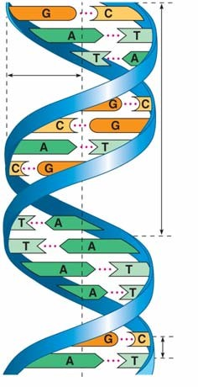
  - distance across molecule _______________________

  - distance between nucleotides ____________________

  - distance between turns _________________________

  - components of the backbone ____________________

  - components of the “rungs”_____________________

- Explain what is meant by 5' and 3' ends of the nucleotide.

- What do we mean when we say the two strands of DNA are antiparallel?

Concept 16.2 Many proteins work together in DNA replication and repair

- What is the semiconservative model of replication?

- Who performed the experiments that elucidated the correct mechanism of DNA replication?

- How did Meselson and Stahl create “heavy” DNA for their experiments?

- Use Figure 16.11 to explain how Meselson and Stahl confirmed the semiconservative mechanism of DNA replication.

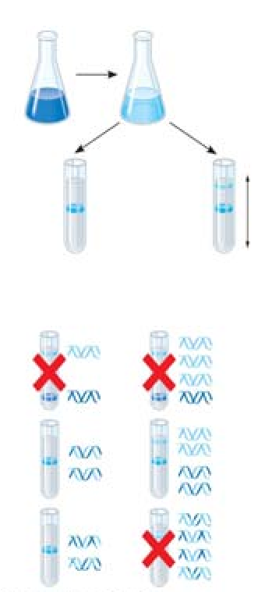
- Define the origins of replication.

- Distinguish between the leading and the lagging strands during DNA replication.

- What is the direction of synthesis of the new strand?

- What are Okazaki fragments? How are they welded together?

- Which enzyme . . .?
a. untwists and separates strands
b. holds DNA strands apart
c. synthesizes RNA primer
d. adds DNA nucleotides to new strand
e. relieves strain caused by unwinding
f. joins DNA fragments together
g. removes RNA primer and replaces with DNA

- Label the following figures. Include 3' and 5' strands, RNA primer, primase, SSBP, topoisomerase, helicase, leading strand, lagging strand, DNA pol I, DNA pol III, DNA ligase, parental DNA, and new DNA.
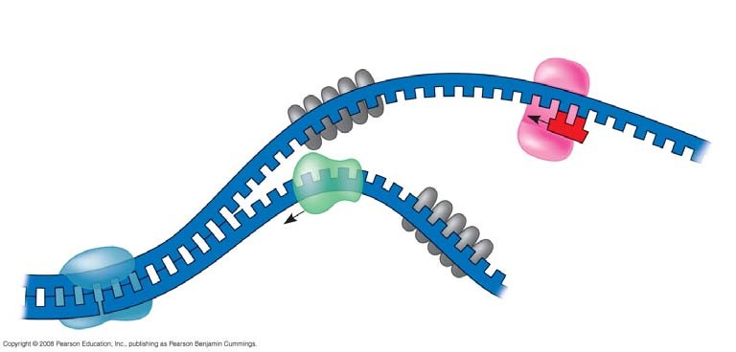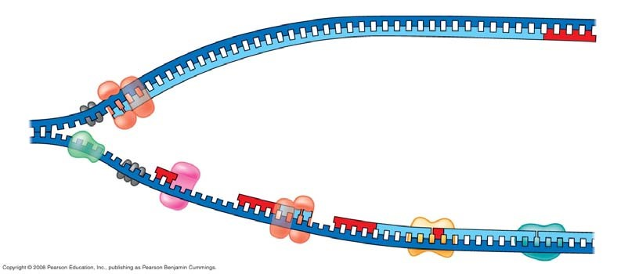

- Put it all together! Make a detailed list of the steps that occur in the synthesis of a new strand.

- Explain the roles of each of the following enzymes in DNA proofreading and repair.
Enzyme | Role
DNA polymerase
Nuclease
Ligase
Repair enzymes

- What is a thymine dimer? How might it occur? How is it repaired?

- Make a sketch of a chromosome and label the telomeres.

- Explain telomere erosion and the role of telomerase.

- Why are cancer cells immortal, but most body cells have a limited life span?

Concept 16.3 A chromosome consists of a DNA molecule packed together with proteins

- On the diagrams below, identify the following: 30-nm fiber, metaphase chromosome, double helix, histone proteins, nucleosomes, protein scaffold, and looped domains (300-nm fiber).

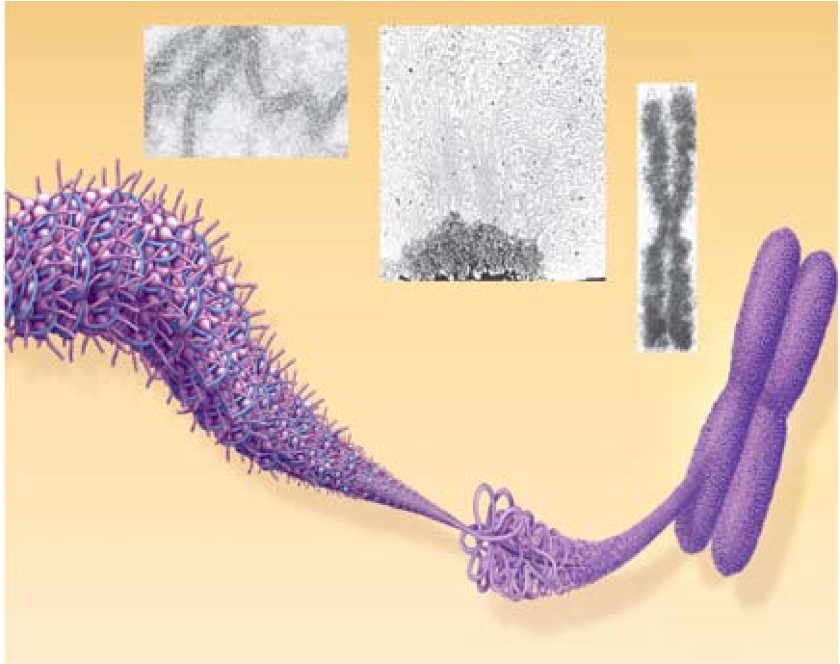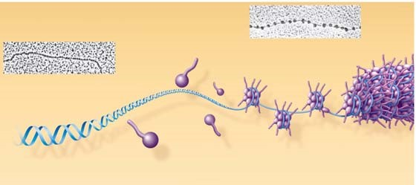

- Distinguish between heterochromatin and euchromatin.

