AP BIOLOGY 2021-22 January 19, 2022

Today’s Agenda (Day 90)

- Housekeeping Items

- Homework Check:

- Class Activity:
CONT’D: Chapter 15
- Section 15.3 – Linked genes tend to be inherited together
- Section 15.4 – Alterations of chromosome number or structure cause some genetic disorders
- Section 15.5 – Some inheritance patterns are exceptions to standard Mendelian inheritance

HOMEWORK:
- READ: Chapters 14 – 18
- COMPLETE: Ch 16 Reading Guide
- STUDY: Chapter 15 Test

Chapter 15 – Chromosomal Basis of Inheritance
aneuploidy | Barr body | chromosome theory of inheritance | Deletions | Down syndrome | duplications
genomic imprinting | Inversions | linkage map | linked genes | monosomy | nondisjunction
parental types | Polyploidy | recombinant types | sex-linked genes | Translocations | trisomy

Chapter 16 – Molecular Basis of Inheritance
Antiparallel | DNA ligase | DNA pol I | DNA pol III | DNA replication | double helix
Euchromatin | Helicase | Heterochromatin | Histone | lagging strand | leading strand
mismatch repair | Nucleases | Nucleosomes | nucleotide excision repair | Okazaki fragments | Phages
Primase | Primer | replication fork | semiconservative | Telomeres

REMINDERS:

- TEST: Chapter 15 January 20
- Ch 16 Vocabulary – Jan. 24
- QUIZ: Ch 15_16 Vocabulary Jan. 25
- Ch 16 Reading Guide – Jan. 26
- TEST: Chapter 16 January 27

AP BIOLOGY 2021-22 READING GUIDE

Chapter 16: The Molecular Basis of Inheritance

Concept 16.1 DNA is the genetic material

- What are the two chemical components of chromosomes?

- Why did researchers originally think that protein was the genetic material?

- Distinguish between the virulent and nonvirulent strains of Streptococcus pneumoniae studied by Frederick Griffith.

- What was the purpose of Griffith’s studies?

- Use this figure to summarize the experiment in which Griffith became aware that hereditary information could be transmitted between two organisms in an unusual manner.
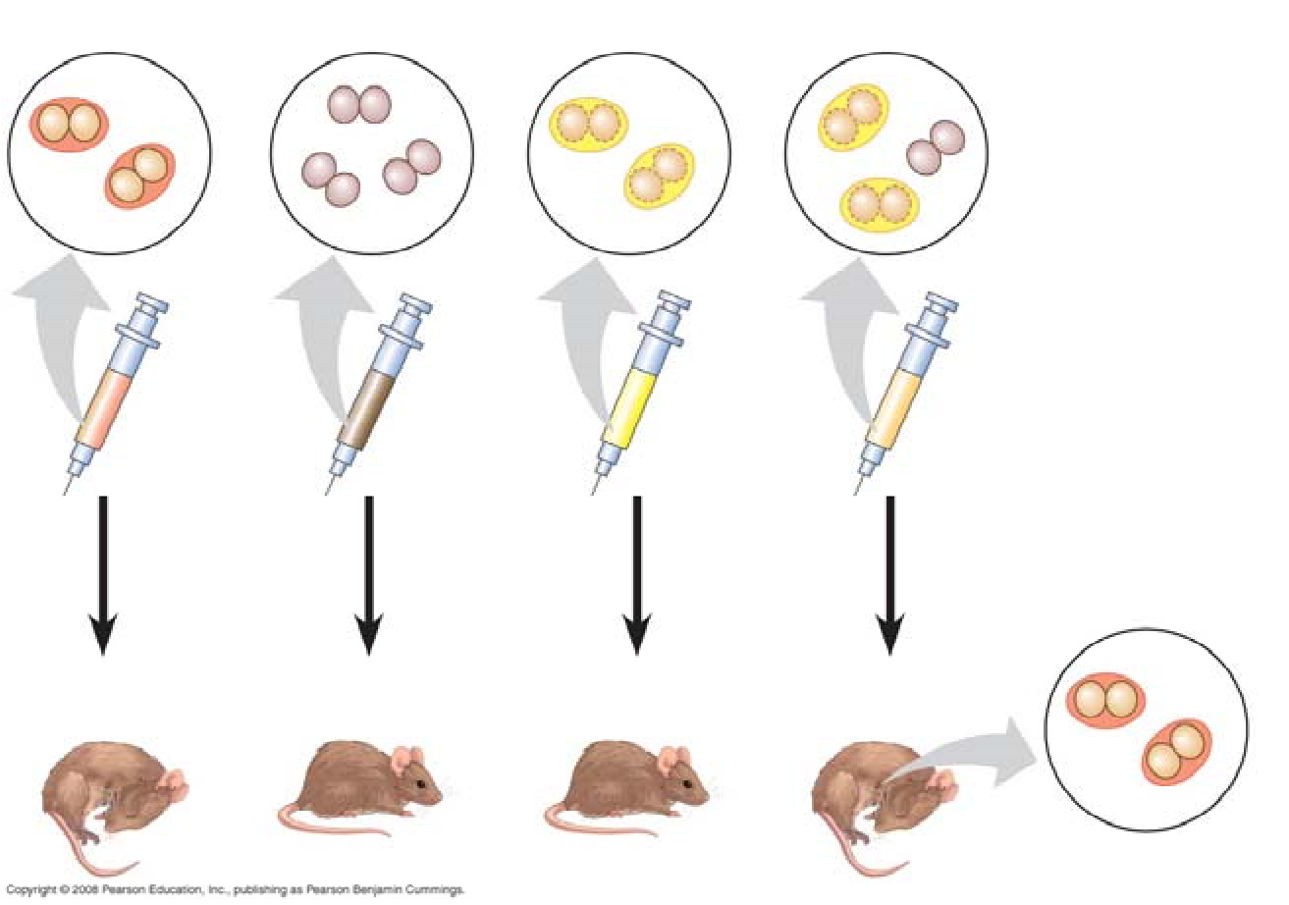
- Define transformation.

- What did Oswald Avery determine to be the transforming factor? ___________ Explain his experimental approach.

- Sketch a T2 bacteriophage and label its head, tail sheath, tail fiber, and DNA.

- How does a bacteriophage destroy a bacterial cell? Look ahead to Chapter 19, Figure 19.5, to explain this.

- How did Hershey and Chase “label” viral DNA and viral protein so that they could be distinguished? Explain why they chose each radioactive tag in light of the chemical composition of DNA and protein.
- Describe the means by which Hershey and Chase established that only the DNA of a phage enters an E. coli cell. What conclusions did these scientists draw based on these observations?

- What are Chargaff’s Rules? How did he arrive at them?

- List the three components of a nucleotide.

- Who built the first model of DNA and shared the 1962 Nobel Prize for discovery of its structure?

- What was the role of Rosalind Franklin in the discovery of the double helix?

- Distinguish between the structure of pyrimidines and purines. Explain why adenine bonds only to thymine.

- How did Watson and Crick’s model explain the basis for Chargaff’s rules?

- Given that the DNA of a certain fly species consists of 27.3% adenine and 22.5% guanine, use Chargaff’s rules to deduce the percentages of thymine and cytosine.

- Name the five nitrogenous bases and put a checkmark in the correct column for each base. Also indicate if the base is found in DNA (D), RNA (R), or both (B).

Nitrogenous Base | Purine | Pyrimidine | D, R or B

- Explain the base-pairing rule.

- Describe the structure of DNA relative to each of the following:
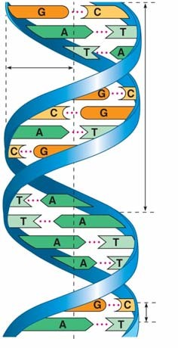
  - distance across molecule _______________________

  - distance between nucleotides ____________________

  - distance between turns _________________________

  - components of the backbone ____________________

  - components of the “rungs”_____________________

- Explain what is meant by 5' and 3' ends of the nucleotide.

- What do we mean when we say the two strands of DNA are antiparallel?

Concept 16.2 Many proteins work together in DNA replication and repair

- What is the semiconservative model of replication?

- Who performed the experiments that elucidated the correct mechanism of DNA replication?

- How did Meselson and Stahl create “heavy” DNA for their experiments?

- Use Figure 16.11 to explain how Meselson and Stahl confirmed the semiconservative mechanism of DNA replication.

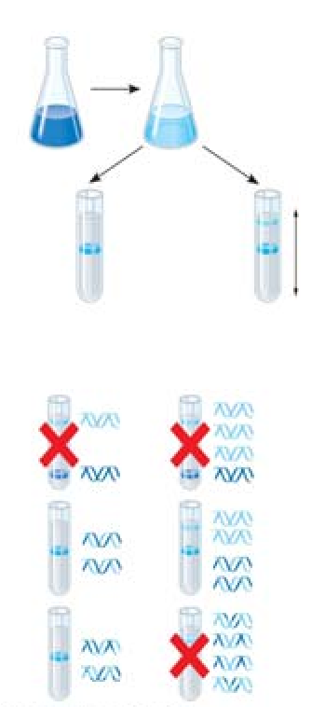
- Define the origins of replication.

- Distinguish between the leading and the lagging strands during DNA replication.

- What is the direction of synthesis of the new strand?

- What are Okazaki fragments? How are they welded together?

- Which enzyme . . .?
a. untwists and separates strands
b. holds DNA strands apart
c. synthesizes RNA primer
d. adds DNA nucleotides to new strand
e. relieves strain caused by unwinding
f. joins DNA fragments together
g. removes RNA primer and replaces with DNA

- Label the following figures. Include 3' and 5' strands, RNA primer, primase, SSBP, topoisomerase, helicase, leading strand, lagging strand, DNA pol I, DNA pol III, DNA ligase, parental DNA, and new DNA.
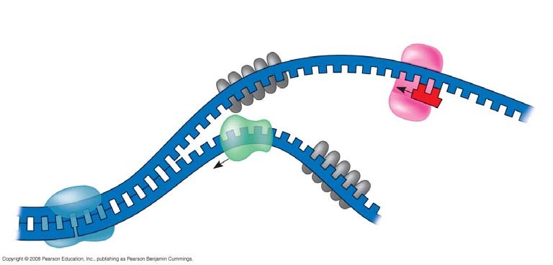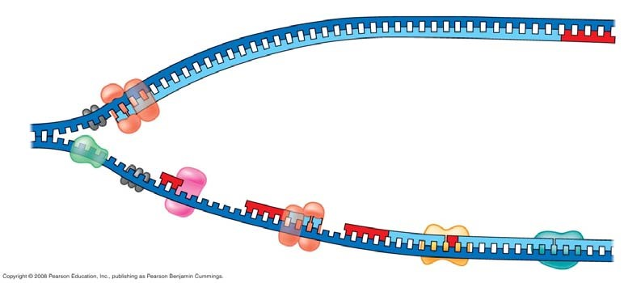

- Put it all together! Make a detailed list of the steps that occur in the synthesis of a new strand.

- Explain the roles of each of the following enzymes in DNA proofreading and repair.
Enzyme | Role
DNA polymerase
Nuclease
Ligase
Repair enzymes

- What is a thymine dimer? How might it occur? How is it repaired?

- Make a sketch of a chromosome and label the telomeres.

- Explain telomere erosion and the role of telomerase.

- Why are cancer cells immortal, but most body cells have a limited life span?

Concept 16.3 A chromosome consists of a DNA molecule packed together with proteins

- On the diagrams below, identify the following: 30-nm fiber, metaphase chromosome, double helix, histone proteins, nucleosomes, protein scaffold, and looped domains (300-nm fiber).

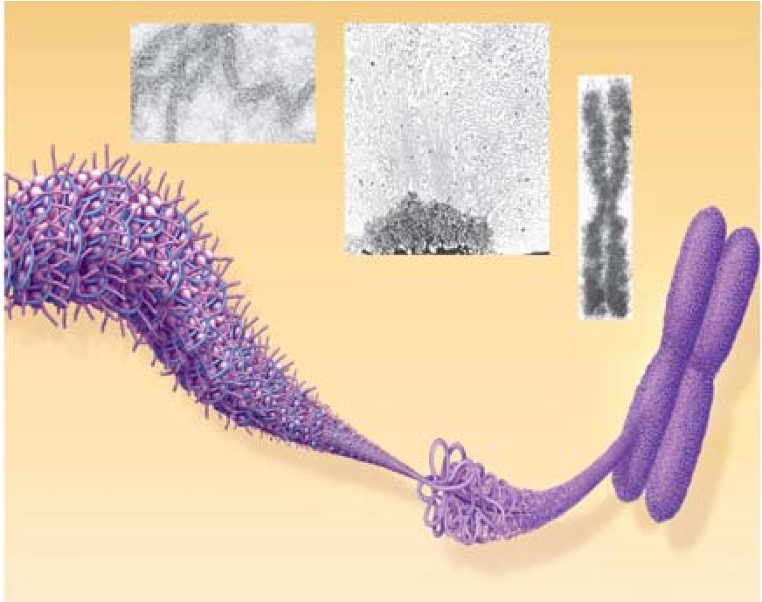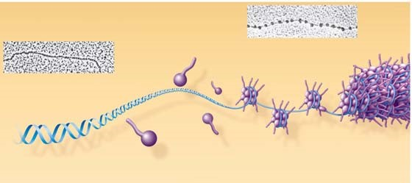

- Distinguish between heterochromatin and euchromatin.

