AP BIOLOGY 2021-22 January 12, 2022

Today’s Agenda (Day 85)

- Housekeeping Items

- Homework Check:

- Class Activity:
BEGIN: Chapter 15
- Section 15.1 – Morgan showed that Mendelian inheritance has its physical basis in behavior of chromosomes
- Section 15.2 – Sex-linked genes exhibit unique patterns of inheritance
- Section 15.3 – Linked genes tend to be inherited together
- Section 15.4 – Alterations of chromosome number or structure cause some genetic disorders
- Section 15.5 – Some inheritance patterns are exceptions to standard Mendelian inheritance

HOMEWORK:
- READ: Chapters 14 – 18
- COMPLETE: Chapter 15 Vocabulary & Reading Guide
- STUDY: Chapter 15 Test

Chapter 15 – Chromosomal Basis of Inheritance
aneuploidy | Barr body | chromosome theory of inheritance | Deletions | Down syndrome | duplications
genomic imprinting | Inversions | linkage map | linked genes | monosomy | nondisjunction
parental types | Polyploidy | recombinant types | sex-linked genes | Translocations | trisomy

REMINDERS:

- Chapter 15 Vocabulary – January 13
- Chapter 15 Reading Guide – January 14
- TEST: Chapter 15 January 18

AP BIOLOGY 2021-22 READING GUIDE

Chapter 15: The Chromosomal Basis of Inheritance

Concept 15.1 Mendelian inheritance has its physical basis in the behavior of chromosomes

- What is the chromosome theory of inheritance?

- Explain the law of segregation. Use two different colored pencils to illustrate the segregation of alleles. You may want to consult Figure 15.2 in your text and model your sketches on this.

F₁ Parent Cell

r
R
r
R

Haploid Gametes

- Explain the law of independent assortment. To demonstrate that you understand this concept, consider a cell with two pairs of chromosomes. Sketch the two different ways these chromosomes might be arranged during metaphase I.

- Thomas Hunt Morgan selected Drosophila melanogaster as his experimental organism. List at least three reasons the fruit fly is an excellent subject for genetic studies.

- The notation for wild type and mutant traits follows some accepted conventions. Notate the following genotypes for a female fruit fly:
  - a fly homozygous for red eyes
  - a fly heterozygous for red eyes
  - a fly homozygous for white eyes

- When Thomas Hunt Morgan mated a white-eyed male fly with a red-eyed female, he came to the startling conclusion that the trait for eye color was located on the chromosome that determines sex. Show this cross. Begin with the parental generation and go through the F₂.
parental generation

F₁ generation

F₂ generation

7. What unusual result suggested that the eye-color trait is located on the X chromosome?

Concept 15.2 Sex-linked genes exhibit unique patterns of inheritance

- There are several variations on the way sex is determined in different species. Complete Figure
15.6 (on the next page) to explain four different methods of sex determination.

- What is the SRY gene? Where is it found, and what does it do?

- What is the definition of a sex-linked gene?

- In humans, how has that term been historically modified?

- Name and describe three human sex-linked disorders.

- Try the following problem (Figure 15.7b in your text). A female who carries an allele for colorblindness, but who is not color-blind, mates with a male who has normal color vision. What is the probability that they will have a son who is color-blind? A Punnett square to use for this problem is shown below.
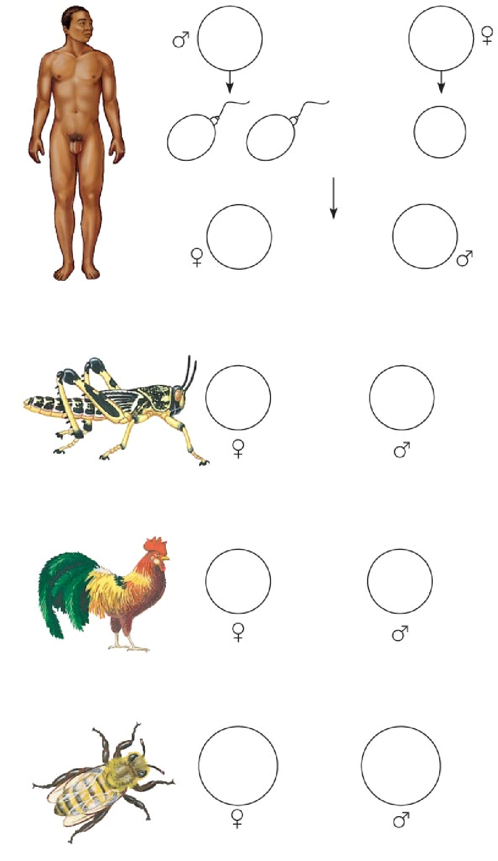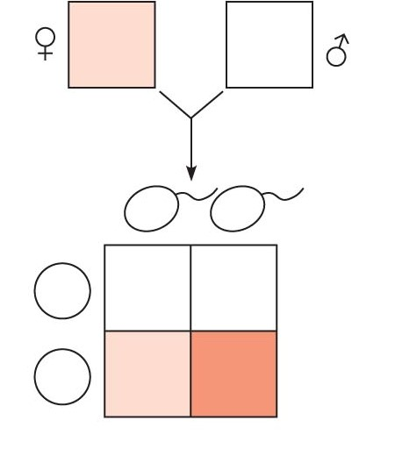

- What is a Barr body? Why do human females show a Barr body in their cells?
- X inactivation maintains the proper gene dosage How is the X chromosome inactivated?
- Why can you say that all calico cats are females?

Concept 15.3 Linked genes tend to be inherited together because they are located near each other on the same chromosome

- What are linked genes? Do linked genes sort independently?

- If two genes are linked on the same chromosome, we call this combination the parental combination. These genes will be transmitted as a unit and will not sort independently. However, during meiosis, crossing over occurs between homologous chromosomes, and the linked genes can become “unlinked.” In general, the farther two genes are from each other along the chromosome, the more often they will come “unlinked.” Genetic recombination is the process during which linked genes become unlinked. What do geneticists call the offspring that show these new combinations?

- Review meiosis. When does crossing over occur?

- Alfred H. Sturtevant, a student of Thomas Hunt Morgan, used assumptions from observations of crossovers to map genes. What is a linkage map?

- What is a map unit?

- Use the figure below, which is from Figure 15.10. It shows the results of a cross between a fruit fly that is heterozygous for gray body with normal wings, and a fruit fly that has a black body with vestigial wings. Because these genes are linked, the results are not what might have been predicted. Show the phenotypes and number of each type of offspring. Indicate which offspring are the recombinants and which are the parental type. Finally, calculate the map distance between the two genes. Show all your work here.

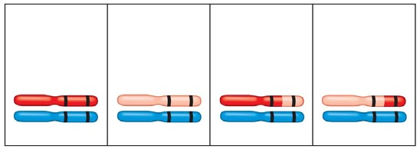

Concept 15.4 Alterations of chromosome number or structure cause some genetic disorders
- What occurs in nondisjunction?
- Explain each of the following terms:

aneuploidy monosomy trisomy polyploidy
- Which of these events results in Down syndrome? What are four characteristics of Down syndrome?

- For each of the following human aneuploidies, give the sex of the individual as well as any physical manifestation of the syndrome.
 | Sex | Physical Traits
XXY
XXX
XO
XYY

- Chromosome structure can be altered in several ways. Label each type of alteration shown in this figure and explain what occurs.

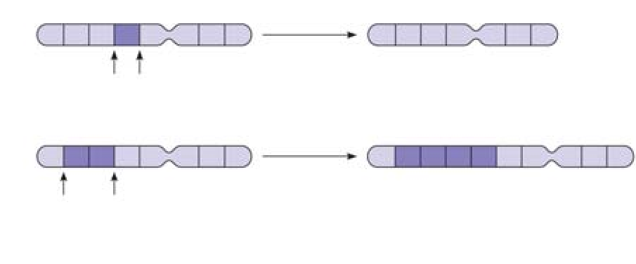
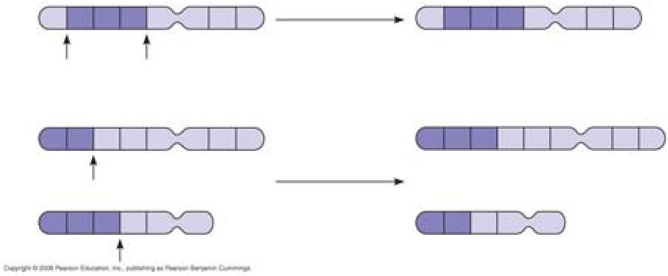
deletion

duplication

inversion

translocation

Concept 15.5 Some inheritance patterns are exceptions to the standard chromosome theory

- A number of genes will cause a variation in phenotype, depending on whether the gene came from the father or the mother. This variation occurs because of genomic imprinting. Explain genomic imprinting.

- Although you inherited one chromosome of each pair from your mother and your father, you have inherited a group of genes from your mother only. What genes are these?

- You should have identified mitochondrial DNA as the correct response to question 28 above. What other organelle has its own genes? These are extranuclear genes.

