AP BIOLOGY 2021-22 August 2, 2021

Today’s Agenda (Day 8)

- Housekeeping Items
REQUEST FOR ITEMS: a) Cake in a Mug next Friday
- Homework Check:
Chapter 1 Reading Guide
Lab Report: Lung Capacity
- Class Activity:
CONT’D: Chapter 1 PPT Review

HOMEWORK:
- READ: Chapters 1 – 3
- COMPLETE: Chapter 2 Reading Guide – see END of document
- STUDY: Chapter 1 & 2 Vocabulary Quiz
- STUDY: Chapter 1 Test
- MEMORIZE: Chemical elements and polyatomic ions – see p. 2 -3 of document

Chapter 1 Vocabulary
Adaptive radiation | Archaea | Bacteria | Bioinformatics | Biology | Biosphere
Community | Consumer | Controlled experiment | Deductive reasoning | Dependent variable | DNA
Domains | Ecosystem | Emergent property | Eukarya | Eukaryotic cell | Evolution
Experiment | Feedback regulation | Gene expression | Genes | Genome | Genomics
Hypothesis | Independent variables | Inductive reasoning | Inquiry | Model organism | Natural selection organisms
Population | Producer | Prokaryotic cell | Proteome | Proteomics | Qualitative data
Quantitative data | Systems biology | Technology | theory

Chapter 2 Vocabulary
Anion | Atom | Atomic mass | Atomic nucleus | Atomic number | Balance
Cation | Chemical bonds | Chemical equilibrium | Compound | Dalton | Double bond
Electron shells | Electronegativity | Electrons | Element | Energy | Essential elements
Half-life | Hydrogen bond | Ionic compound/salts | Ionic bond | Ion | Isotope
Mass number | Matter molecule | Neutron | Nonpolar covalent bond | Covalent bond | Orbital
Polar covalent bond | Potential energy | Product | Proton | Radioactive isotope | Radiometric dating
Reactant | Single bond | Trace elements | Valence electrons | Valance shell | Van der Waals interactions
REMINDERS:
- Chapter 2 Reading Guide – Monday, Aug. 30
- QUIZ: Ch 1 & 2 Vocabulary August 31
- TEST: Ch 1 & 2 Sept. 1
- TEST: Ch 3 & Chemical Symbols Sept. 8
AP BIOLOGY 2021-22 CHEMISTRY REVIEW
POLYATOMIC IONS TO MEMORIZE
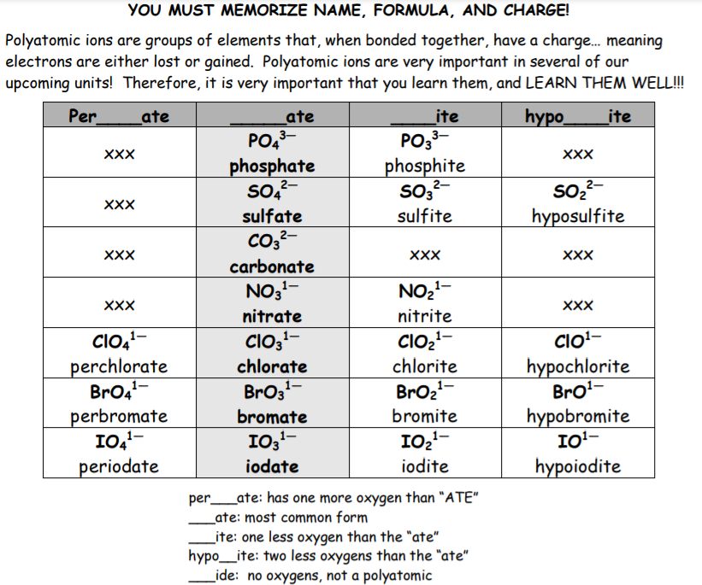
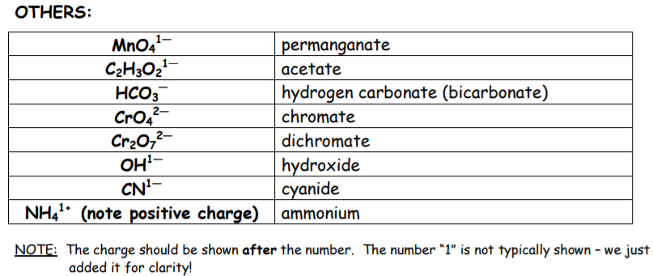
AP BIOLOGY 2021-22 CHEMISTRY REVIEW

Important elements
DIRECTIONS: Find the ionic charge for each of the elements listed below. Then memorize the element name, chemical symbol and ionic charge.

Symbol | Name | Ionic Charge | Symbol | Name | Ionic Charge | Symbol | Name | Ionic Charge
Al | Aluminum |  | F | Fluorine |  | O | Oxygen
As | Arsenic |  | Au | Gold |  | P | Phosphorus
Ba | Barium |  | He | Helium |  | Pt | Platinum
Be | Beryllium |  | H | Hydrogen |  | K | Potassium
B | Boron |  | Fe | Iron |  | Si | Silicon
Cd | Cadmium |  | Pb | Lead |  | Ag | Silver
Ca | Calcium |  | Mg | Magnesium |  | Na | Sodium
C | Carbon |  | Mn | Manganese |  | Sr | Strontium
Cl | Chlorine |  | Mo | Molybdenum |  | S | Sulfur
Cr | Chromium |  | Ne | Neon |  | Ti | Titanium
Co | Cobalt |  | Ni | Nickel |  | U | Uranium
Cu | Copper |  | N | Nitrogen |  | Zn | Zinc

AP BIOLOGY 2021-22 READING GUIDE

Chapter 2: The Chemical Context of Life

This chapter covers the basics that you may have learned in your chemistry class. Whether your teacher goes over this chapter or assigns it for you do review on your own, the questions that follow should help you focus on the most important points.

Concept 2.1 Matter consists of chemical elements in pure form and in combinations called compounds

1. Define and give an example of the following terms:

Define Example

matter

element

compound
- What four elements make up 96% of all living matter?

- What is the difference between an essential element and a trace element?
essential element

trace element

Concept 2.2 An element’s properties depend on the structure of its atoms

- Sketch a model of an atom of helium, showing the: electrons, protons, neutrons, and atomic nucleus.

- What is the atomic number of helium? _________ Its atomic mass? ________

- Here are some more terms that you should firmly grasp. Define each term: neutron, proton, electron, atomic number, atomic mass, isotope, electron shells , energy

- Consider this entry in the periodic table for carbon: C⁶ ₁₂

What is the atomic mass? ______ atomic number? _______

How many electrons does carbon have? _______ neutrons? _______

- Which is the only subatomic particle that is directly involved in the chemical reactions between atoms?

- What is potential energy?

- Explain which has more potential energy in each pair:

  - boy at the top of a slide/boy at the bottom

  - electron in the first energy shell/electron in the third energy shell

  - water/glucose

- What determines the chemical behavior of an atom?

- Here is an electron distribution diagram for sodium:

  - How many valence electrons does it have? ______ Circle the valence electron(s).

  - How many protons does it have? ______
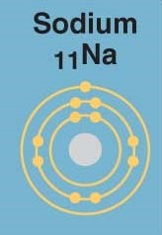

Concept 2.3 The formation and function of molecules depend on chemical bonding between atoms
- Define molecule.

- Now, refer back to your definition of a compound and fill in the following chart:

 | Molecule? (y/n) | Compound? (y/n) | Molecular Formula | Structural Formula
Water
Carbon dioxide
Methane
O₂ |  |  | O₂

- What type of bond is seen in O₂? Explain what this means.

- What is meant by electronegativity?

- Explain the difference between a nonpolar covalent bond and a polar covalent bond.

- Make an electron distribution diagram of water. Which element is most electronegative? Why is water considered a polar molecule? Label the regions that are more positive or more negative. (This is a very important concept. Spend some time with this one!)

- Another bond type is the ionic bond. Explain what is happening in the figure below (2.14):
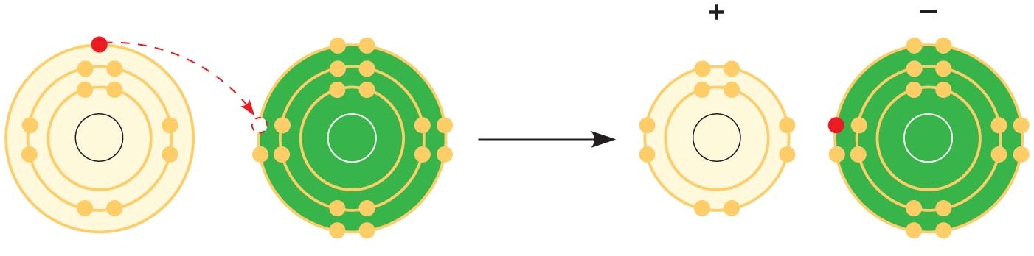
- What two elements are involved above?

- Define anion and cation. In the preceding example, which is the anion?

- What is a hydrogen bond? Indicate where the hydrogen bond occurs in this figure.
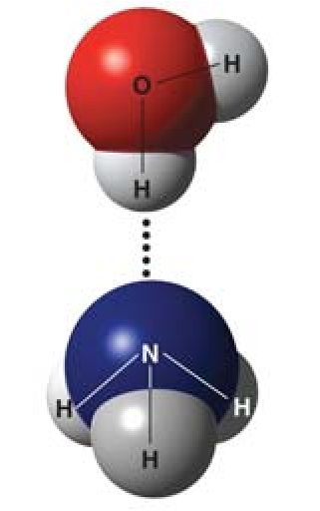

- Explain van der Waals interactions. Though they represent very weak attractions, when these interactions are numerous they can stick a gecko to the ceiling!

- Here is a list of the types of bonds and interactions discussed in this section. Place them in order from the strongest to the weakest: hydrogen bonds, van der Waals interactions, covalent bonds, ionic bonds.

STRONG

WEAK

25. Use morphine and endorphins as examples to explain why molecular shape is crucial in biology.

Concept 2.4 Chemical reactions make and break chemical bonds
- Write the chemical shorthand equation for photosynthesis. Label the reactants and the products.

- For the equation you just wrote, how many molecules of carbon dioxide are there? _____

How many molecules of glucose? _________ How many elements in glucose? _________

- What is meant by dynamic equilibrium? Does this imply equal concentrations of each reactant and product?

Testing Your Knowledge: Self-Quiz Answers
Now you should be ready to test your knowledge. Place your answers here:

