AP BIOLOGY 2021-22 January 4, 2022

Today’s Agenda (Day 79)

- Housekeeping Items

- Homework Check:

- Class Activity:
BEGIN: Chapter 14 PPT Review
- Section 14.1 – Mendel used scientific approach to identify two laws of inheritance
- Section 14.2 – Probability laws govern Mendelian inheritance
- Section 14.3 – Inheritance patterns are often more complex than predicted by simple Mendelian genetics
- Section 14.4 – Many human traits follow Mendelian patterns of inheritance

HOMEWORK:
- READ: Chapters 14 - 18
- COMPLETE: Ch 14 Vocabulary and Reading Guide
- STUDY: Chapter 14 Test
Chapter 14 – Mendel and the Gene Idea
Addition rule | Alleles | Amniocentesis | Carriers | Chorionic villus sampling | Dihybrids
Dominant allele | Heterozygotes | Homozygotes | Law of independent assortment | Law of segregation | Monohybrids
Multifactorial | Multiplication rule | Pedigrees | Recessive allele | True breeding

REMINDERS:

- Ch 14 Vocabulary – Jan. 6
- Ch 14 Reading Guide – Jan. 7
- TEST: Chapter 14 January 11

AP BIOLOGY 2021-22 READING GUIDE

Chapter 14: Mendel and the Gene Idea

Overview:

1. In the 1800s the most widely favored explanation of genetics was blending. Explain the concept of blending, and then describe how Mendel’s particulate (gene) theory was different.

Concept 14.1 Mendel used the scientific approach to identify two laws of inheritance

- One of the keys to success for Mendel was using pea plants. Explain how using pea plants allowed Mendel to control mating; that is, how did this approach let Mendel be positive about the exact characteristics of each parent?

- Define the following terms. Then, consider your own family. Which generation would your mom’s grandparents be? Your Mom? You?

P generation

F₁ generation

F₂ generation
- Explain how Mendel’s simple cross of purple and white flowers did the following:

refuted blending

determined dominant and recessive characteristics

demonstrated the merit of experiments that covered multiple generations

- Alternate versions of the same gene, like purple and white flower color, are termed
_____________.
- On the figure at below, label the allele for both purple and white flower color, a homologous pair, and the locus of the flower color gene.
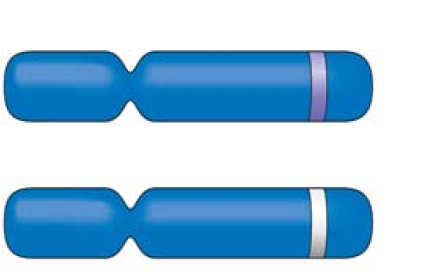

- In sexually reproducing organisms, why are there exactly two chromosomes in each homologue?

- Mendel’s model consists of four concepts. Describe each concept in the appropriate space below. Indicate which of the concepts can be observed during meiosis by placing an asterisk by the concept.

Mendel’s Four Concepts | Description of Concept
1st concept
2nd concept
3rd concept
4th concept
(law of segregation)
- Using Figure 14.5 as your guide, provide the missing notations for the figure below. (P, F₁, F₂).

  - What is the F₂ phenotypic and genotypic ratio?

  - Which generation is completely heterozygous?

  - Which generation has both heterozygous and homozygous offspring?

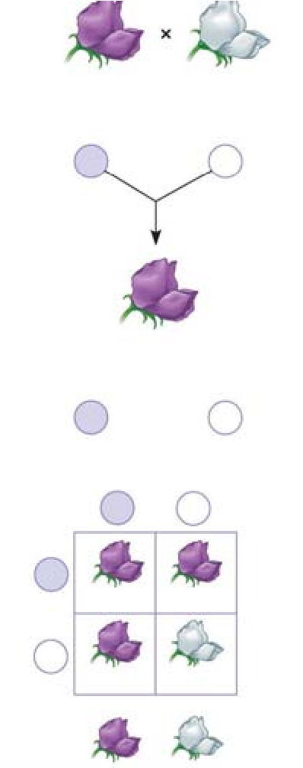

- In pea plants, T is the allele for tall plants, while t is the allele for dwarf plants. If you have a tall plant, demonstrate with a test cross how it could be determined if the plant is homozygous tall or heterozygous tall.

- Explain the difference between a monohybrid cross and a dihybrid cross.

- As you start to work word problems in genetics, two things are critical: the parent’s genotype must be correct, and the gametes must be formed correctly. Using Figure 14.8 as your guide, explain how the gametes are derived for the following cross. (You should have four different gametes).

YyRr × YyRr

- Complete the cross given in questions 12 by placing the gametes in a Punnett square. Then provide the phenotypic ratio of the offspring.

Phenotypes/Phenotypic Ratio

14. Explain Mendel’s law of independent assortment

Concept 14.2 The laws of probability govern Mendelian inheritance
- An event that is certain to occur has a probability of _______, while an event that is certain not to occur has a probability of ________.
- In probability, what is an independent event?

- State the multiplication rule and give an original example.

- State the addition rule and give an original example.

- What is the probability that a couple will have a girl, a boy, a girl, and a boy in this specific order?

Concept 14.3 Inheritance patterns are often more complex than those predicted by simple Mendelian genetics

- Explain how incomplete dominance is different from complete dominance and give an example of incomplete dominance.

- Compare and contrast codominance with incomplete dominance.

- Dominant alleles are not necessarily more common than recessive alleles in the gene pool. Explain why this is true.

- Explain what is meant when a gene is said to have multiple alleles.

- Blood groups are so important medically that you should be able to solve genetics problems based on blood types. The first step in accomplishing that is to understand the genotypes of each blood type. Before working any problems, complete this ABO blood type chart.

Genotype | Red Blood Cell Appearance | Phenotype (blood group)

- Question 2 in the 14.3 Concept Check is a blood type problem. Complete it here and show your work.

- What is pleiotropy? Explain why this is important in diseases like cystic fibrosis and sickle cell disease.

- Explain epistasis.

- Explain why the dihybrid cross detailed in Figure 14.12 has 4 white mice instead of the 3 that would have been predicted by Mendel’s work.

- Why is height a good example of polygenic inheritance?

- Quantitative variation usually indicates ______________________________.

- Using the terms norm of reaction and multifactorial, explain the potential influence of the environment on phenotypic expression.

Concept 14.4 Many human traits follow Mendelian patterns of inheritance
- Pedigree analysis is often used to determine the mode of inheritance (dominant or recessive, for example). Be sure to read the “Tips for pedigree analysis” in Figure 14.15; then complete the unlabeled pedigree by indicating the genotypes for all involved. What is the mode of inheritance for this pedigree?
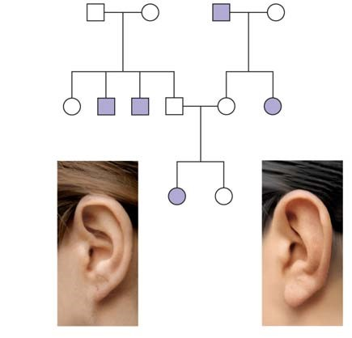
- Explain why you know the genotype of one female in the third generation but are unsure of the other.

- Describe what you think is important to know medically about the behavior of recessive alleles.

- Students are expected to have a general knowledge of the pattern of inheritance and the common symptoms of a number of genetic disorders. Provide this information for the disorders listed below.

  - cystic fibrosis

  - sickle-cell disease

  - achondroplasia

d. Huntington’s disease

- Amniocentesis and chorionic villus sampling are the two most widely used methods for testing a fetus for genetic disorders. Use the unlabeled diagram below to explain the three main steps in amniocentesis and the two main steps of CVS.

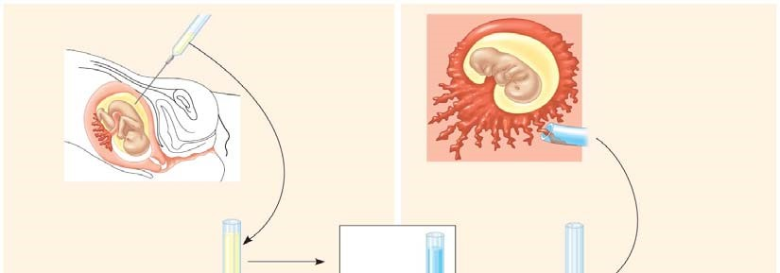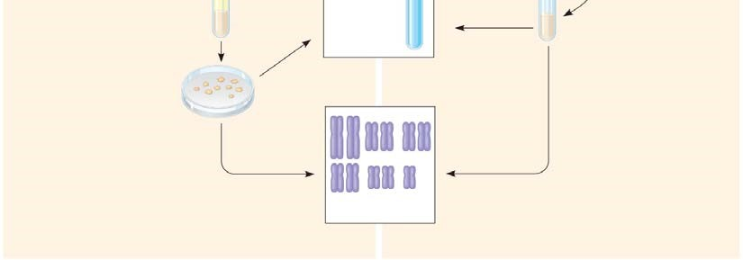

- What are the strengths and weaknesses of each fetal test?

- Explain the symptoms of phenylketonuria and describe how newborn screening is used to identify children with this disorder.

