AP BIOLOGY 2021-22 December 9, 2021

Today’s Agenda (Day 71)

- Housekeeping Items

- Homework Check:
Chapter 12 Vocabulary
Chapter 12 Reading Guide

- Class Activity:
TEST: Chapter 12
*Go to www.socrative.com enter room “MSBAPBIO” enter ID #

HOMEWORK:
- READ: Chapters 11 – 13
- COMPLETE: College Board Progress Check Questions [units 1 – 4]
- STUDY: Midterms

REMINDERS:

- TEST: Chapter 12 Dec. 9
- Chapter 13 Vocabulary – Dec. 10
- Chapter 13 Reading Guide – Dec. 13
Allele | Alternation of generations | Asexual reproduction | Autosomes | Chiasmata | Clone
Crossing over | Diploid cell | Fertilization | Genes | Genetics | Haploid cell
Heredity | Homologous chromosomes (homologs) | Karyotype | Life cycle | Locus | Meiosis
Meiosis I | Meiosis II | Recombinant chromosomes | Sex chromosomes | Sister chromatid cohesion | Synapsis
Synaptonemal complex | Variation | zygote
- MIDTERM: Covers Ch 1 – 13

Chapter 13 – Meiosis and Sexual Life Cycle

AP BIOLOGY 2021-22 READING GUIDE

Chapter 13: Meiosis and Sexual Life Cycles

Concept 13.1 Offspring acquire genes from parents by inheriting chromosomes

- Let’s begin with a review of several terms that you may already know. Define:

gene locus gamete male gamete
female gamete asexual reproduction sexual reproduction
- How many chromosomes are in human cells? What is a chromosome?
- Which type of reproduction will result in genetically identical offspring?

Concept 13.2 Fertilization and meiosis alternate in sexual life cycles
- What is a somatic cell? Give examples of two human somatic cell types.
- How does a somatic cell compare to a gamete in terms of chromosome number?

- Distinguish between sex chromosomes and autosomes. How many of each are found in human cells?

 | Explanation | # in Human Cells
Sex chromosome
Autosome

- What is a karyotype? How is it prepared? What are three things that can be determined from a karyotype?

- Explain what is meant by homologous chromosomes.
- Cells that have only one of each homologous pair are said to be haploid, a condition that is represented by n. Cells that have two of each homologous pair are said to be diploid or 2n. For each of the following, is the cell haploid or diploid?

liver cell____________________________ gamete________________________________

egg_________________________________ zygote________________________________

skin cell_____________________________ sperm ________________________________

somatic cell__________________________ sex cell_______________________________

- The muscle cells of a dog have 78 chromosomes. Fill in the correct chromosome number in a:

bone cell_______ sperm_______ haploid cell_______ somatic cell_______ zygote_______

- In the cell at right, the chromosomes are shaded in two colors to represent the parent of origin. On this sketch, label the following:

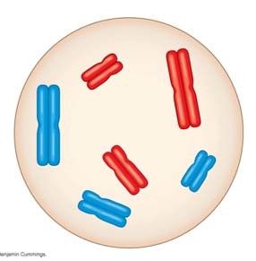
- sister chromatids

- homologous chromosomes

- centromere

- replicated chromosome

e. maternal chromosomes

- How many chromosomes does the cell above have?

How many homologous pairs?

How many chromatids?

Is this cell haploid or diploid?

- Where are the gametes of an animal produced? Be specific as to male and female gametes.

- By what process are gametes produced?

- What is another term for a fertilized egg? __________________What is the chromosome number of the fertilized egg? (Answer this in general terms, haploid, n, or diploid, 2n.)

- What is the purpose of meiosis?
- Study Figure 13.6. You will see that plants have a life cycle that involves spores, which form because of meiosis, so these spores are haploid. Notice also that both haploid and diploid cells can divide by mitosis. However, meiosis always begins with cells that are _________________, and because of meiosis, daughter cells are formed that are always _________________. These cells can be gametes (in animals) or spores (in plants).

- Your study of plants this year will include knowing that they exhibit alternation of generations.

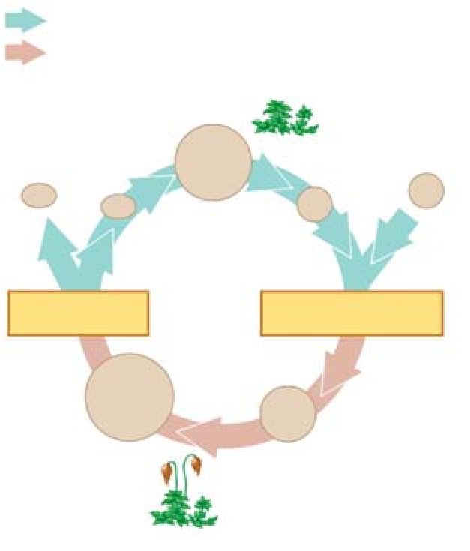
What does this mean?

What are the two generations?

Which is haploid, and which is diploid?

Use this information to label the moss life cycle here.

Concept 13.3 Meiosis reduces the number of chromosome sets from diploid to haploid

- What are alleles? Give an example.
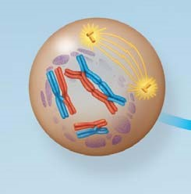
- In meiosis, the DNA is replicated during interphase, followed by two divisions. The first division is meiosis I. Study the events of prophase I as they are significant. Explain each of these events:

synapsis

crossing over PROPHASE I

chiasmata

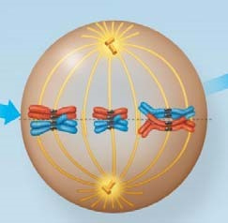
- The figure at the right shows metaphase I. How is the arrangement of chromosomes different from metaphase of mitosis?

METAPHASE I

- There will be two divisions in meiosis. What will separate in the first division in meiosis I?
- Now study the chromosomes in anaphase I and telophase I carefully. How many chromosomes are in each cell at the end of the first meiotic division?

Are the resultant daughter cells haploid, or diploid?

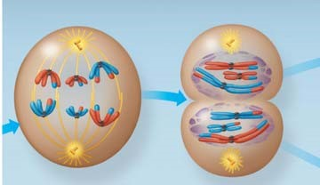
ANAPHASE I TELOPHASE I

- From this figure, you should see that chromosome number is reduced in meiosis I and that the daughter cells at the end of meiosis I are haploid. Remember this!

- During meiosis I, homologous chromosomes separate. What separates during meiosis II?

- To check that you have the big picture, here are some quick review questions.
  - What happens to chromosome number in meiosis?
  - During which division is the chromosome number reduced?
  - What is the purpose of meiosis?
  - How many times does the cell divide in meiosis?
  - How many times do the chromosomes duplicate?
  - How many daughter cells are formed?
  - What is the chromosome number?
  - What are homologs (homologous chromosomes)?
  - What occurs in synapsis?
  - What is crossing over?

- Use Figure 13.9 to compare of mitosis and meiosis. Add these labels:

Parent cell, Mitosis, Meiosis, Synapsis, Homologous chromosomes, Replicated chromosomes, Sister chromatids, Daughter cells, Meiosis I, Meiosis II, Crossing over

As you label the drawing, carefully think about each process and review its important features.
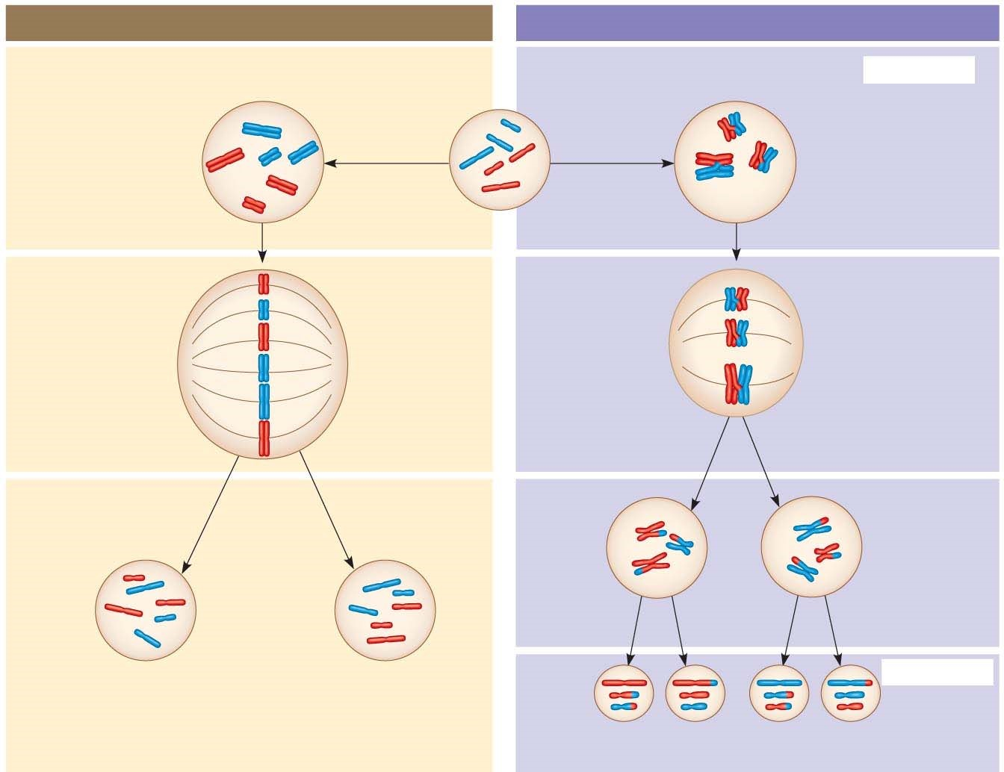

- Students often get confused about the differences between mitosis and meiosis. To help with this, work through the following chart:
 | Mitosis | Meiosis
Role in the animal body
Number of DNA replications
Number of divisions
Number of daughter cells
Chromosome number of daughter cells

- Synapsis and crossing over are unique to meiosis. During what specific phase do these occur?
- Explain the physical events of crossing over. You may wish to make a sketch of the event. Include these terms: synaptonemal complex, chiasmata, homologs, sister chromatids.

Concept 13.4 Genetic variation produced in sexual life cycles contributes to evolution

- An important idea for you to understand is that new alleles arise by changes in the DNA or mutation, but genetic diversity occurs when the deck that is dealt is simply reshuffled. So, there are three ways that sexually reproducing organisms “shuffle the deck.” They are listed below. Explain what occurs in each, and how this increases diversity.

independent assortment of chromosomes
crossing over
random fertilization

