AP BIOLOGY 2021-22 December 6, 2021

Today’s Agenda (Day 68)

- Housekeeping Items

- Homework Check:
Chapter 12 Vocabulary
- Class Activity:
CONT’D: Chapter 12 PPT Review
- Section 12.2 – The mitotic phase alternates with interphase in cell cycle
- Section 12.3 – Eukaryotic cell cycle is regulated by molecular control system

HOMEWORK:
- READ: Chapters 11 – 13
- STUDY: Chapter 12 Test
Chapter 12 – Cell Cycle
Anaphase | Anchorage dependence | Aster | Benign tumor | Binary fission | Cell cycle
Cell cycle control system | Cell division | Cell plate | Centromere | Centrosome | Checkpoint
Chromatin | Chromosomes | Cleavage | Cleavage furrow | Cyclin-dependent kinase | Cytokinesis
Density-dependent inhibition | G0 phase | G1 phase | G2 phase | Gametes | Genome
Growth factor | Interphase | Kinetochore | Malignant tumor | Metaphase | Metaphase plate
Metastasis | Mitosis | Mitotic spindle | Maturation promoting factor (MPF) | Origin of replication | Prometaphase
Prophase | S phase | Sister chromatids | Somatic cells | Telophase | transformation
REMINDERS:

- Chapter 12 Reading Guide – Dec. 7
- TEST: Chapter 12 Dec. 9
- Chapter 13 Vocabulary – Dec. 10
- Chapter 13 Reading Guide – Dec. 13
Allele | Alternation of generations | Asexual reproduction | Autosomes | Chiasmata | Clone
Crossing over | Diploid cell | Fertilization | Genes | Genetics | Haploid cell
Heredity | Homologous chromosomes (homologs) | Karyotype | Life cycle | Locus | Meiosis
Meiosis I | Meiosis II | Recombinant chromosomes | Sex chromosomes | Sister chromatid cohesion | Synapsis
Synaptonemal complex | Variation | zygote
- MIDTERM: Covers Ch 1 – 13

Chapter 13 – Meiosis and Sexual Life Cycle

AP BIOLOGY 2021-22 READING GUIDE

Chapter 12: The Cell Cycle

Overview:

- What are the three key roles of cell division? State each role and give an example.

Key Role | Example

- What is meant by the cell cycle?
Concept 12.1 Cell division results in genetically identical daughter cells
- What is the meaning of genome? Compare your genome to that of a prokaryotic cell.
- How many chromosomes are in a human somatic cell?
- Name two types of somatic cells in your body.
- What is a gamete?
- Name the two types of gametes.
- How many chromosomes in a human gamete?
- Define chromatin.
- Think carefully, now. How many DNA molecules are in each of your somatic cells?
- You are going to have to learn the difference between several similar-sounding terms. The sketch that looks like an X represents a replicated chromosome that has two sister chromatids. The narrow “waist” represents the location of the centromere. Students often get all these terms confused, so take time now to label the indicated areas of the figure and then define each of the terms below.

chromosome chromatid centromere chromatin

- Study Figure 12.4. Label the figure below and summarize what occurs at the DNA level in each stage.
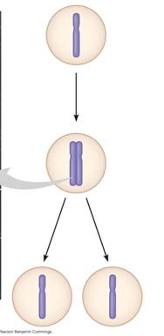
- What is mitosis? How is it different from cytokinesis?
- What occurs in meiosis? How is the chromosome number of daughter cells different?
- Select either mitosis or meiosis to answer the following questions.
___________________ By what process are the damaged cells in a wound replaced?
___________________ By what process are eggs formed?
___________________ By what process does a zygote develop into a multicellular organism?
___________________ In which process are identical daughter cells produced?
___________________ Which process reduces chromosome number of daughter cells?

- Don’t skip the Concept Check Questions! They are a good way to verify your understanding. Here is a variation of question 3. Answer it here: A hedgehog has 90 chromosomes in its somatic cells.
  - How many chromosomes did the hedgehog inherit from each parent?
  - How many chromosomes are in each of the hedgehog’s gametes?
  - How many chromosomes will be in each somatic cell of the hedgehog’s offspring?
Concept 12.2 The mitotic phase alternates with interphase in the cell cycle
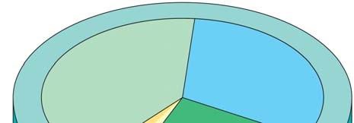
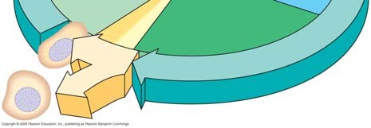
- Label each of the parts of the cell cycle listed below and give a brief explanation of what happens in each phase.
G₁
S
G₂
M

- What are the components of the mitotic spindle? What is the source of these components?

- In animal cells, the assembly of spindle microtubules starts at the centrosome. What is another name for the centrosome?

- Sketch and label a centrosome with two centrioles.

- Describe what happens to the centrosome during interphase and then prophase.

- What is a kinetochore? Read your text carefully, and then make a labeled sketch that shows a replicated chromosome with two kinetochores and some attached spindle fibers. Figure 12.7 may help.
- You will need to spend some serious time with Figure 12.6. Use it to help you label this figure. Label each phase by name; then label the smaller structures. Finally, make 2 or 3 summary statements that indicate important features to note about the phase.
Phase | Important Feature of Phase
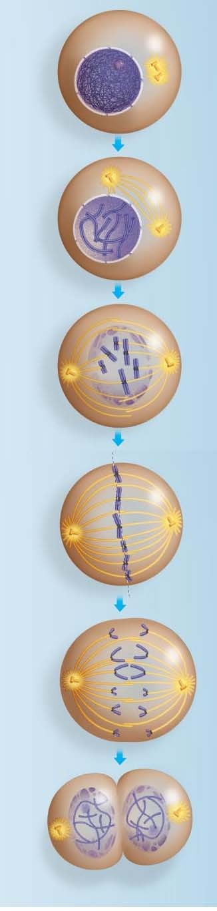

- Explain the difference between kinetochore and non-kinetechore microtubules. What is the function of each?

- What are the components of the mitotic spindle?

- At which end do kinetochore microtubules shorten during anaphase? Explain the data that supports where this shortening occurs.
- Describe cytokinesis in an animal cell. Use a labeled sketch that shows the cleavage furrow.

- Describe cytokinesis in a plant cell. Use a labeled sketch that shows the cell plate.

- How is the cell plate formed? What is the source of the material for the cell plate?

- Prokaryote reproduction does not involve mitosis, but instead occurs by binary fission. This process involves an origin of replication. Describe binary fission.

- Notice that now you are learning several differences between prokaryotic and eukaryotic cells. Besides the fact that prokaryotes lack a membrane-bounded nucleus, describe the following differences:

Mode of reproduction?
Number of chromosomes?
Shape of the bacterial chromosome?

Concept 12.3 The eukaryotic cell cycle is regulated by a molecular control system

- What controls the cell cycle? Study the Inquiry Figure 12.13 to help you answer this question.
- What is a cell cycle checkpoint?
- Summarize what happens at each checkpoint. You may add to this chart as you study this section.

Checkpoint | What happens? How is it controlled?
G₁
G₂
M

- What is the G_{o} phase? Describe this phase.

- What is a protein kinase?
- Kinases drive the cell cycle, but they must be activated by attachment of a ________________.
- The activity of cyclin-dependent kinases (CDks) rises and falls. Why?
- What does MPF trigger? What are some specific activities that it triggers?

- What happens if all the chromosome kinetochores are not attached to spindle fibers? When this occurs, which checkpoint is not passed?

- What are growth factors? How does PDGF stimulate fibroblast division?

- Cancer cells exhibit different behaviors than normal cells. Here are two normal behaviors they no longer show. Explain each behavior.

density-dependent inhibition
anchorage dependence
- Cancer cells also show loss of cell cycle controls and may divide without being checked. The story of HeLa cells is worth noting. What is their source? How old are they? Note that, unlike normal cells, HeLa cells are immortal!

- What is transformation? metastasis?

- Distinguish between a benign tumor and a malignant tumor.

- List two specific cancer treatments and tell how each treatment works.

- Identify each phase of the cell cycle.

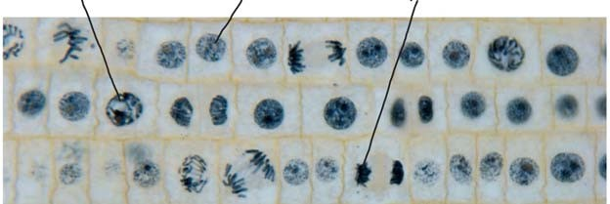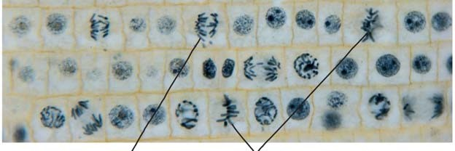

AP BIOLOGY 2021-22 READING GUIDE

Chapter 13: Meiosis and Sexual Life Cycles

Concept 13.1 Offspring acquire genes from parents by inheriting chromosomes

- Let’s begin with a review of several terms that you may already know. Define:

gene locus gamete male gamete
female gamete asexual reproduction sexual reproduction
- How many chromosomes are in human cells? What is a chromosome?
- Which type of reproduction will result in genetically identical offspring?

Concept 13.2 Fertilization and meiosis alternate in sexual life cycles
- What is a somatic cell? Give examples of two human somatic cell types.
- How does a somatic cell compare to a gamete in terms of chromosome number?

- Distinguish between sex chromosomes and autosomes. How many of each are found in human cells?

 | Explanation | # in Human Cells
Sex chromosome
Autosome

- What is a karyotype? How is it prepared? What are three things that can be determined from a karyotype?

- Explain what is meant by homologous chromosomes.
- Cells that have only one of each homologous pair are said to be haploid, a condition that is represented by n. Cells that have two of each homologous pair are said to be diploid or 2n. For each of the following, is the cell haploid or diploid?

liver cell____________________________ gamete________________________________

egg_________________________________ zygote________________________________

skin cell_____________________________ sperm ________________________________

somatic cell__________________________ sex cell_______________________________

- The muscle cells of a dog have 78 chromosomes. Fill in the correct chromosome number in a:

bone cell_______ sperm_______ haploid cell_______ somatic cell_______ zygote_______

- In the cell at right, the chromosomes are shaded in two colors to represent the parent of origin. On this sketch, label the following:

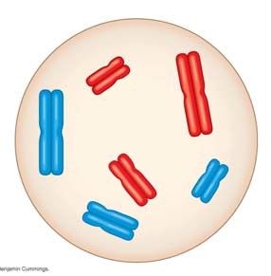
- sister chromatids

- homologous chromosomes

- centromere

- replicated chromosome

e. maternal chromosomes

- How many chromosomes does the cell above have?

How many homologous pairs?

How many chromatids?

Is this cell haploid or diploid?

- Where are the gametes of an animal produced? Be specific as to male and female gametes.

- By what process are gametes produced?

- What is another term for a fertilized egg? __________________What is the chromosome number of the fertilized egg? (Answer this in general terms, haploid, n, or diploid, 2n.)

- What is the purpose of meiosis?
- Study Figure 13.6. You will see that plants have a life cycle that involves spores, which form because of meiosis, so these spores are haploid. Notice also that both haploid and diploid cells can divide by mitosis. However, meiosis always begins with cells that are _________________, and because of meiosis, daughter cells are formed that are always _________________. These cells can be gametes (in animals) or spores (in plants).

- Your study of plants this year will include knowing that they exhibit alternation of generations.

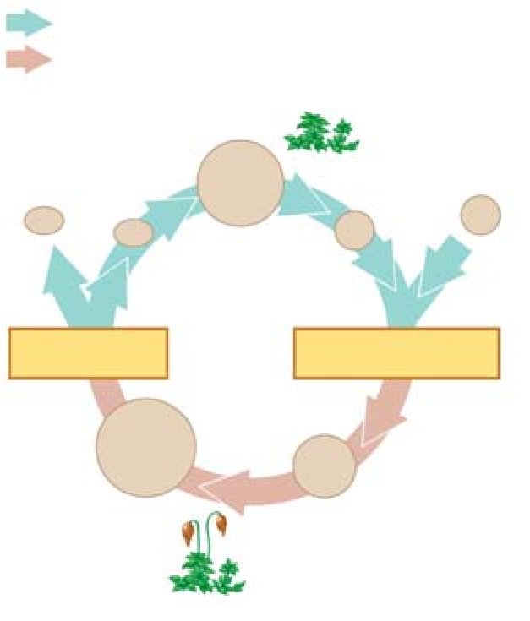
What does this mean?

What are the two generations?

Which is haploid, and which is diploid?

Use this information to label the moss life cycle here.

Concept 13.3 Meiosis reduces the number of chromosome sets from diploid to haploid

- What are alleles? Give an example.
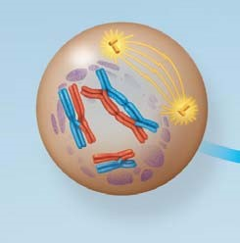
- In meiosis, the DNA is replicated during interphase, followed by two divisions. The first division is meiosis I. Study the events of prophase I as they are significant. Explain each of these events:

synapsis

crossing over PROPHASE I

chiasmata

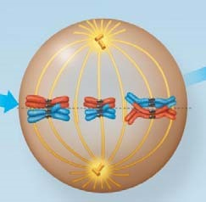
- The figure at the right shows metaphase I. How is the arrangement of chromosomes different from metaphase of mitosis?

METAPHASE I

- There will be two divisions in meiosis. What will separate in the first division in meiosis I?
- Now study the chromosomes in anaphase I and telophase I carefully. How many chromosomes are in each cell at the end of the first meiotic division?

Are the resultant daughter cells haploid, or diploid?

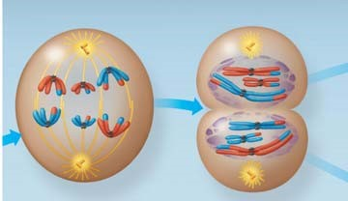
ANAPHASE I TELOPHASE I

- From this figure, you should see that chromosome number is reduced in meiosis I and that the daughter cells at the end of meiosis I are haploid. Remember this!

- During meiosis I, homologous chromosomes separate. What separates during meiosis II?

- To check that you have the big picture, here are some quick review questions.
  - What happens to chromosome number in meiosis?
  - During which division is the chromosome number reduced?
  - What is the purpose of meiosis?
  - How many times does the cell divide in meiosis?
  - How many times do the chromosomes duplicate?
  - How many daughter cells are formed?
  - What is the chromosome number?
  - What are homologs (homologous chromosomes)?
  - What occurs in synapsis?
  - What is crossing over?

- Use Figure 13.9 to compare of mitosis and meiosis. Add these labels:

Parent cell, Mitosis, Meiosis, Synapsis, Homologous chromosomes, Replicated chromosomes, Sister chromatids, Daughter cells, Meiosis I, Meiosis II, Crossing over

As you label the drawing, carefully think about each process and review its important features.
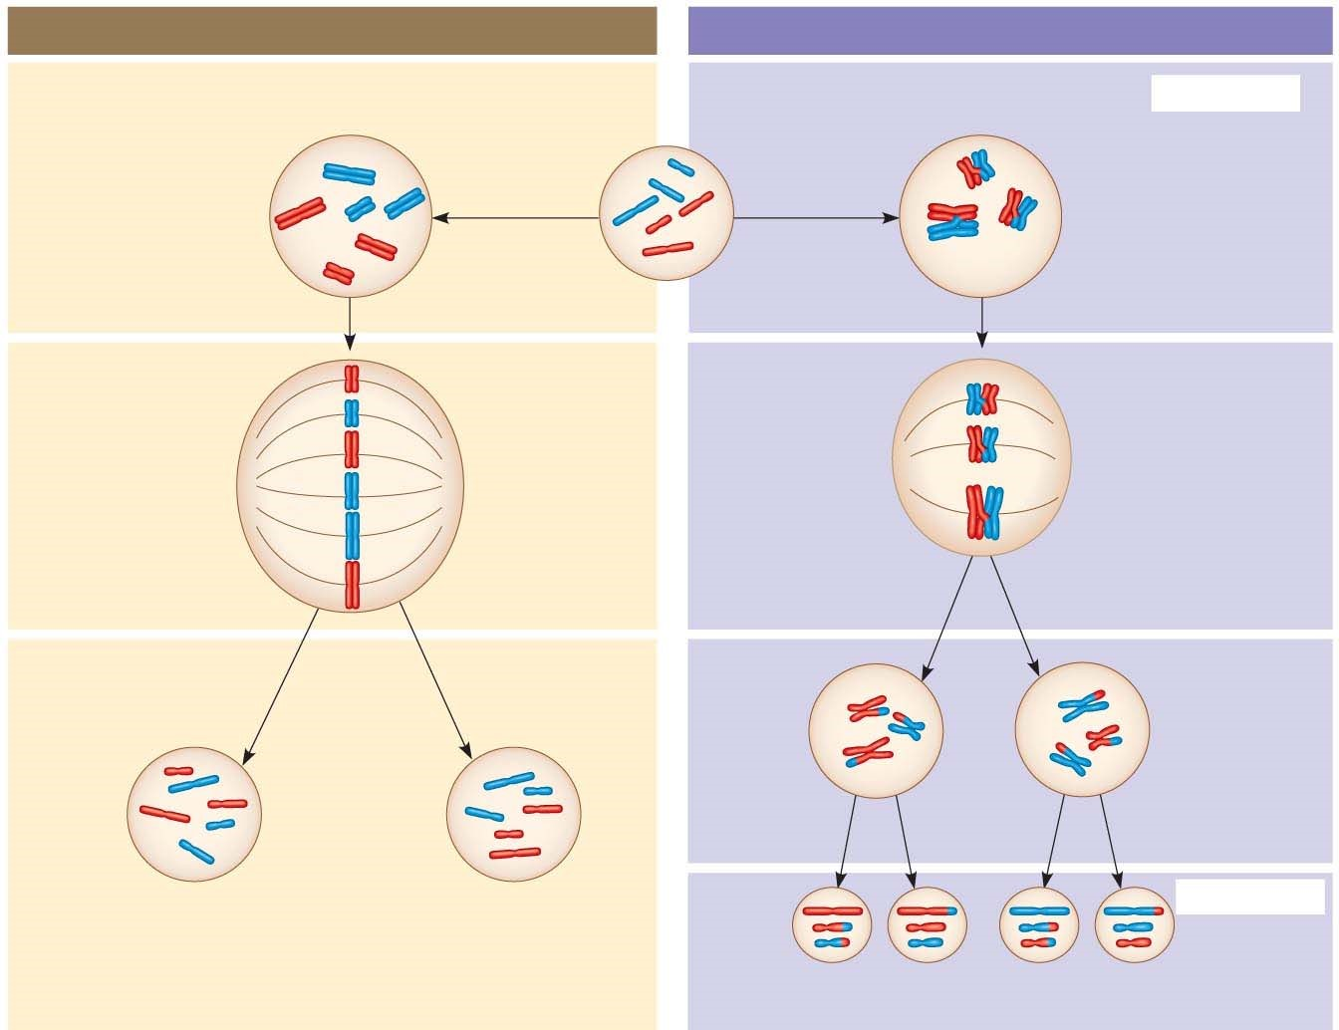

- Students often get confused about the differences between mitosis and meiosis. To help with this, work through the following chart:
 | Mitosis | Meiosis
Role in the animal body
Number of DNA replications
Number of divisions
Number of daughter cells
Chromosome number of daughter cells

- Synapsis and crossing over are unique to meiosis. During what specific phase do these occur?
- Explain the physical events of crossing over. You may wish to make a sketch of the event. Include these terms: synaptonemal complex, chiasmata, homologs, sister chromatids.

Concept 13.4 Genetic variation produced in sexual life cycles contributes to evolution

- An important idea for you to understand is that new alleles arise by changes in the DNA or mutation, but genetic diversity occurs when the deck that is dealt is simply reshuffled. So, there are three ways that sexually reproducing organisms “shuffle the deck.” They are listed below. Explain what occurs in each, and how this increases diversity.

independent assortment of chromosomes
crossing over
random fertilization

