**AP BIOLOGY 2021-22 November 19, 2021**

**Today’s Agenda (Day 59)**

1. Housekeeping Items

🡪 REQUEST FOR ITEMS: baking soda, ice

1. Homework Check:

🡪 READING GUIDE: Ch 10

1. Class Activity:

🡪 **LAB: Osmosis and Diffusion (Part 2) – see p. 17 of doc**

[AP Bio Lab 1 - Diffusion & Osmosis — bozemanscience](http://www.bozemanscience.com/ap-bio-lab-1-diffusion-osmosis)

[Diffusion Demo — bozemanscience](http://www.bozemanscience.com/diffusion-demo)

🡪 **LAB: Photosynthesis – see p. 14 of doc**

[Photosynthesis Lab Walkthrough — bozemanscience](http://www.bozemanscience.com/photosynthesis-lab-walkthrough)

[AP Bio Lab 4 - Plant Pigments & Photosynthesis — bozemanscience](http://www.bozemanscience.com/ap-bio-lab-4-plant-pigments-photosynthesis)

🡪 **LAB: Cellular Respiration – see p. 8 of doc**

[Cellular Respiration Lab Walkthrough — bozemanscience](http://www.bozemanscience.com/cellular-respiration-lab-walkthrough)

[AP Bio Lab 5 - Cellular Respiration — bozemanscience](http://www.bozemanscience.com/ap-bio-lab-5-cellular-respiration)

**\*REVIEW ALL THE LABS. COMPLETE HYPOTHESES FOR EACH LAB\***

HOMEWORK:

* READ: Chapters 9 – 13
* STUDY: Ch 10_11 Vocabulary Quiz

Chapter 10 - Photosynthesis

|  |  |  |  |  |  |
| --- | --- | --- | --- | --- | --- |
| Absorption spectrum | Action spectrum | Bundle-sheath cells | C3 plant | C4 plant | Calvin cycle |
| CAM plant | Carbon fixation | Carotenoids | Chlorophyll | Crassulacean acid metabolism (CAM) | Cyclic electron flow |
| Electromagnetic spectrum | Glyceraldehyde 3-phospate (G3P) | Light reactions | Light-harvesting complex | Linear electron flow | Mesophyll |
| Photons | Photophosphorylation | Photorespiration | Photosystem | Photosystem I | Photosystem II |
| PEP carboxylase | Primary electron acceptor | Reaction-center complex | Rubisco | Spectrophotometer | Stomata |
| Stroma | Thylakoids | Visible light | wavelength |  |  |

REMINDERS:

* QUIZ: Ch 10 & 11 Vocabulary 🡪 Nov. 24
* Ch 11 Reading Guide – Nov. 24
* **TEST: Chapter 11 🡪 Nov. 30**
* **TEST: Chapter 12 🡪 Dec. 9**
* **MIDTERM:** Covers Ch 1 – 13

Chapter 11 – Cell communication

|  |  |  |  |  |  |
| --- | --- | --- | --- | --- | --- |
| Adenylyl cyclase | Apoptosis | Biofilm | Chemical messengers | Cyclic AMP | Diacylglycerol (DAG) |
| Endocrine signaling | Growth factors | Hormones | Inositol triphosphate (IP3) | Ligand | Paracrine signaling |
| Phosphorylation cascade | Plant growth regulators | Protein kinase | Protein phosphatases | Scaffolding proteins | Second messengers |
| Signal transduction pathway | Synaptic signaling |  |  |  |  |

**AP BIOLOGY 2021-22 READING GUIDE**

# Chapter 11: Cell Communication

Chapters 9, 10, and 11 form three of the most difficult chapters in the book. The special challenge in Chapter 11 is not that the material is so difficult, but that most of the material will be completely new to you. Cell communication is normally not covered in standard high school biology books, yet perhaps no other section of biology has grown as much as cell signaling has in the last ten years. Take your time with this section, and you will be rewarded with a knowledge base that will be most helpful in this course and courses to come.

## Concept 11.1 External signals are converted into responses within the cell

1. What is a **signal transduction pathway**?

1. How does yeast mating serve as an example of a signal transduction pathway?

1. Complete the chart of local chemical signaling in cell communication in animals.

|  |  |
| --- | --- |
| **Local Signaling Types** | **Specific Example** |
| Paracrine |  |
| Synaptic |  |

1. How does a hormone qualify as a long-distance signaling example?

1. A signal transduction pathway has three stages. Use Figure 11.6 to label the missing parts of the preview figure below, and then explain each step.

## Reception

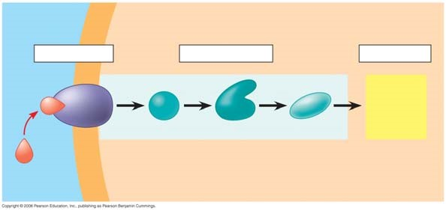

**Transduction**

## Response

### **Concept 11.2 Reception: A signal molecule binds to a receptor protein, causing it to change shape**

1. Explain the term ***ligand***. (This term is not restricted to cell signaling. You will see it in other situations during the year.)

1. The text will explain three major types of membrane receptors in Figure 11.7. This material is of fundamental importance, so we will work thorough the specific figures for each type of membrane receptor. The first example is a ***G protein-linked receptor***. In the first figure, label the components and then describe the role of the three components.

1. Label and then describe what happens in step 2.

1. Label then describe what happens in step 3. (The yellow box at the bottom right is important!)

1. Equally important to starting a signal is stopping a signal. Step 4 stops the signal. (Failure to do so can lead to serious problems, like cancer.) Label and then describe how the signal is halted.

1. What activates a G protein?

1. A G protein is also a GTPase enzyme. Why is this important?

1. The second type of receptor described is ***receptor tyrosine kinase***. Explain what a kinase enzyme does.
2. How does tyrosine kinase function in the membrane receptor?

1. What is a key difference between receptor tyrosine kinases and G protein-coupled receptors?

1. Provide all the missing labels on the diagram; then explain what happens in step 1.

1. Label step 2 and then describe what happens to receptors tyrosine kinases when signaling molecules have attached.

1. Label and explain how the receptors are activated in step 3.

1. Use step 4 to explain how the activated receptor can stimulate multiple cellular response pathways.

1. Each activated protein in the figure above triggers a signal _________________ pathway leading to a ______________ response.

1. Moving to ***ion channel receptors***, the example in Figure 11.7 shows the flow of ions into the cell. Ion channel receptors can also stop the flow of ions. These comparatively simple membrane receptors are explained in three steps. In the first step, label the diagram and then explain the role of the labeled molecules.

1. Label the diagram and then explain what has happened with the binding of the ligand to the receptor.

1. The ligand attachment to the receptor is brief. Label and explain what happens as the ligand dissociates.

1. In what body system are ***ligand-gated ion channels*** and ***voltage-gated ion channels*** of particular importance?
2. Intracellular receptors are found in the __________ or ____________ of the cell, where they bond to chemical messengers that are ________________ or very small, like nitric oxide.

1. This diagram uses testosterone, a hydrophobic hormone, to detail how intracellular receptors work. At each arrow, add an explanation of what is happening in the cell.

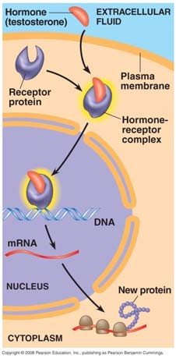

1. An important idea, ***transcription factors***, is introduced in Figure11.8. Explain the function of transcription factors in the cell.

### **Concept 11.3 Transduction: Cascades of molecular interactions relay signals from receptors to target molecules in the cell**

1. What are two benefits of multistep pathways like the one in Figure 11.9?

1. Explain the role of these two categories of enzymes in transduction.

**Protein kinase**

## Protein phosphatases

1. Using Figure 11.9 as your guide, explain what is occurring in the cell at each arrow.

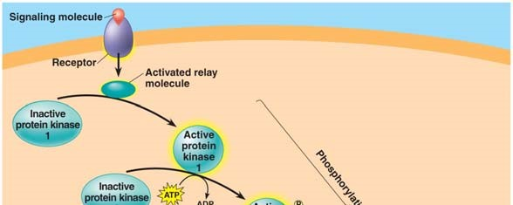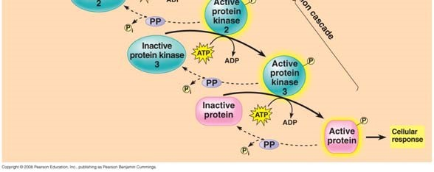

1. What is the difference between a **first messenger** and a **second messenger**?

1. Two common ***second messengers*** are cyclic AMP (cAMP) and calcium ions (Ca2+). Explain the role of the second messenger cAMP in Figure 11.11 from the text.

1. What is the important relationship between the second messenger and ***protein kinase A***?

1. Figure 11.11 explains how to initiate a cellular response; how might that response be inhibited?
2. Using your new knowledge of cell signaling, explain the mechanism of disease in cholera.
3. List three types of pathways often induced by calcium ions.

1. What happens to the cytoplasmic concentration of calcium when it is used as a second messenger?

### **Concept 11.4 Response: Cell signaling leads to regulation of transcription or cytoplasmic activities**

1. When cell signaling causes a response in the nucleus, what normally happens?
2. When cell signaling causes a response in the cytoplasm, what normally happens?
3. Figure 11.15 shows a single molecule of epinephrine resulting in the formation of __________ molecules of glucose-1-phosphate!

1. Figure 11.17 shows four different cellular results from a single signaling molecule. Briefly describe each response.

**Cell A**

**Cell B**

**Cell C**

## Cell D

42. How do **scaffolding proteins** enhance a cellular response?

### **Concept 11.5 Apoptosis (programmed cell death) integrates multiple cell-signaling pathways**

1. What specifically happens to a cell during the process of **apoptosis**?

1. The signal for apoptosis can come from outside or inside the cell. Give one example when the signal comes from outside the cell and two examples of cellular occurrences that would prompt an apoptosis signal from inside the cell.

**AP BIOLOGY 2021-22 LAB ACTIVITY 2**

**Investigation - What Factors Effect Cellular Respiration?**

*This investigation uses respirometry techniques to calculate the rate of oxygen consumption (cellular respiration) in germinating pea seeds. The effect of temperature and whether a seed has broken dormancy are quantified and graphed. The ideal gas law and its concepts are reviewed and applied.*

Objectives

* *Understand the relationships between temperature, pressure and volume.*
* *Study the effects of diffusion through a semipermeable membrane*
* *Quantify oxygen consumption rates in germinating peas under different conditions*
* *Predict the effect of temperature and germination state on the rate of cell respiration*

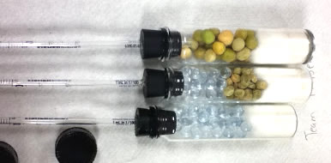

**Background**

Each individual cell is responsible for the energy exchanges necessary to sustain its ordered structure.  Cells accomplish this task by breaking down nutrient molecules to generate ATP (adenosine triphosphate), which can then be used to run cellular processes that require energy.  This process is called cellular respiration which requires nutrient molecules and oxygen.   Carbon dioxide and water are products of the series of reactions involved in cellular respiration.

equation

METHODS OF MEASURING THE RATE OF CELLULAR RESPIRATION:

There are several methods of indirectly measuring the rate of cellular respiration in organisms.  (1) One method involves monitoring changes in temperature; since the process of respiration is exergonic (produces heat).  (2) Another method is to measure either the oxygen consumption or the carbon dioxide production.  Respirometers are devices that measure these types of gas volume changes, and therefore provide information about the rate of cellular respiration.

In order to be able to use a respirometer, you will need to use the ideal gas law, which describes the relationship between temperature, pressure and volume. (PV = nrT)

During cellular respiration, two gases are changing in volume.  Oxygen gas is being consumed by the respiring cells and carbon dioxide gas is diffusing out of the cells.  The respirometer, therefore, has to be able to deal with two simultaneously changing gas volumes.  This is accomplished by introducing potassium hydroxide into the device.  KOH absorbs carbon dioxide, following this equation:

CO2 + 2KOH --> K2CO3 + H2O

Potassium carbonate (K2CO3 ) is a solid precipitate.  Any CO2 produced is immediately converted from a gas to a solid and is therefore no longer governed by gas laws.  This allows the respirometer to measure only one variable, the consumption of oxygen gas by living cells.

**Assembling the Respirometers**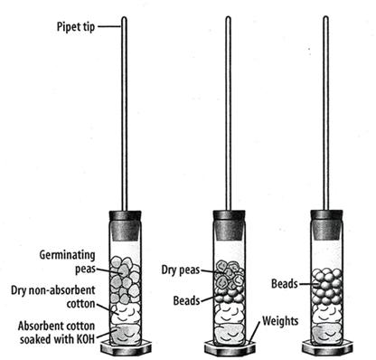

Two sets of three respirometers will be assembled during this lab exercise.  Each set will be incubated at a different temperature.  One respirometer will contain germinated seeds, one will contain a mix of non-germinating seeds and plastic beads, and a third will contain only plastic beads.

The purpose of the beads is to ensure that each respirometer is uniform in volume.  The respirometers will also contain a layer of cotton that has been saturated with KOH so that carbon dioxide will be absorbed.   The respirometers will be submerged in a pan of water; water will flow from an area of high pressure to an area of low pressure.  As oxygen is used up by the respiring seeds, the gas pressure inside the respirometer will decrease and the water will flow into the pipet down its pressure gradient.

**Lab Materials**:   50 germinating pea seeds, 50 dry seeds, 100 plastic beads, 3 respirometer vials, Weights for vials,3 stoppers, 1 ml graduated pipets, sealant (Vaseline), absorbent cotton, nonabsorbent cotton, 1 round wood stick, 3 pieces of paper towel, marking pen, water bath, ice, 100 ml graduated cylinder, thermometer, masking tape, stopwatch or clock, water. Dropper Bottle of 15% KOH

Safety – wear safety goggles.  KOH is caustic, avoid direct skin contact.

**Procedure: Day 1**

1.  Label three paper towels as follows:  1a, 2a, 3a.  These numbers will correspond to the respirometers of the same numbers. checkbox

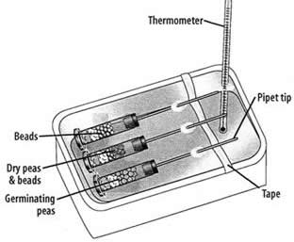2.  Fill a graduated cylinder with 20 ml of water.  Count out 25 germinating seeds and place them into the graduated cylinder.   Record the total volume of the seeds and water in the data table.  Subtract the initial 20 ml to determine the total volume of the germinating seeds.  Pour out the water from the graduated cylinder and place the 25 germinating seeds on paper towel 1a. checkbox

3.  Fill the graduated cylinder with 20ml of water.  Count out 25 dry (non-germinating) seeds and place them into the water.  Drop plastic beads into the cylinder until the final volume is the same as from step 3. 

4. Place the pea/bead mixture on paper towel 2a.  (Your goal here is to make sure each respirometer has the same volume).checkbox 

5.  Fill the graduated cylinder with 20 ml of water.  Add beads to the water until the total volume equals the final volume from steps 2 & 3.  Place the beads on paper towel 3a. checkbox

6.  Assemble the respirometers.  Begin with 3 vials, rubber stoppers and 1 ML pipets.  You will also need a sealant and a marker to label the vials 1a, 2a, 3a. checkbox

7.  Insert the **non-tapered** end of one pipet into the upper surface of one of the rubber stoppers.  It should fit tightly.  Place a layer of sealant around the junction between the pipet and the stopper so that no air can escape.  (*The pointy end of the pipet should be outside, not inside) checkbox

8.  Place a piece of absorbent cotton in the bottom of each of the weighted vials.  Push the cotton firmly into the bottom of the vial with a wooden stick or stirring rod.  Saturate the cotton in the vial with a few drops of 15% KOH, or alternatively use KOH pellets.  Use the same number of drops on each cotton ball.  *Caution, KOH is caustic.checkbox   

9.  Place a piece of nonabsorbent cotton on top of the saturated cotton in each vial.  Push the cotton to the bottom of the vial. (If using KOH pellets, only the nonabsorbent cotton is necessary to prevent peas from touching poisonous pellets.checkbox

10.  Add the peas, peas/beads, and beads to the appropriate respirometer.  Place the stoppers on each of the vials and ensure they are secured tightly.  Any leaks will cause the experiment to fail.  Set your apparatus aside for day 2. checkbox

**Day 2**

1.  Place a strip of masking tape across the narrow width of the water bath, approximately 2/3 of the way from one end (see diagram).  Place a white paper towel in the bottom of the tub so that you can more easily read pipettes. checkbox

2.  Place respirometers 1a, 2a, 3a into the room temperature water bath so that the pipets rest on the masking tape prop.  Begin time for a total of 2 minutes – this is the equilibration period, where your respirometers will become the same temperature as the water. Use a thermometer to determine the water temperature:  ____ checkbox

3. Submerge each of the tubes entirely in the water bath. Some water will enter the tip of the pipet, but the influx of water should stop fairly quickly.  If it does not stop, check the respirometer for leaks.   checkbox

4.  At this point, check to make sure you can read the pipets. The air bubble should extend from the main chamber up the tube of the pipet.  The pipet may need to be rotated so that you can see the numbers. checkbox

5.  If your respirometers float, you may need to weight them.  Some come with weights inside and some do not. You can improvise here, stainless steel dissection scissors; for instance, can serve to weight the tubes. checkbox

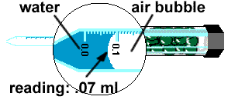6.    Record the water level in each pipet onto the data table at the Time Interval 0.  checkbox

7.  Record the position of the water in each pipet at the end of 5, 10, and 15, 20 min on Data Table 2. checkbox

8.  Remove the respirometers from the water and set aside for Day 3 checkbox

**Day 3**

*\*Alternatively, assign groups for room temperature and cold water to reduce this lab by a day.*

1.  Add ice to the water bath to lower the temperature to about 10 Celsius.    checkbox

2.  Now submerge the respirometers into the ice bath and let them sit for 2 minutes so their temperature becomes equal to the water bath temperature. checkbox

3.  Record the position of the water at 0, 5, 10, 15, 20 min. checkbox

**Extension:**   Remove your peas from the chamber and replace with a living organism. You could use a cricket or a mealworm for instance.

**DATA & ANALYSIS**

|  |  |  |  |
| --- | --- | --- | --- |
| **DATA TABLE 1: Calculation of Volume in Respirometers** | | | |
|  | Respirometer 1a (germinating seeds) | Respirometer 2a (non germinating) | Respirometer 3a (beads only) |
| Initial Volume (mL) | 20 | 20 | 20 |
| Final Volume (mL) |  |  |  |
| Volume of beads/seeds |  |  |  |

|  |  |  |  |  |  |
| --- | --- | --- | --- | --- | --- |
| **Data Table 2: Calculation of Oxygen Consumption** | | | | | |
| Respirometer 1a:  Room Temperature, Germinating Peas | | | | | |
| Time interval (min): | **0 min** | **5 min** | **10min** | **15 min** | **20 min** |
| Reading, mL |  |  |  |  |  |
| Δ  Volume, mL (reading – time 0) | N/A |  |  |  |  |
| Respirometer 2a: Room Temperature, Dry Pea Seeds | | | | | |
| Reading, mL |  |  |  |  |  |
| Δ  Volume, mL (reading – time 0) | N/A |  |  |  |  |
| Respirometer 3a:  Room Temperature, Beads Only | | | | | |
| Reading, mL |  |  |  |  |  |
| Δ  Volume, mL (reading – time 0) | N/A |  |  |  |  |
| Respirometer 1b:  10°C, Germinating Pea Seeds | | | | | |
| Time interval (min): | **0 min** | **5 min** | **10 min** | **15 min** | **20 min** |
| Reading, mL |  |  |  |  |  |
| Δ  Volume, mL (reading – time 0) |  |  |  |  |  |
| Respirometer 2b:  10°C, Dry Pea Seeds | | | | | |
| Reading, mL |  |  |  |  |  |
| Δ  Volume, mL (reading – time 0) | N/A |  |  |  |  |
| Respirometer  3b: 10°C, Beads only | | | | | |
| Reading, mL |  |  |  |  |  |
| Δ  Volume, mL (reading – time 0) | N/A |  |  |  |  |
|  | | | | | |
| **Extension:  Living Organism** | **0 min** | **5 min** | **10 min** | **15 min** | **20 min** |
| Reading, mL |  |  |  |  |  |
| Δ  Volume, mL (reading – time 0) |  |  |  |  |  |

**Graph:**  Graph a line for: Germinating Peas (room temp) | Germinating Peas (cold) | Non Germinating peas (room temp) | Non Germinating peas (cold) **Use a line of BEST FIT so that you can calculate slope**

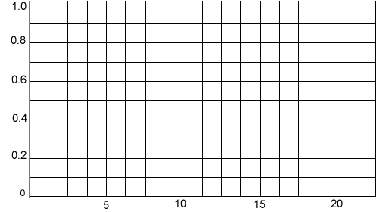

**Analysis**

1.   State a hypothesis that relates to temperature that is being tested by this lab exercise.

2.   State a hypothesis that relates to the state of seed germination that is being tested by this lab exercise.

3.  Calculate the RATE of oxygen consumption for the germinating seeds in both cold and room temperature water.  Rate can be calculated by determining the SLOPE of the line from your graph above.

4.  In this lab exercise, what is the purpose of the ….

a) Beads

b) KOH

c) Respirometer

5.  Explain why the water moved within the pipet.

6. Design another experiment to compare the respiration rates of an animal, like a worm at different temperatures (ex. At 10 ⁰C vs. 22 ⁰C). What would you predict would happen to the worm's respiration rate?

7. Compared to a worm, do you think an endothermic (warm-blooded) animal would have a higher or lower rate or respiration? Explain your prediction in terms of metabolism of the animal.

8. Imagine that you are given 25 germinating pea seeds that have been placed in boiling water for five minutes. You place these seeds in a respirometer and collect data. Predict the rate of oxygen consumption (cellular respiration) for these seeds and explain your reasons.

9. What difficulties would there be if you used a living green plant in this investigation instead of germinating seeds?

**AP BIOLOGY 2021-22 LAB ACTIVITY**

**Photosynthesis Lab**

**Floating Leaf Disk Assay**

**Introduction**

Light is a part of a continuum of radiation, or energy waves. Shorter wavelengths of energy have greater amounts of energy. For example, high-energy ultraviolet rays, with wavelengths of approximately 1 nanometer (nm) to 380 nm, can harm living tissues due to the large amount of energy they carry. Wavelengths of light within the visible part of the light spectrum power *photosynthesis*. The visible light spectrum is from about 400 to 750 nm (1 billionth of a meter). Only visible light, with its intermediate wavelengths, has enough energy to cause chemical change without destroying biological molecules. The short, high frequency waves of gamma rays (10-5 nm) have too much energy and break the hydrogen bonds found within biological molecules such as proteins and nucleic acids like DNA. The longer waves of heat, microwaves and radio waves (103 nm to 103 meters) do not possess enough energy and are absorbed by the water molecules in a plant.

When light is absorbed by leaf pigments such as *chlorophyll a or b*, electrons within each Photosystem are boosted to a higher energy level. This energy is used to produce ATP, to reduce NADP to NADPH and then used to incorporate carbon dioxide (CO2) into organic molecules in a process called *carbon fixation.* Leaf disks float, normally. When the air spaces are infiltrated with a solution the overall density of the leaf disk increases and the disk sinks. The infiltration solution includes a small amount of sodium bicarbonate (NaHCO3) thus enabling the bicarbonate ion to serve as the carbon source for photosynthesis. As photosynthesis proceeds, oxygen is released into the interior of the leaf which changes its buoyancy causing the disks to rise. Since cellular respiration is taking place at the same time within the leaf, consuming the oxygen generated by photosynthesis, the rate that the disks rise is an indirect measurement of the net rate of photosynthesis. In this lab, you will measure the net rate of photosynthesis for several plants under various lighting conditions.



**Materials:**

|  |
| --- |
| 1.               Sodium bicarbonate (Baking soda)  2.               Liquid Soap  3.               Plastic syringe (10 cc or larger)  4.               Leaf material  5.               Hole punch  6.               Plastic cups  7.               Timer  8.               Light source |

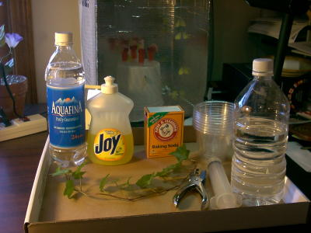

**Part A Procedure:**

1. Prepare 300 ml of bicarbonate solution for each trial.
   1. The bicarbonate serves as an alternate dissolved source of carbon dioxide for photosynthesis. Prepare a 0.2% solution. (This is not very much—it’s about 1/8 of a teaspoon of baking soda in 300 ml of water.) Too much bicarbonate will cause small bubbles (CO2) to form on the surface of the leaf which will make it difficult to sink the leaf disk.
   2. Add 1 drop of dilute liquid soap to this solution. The soap wets the hydrophobic surface of the leaf allowing the solution to be drawn into the leaf. It’s difficult to quantify this since liquid soaps vary in concentration. Avoid suds. If your solution generates suds then dilute it with more bicarbonate solution.

1. Cut 10 or more uniform leaf disks for each trial

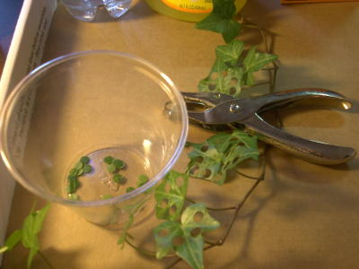

* 1. Single hole punches work well for this but stout plastic straws will work as well
  2. Choice of the leaf material is perhaps the most critical aspect of this procedure. The leaf surface should be smooth and not too thick. Avoid plants with hairy leaves. Ivy, fresh spinach, —all work well. Ivy seems to provide very consistent results. Any number of plants work.
  3. Avoid major veins.

1. Infiltrate the leaf disks with sodium bicarbonate solution.
   1. Remove the piston or plunger and place the leaf disks into the syringe barrel. Replace the plunger being careful not to crush the leaf disks. Push on the plunger until only a small volume of air and leaf disk remain in the barrel (< 10%).

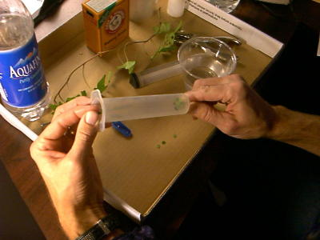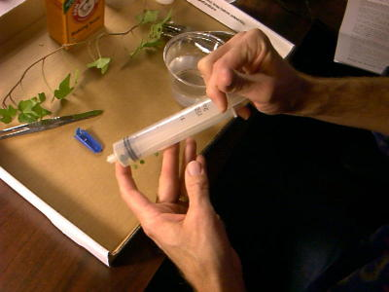

* 1. Pull a small volume of sodium bicarbonate solution into the syringe. Tap the syringe to suspend the leaf disks in the solution.

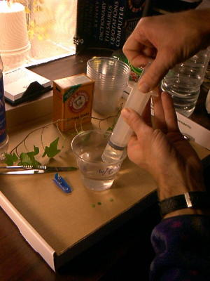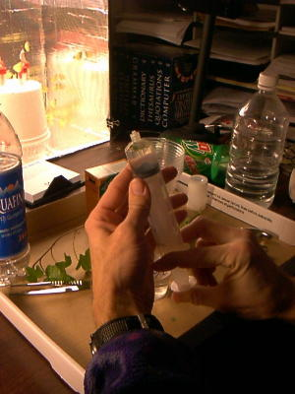

* 1. Holding a finger over the syringe-opening, draw back on the plunger to create a vacuum. Hold this vacuum for about 10 seconds. While holding the vacuum, swirl the leaf disks to suspend them in the solution. Let off the vacuum. The bicarbonate solution will infiltrate the air spaces in the leaf causing the disks to sink. You will probably have to repeat this procedure several times in order to get the disks to sink. You may have difficulty getting the disks to sink even after applying a vacuum three or four times. Generally, this is usually an indication that you need more soap in the bicarbonate solution. Some leaf surfaces are more water repellent than others are. Adding a bit more soap usually solves the problem.

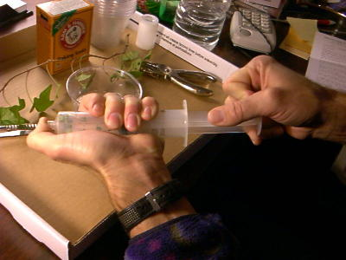

1. Pour the disks and solution into a clear plastic cup. Add bicarbonate solution to a depth of about 3 centimeters. Use the same depth for each trial. Shallower depths work just as well. Label the cup with CO2.
2. Set up a control. Infiltrate leaves with just water solution with a drop of soap---no bicarbonate. Pour the disks and solution into a clear plastic cup. Add just water solution to a depth of about 3 centimeters. Label the cup without CO2.
3. Develop a hypothesis before you begin testing.

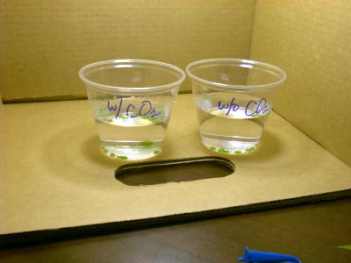

1. Place under the light source and start the timer. At the end of each minute, record the number of floating disks. Then swirl the disks to dislodge any that are stuck against the sides of the cups. Continue until all of the disks are floating.

|  |  |  |
| --- | --- | --- |
| **Time (minutes)** | **# of disks floating**  **With CO2** | **# of disks floating**  **Without CO2** |
|  |  |  |
|  |  |  |
|  |  |  |
|  |  |  |
|  |  |  |
|  |  |  |
|  |  |  |
|  |  |  |
|  |  |  |
|  |  |  |
|  |  |  |
|  |  |  |
|  |  |  |
|  |  |  |
|  |  |  |

Make a graph to analyze the data. To make comparisons between experiments, a standard point of reference is needed. Repeated testing of this procedure has shown that the point at which 50% of the

leaf disks are floating (the median or ET 50, the Estimated Time it takes 50% of the disks

to float) is a reliable and repeatable point of reference for this procedure. **Make sure to find the ET 50 of your data.**

*Sample graph to find ET 50.

**Part B**: **Design your own experiment to test what factors affect the rate of photosynthesis**

Once you have mastered the floating disk technique, you will design an experiment

to test another variable that might affect the rate of photosynthesis. Some ideas

include the following:

* Distance of light source
* Color of light source
* Type of leaf
* Turning light off after 15 minutes
* % of bicarbonate solution

**Summary Questions:**

1) What was the function of the sodium bicarbonate in this experiment?

2) Explain the process of carbon fixation.

3) Explain the process that causes the leaf disks to rise.

4) Which trial worked the best? Explain.

5) What was the purpose of using water/soap solution for one of the trials?

6) What factors may affect photosynthesis?

**Lab Report Guidelines:**

* **Title**
* **Objective**
* **Background Information**
* **Materials**
* **Part A:**
  + **Hypothesis**
  + **Procedure**
  + **Data table**
  + **Graph with ET 50 value**
  + **Conclusion**
* **Part B:**
  + **Hypothesis**
  + **Procedure/experimental design**
  + **Data table**
  + **Graph with ET value**
  + **Conclusion**
* **Answers to summary questions**

**AP BIOLOGY 2021-22 LAB ACTIVITY 2**

